
Riverview Football Program - Match reports Saturday 13th, June 2026
YEAR 7
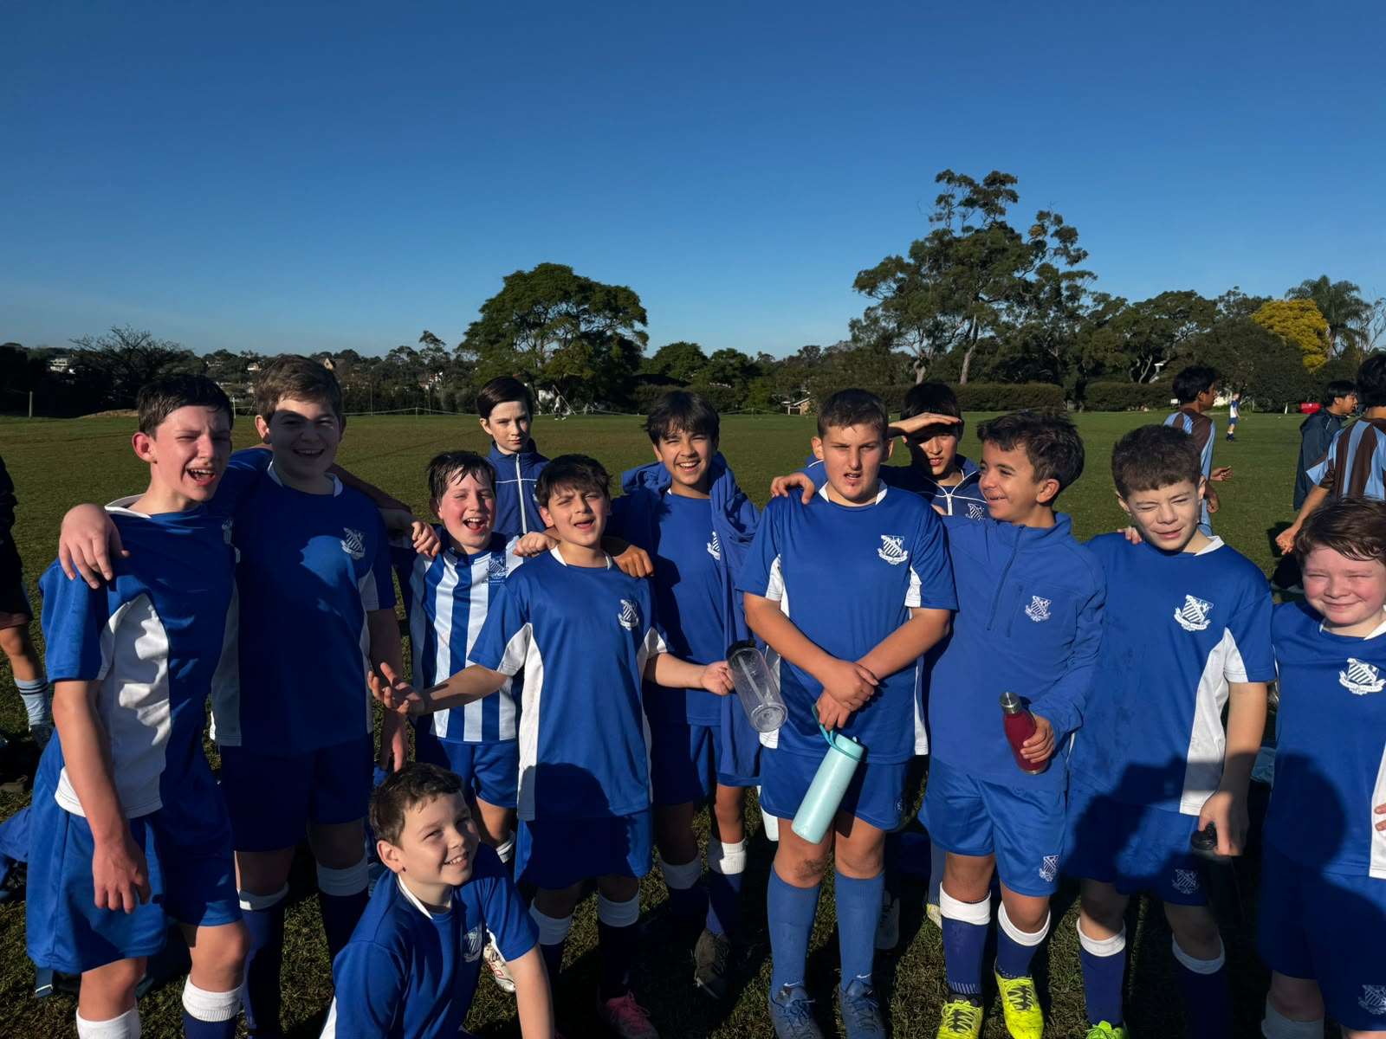

13F Match Report: Coach Sam Burkitt
The 13Fs produced another determined performance despite falling short on the scoreboard. The boys competed strongly from start to finish, showing resilience, teamwork. While the result was disappointing, there were clear signs of improvement and the effort displayed by the team was something they should be proud of. If they continue to bring the same attitude and commitment each week, positive results will follow.

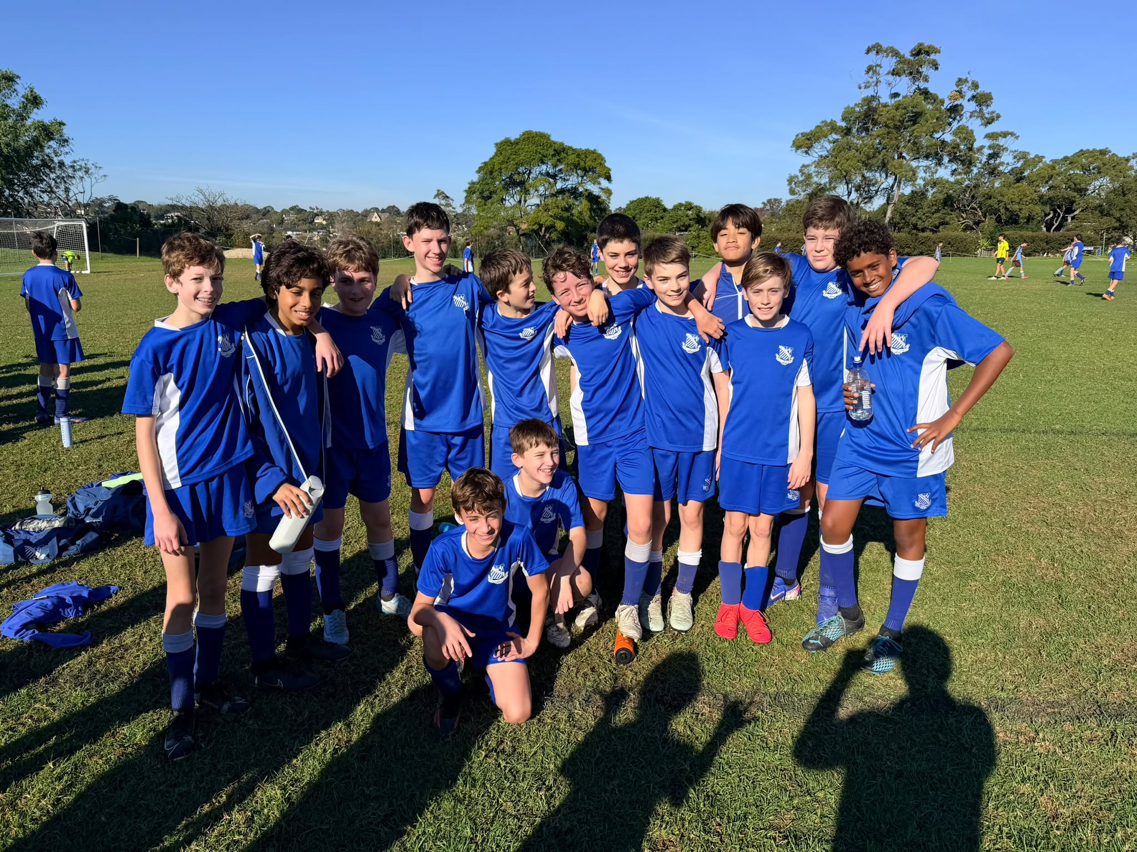
13E Match Report: Coach Michael Portale
A solid home performance from Riverview 13E, who secured a well-deserved 4–1 victory. The team showed great energy from the start, pressing high and creating plenty of chances throughout the match. The attacking play was a real highlight, with the side finding the net four times through good team movement and sharp finishing. Each goal reflected strong combination play and a willingness to take on opportunities when they arose. Defensively, there were a few moments that allowed the opposition back into the game, conceding once, but overall, the team stayed composed and limited further damage. This was a strong all-round display, with plenty of positives to take into training. The squad’s confidence will be high heading into the next fixture after a performance that showed real promise both in attack and defence.
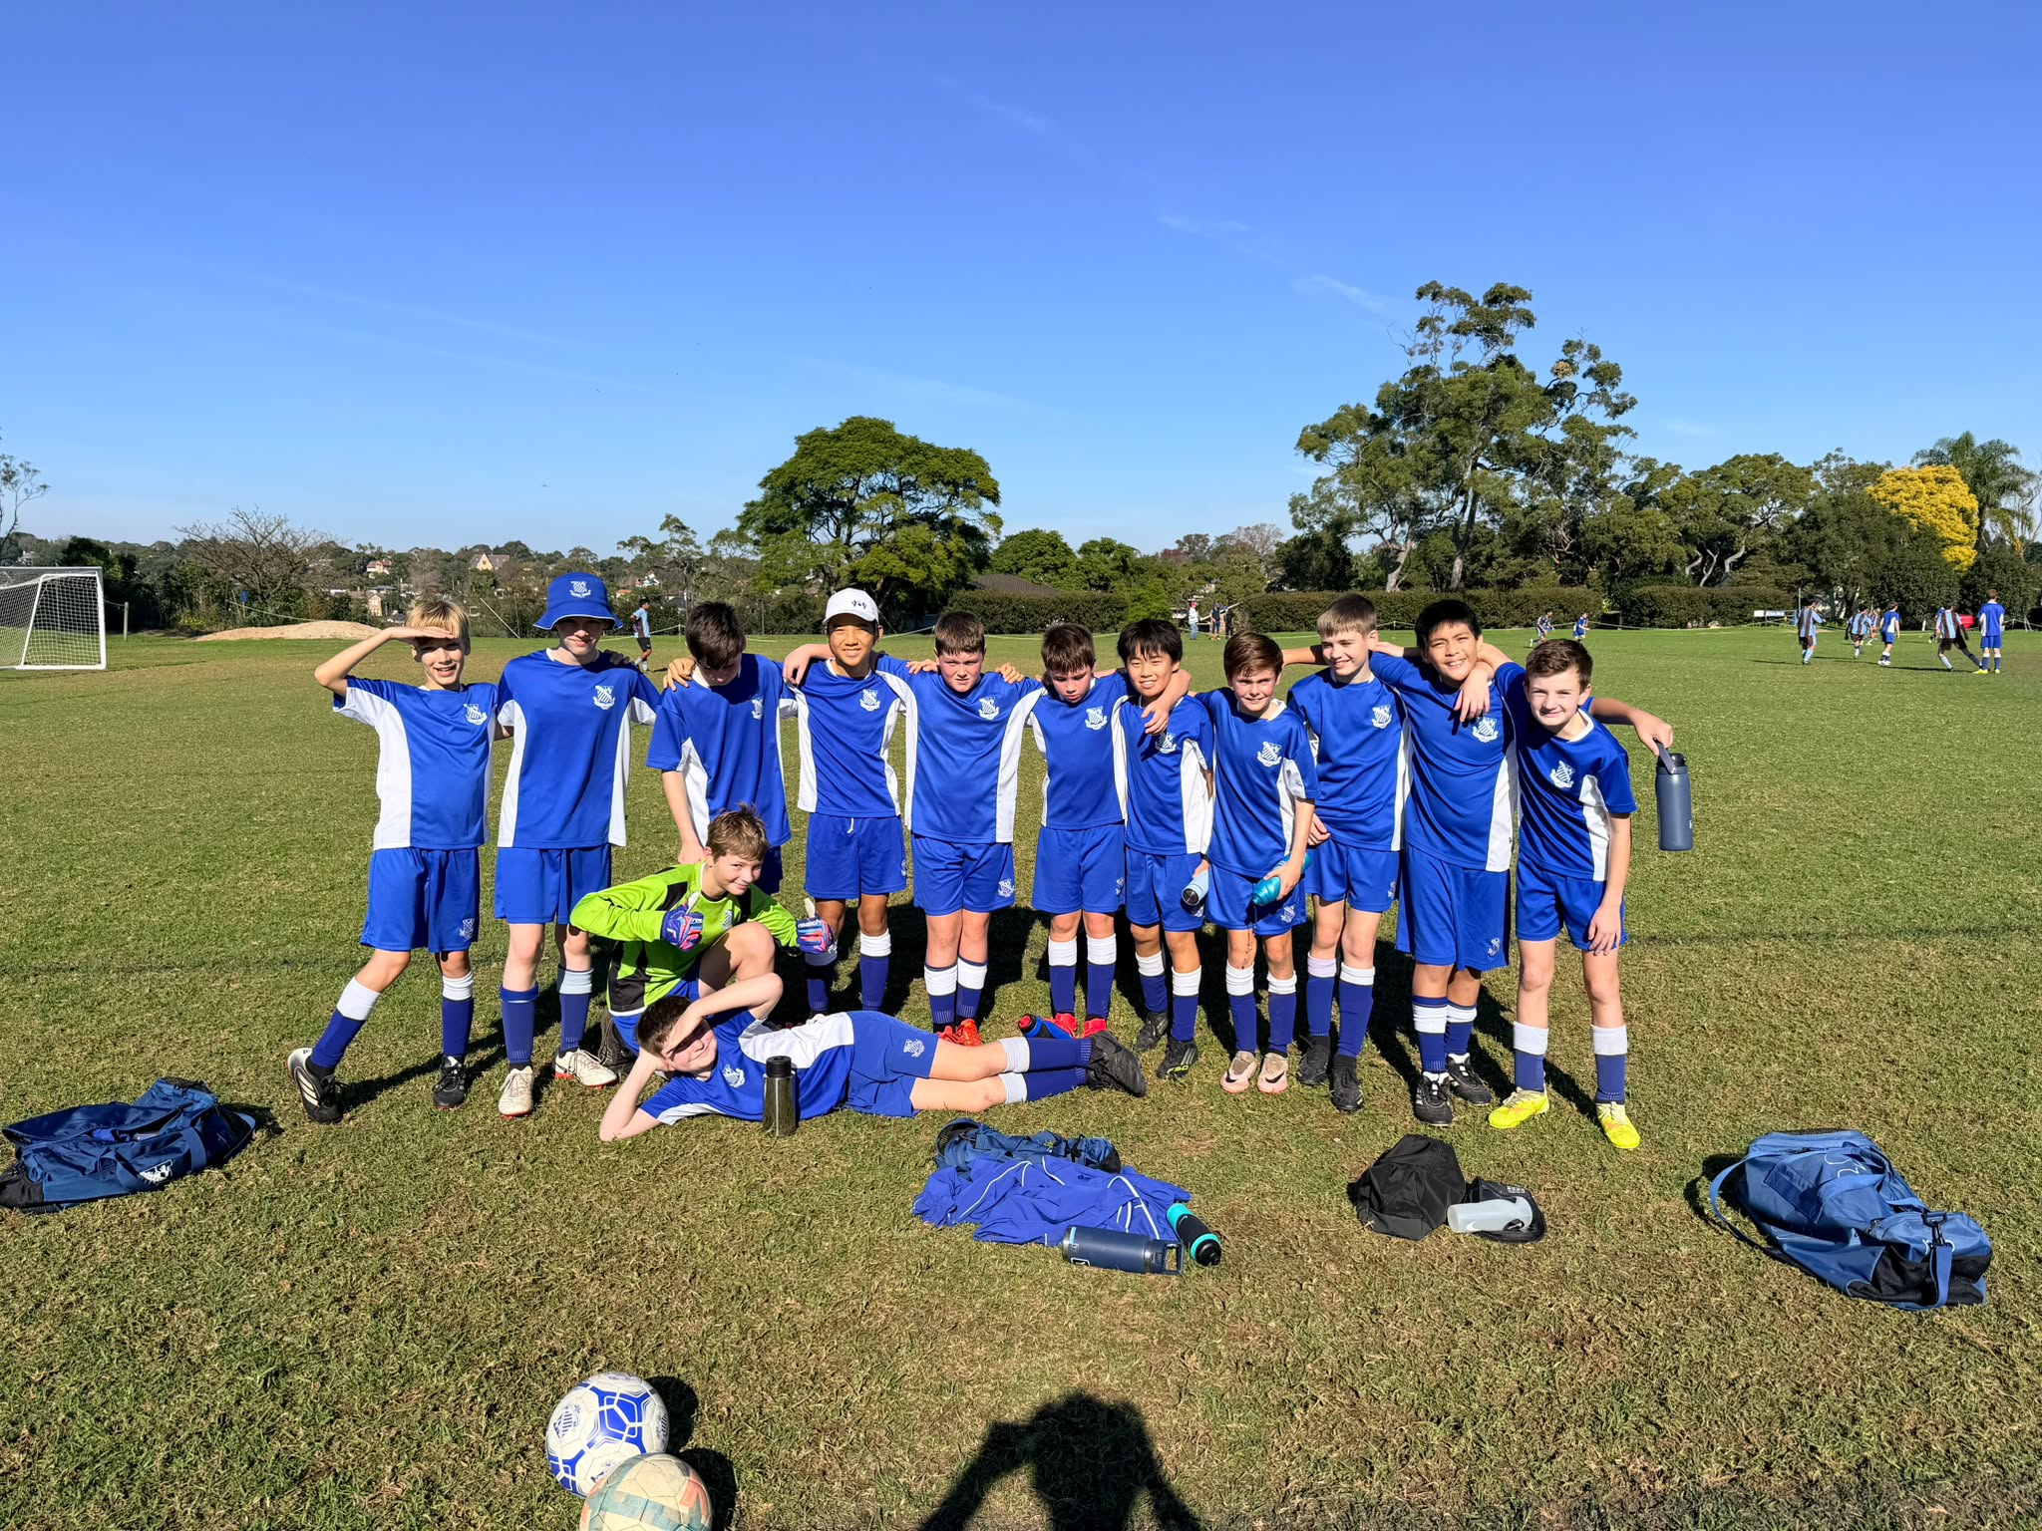
13D Match Report: Coach Michael Portale
A dominant performance from Riverview 13D, who ran riot against Sydney Boys High with a commanding 10–0 victory. From start to finish, the team controlled every aspect of the game, showcasing sharp attacking play, slick passing, and relentless pressure. The goals came from all over the pitch, reflecting a genuinely team-wide effort and a real attacking threat throughout the lineup. Defensively, the side was equally impressive, keeping a clean sheet and rarely allowing Sydney Boys High a foothold in the match. This was the kind of complete performance the coaching staff will want to see more of - confident, clinical, and well-organised across the park. A fantastic result and a great confidence boost heading into the next fixture.
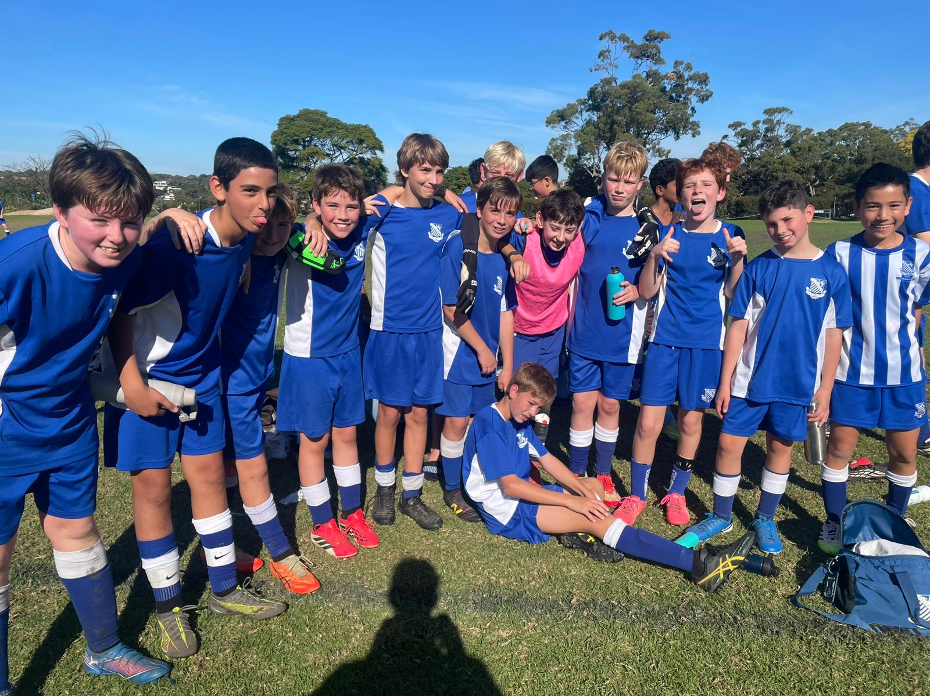
13C Match Report: Coach Nelson Meehan
This Saturday saw one of Riverview’s best performances this season with a 4-1 win over Sydney Boys High. Notably, the Riverview man of the match, Josh had some amazing play down the right wing, playing exactly like we had practiced in training and putting some incredible crosses in which led to some Riverview goals. As well, there was some great defensive work from Riverview, especially with Dylan Wong having a great game marking some fast wingers. Overall, every Riverview player had a fantastic game, and it is a great example of how well the team can play at their best. Lots to look forward to in coming weeks.
.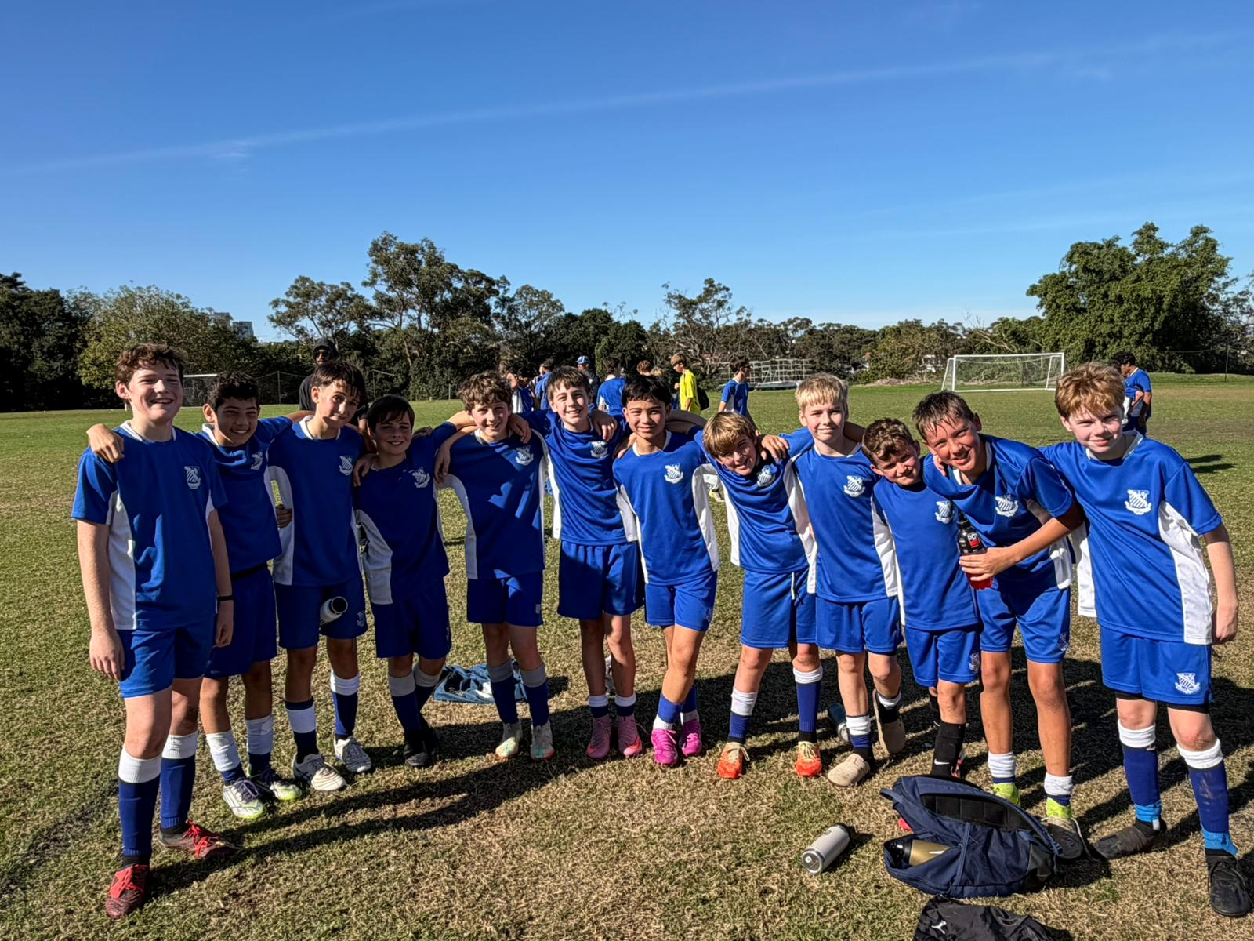
13B Match Report: Coach Josh Engelmann
The 13B’s produced a strong performance to defeat Sydney Boys High 6–1 in an impressive team display. Riverview started brightly, with Josh opening the scoring to give the side an early 1–0 lead. Sydney Boys High responded to make it 1–1, but from there Riverview took control. Xavi restored the lead before Xavier made it 3–1 with a brilliant dribble through the defenders, calmly slotting the ball into the bottom corner. Xavi then continued his dominant display, weaving in and out of defenders to score again and stretch the lead to 4–1. He completed his hat-trick with a superb left-footed strike from outside the box, a goal worthy of the occasion. Josh added his second late in the game to seal a deserved 6–1 win. It was a clinical attacking performance, backed up by strong effort, teamwork, and confidence across the pitch.

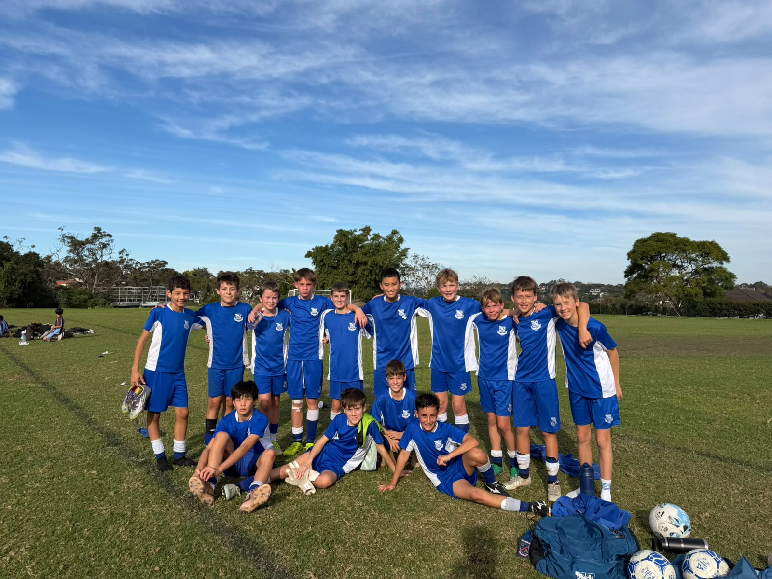
13A Match Report: Coach Lewis Morsella
A great game on the weekend both teams doing really well and making it very hard we copped two pretty easy goals almost back-to-back under a minute which wasn’t ideal, but we soon turned the game around dominating every first and second ball with great reactions when we lost the ball as well. I will have to give my man of the match to Dre who scored a last-minute winner to seal the deal for us. Overall, a great performance.

YEAR 8

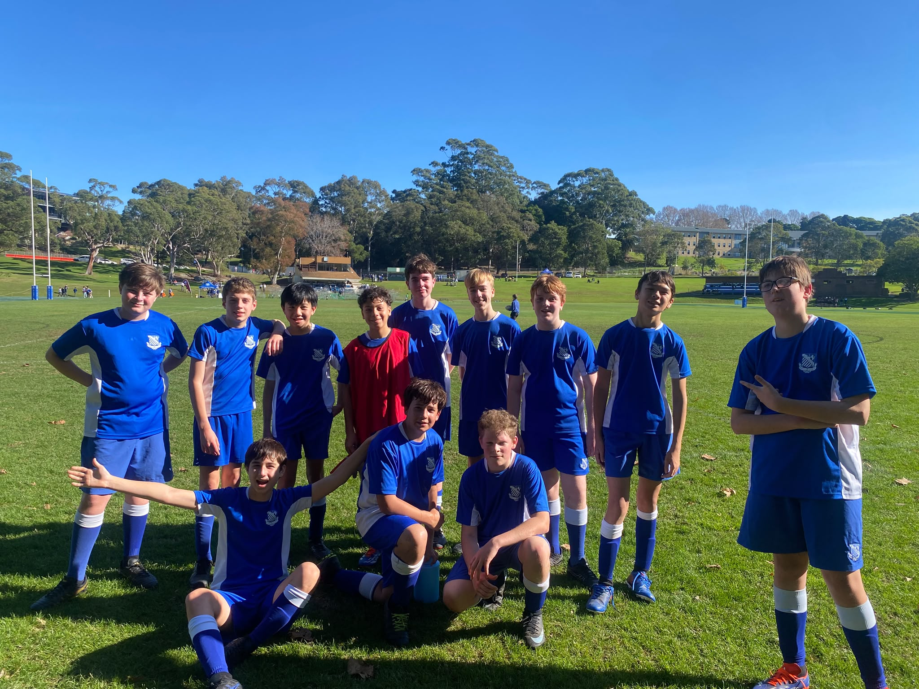
14D Match Report: Coach Matthew Chung
The U14 D team produced one of their strongest performances of the season against Sydney Boys High School. The usual defensive line of Noah Ang, Byron Hunt, Alex Marren and James Kearney was outstanding, making numerous important tackles and working hard to limit the opposition's chances. Out wide, Angus Healy and Lachlan Lay provided excellent support in both defence and attack, while George Palmer and Flynn Nolan were exceptional in central midfield, helping move the ball out of our half and up the pitch. A highlight of the match came when Flynn's free kick struck the crossbar, coming agonisingly close to a goal. Up front, Sam Cleary and Hamish Munnelly challenged the opposition defence, with Sam particularly impressive in the second half as he carried the ball forward on several occasions to relieve pressure and create attacking opportunities. Although the match ended in a 2–0 defeat, the boys showed tremendous improvement and should be very proud of their performances.
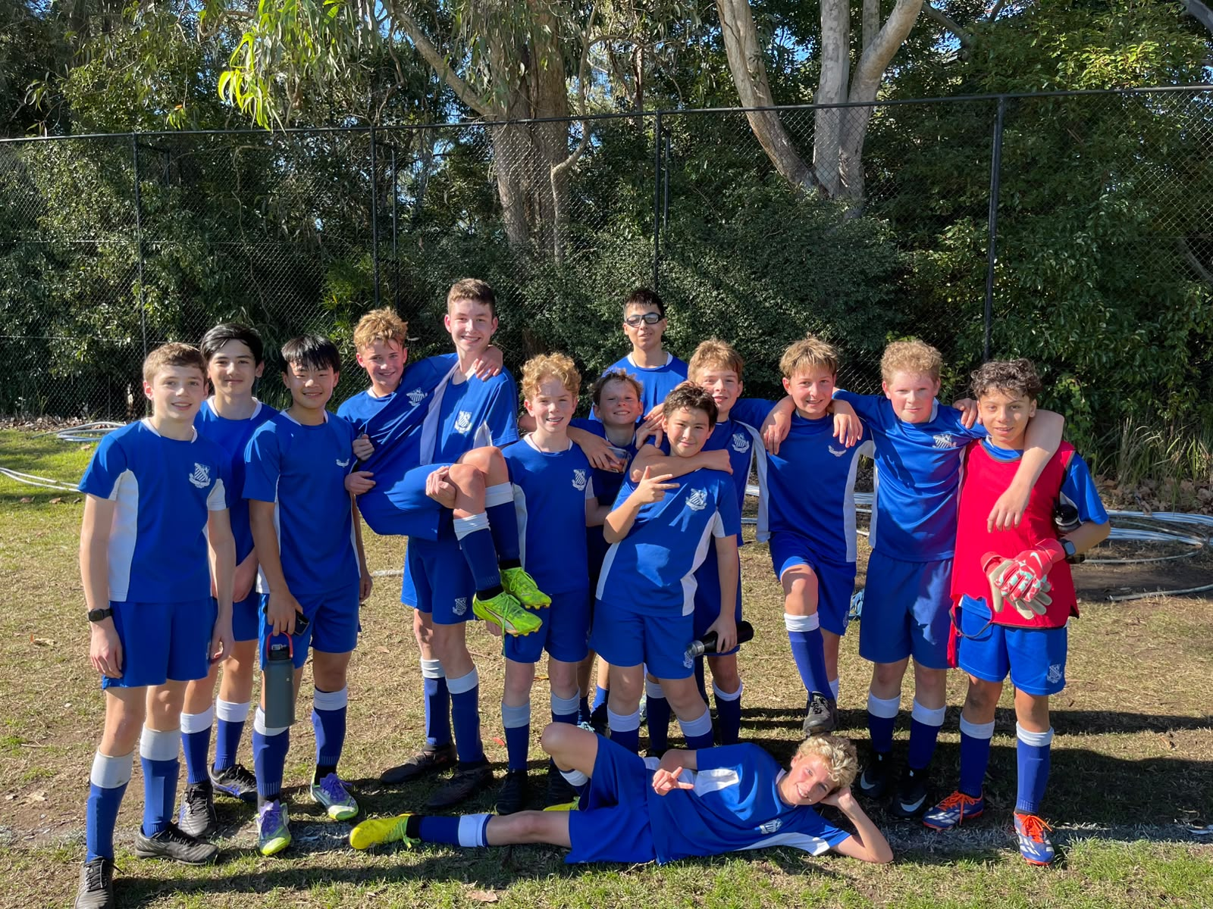
14C Match Report: Coach Tom Kalogerou
Riverview U14Cs returned to winning ways with a hard-fought 2-1 victory over Sydney Boys High. In a tight and competitive match, the View boys came out on top through positive play, commitment and hard work for each other. Riverview opened the scoring early in the first half through Charlie McDonald, who finished well to give the team a strong start. From there, the game became an end-to-end battle, with both sides pushing hard for goals. Midway through the second half, Jack Malouf doubled the lead with a superb volley from outside the box, sailing over the keeper’s head in what was surely a goal-of-the-season contender. Sydney Boys High pushed back late, but Jakob Mikhael’s excellent penalty save helped keep Riverview ahead. A late goal made things nervous, but the boys held on for a deserved win.

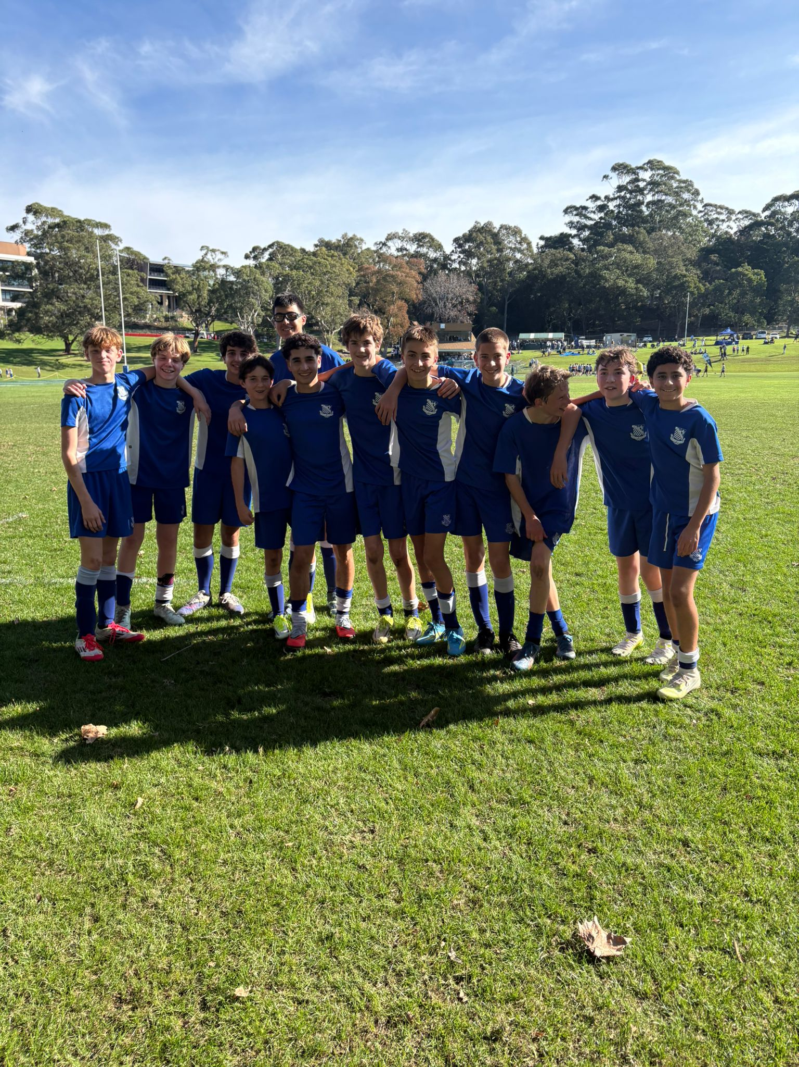
14B Match Report: Coach Lachlan Iacono
The 14B’s played against Sydney Boys High this week. We began the game with heaps of chances up front with a few unlucky to find the net. Our defence did well to stop anything that came their way all throughout the game, as well as our midfield who were constantly feeding our forwards great passes through the defensive lines of Sydney boys. The first half saw no goals as both teams failed to convert their chances. Going into the second half we tried to test the goalkeeper as much as possible which eventually paid dividends for us, especially Dan Musso who scored two in quick succession. Before a slight mishap in front of goal, Charles ended up scoring from way back over the goalkeeper’s head. We had a comfortable lead going into the final 10 minutes where we held them out and took home a win.
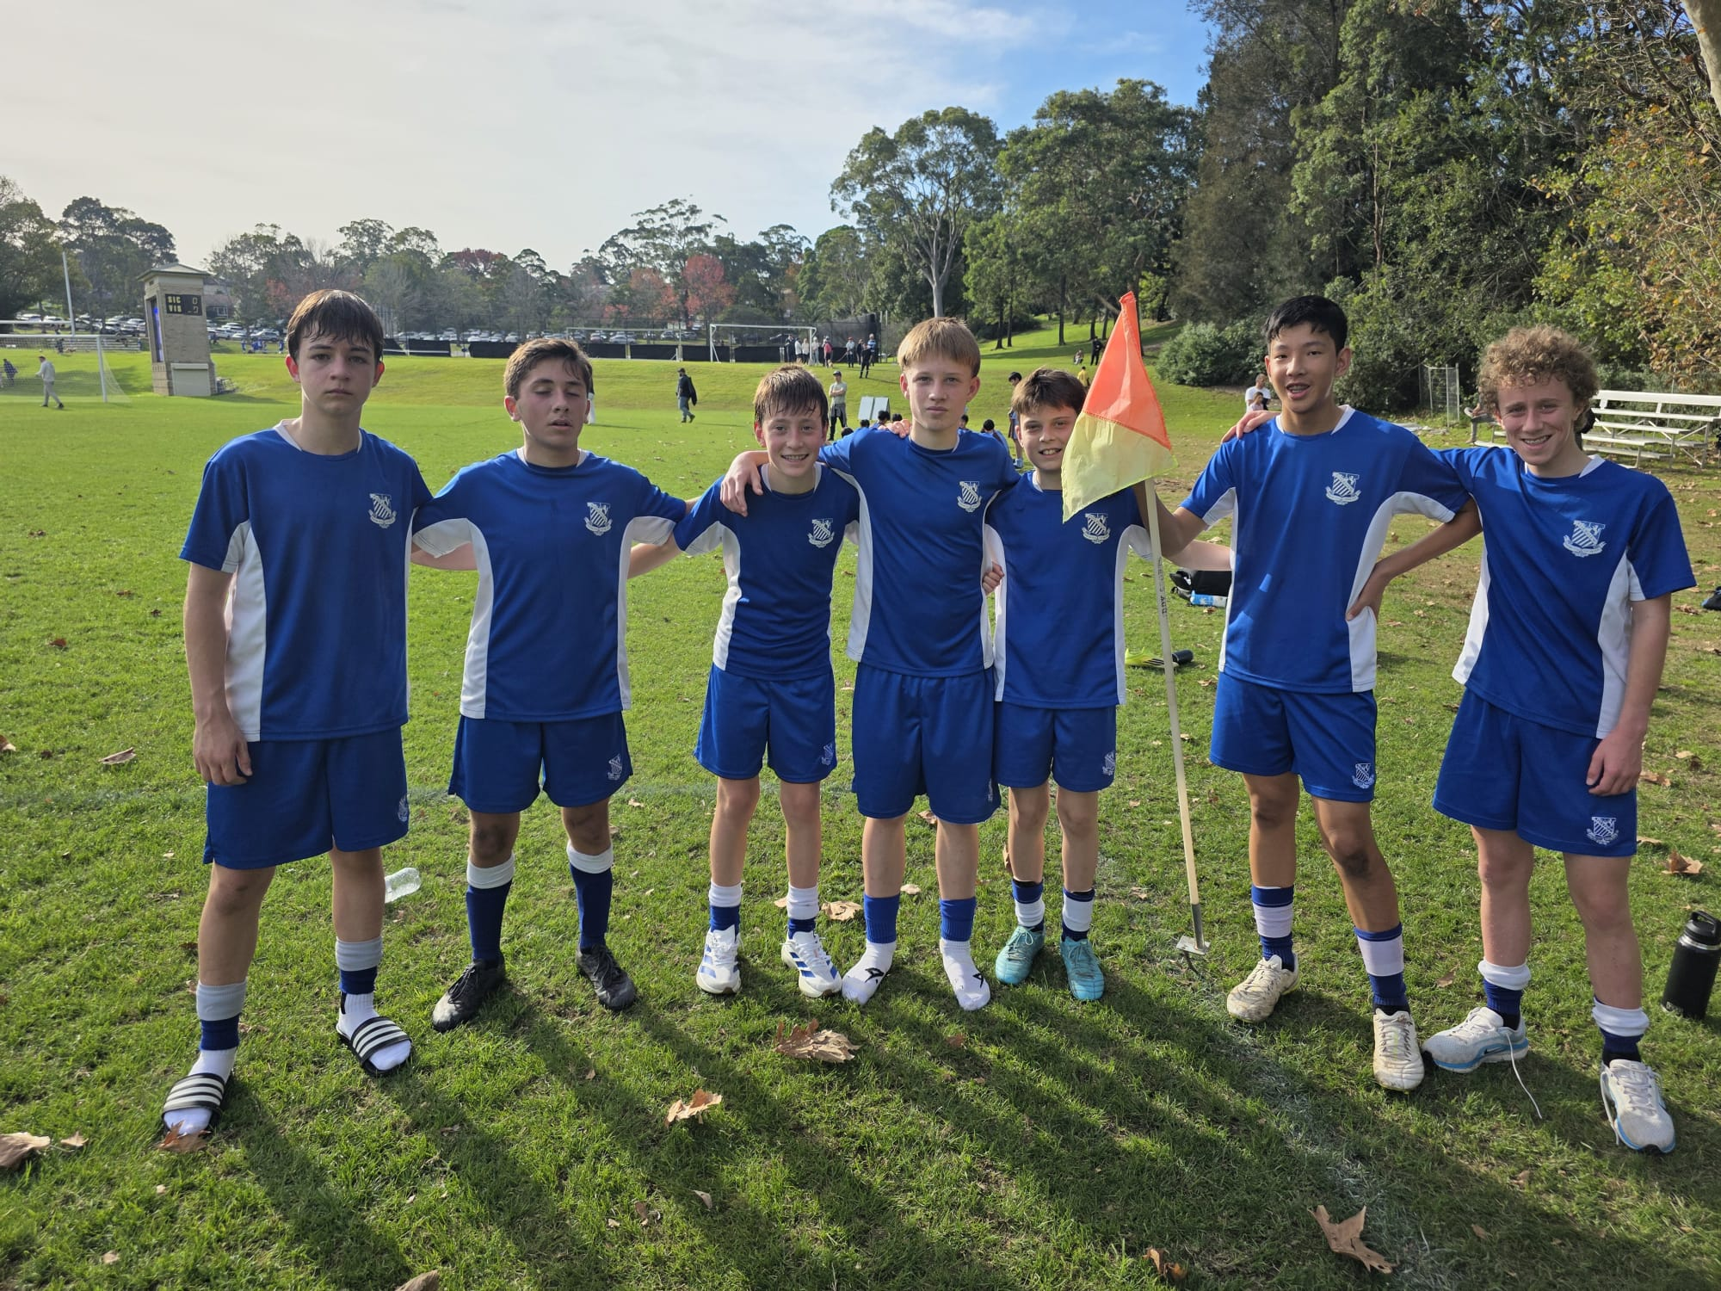
14A Match Report: Coach Domenico Garreffa
The 14A's delivered a dominant and complete performance, producing some excellent attacking football in a convincing 7-1 victory over Sydney Boys High. From the opening whistle, the boys played with confidence and intensity, controlling possession and creating chances through quick ball movement and positive attacking play. Jakob Stalley was in outstanding form, leading the scoring with an impressive hat-trick and consistently threatening the opposition's defence. David Raphael and Leo Stevens each added a goal of their own, while Samuel Hendry also found the back of the net to cap off a strong team display. One additional goal completed the scoring in an all-round attacking performance. Defensively, the side remained organised and disciplined, limiting Sydney Boys High to very few opportunities and responding positively after conceding their lone goal. The boys showed excellent teamwork, work ethic and composure throughout the match, making it one of their most complete performances.
YEAR 9
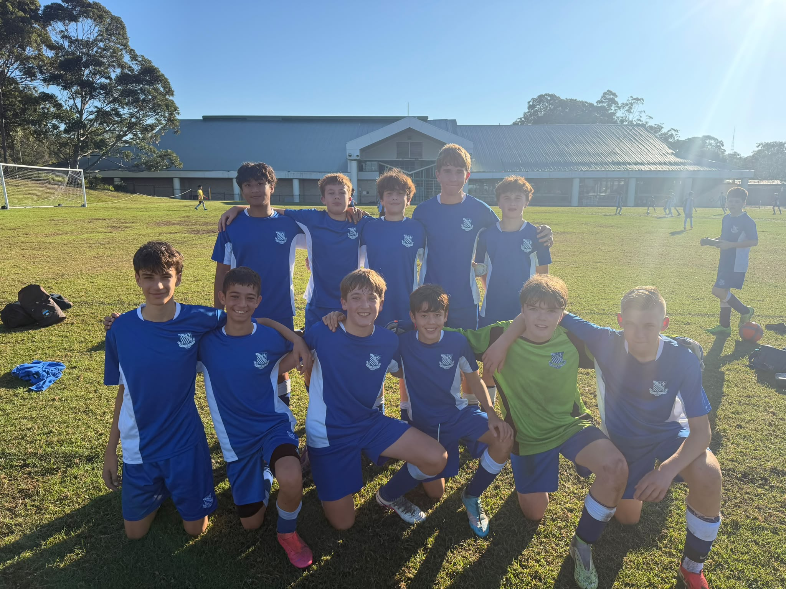
15A Match Report: Coach Travis Cooper
We produced a solid performance to earn a 2–2 draw against Sydney Boys High School, with the boys showing resilience and significant improvement, particularly in defence. After falling 1–0 behind, the team responded positively and remained composed. Our defensive display was much stronger than in recent weeks, with the group showing greater organisation and commitment without the ball. The boys were rewarded for their efforts by scoring twice to take a 2–1 lead and put themselves in a strong position to secure an important victory. Unfortunately, Sydney Boys High found an equaliser in the final five minutes to level the scores at 2–2. Despite the late disappointment, there was still time for one final chance, and we came agonisingly close to finding a winner in the dying moments of the match. While there was frustration at not holding on for all three points, the performance showed clear progress.
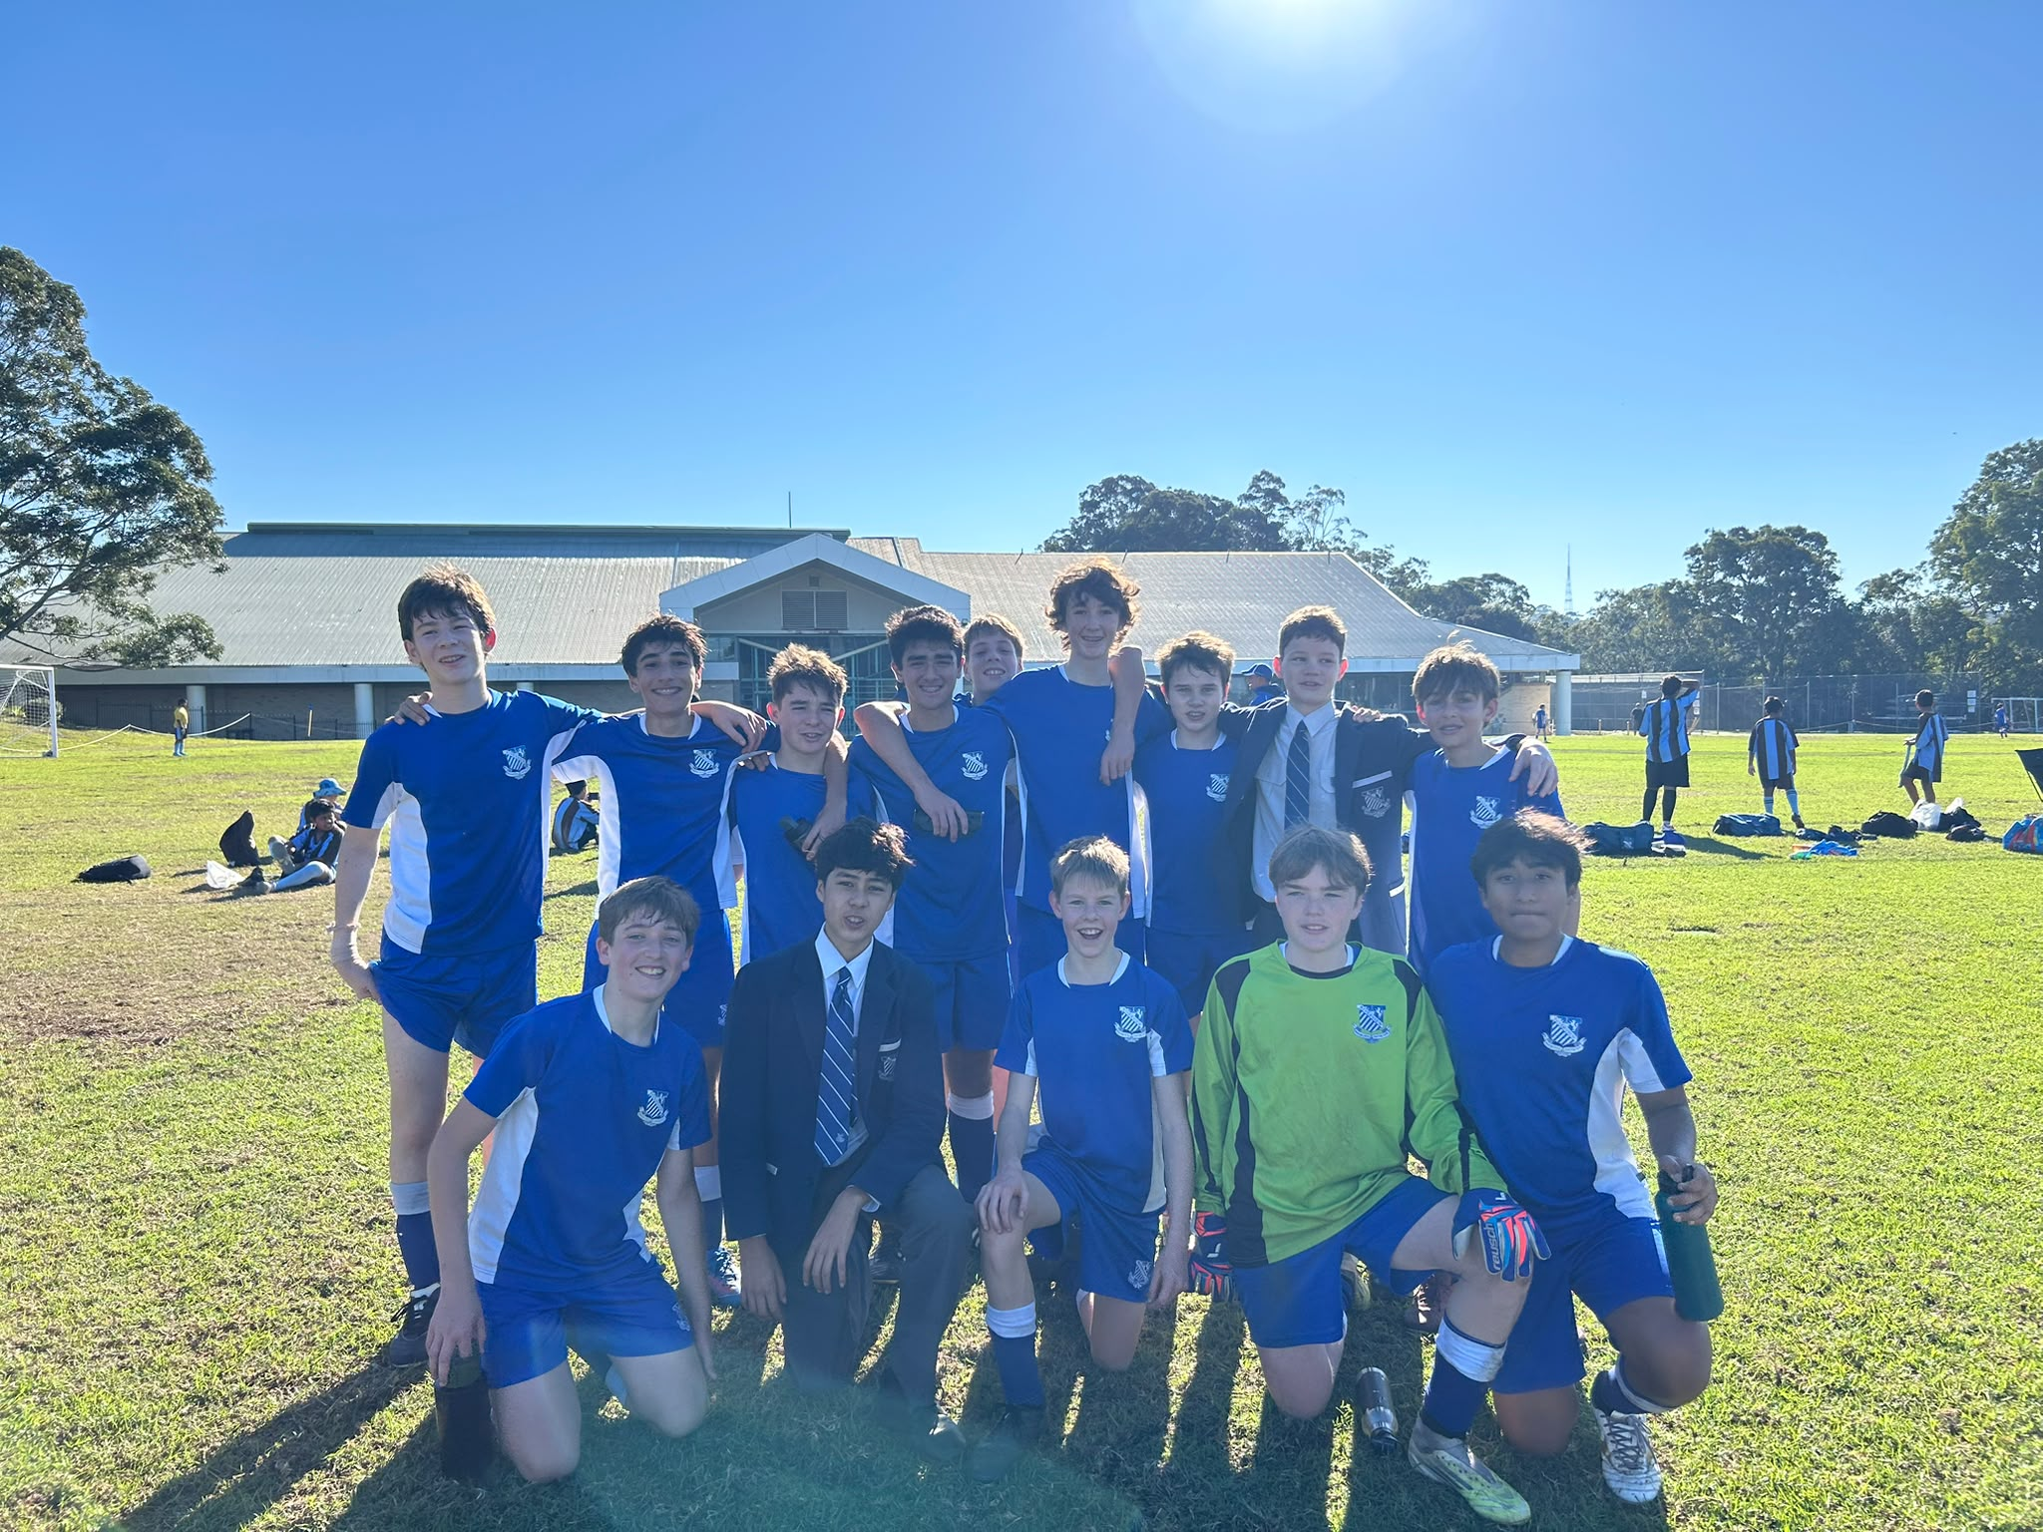
15B Match report: Coach Jonathan Codemo
The 15Bs produced an exciting performance on the weekend, coming away with a hard-fought 4–3 victory over SBHS. In a match full of attacking football, Riverview showed great determination and resilience to edge out a strong opposition. The boys created numerous chances throughout the game and were rewarded with four well-taken goals. Despite conceding three times, the team remained composed and continued to push forward, showing excellent character to secure the win. It was a fantastic team effort and an important result for the group.

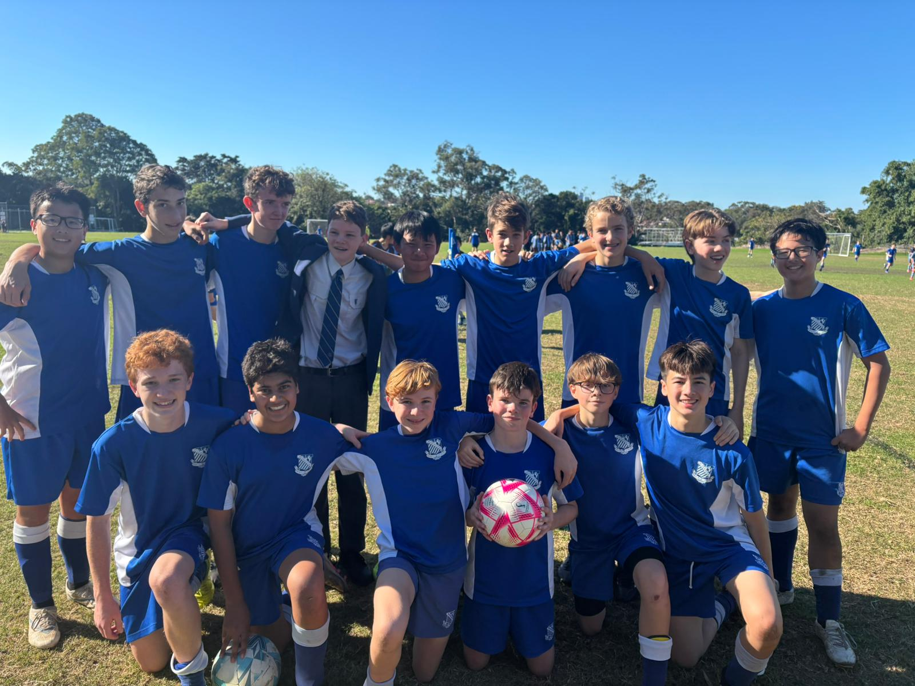
15C Match Report: Coach Atticus Ireland
The first half saw a strong start, with Tom S producing a moment of magic in the opposition box to give us a 1–0 lead heading into the break. Unfortunately, we couldn't replicate that attacking success in the second half and struggled to maintain possession, which culminated in a devastating last-minute goal following a defensive mishap. A great effort from everyone, and we'll look to put things right next week.
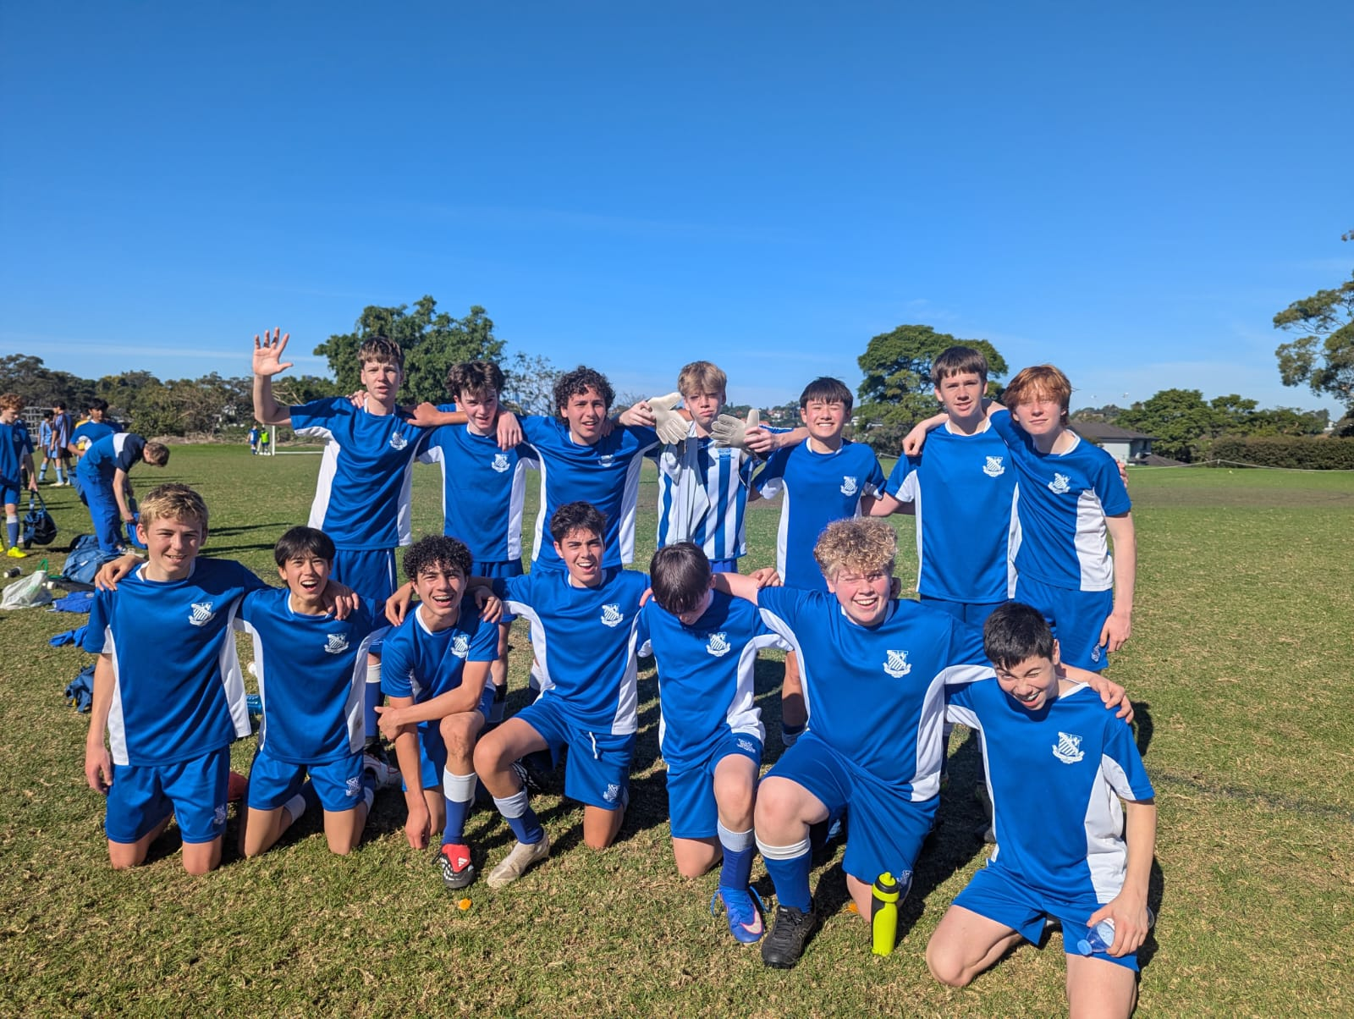
15D Match Report: Coach Alexander Mansfield
15Ds played well this week, showing improvement in keeping shape both in possession and defence. Three goals in the first half gave Riverview a comfortable scoreline and saw some impressive finishing from strikers Max Molesworth and Ben Allan. In the second half, Sydney Boys High were able to create more chances but only converted one to a goal.
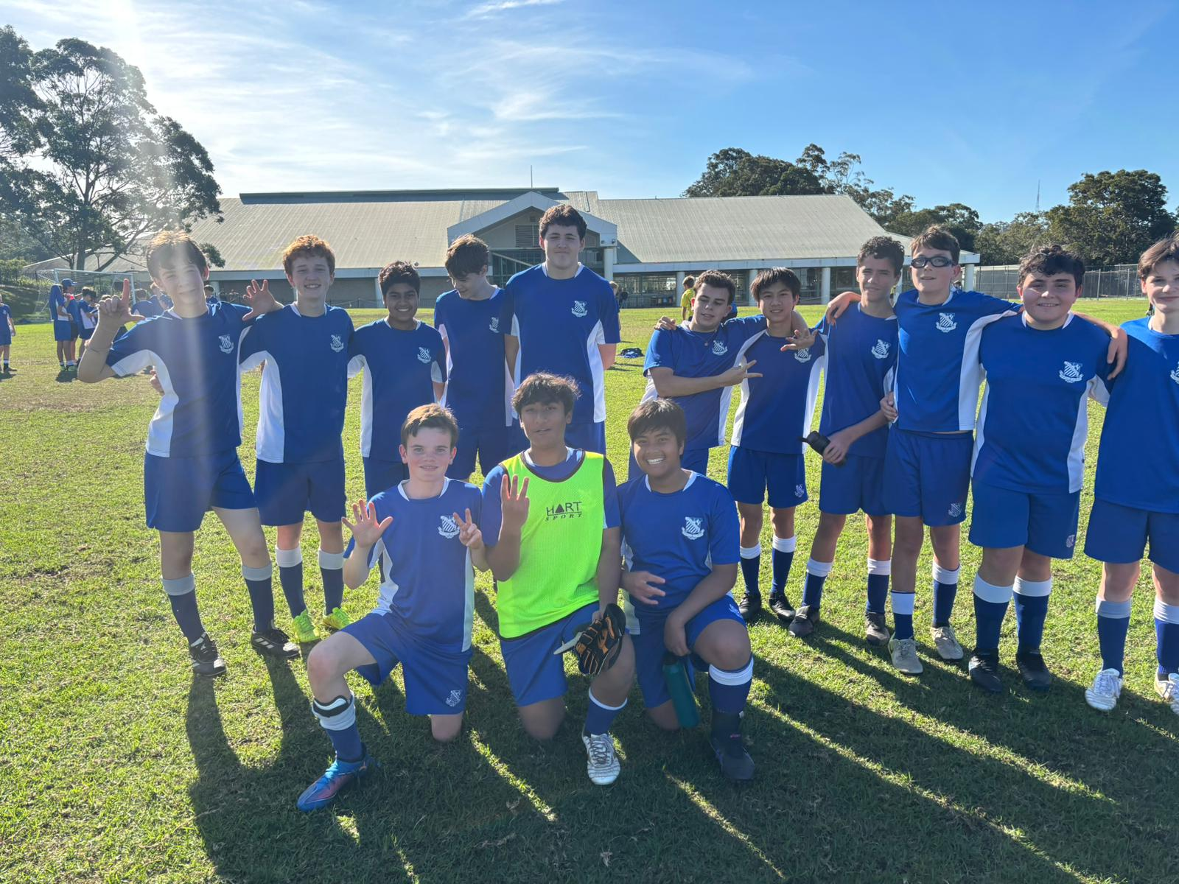
15E Match report: Coach Atticus Ireland
First win of the season, and it was a convincing one. The first half saw us score four goals while maintaining strong defensive composure. We built on that in the second half, with Mac and Angus S adding two more well-taken goals. However, the standout performances belonged to the back four, who shut the opposition out and secured our first clean sheet of the season. Many thanks to the boys from other teams who helped fill the numbers and contributed to a tremendous team effort.

YEAR 10
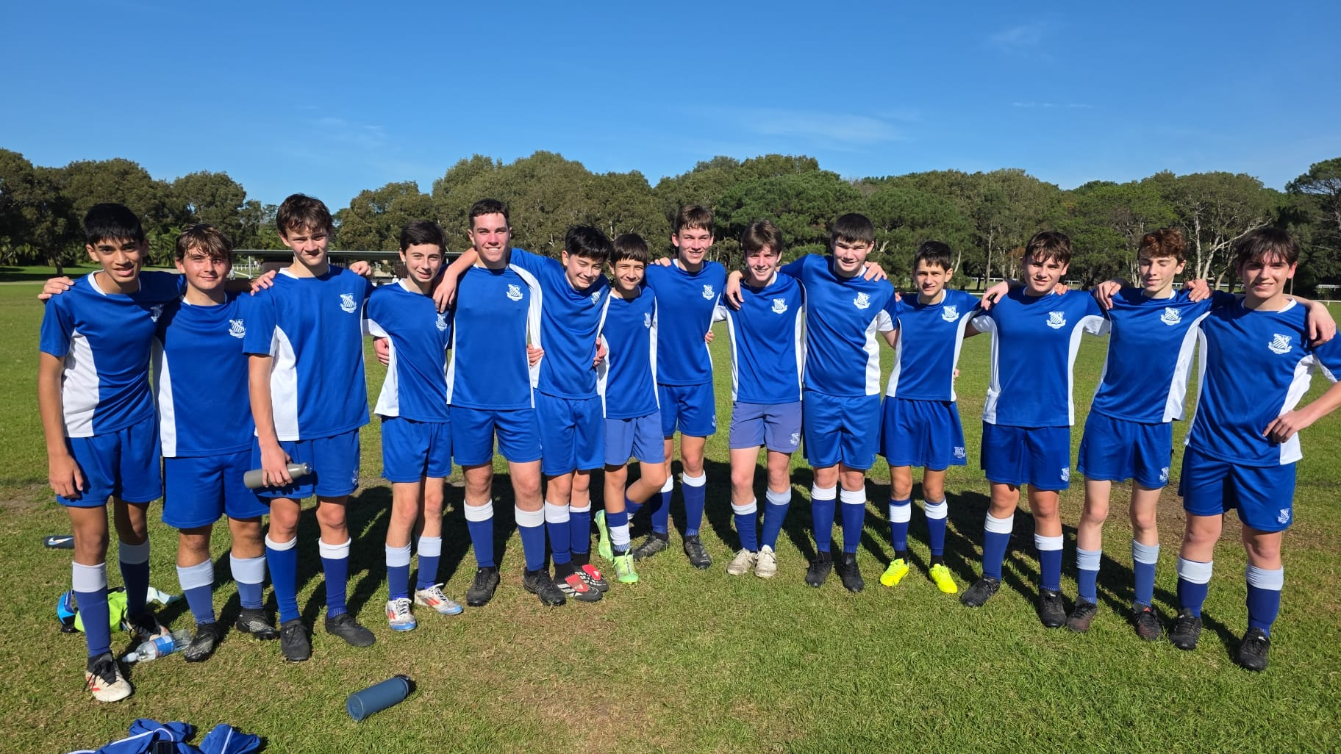
16D Match Report: Coach Jacob Stevens
Another tough contest against a well-matched Sydney Boys side, and one that exposed areas we must improve. Our build-up play showed promise; we moved the ball with purpose at times and created openings. However, we lacked conviction in the final third, hesitating when chances emerged. Sydney Boys were more clinical, capitalising on three separate opportunities to take control of the match. We need to be braver in front of goal and trust our attacking instincts in future fixtures. The effort and structure were there, but composure and decisiveness will be key moving forward as we prepare for the next challenge.

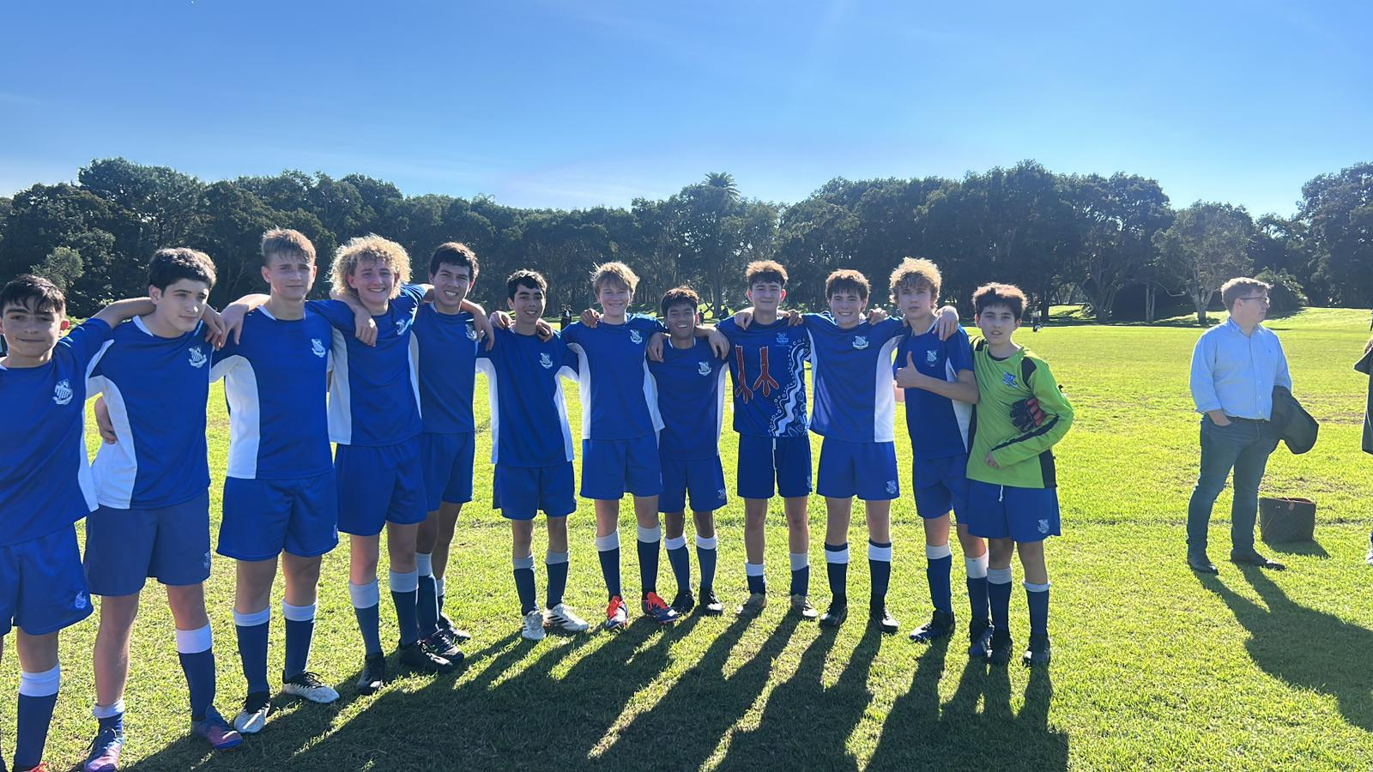
16C Match Report: Coach Marcus Kulukovski
The Riverview 16C’s played Sydney Boys on Saturday in what was a very close affair. The boys started the game off very well with numerous chances by Remy Camus and Hugo Lennon being saved by the opposition keeper. Near the end of the half, Sydney Boys were able to capitalise through a counterattack to make it 1-0. Riverview’s domination in possession continued throughout the second half. The boys were finally rewarded for their hard work with a superb finish by Jono Hogben from outside the box to make it 1-1. Overall, a very pleasing effort by the boys.
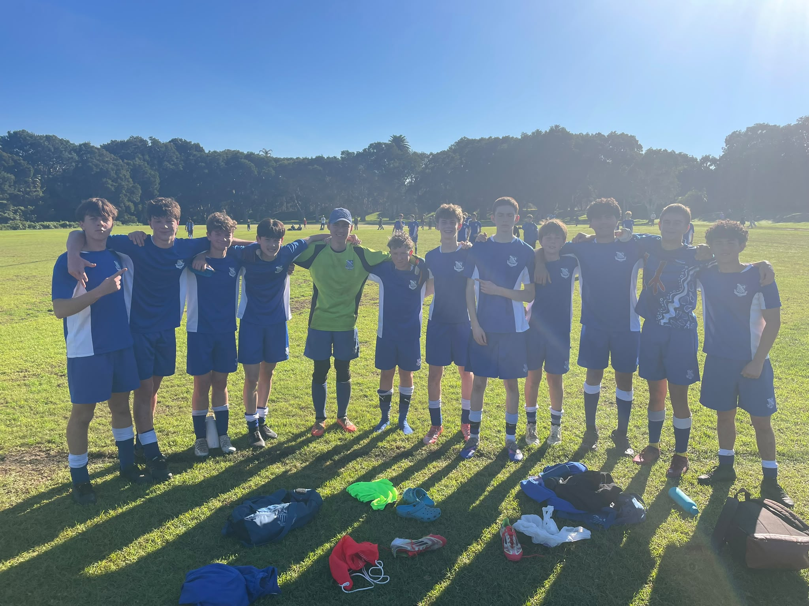
16B Match Report: Coach Stefan Visscher
Riverview battled hard to earn a 2–2 draw against Sydney Boys High in an entertaining contest. Sabian opened the scoring with a stunning strike, producing a moment of real quality to put his side ahead. Angus also found the back of the net, continuing his strong form with a well-taken goal. Xavier was a constant threat down the right flank, using his pace and direct running to cause Sydney Boys High all sorts of problems throughout the match. His energy and attacking intent created numerous opportunities and kept the opposition defence under pressure. At the other end, Sam delivered an outstanding performance after stepping up from the C’s team. He defended confidently, won crucial challenges, and showed great composure. While the result may feel a little unlucky given the chances created, there were plenty of positives to take from the performance. The boys will look to build on this effort and go again next week.
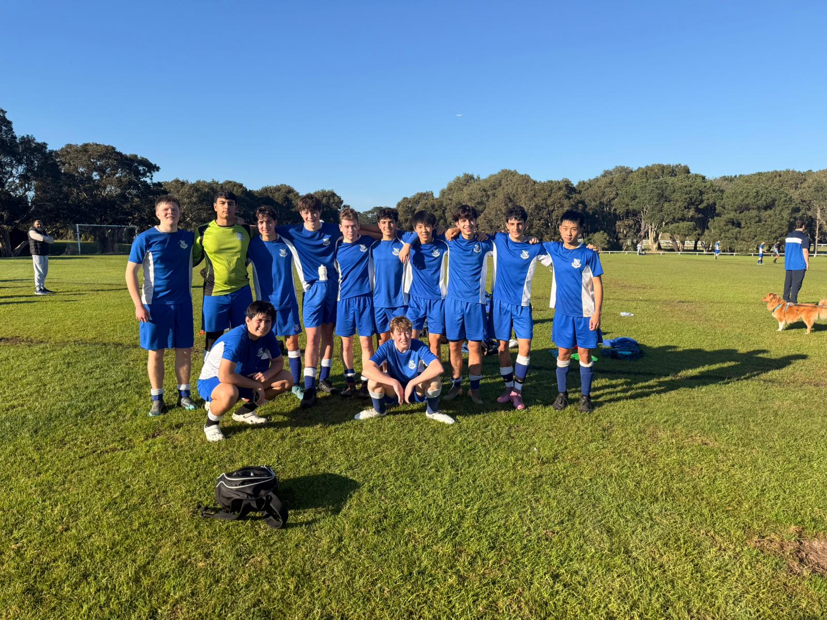
16A Match Report: Coach Stefano Rossello
The 16As produced a dominant performance on the weekend, defeating Sydney Boys High 6-0 in a match they controlled from start to finish. Oli opened the scoring in the first half with a superb long-range strike, but despite creating plenty of chances, the boys went into the break only 1-0 up. The performance was strong, but the boys will know they need to be more clinical in front of goal. The second half saw Riverview turn their dominance into goals. James Dart led the way with an outstanding hat-trick, while Gibbo also found the back of the net. Freddie capped off a memorable debut for the As by scoring in his first game for the side after an impressive game at the back Defensively, the boys were excellent, restricting Sydney Boys High to just one shot all game. Overall, it was a complete team performance and a well-deserved 6-0 victory, with plenty of positives to take from the match.
OPENS SQUADS
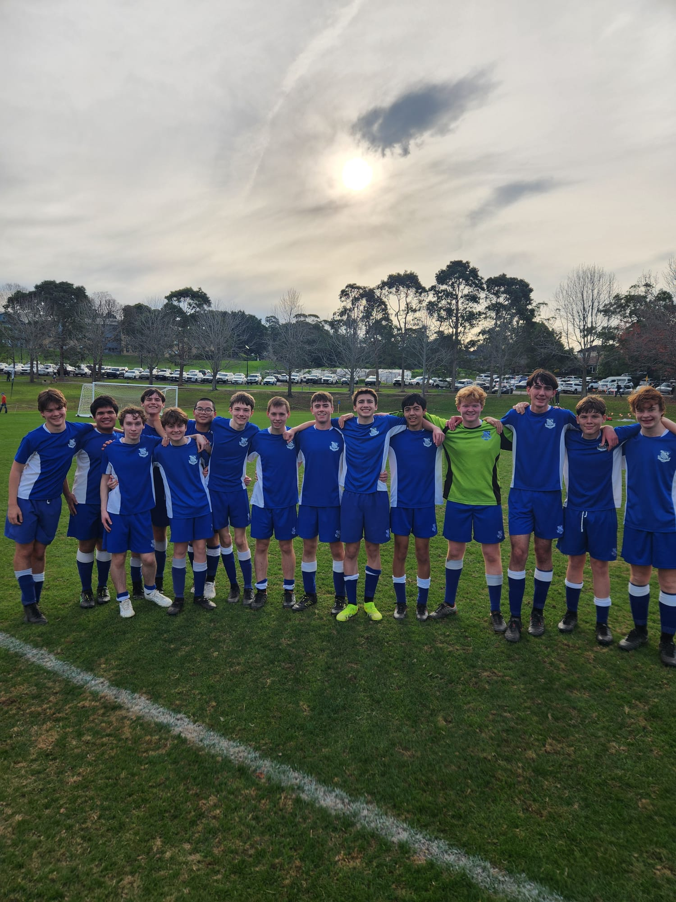
6th Match Report: Coach Maximus Joosse
The 6ths faced a tough challenge this week against Sydney Boys High. With Sydney Boys fielding 13 teams compared to our 6, we knew it was always going to be a difficult game. The first half was especially challenging, with the boys spending much of the time on the back foot as they adjusted to the intensity and quality of the opposition. Despite the pressure, the team continued to work hard and support each other, refusing to give up. The second half saw a much stronger performance from the boys. They stepped up, competed well across the park, and gave Sydney Boys a real challenge. Their effort and determination paid off, finishing the second half 2-1 and showing what they are capable of when they play with confidence. While the final result did not go our way, the boys should be proud of the hard work and resilience they showed throughout the match. Their attitude and effort never dropped, and they continued to fight until the final whistle. Well done to all the boys.
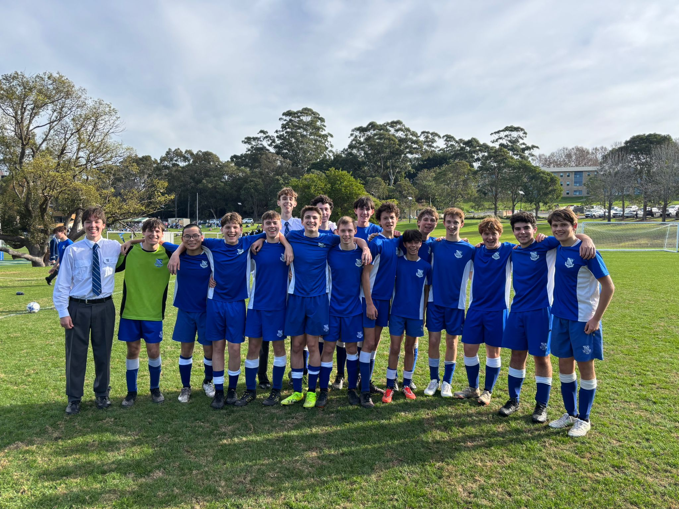
5th Match Report: Coach Jack Aman
A hard-fought game for the 5ths team. The SBH team had a very good attacking three players who helped them massively take control of the game. The boys did well to defend an Oli in net made some great saves. Unfortunate result. Positives to look on from this.
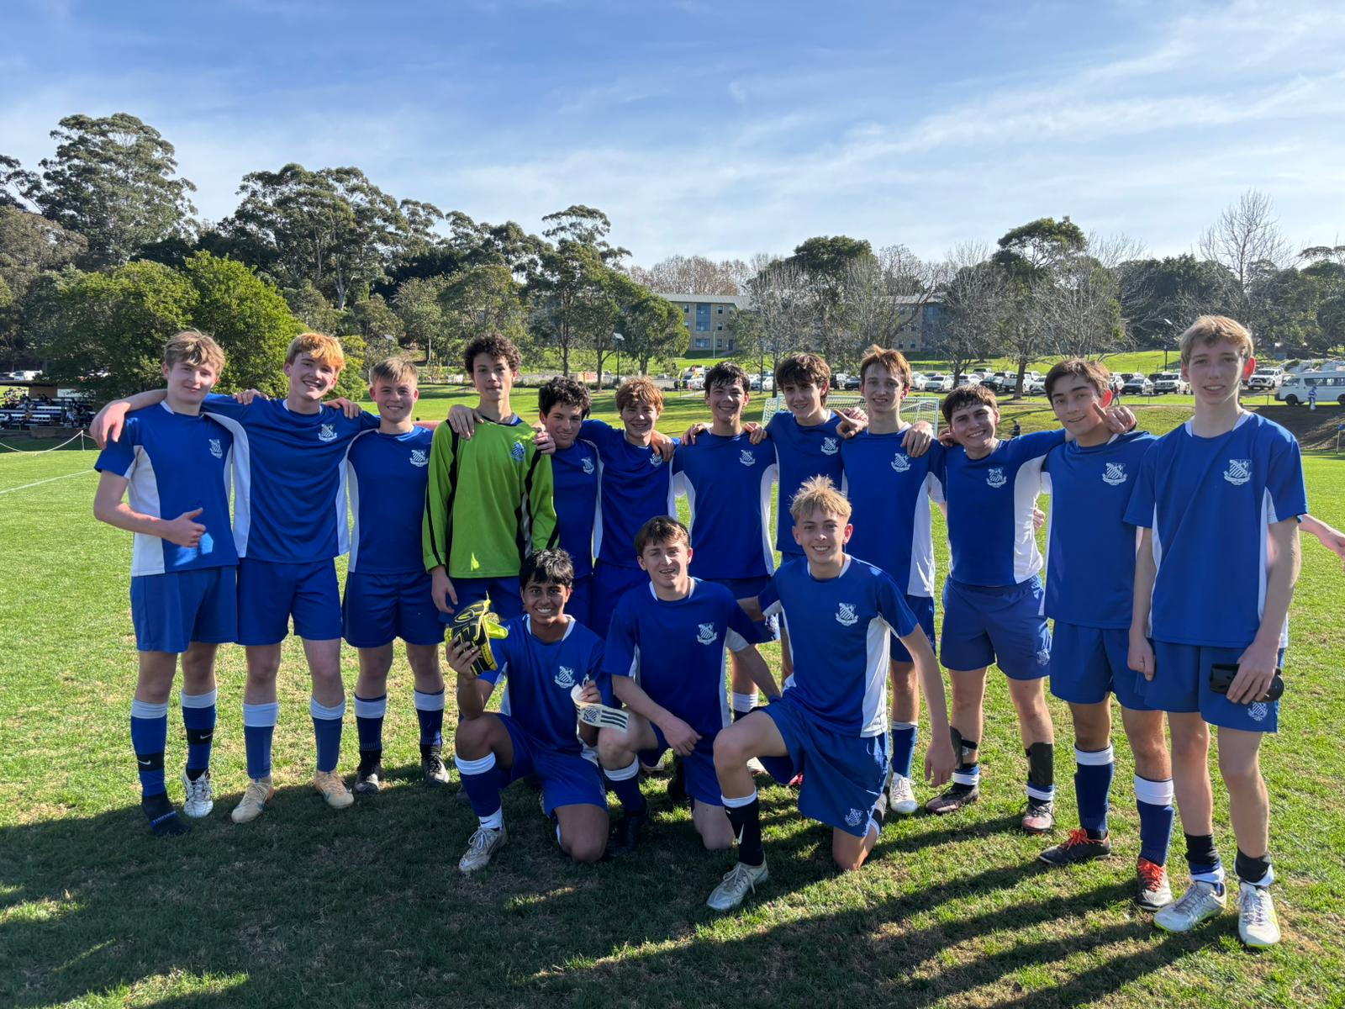
4th Match Report: Coach Gabriel De Haast
After dominating the first half and seeing nothing go in the back of the net the boys were a bit disappointed. But after a few words of encouragement and some tactical adjustments at the half the boys were motivated to get the result, they wanted. Harry Horden Smith opened the scoring after the opposing team didn’t clear their lines from a dangerous corner delivery. Shortly after Will Thomas playing in mismatched boots scored the second to put the game to rest after a great cutback ball from Lewis Mills.

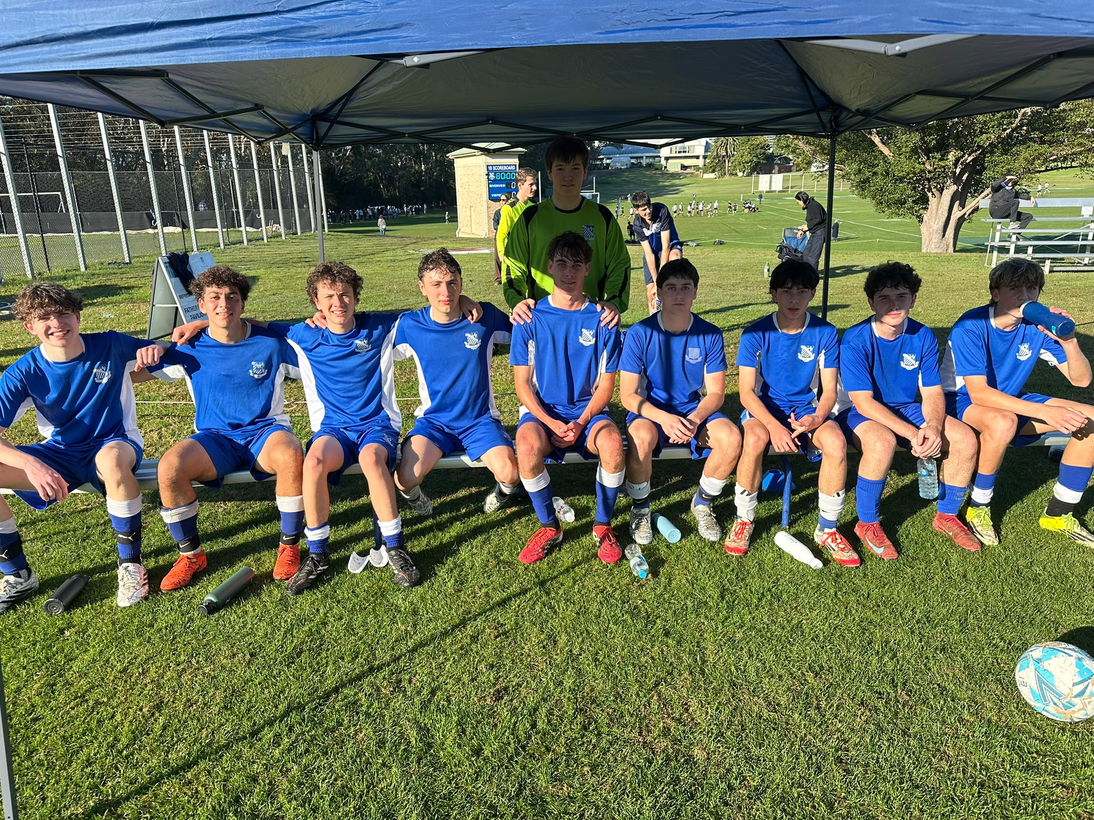
3rd Match Report: Coach Andrew Ferrara
St Ignatius’ College Riverview defeated Sydney Boys High School 2–1 in a well-earned victory after a strong overall performance. Riverview started the match brightly and took an early lead through Finn Richards, who tapped home at the back post following an excellent team move and a well-delivered assist. The side continued to dominate much of the first half, creating several chances and finding consistent success playing over the top. Sydney Boys worked their way back into the contest in the second half after capitalising on a cheap goal, while Riverview struggled at times to build momentum and control possession. Pushing hard for a winner late in the game, Riverview switched to a more attacking 4-4-2 formation in the final minutes. The pressure paid off when Jules reacted quickest to steal the ball from the goalkeeper and calmly tap home the winner, sealing a deserved 2–1 result.

