
Riverview Football Program - Match Reports Saturday 20th, June 2026
YEAR 7
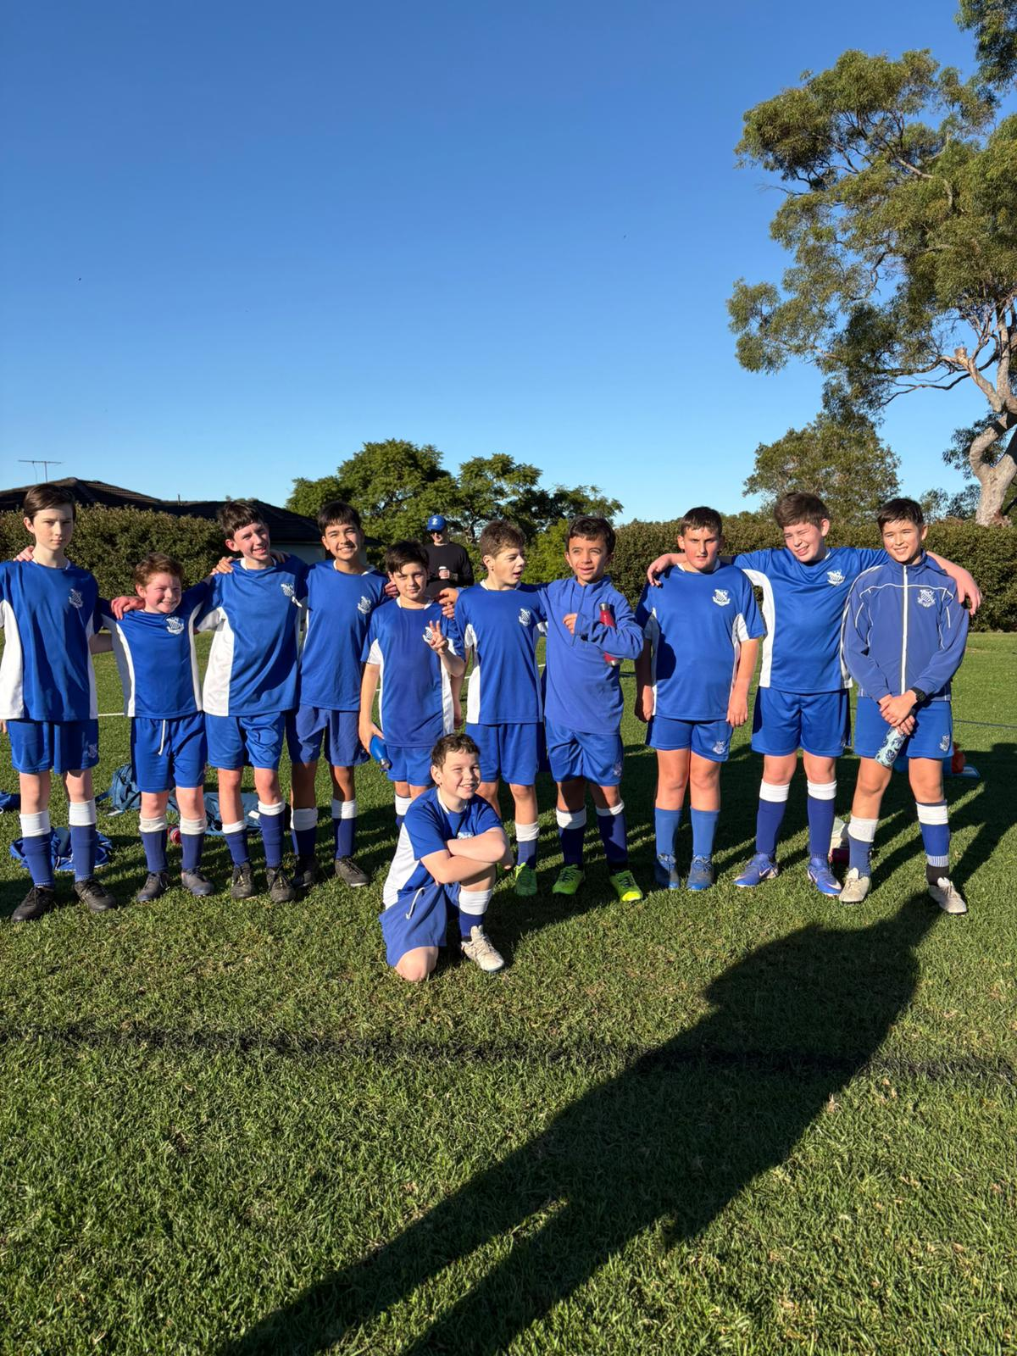
13F Match Report: Coach Joseph Salameh
The 13Fs played a hard-fought loss this Saturday morning against Saint Augustine. The boys came out strong in the first 10 minutes, Hugh, Ned and Christian were controlling the attacking half early and the boys truly held possession advantage. Unfortunately, the opposition got an early advantage with a quick counterattack goal and from there they controlled the tempo of the game. It was an unfortunate result as the boys truly put in 100% effort and played as hard as they could. Alex was communicating effectively; Cruz and Massimo were controlling the defence as well as Ollie in the middle. Niko played hard and had some good runs, however St Augustine’s got the better this week. The boys will be back next term looking for some better results!
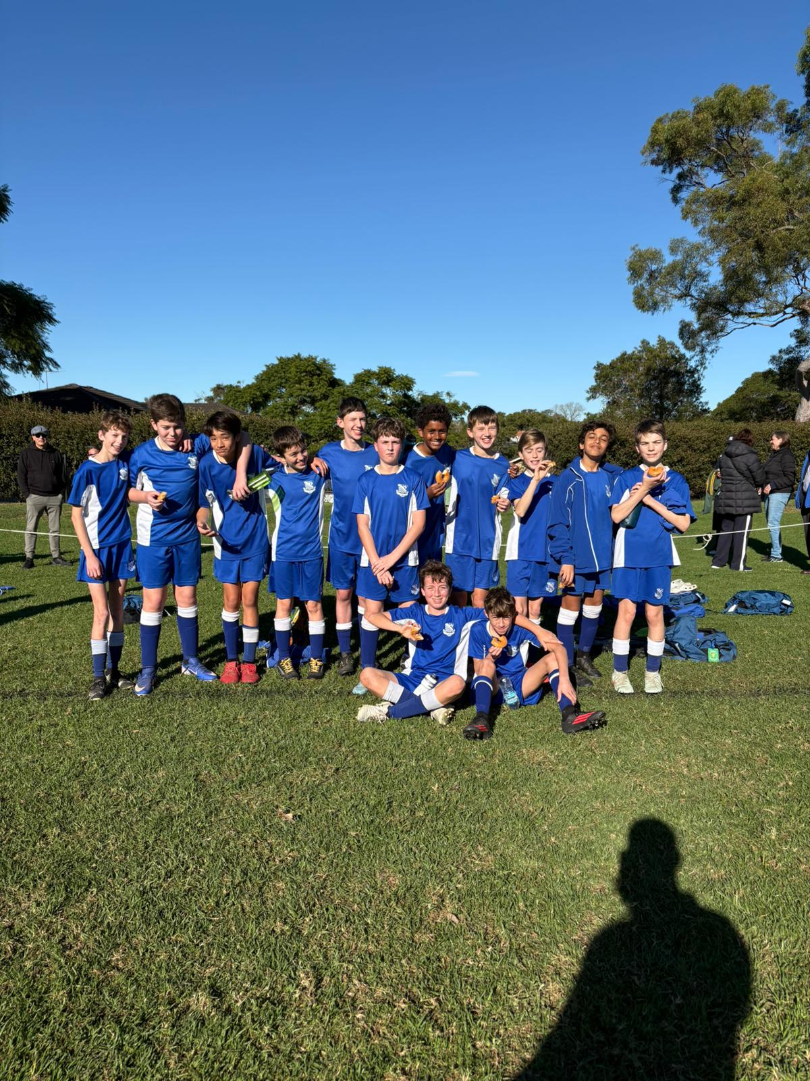
13E Match Report: Coach Joseph Salameh
The 13Es came out and continued their impressive win streak with a dominate win over Sydney Grammar. Starting with Ezekiel scoring early, leading to a hat-trick, as well as James scoring a hat-trick, the goals were piling up! Seb played superb, excellent playmaking as well as scoring incredible goals! As always, Ollie was consistent and played an amazing all-round game, scoring as well as leading with his dribbling, passing and taking initiative with throw ins. Henry scored a great goal near the end of the game to secure a bacon and egg roll deal from his father! George and Callum putting their hands up to play goalkeeper was very important and appreciated by the rest of the team, they both made great plays to keep the game in our favour. Furthermore, Ollie in defence was as consistent as ever, not letting anything past, combining with Will and Luke to have a very strong back line. Finally, the birthday boy Sam on his special day played his heart out and made many amazing plays, as well as bringing donuts for the team post-game!
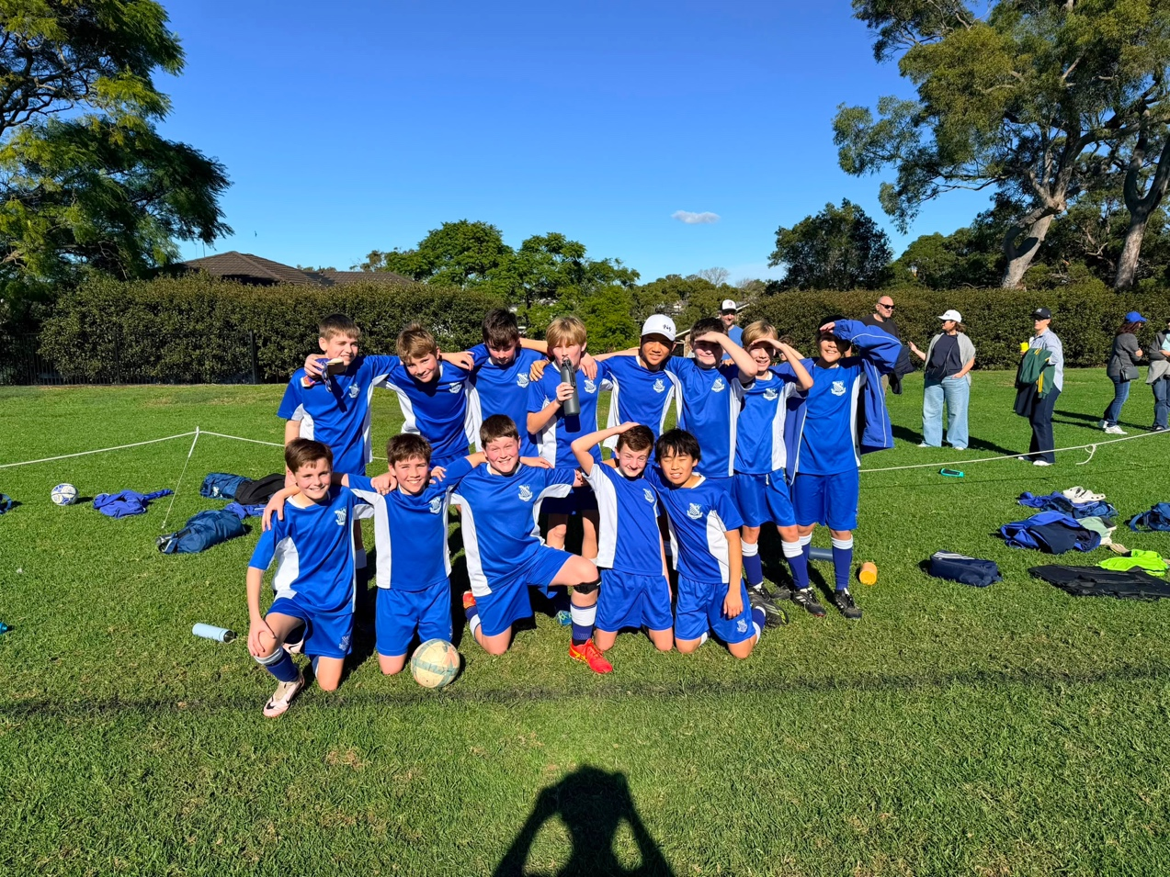
13D Match Report: Coach Michael Portale
An outstanding home performance from Riverview 13D, who swept aside Grammar with a convincing 6–0 victory. The team were in fine form from the opening whistle, pressing high and moving the ball with real confidence and purpose throughout. The attacking play was relentless, with six goals highlighting just how clinical the side were in front of goal. Good movement, sharp passing, and a hunger to get on the scoresheet made life very difficult for a Grammar side who struggled to cope with the pressure. Defensively, Riverview 13D were equally impressive, remaining organised and focused to earn a well-deserved clean sheet. It was a complete team performance from back to front. A brilliant result and a real statement win for the group. The squad will head into training this week with confidence high and plenty of momentum to build on.
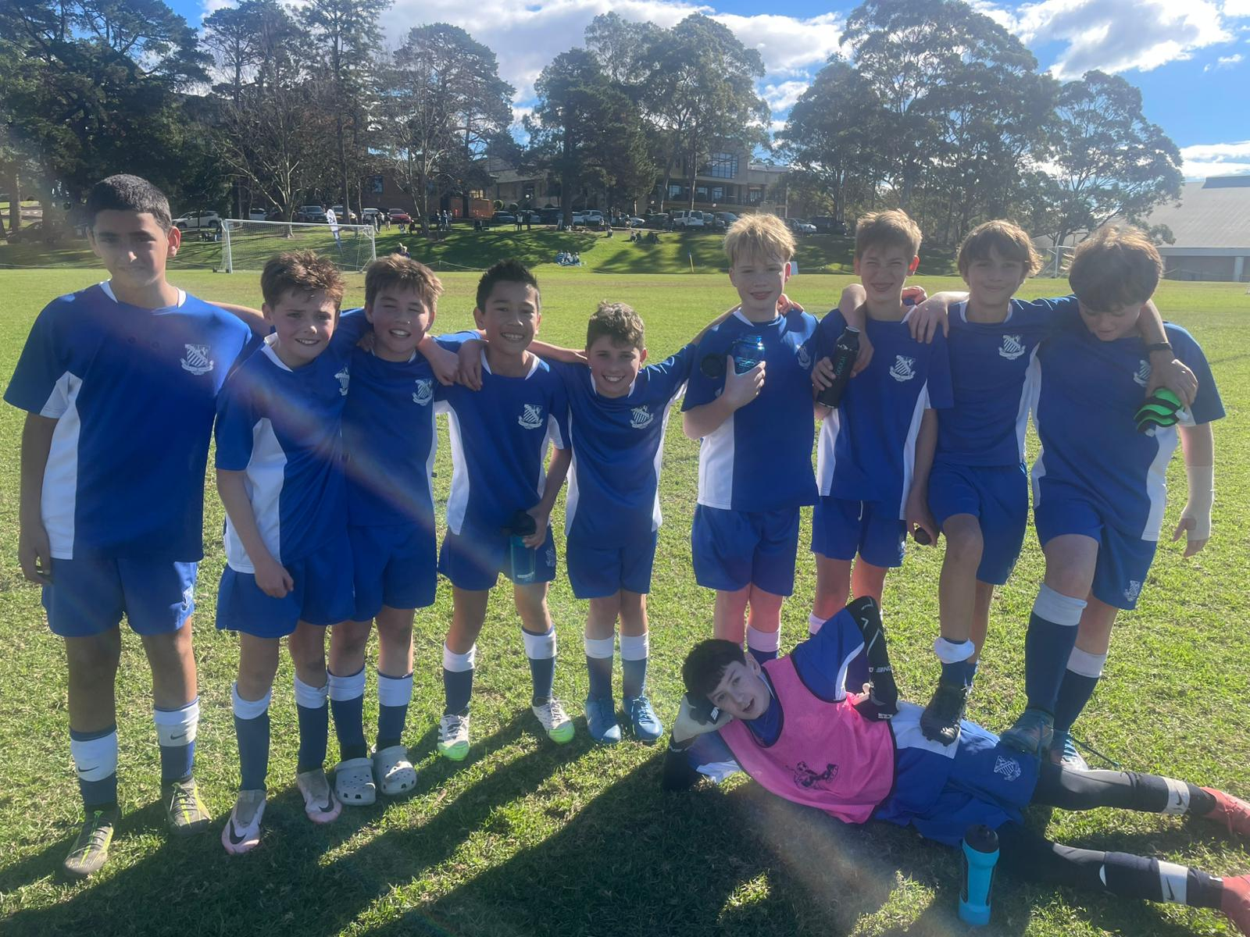
13C Match Report: Coach Nelson Meehan
This week, Riverview dominated the game from the very start, scoring a very early goal and backing it up with a second in the first half, from a viewing perspective, it was the best first half Riverview has had this season. However, it was the second half where things dropped a little, it was a hard game for the View team with no subs on the bench, so energy levels struggled throughout the game. Sydney Grammar were able to get 2 goals back in the second half to tie the game up. Ultimately, it was a strong performance from the Riverview side and a good way to end the first terms football.
.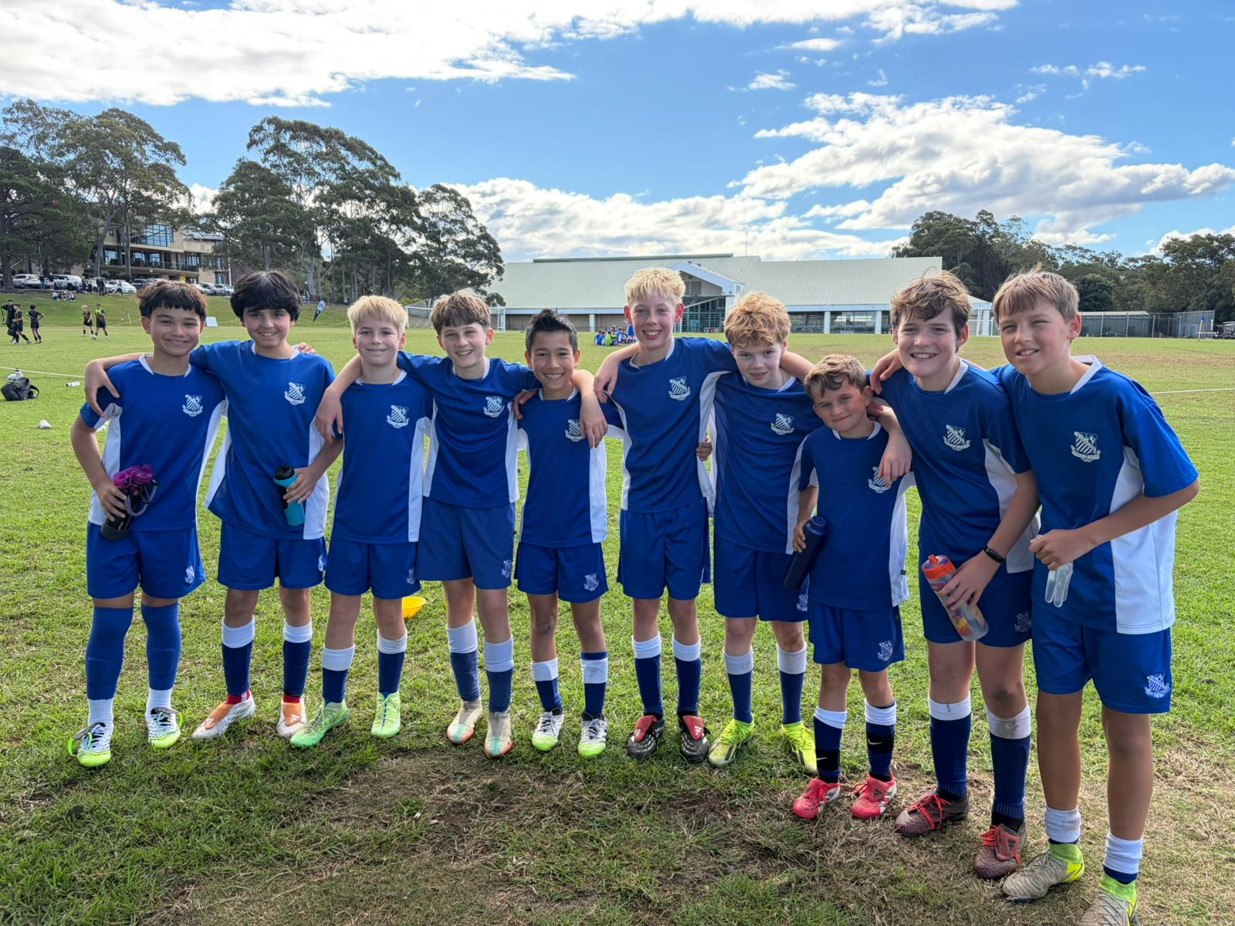
13B Match Report: Coach Josh Engelmann
Riverview 13B’s showed great character to fight back for a hard-earned 2–2 draw against Grammar. The match started poorly, with Grammar scoring twice inside the opening 10 minutes and putting Riverview under serious pressure early. To make things tougher, injuries forced the side into late changes, with last-minute substitutes having to step up quickly. Rather than dropping their heads, the boys worked their way back into the contest. Riverview’s first goal came through Charlie, who met a brilliant cross from Xavier with a strong header to bring the game back to life. From there, the momentum shifted, with Riverview pushing forward and showing real belief. The equaliser came when Orlando broke through one-on-one with the goalkeeper and calmly placed his finish into the bottom corner. It was a gutsy comeback from the 13B’s, showing resilience, teamwork and plenty of fight.

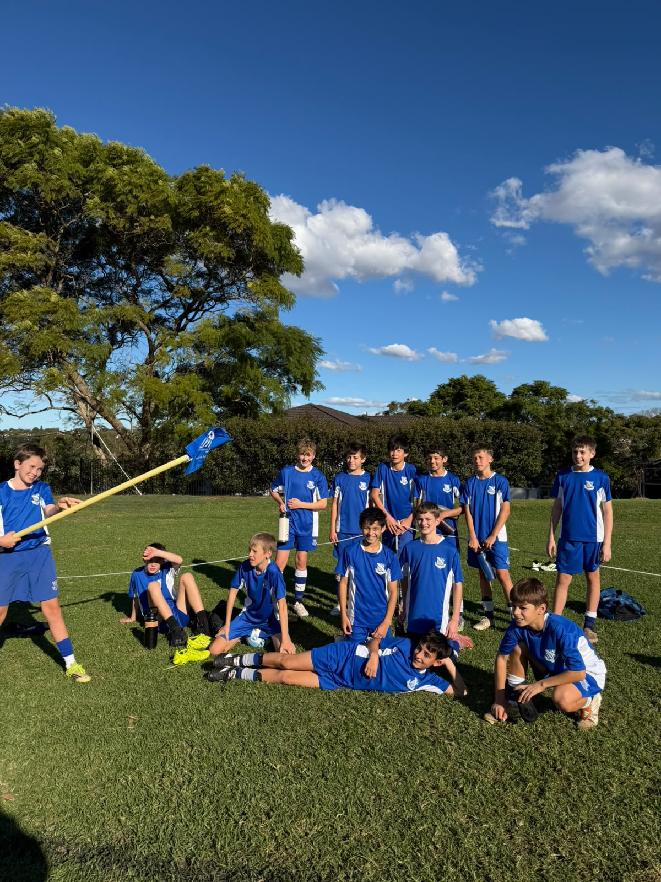
13A Match Report: Coach Lewis Morsella
Great result to end the term in a great game sitting at 2-2 for most of second half of the game. We unfortunately copped to pretty good goals outside the box just too high for keeper to reach. Neils definitely has to be my man of the mate scoring 2 great goals one to win the game in the last seconds of the game. Overall, very pleased with how this team is shaping out to be and can’t wait to see what next term holds for the boys.
YEAR 8
14D Match Report (no photo available): Coach Matthew Chung
The U14 D's faced Sydney Grammar School this Saturday, taking the field with only nine players available. Despite being at a numerical disadvantage from the outset, the boys showed great determination and competed strongly throughout the match. The defensive unit of Flynn Nolan, Alex Marren, Angus Healy and Byron Hunt contained the opposition and held their shape well during the early stages of the game. In midfield, Scott King and Julian Abela provided support out wide, while Sam Cleary and Fergus Curran took on significant responsibility in the centre of the park. Sam and Fergus were instrumental going forward, helping create several attacking opportunities. Compared to our last meeting with Sydney Grammar, the boys looked far more dangerous and registered shots on goal despite being two players short. Despite the score, the effort and attacking improvement were clear positives. The boys should be proud of how they competed and the progress made throughout the season.
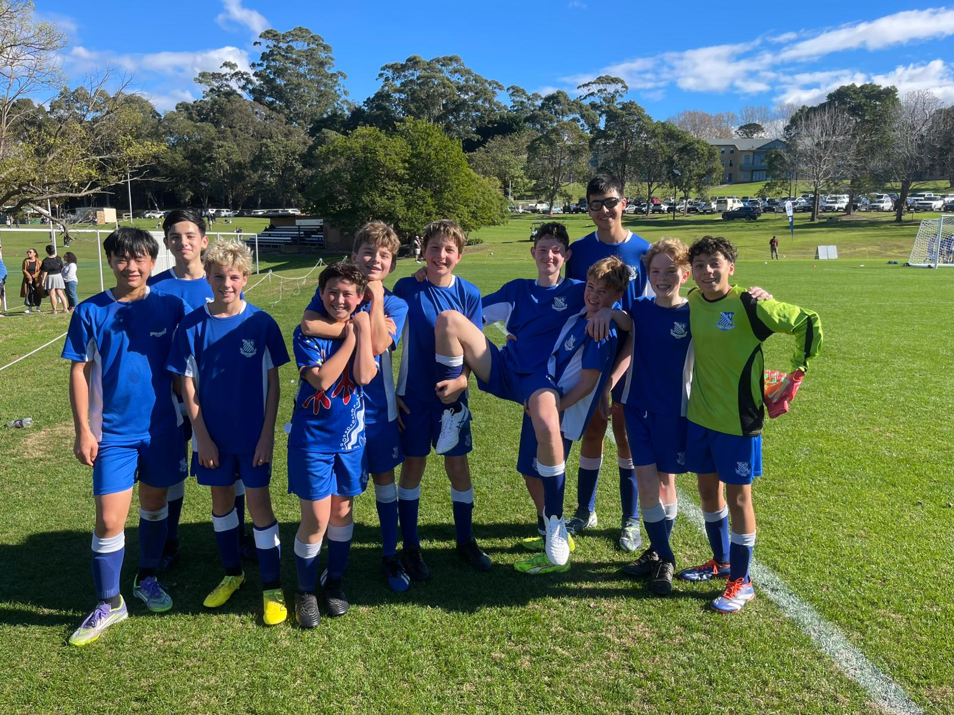
14C Match Report: Coach Tom Kalogerou
Riverview U14Cs went down 3-1 in a rematch against Sydney Grammar but showed clear improvement from the previous meeting. Against a quality side, the View boys started brilliantly, taking an early lead through a spectacular long-range strike from Marcus Strano, who smartly spotted the keeper off his line and finished with confidence. Riverview dominated early and looked sharp going forward, but two handball penalties shifted the momentum and gave Grammar the lead heading into half-time. After regrouping, the boys came out firing in the second half, creating chance after chance and putting Grammar under real pressure. Unfortunately, the final finish just would not come, and a late Grammar goal stretched the scoreline. Despite the result, Riverview fought hard and can take plenty of positives into the holiday break, hungry for more.
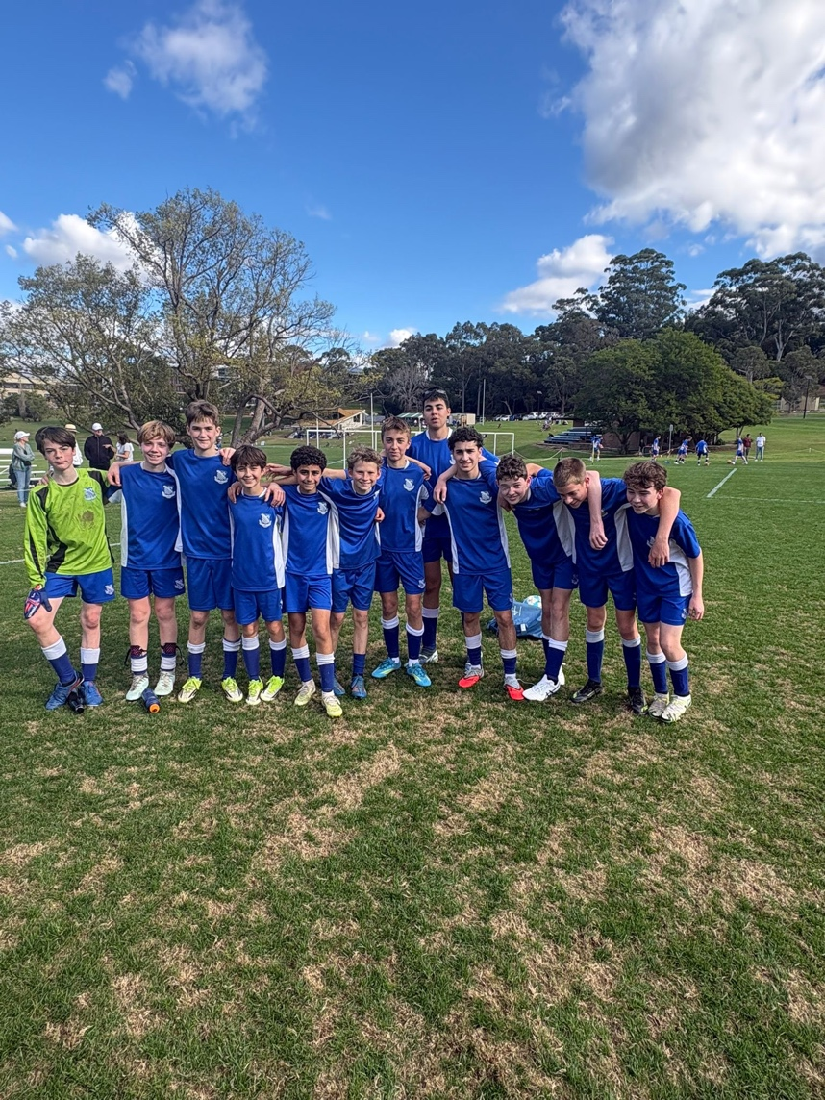
14B Match Report: Coach Lachlan Iacono
The 14Bs faced a difficult challenge at home, going down 6–0 in a tough contest. Despite the scoreline, the boys continued to work hard throughout the match and never stopped competing against a strong opposition. There were periods where the team showed good intent in possession and looked to play positively, but they were unable to capitalise on their opportunities. Defensively, the boys were tested throughout the afternoon and, despite their efforts, found it difficult to contain a clinical opposition. To their credit, the team continued to battle until the final whistle, showing resilience and a willingness to support one another in challenging moments. While the result was disappointing, there are valuable lessons to take from the performance. The boys will look to learn from the experience, continue to improve on the training ground, and bounce back strongly in the weeks ahead.
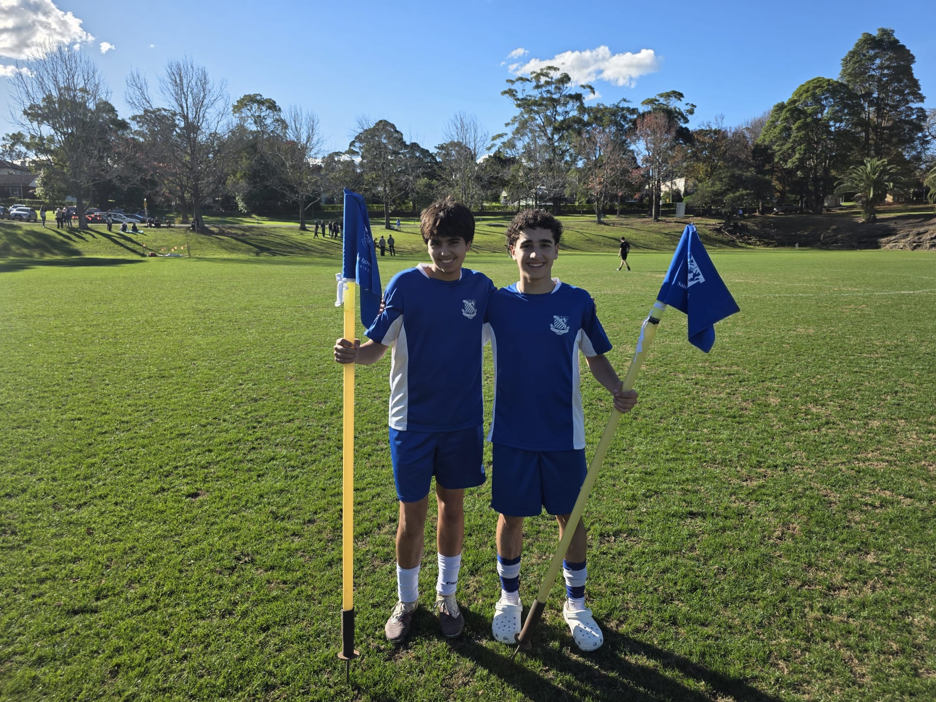
14A Match Report: Coach Domenico Garreffa
The St Ignatius 14A's faced a difficult afternoon against a strong Sydney Grammar outfit, eventually falling 4-0. While the scoreline was disappointing, it does not fully reflect the effort and commitment shown by the boys throughout the contest. The team approached the match with a positive attitude and looked to play with courage in possession, attempting to build attacks and compete in every moment. However, Sydney Grammar proved clinical when opportunities arose, capitalising on key moments and punishing mistakes. Despite the result, the players never dropped their heads and continued to work tirelessly for one another until the final whistle. There were periods where St Ignatius showed encouraging signs, particularly through their determination and willingness to keep playing their football. This match will serve as an important learning experience, and the group will take valuable lessons forward as they continue to develop and grow together.
YEAR 9
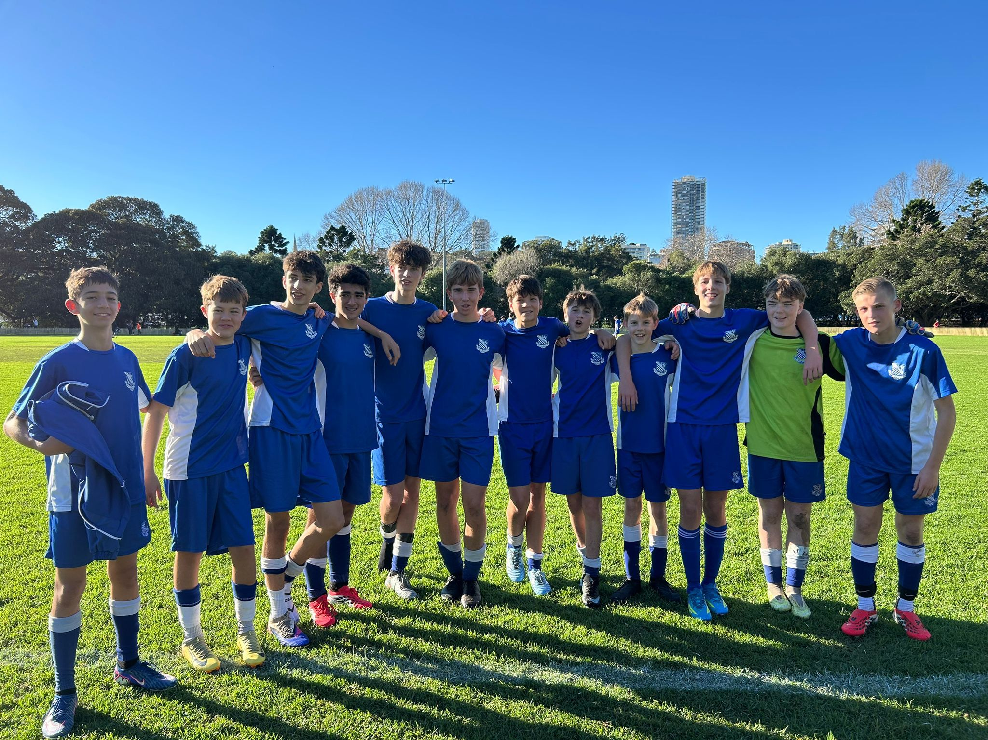
15A Match Report: Coach Travis Cooper
We suffered a 2–0 defeat to Sydney Grammar School, but there were encouraging signs as the team continued to improve defensively following last week's performance. The boys worked hard without the ball and showed greater resilience throughout the contest. However, after successfully blocking a number of shots in the first half, we were unable to fully clear the danger, allowing Sydney Grammar to capitalise and score the opening goal. Despite falling behind, we created several promising opportunities of our own and looked capable of finding an equaliser. Unfortunately, we were unable to convert our chances before the break. The second half followed a similar pattern, with both teams creating opportunities. Sydney Grammar eventually doubled their advantage through an outstanding long-range strike that left little chance for the goalkeeper. While the result was disappointing, there were positives to take from the performance. We continued to improve defensively and created enough chance to score.
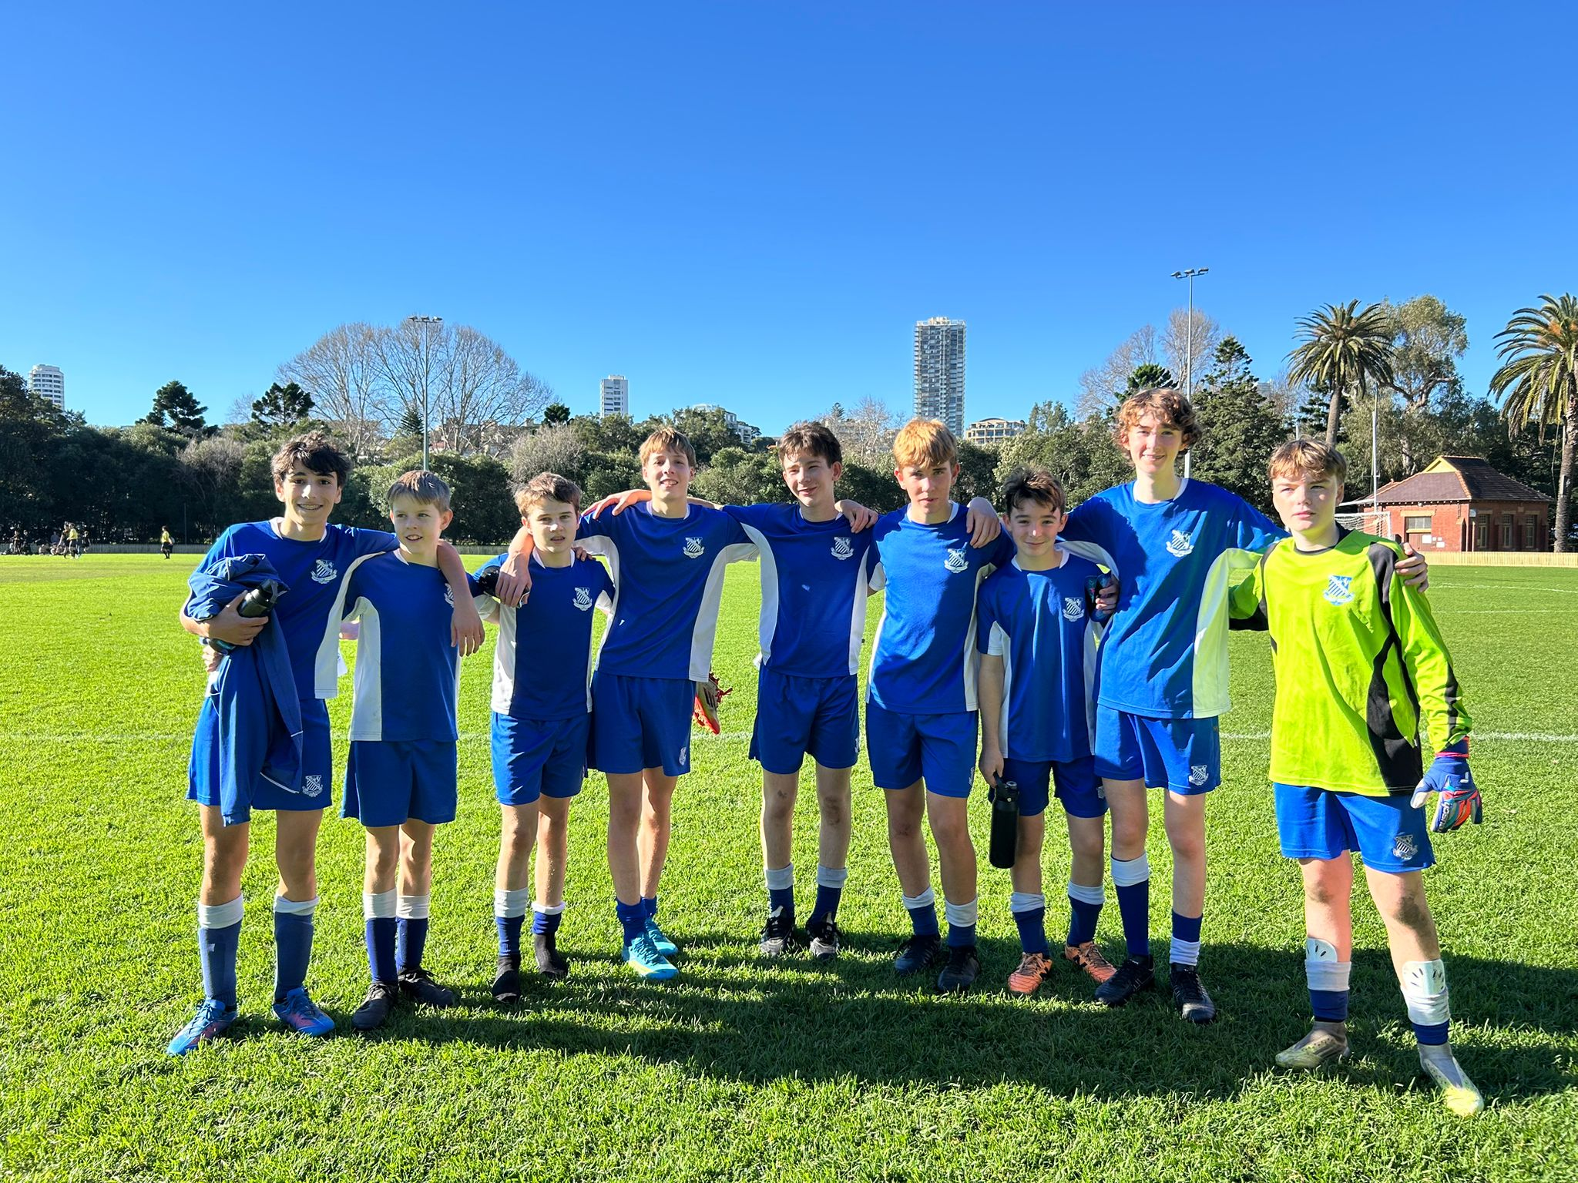
15B Match report: Coach Jonathan Codemo
Despite being short on numbers, the 15Bs came out firing against Grammar, showing great determination and energy from the opening whistle. The boys immediately looked to break down Grammar's defence, moving the ball well and creating attacking opportunities throughout the first half. Their relentless pressure kept Grammar on their toes, with several promising chances unlucky not to find the back of the net. Grammar struck early in the second half, but the setback did little to dampen the team's spirit. The boys continued to play positive football, pushing Grammar onto the back foot and refusing to give in. Their efforts were rewarded when Luke D delivered a magical cross into the box, where Enzo rose highest to power home a brilliant header and level the scores. The boys dug deep and fought hard until the final whistle, but despite their tremendous effort and resilience, Grammar found a late winner, leaving the 15Bs unlucky to fall short.

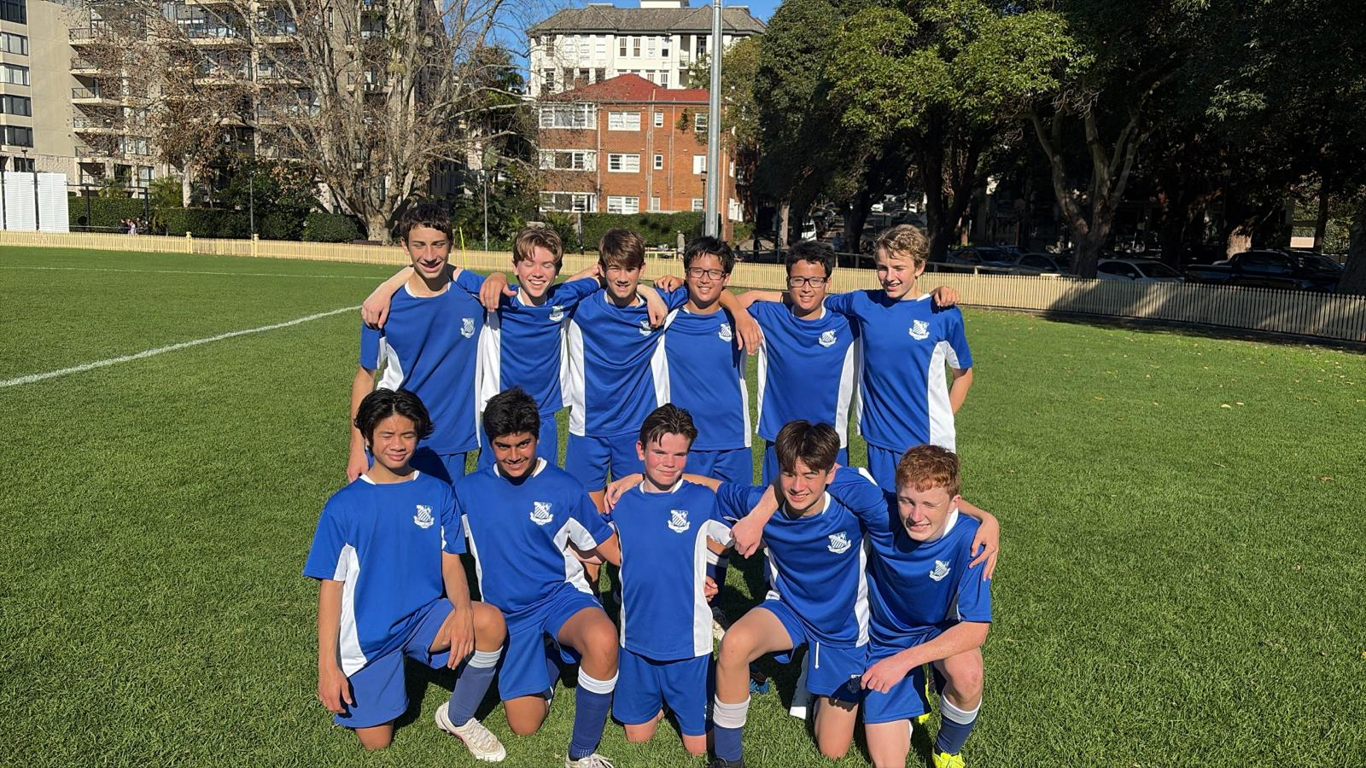
15C Match Report: Coach Cooper Sintras
The 15Cs had a tight game against Grammar on Saturday. Starting off pretty evenly matched, the boys were able to break the deadlock with a great cutback finish from Patty Mills, putting us 1-0 up. Then, after a confusion at the back, we concede to go 1-1 into halftime. Following a motivational halftime talk, the boys came out firing in the second half and had many chances. A first-time top corner finish from Jason Herrera-Hu puts us up 2-1. Then, after a controversial handball call in the box, we concede a penalty to go 2-2. The boys then proceeded to have countless chances, but were unlucky to not convert, leaving the game at 2-2. Man of the match goes to Will Hall.
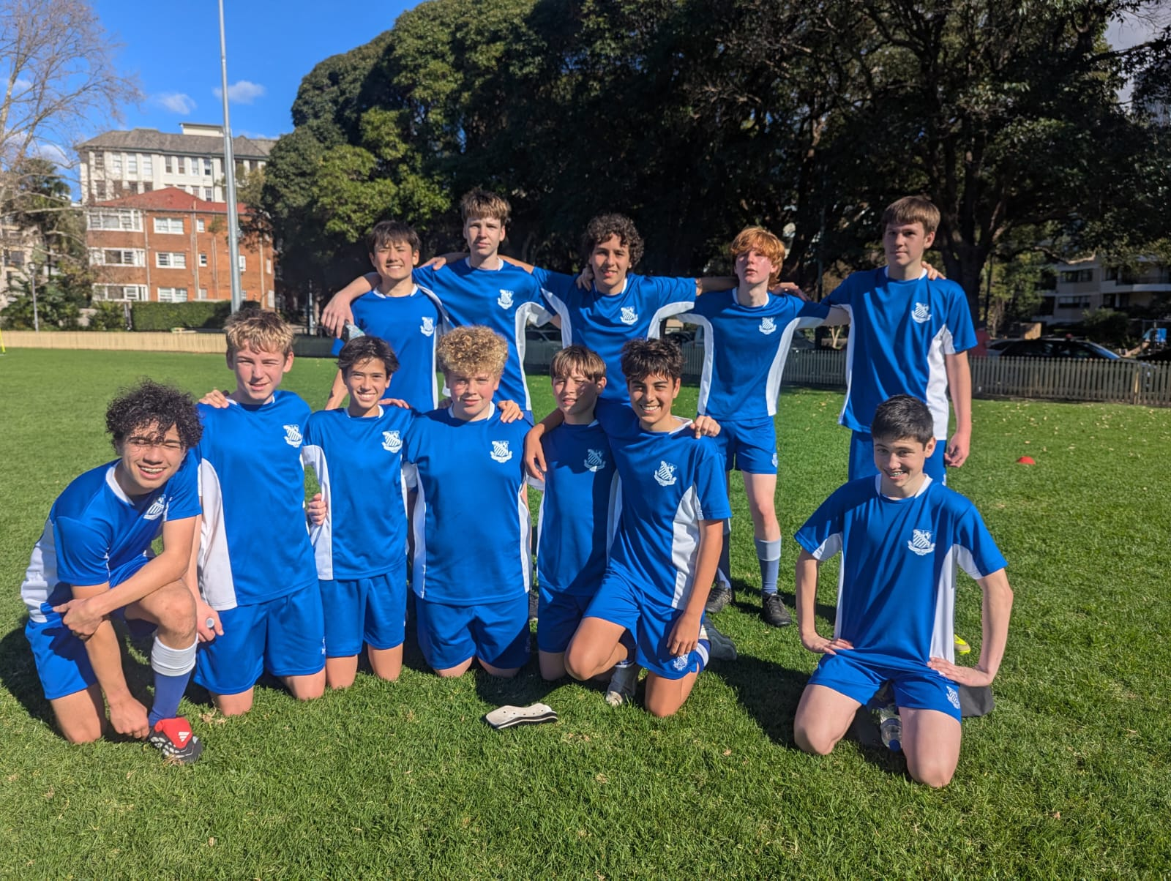
15D Match Report: Coach Alexander Mansfield
The U15Ds put in a strong and disciplined performance in a tightly contested match. Throughout the game, the boys worked hard and created a number of promising opportunities, looking the more dangerous side for large periods. Their movement and build-up play allowed them to get into good positions, but despite their efforts, they were unable to find the finishing touch. Defensively, the team remained organised and limited the opposition to very few clear chances. As the game wore on, both sides began to tire, and the intensity dropped in the second half. Despite continuing to push for a breakthrough, neither team could find a way to break the deadlock, with the match finishing in a hard-fought draw. While disappointed not to come away with a victory, the boys can take plenty of positives from a committed performance and the number of chances they were able to create.

15E Match report (no photo available): Coach Cooper Sintras
The 15Es were involved in a hard-fought and competitive contest against Grammar. The boys battled well throughout the match and showed great determination against a strong opposition. After a tight opening period, Grammar managed to take a 1–0 lead, leaving the boys trailing at half-time. To their credit, the team responded strongly after the break. They lifted their intensity, worked harder off the ball, and began to create more opportunities going forward. Their persistence was eventually rewarded with a deserved equaliser, and the boys continued to push for a winner while remaining solid defensively. In the end, the 15Es earned a well-deserved point with a 1–1 draw, demonstrating resilience, teamwork, and a positive attitude throughout the match.
YEAR 10
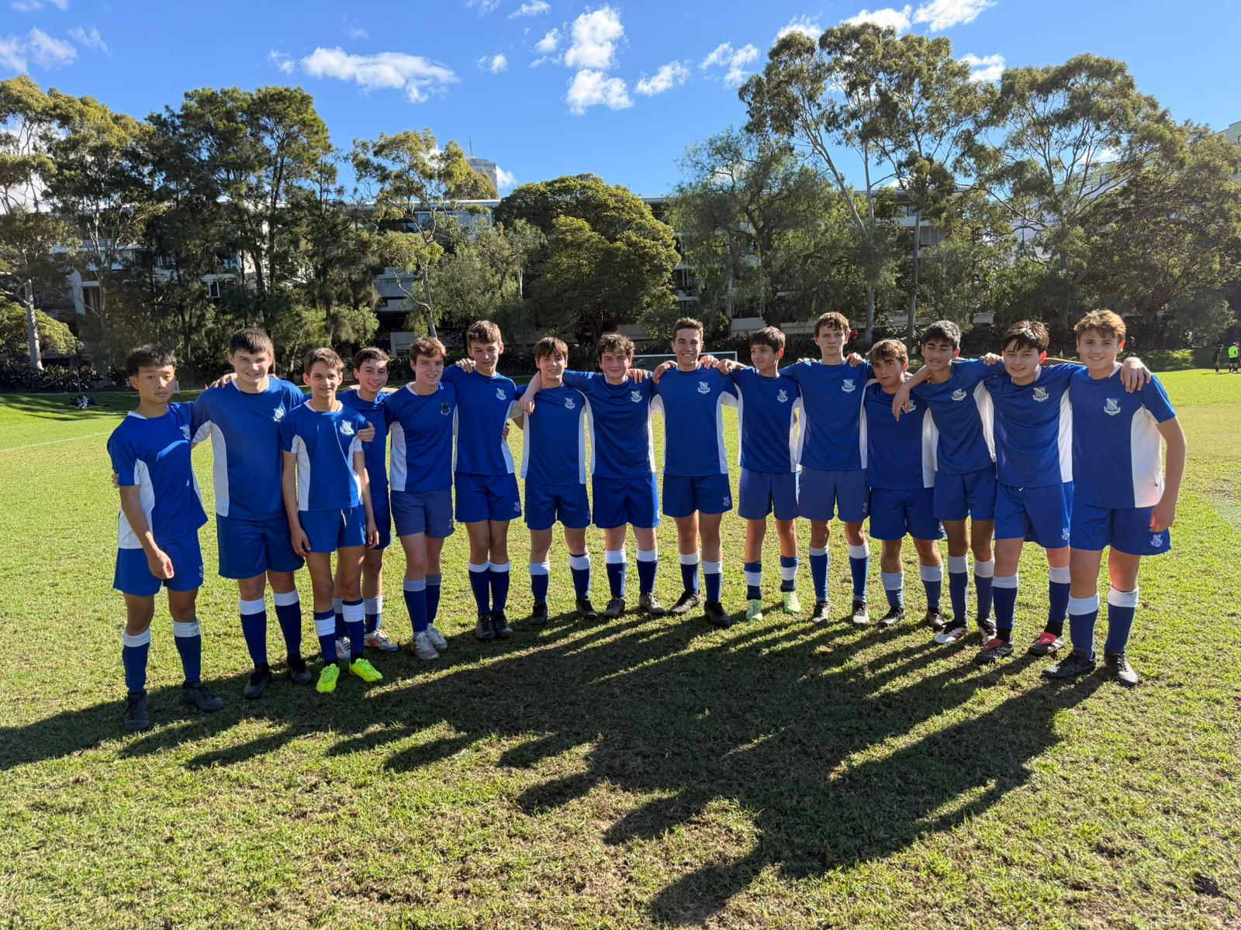
16D Match Report: Coach Stefano Rossello
The 16Ds faced a tough test against Sydney Grammar on the weekend, going down 5-0 to a strong opposition. While the result wasn’t what the boys wanted, they showed great resilience and continued to work hard throughout the match. Despite the scoreline, the team never gave up and continued to compete until the final whistle. There were plenty of positive signs, with the boy’s showing determination, supporting one another, and continuing to play with a positive attitude. Games like these are important learning experiences, and the boys should be proud of the effort they put in. If they continue to train hard and maintain the same commitment, the results will follow.
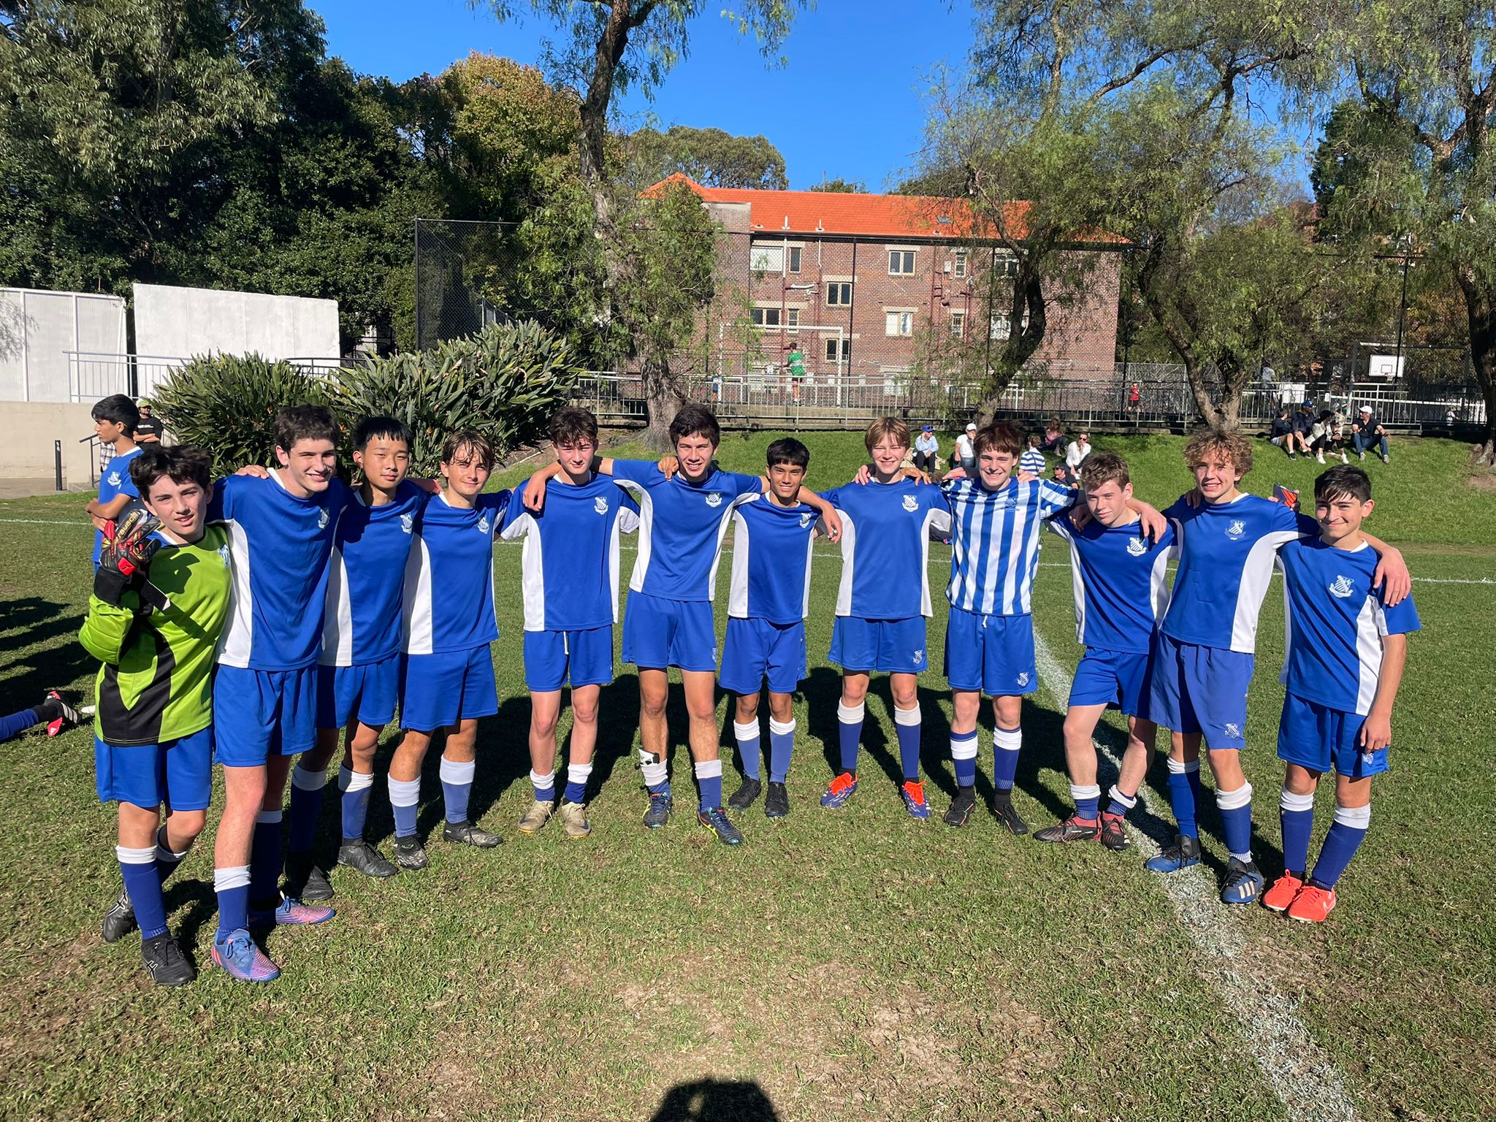
16C Match Report: Coach Stefan Visscher
The 16Cs recorded an impressive 2–1 victory over Grammar in a closely contested match. The boys showed great determination and teamwork throughout the game, competing strongly against a quality opposition. They created a number of promising chances and were rewarded with two well-taken goals, while remaining disciplined and organised at the back. Grammar managed to find a goal of their own to keep the contest tight, but the 16Cs responded well and never allowed the opposition to gain control of the match. The team worked tirelessly for one another, with strong defensive efforts and a willingness to battle for every ball proving crucial in the closing stages. Despite some late pressure from Grammar, the boys remained composed and defended resolutely to see out the game and secure a deserved 2–1 win. It was an excellent all-round performance and another positive result built on hard work, resilience, and strong team spirit.

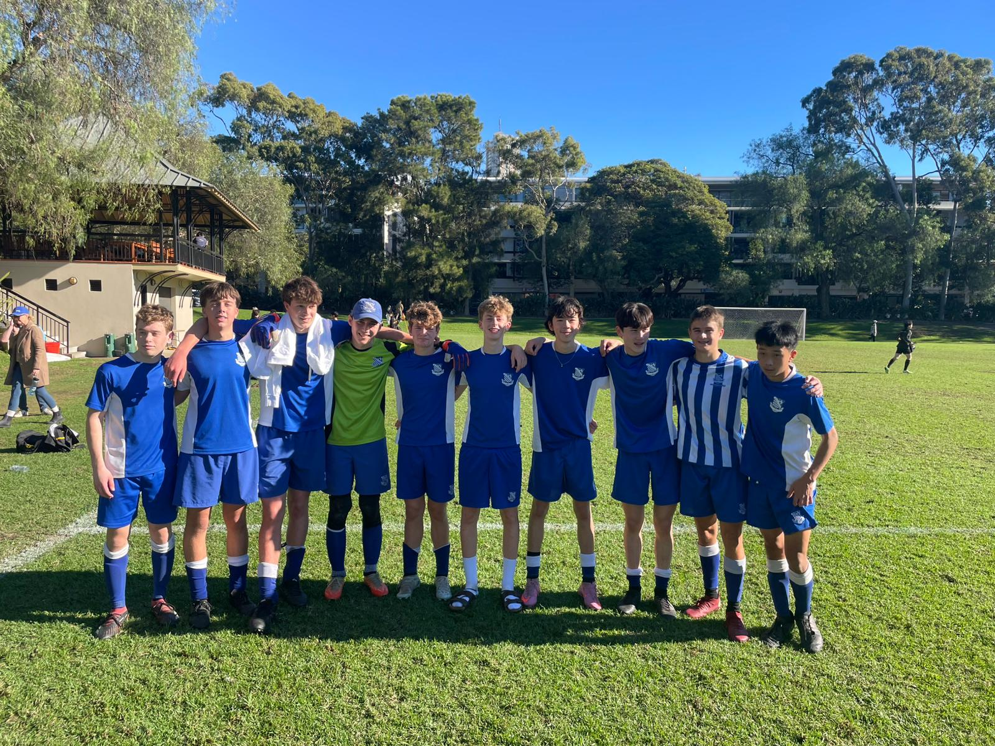
16B Match Report: Coach Stefan Visscher
The 16Bs were involved in an entertaining and hard-fought contest against Grammar, eventually sharing the points in a 2–2 draw. The boys showed great character throughout the match, responding well to the challenges posed by a determined opposition and producing some excellent passages of play. Going forward, the team created a number of promising opportunities and were rewarded with two goals for their efforts. Grammar proved dangerous as well, and the game remained evenly balanced with both sides enjoying periods of possession and momentum. Despite conceding twice, the boys remained composed and continued to work hard for one another across the pitch. In the closing stages, the 16Bs pushed hard in search of a winner, but neither side was able to find the decisive breakthrough. In the end, a share of the points was a fair reflection of a competitive encounter, with the boys showing plenty of resilience, teamwork, and determination throughout the match.
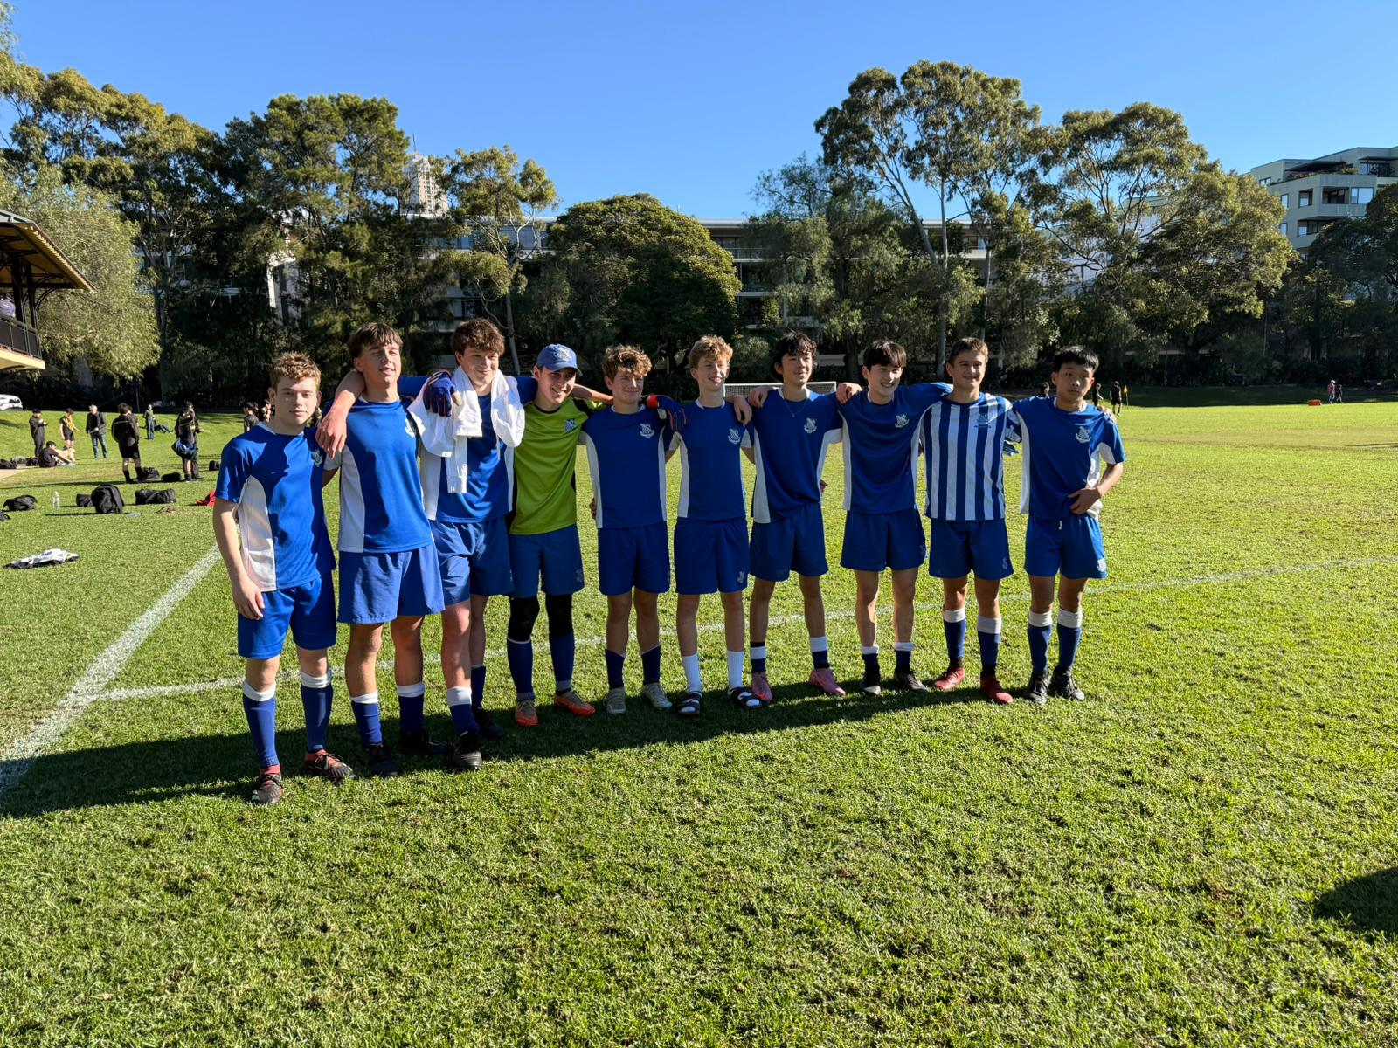
16A Match Report: Coach Stefano Rossello
The 16As faced a tough challenge against Sydney Grammar on the weekend, going down 2-0 in a competitive match. Despite the result, the boys can be proud of their effort, especially considering the squad was short on numbers and relied on several players stepping up from the Bs. Grammar opened the scoring with a goal that was avoidable after a lapse in concentration. The second came from a penalty that was correctly awarded, but one that could have been prevented with better decision-making in the lead-up. Those two moments ultimately proved costly, as Riverview competed strongly for much of the game. Given the circumstances, the boys showed great character and worked hard from start to finish. The players who stepped up from the Bs did an excellent job and contributed well against a strong Grammar side. While the result wasn’t what we wanted, there were plenty of positives to take away from the performance heading into next term.
OPENS SQUADS
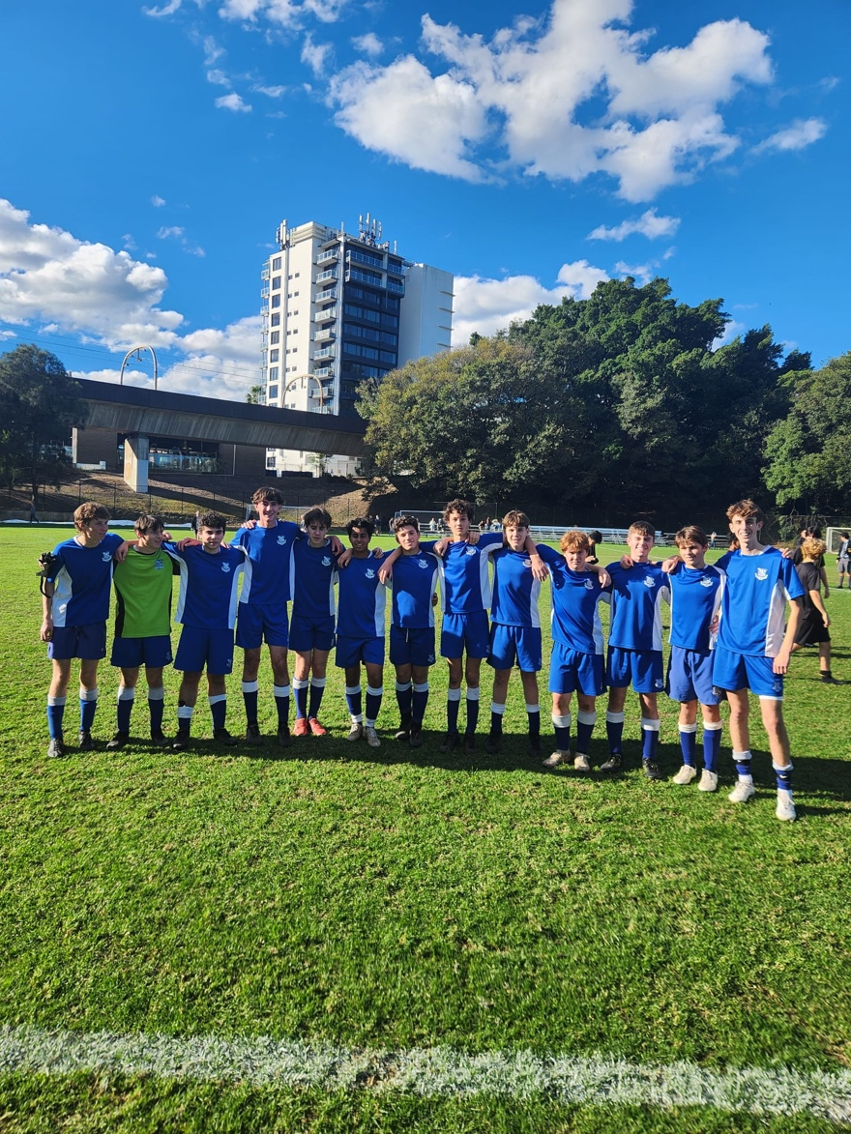
5th Match Report: Coach Max Joosse
The 5ths faced a tough challenge against Sydney Grammar, with only eight players available due to sickness and injury. A big thank you goes to the boys from the 6ths who backed up after their own intense game to help us field a team. Despite the limited numbers, the boys worked hard and never stopped competing. Grammar gradually chipped away at us throughout the match, making the most of their opportunities while our players continued to battle under difficult circumstances. The final score was a 2–0 loss, but the effort, resilience, and willingness to keep fighting for each other was a credit to the team. Well done to all the boys for their commitment and determination.
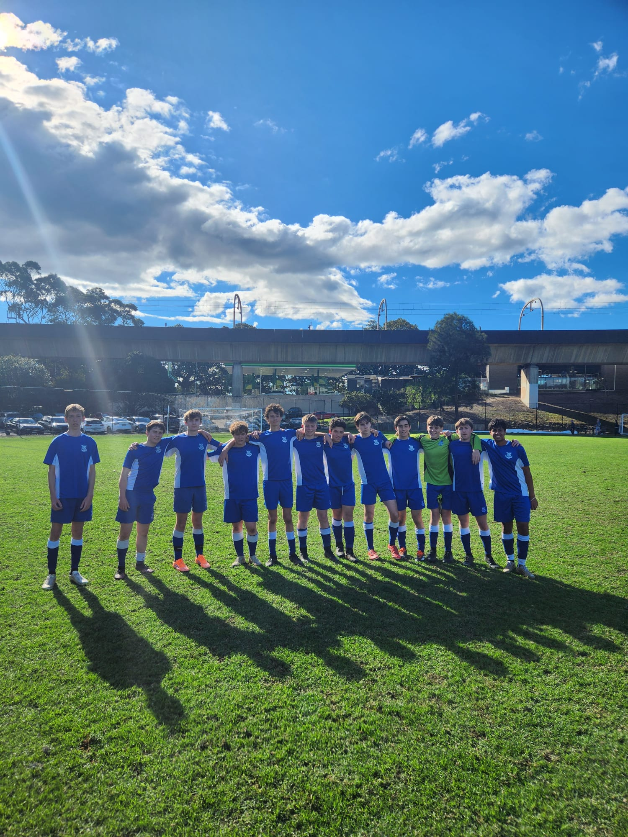
4th Match Report: Coach Max Joosse
Despite a hard-fought 1–0 loss to Sydney Grammar, the boys can be proud of their performance. With only two substitutes available, it was always going to be a tough match, but the team worked tirelessly and continually lifted each other up throughout the game. Grammar's goal came from a corner that caught us off guard early, but the boys responded well and began putting the pressure on. We created several good chances but were unable to find the back of the net. Defensively, Grammar's attack tested us, however a tactical adjustment to the back line helped catch their forwards offside and limit their opportunities. The second half saw some excellent attacking chances from Harry Sadaat and Henry Turnbull, supported by the relentless work rate of midfielders Levi Mannix and Will Thomas. While the result didn't go our way, the effort, teamwork, and determination shown by the boys was outstanding and they should be proud of how hard they fought until the final whistle.
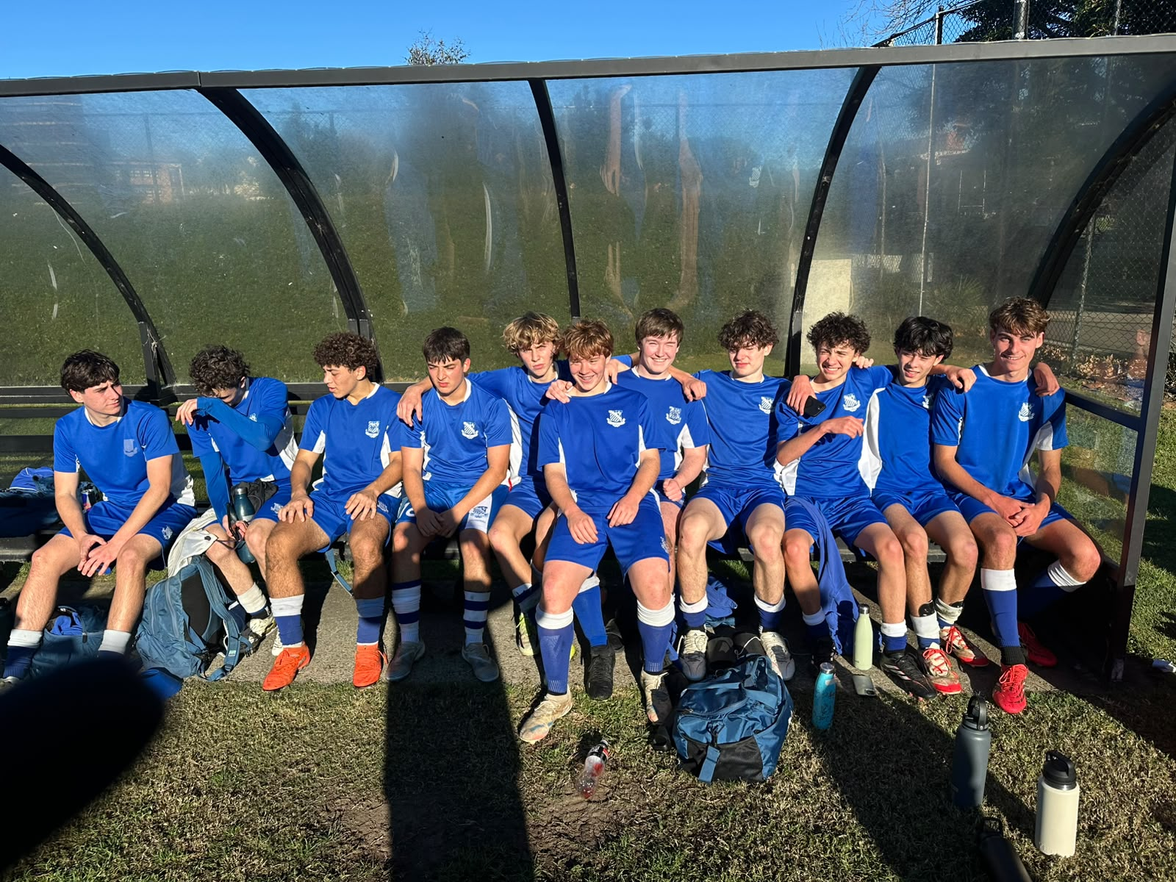
3rd Match Report: Coach Andrew Ferrara
The 3rds produced a disciplined and determined performance to secure a hard-fought 1–0 victory. In a closely contested match, the boys showed great organisation and commitment, working tirelessly both in and out of possession. They created several promising opportunities throughout the game and were rewarded with the decisive goal, which ultimately proved enough to separate the two sides. Defensively, the team was outstanding, remaining compact and composed under pressure while limiting the opposition to very few clear chances. Every player contributed to the result, with the boys showing excellent teamwork and a willingness to fight for one another right until the final whistle. Despite some late pressure from the opposition, the 3rds remained focused and saw out the game professionally to record a deserved 1–0 win. It was another strong team performance built on hard work, discipline, and a solid defensive foundation.

