
Riverview Football Program - Match reports Saturday 23rd, May 2026
YEAR 7
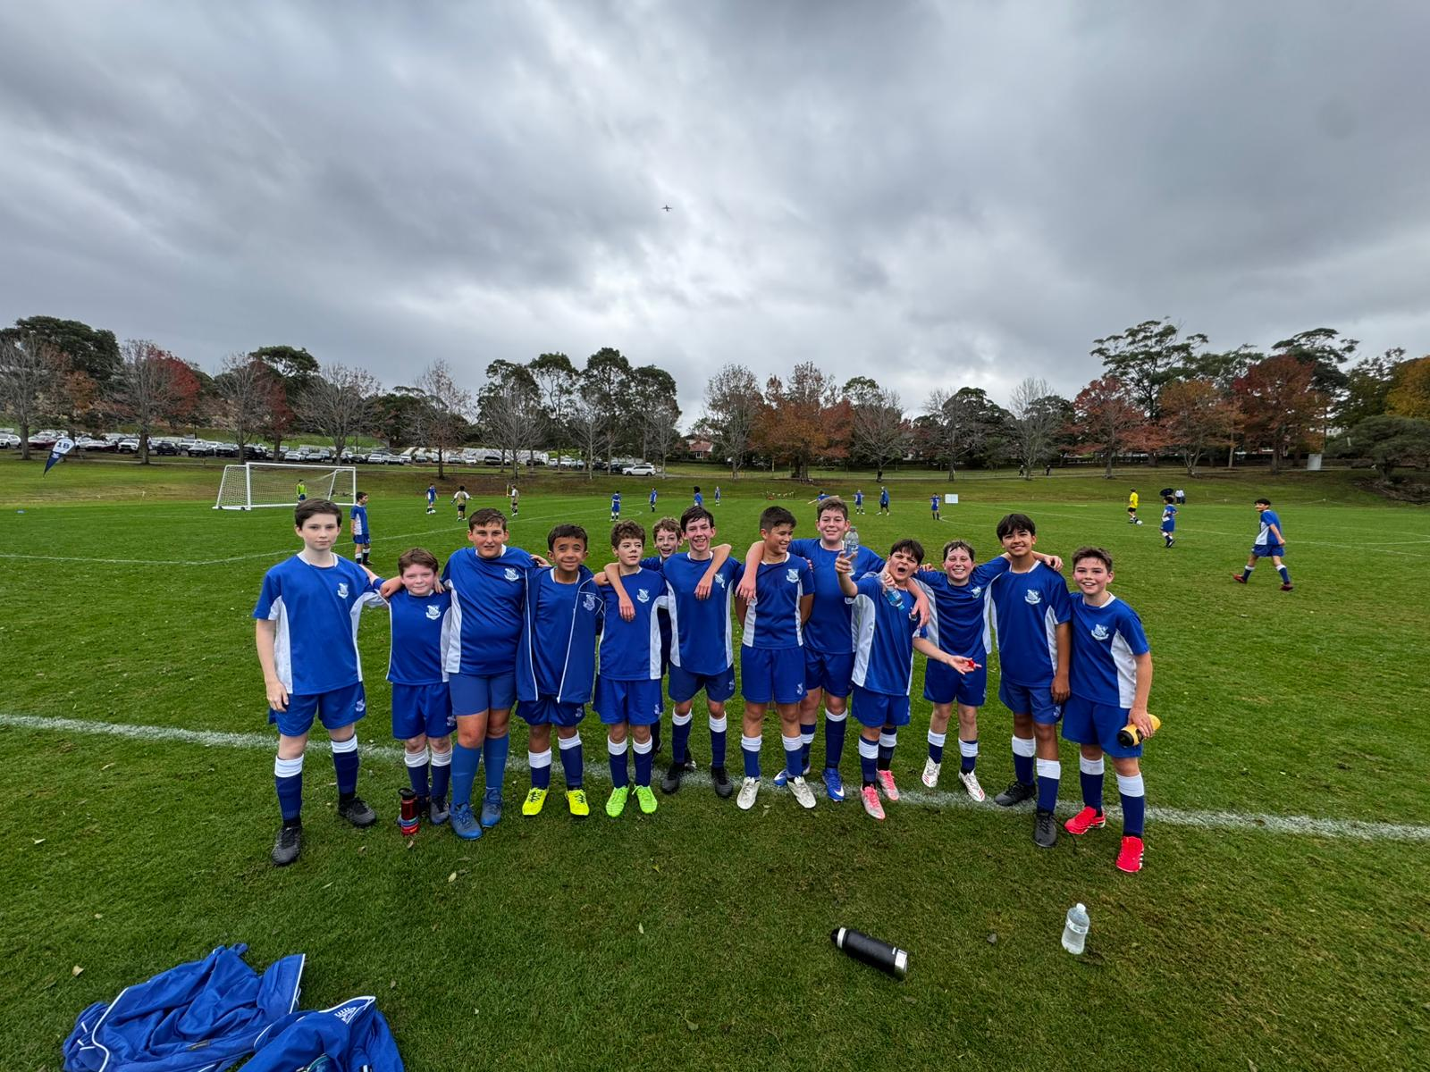
13F Match Report: Coach Sam Burkitt
The 13Fs put together a fantastic performance in a 3–4 loss, conceding a last second winner after an incredibly well fought match. What stood out most was the growth shown since the previous meeting between the two teams. The boys demonstrated resilience and composure throughout the game and never let setbacks affect their effort or attitude. To respond after the previous result and push the opposition right to the final moments showed genuine improvement. While the result did not fall our way, the performance should give the team plenty of confidence moving forward. Well done gents.
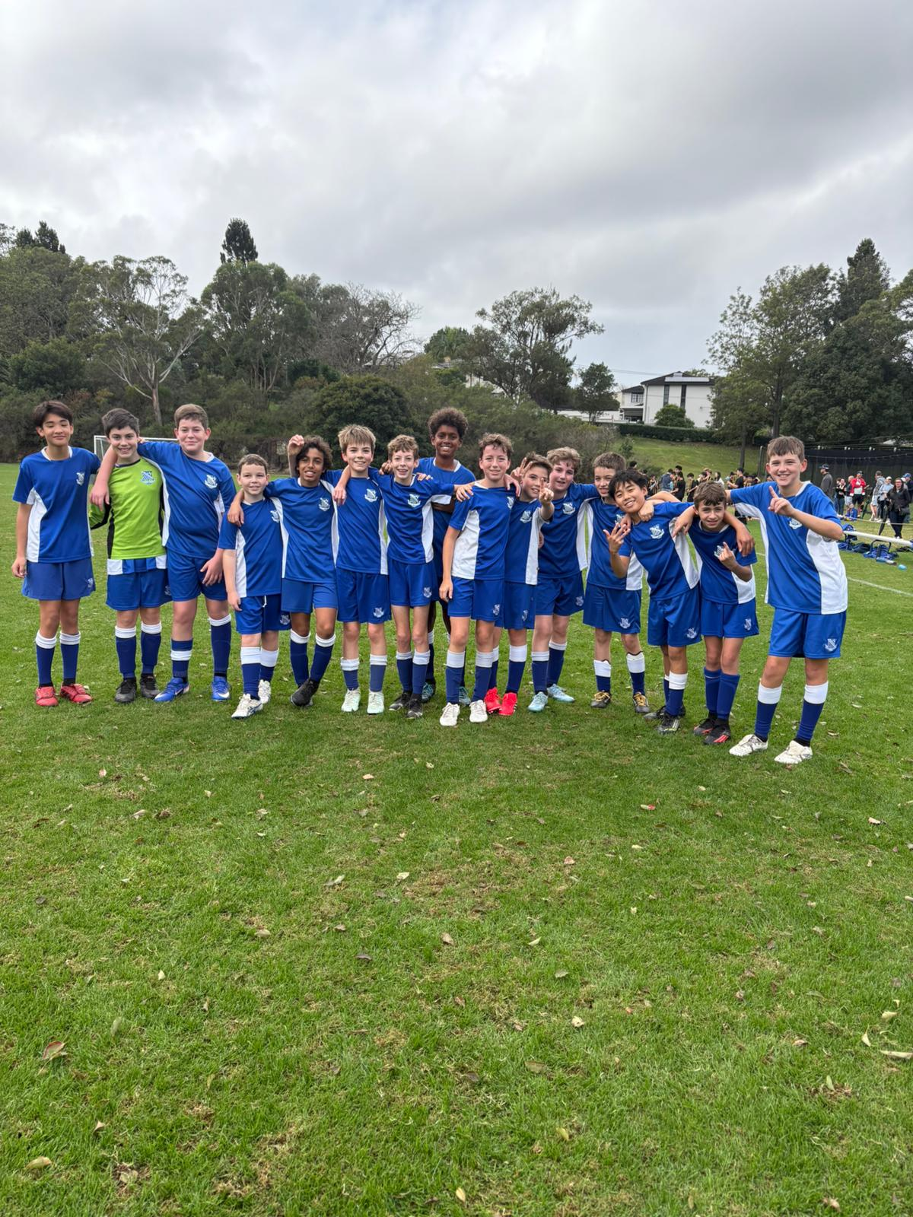
13E Match Report: Coach Joseph Salameh
The Riverview 13Es produced a dominant Saturday morning performance, running out convincing 15–0 winners over Sydney Grammar in a display full of goals, structure, and excellent teamwork. Ezekiel was the standout on the scoresheet with an impressive five goals, while Isaac was equally clinical, finishing with four goals of his own. Henry opened the scoring early to set the tone for the match, while James and Toby also added their names to the scoresheet during an outstanding attacking performance. Sebastian capped off the scoring with a well-deserved goal of his own, rounding out a strong all-round contribution. At the back, Liam was outstanding in goals, keeping a clean sheet and commanding his area confidently throughout the morning. Ollie played a key role in controlling the tempo of the game with his composure on the ball and constant communication, helping keep the team organised from start to finish. Callum’s hard running continually caused problems for the Grammar defence, stretching the field and creating valuable space in wide areas. Defensively, George was solid and dependable all game, while Luke showed great composure and control down the wing in a very disciplined defensive display. It was a complete team performance from the 13Es, with every player contributing to an excellent result and an enjoyable morning of football.
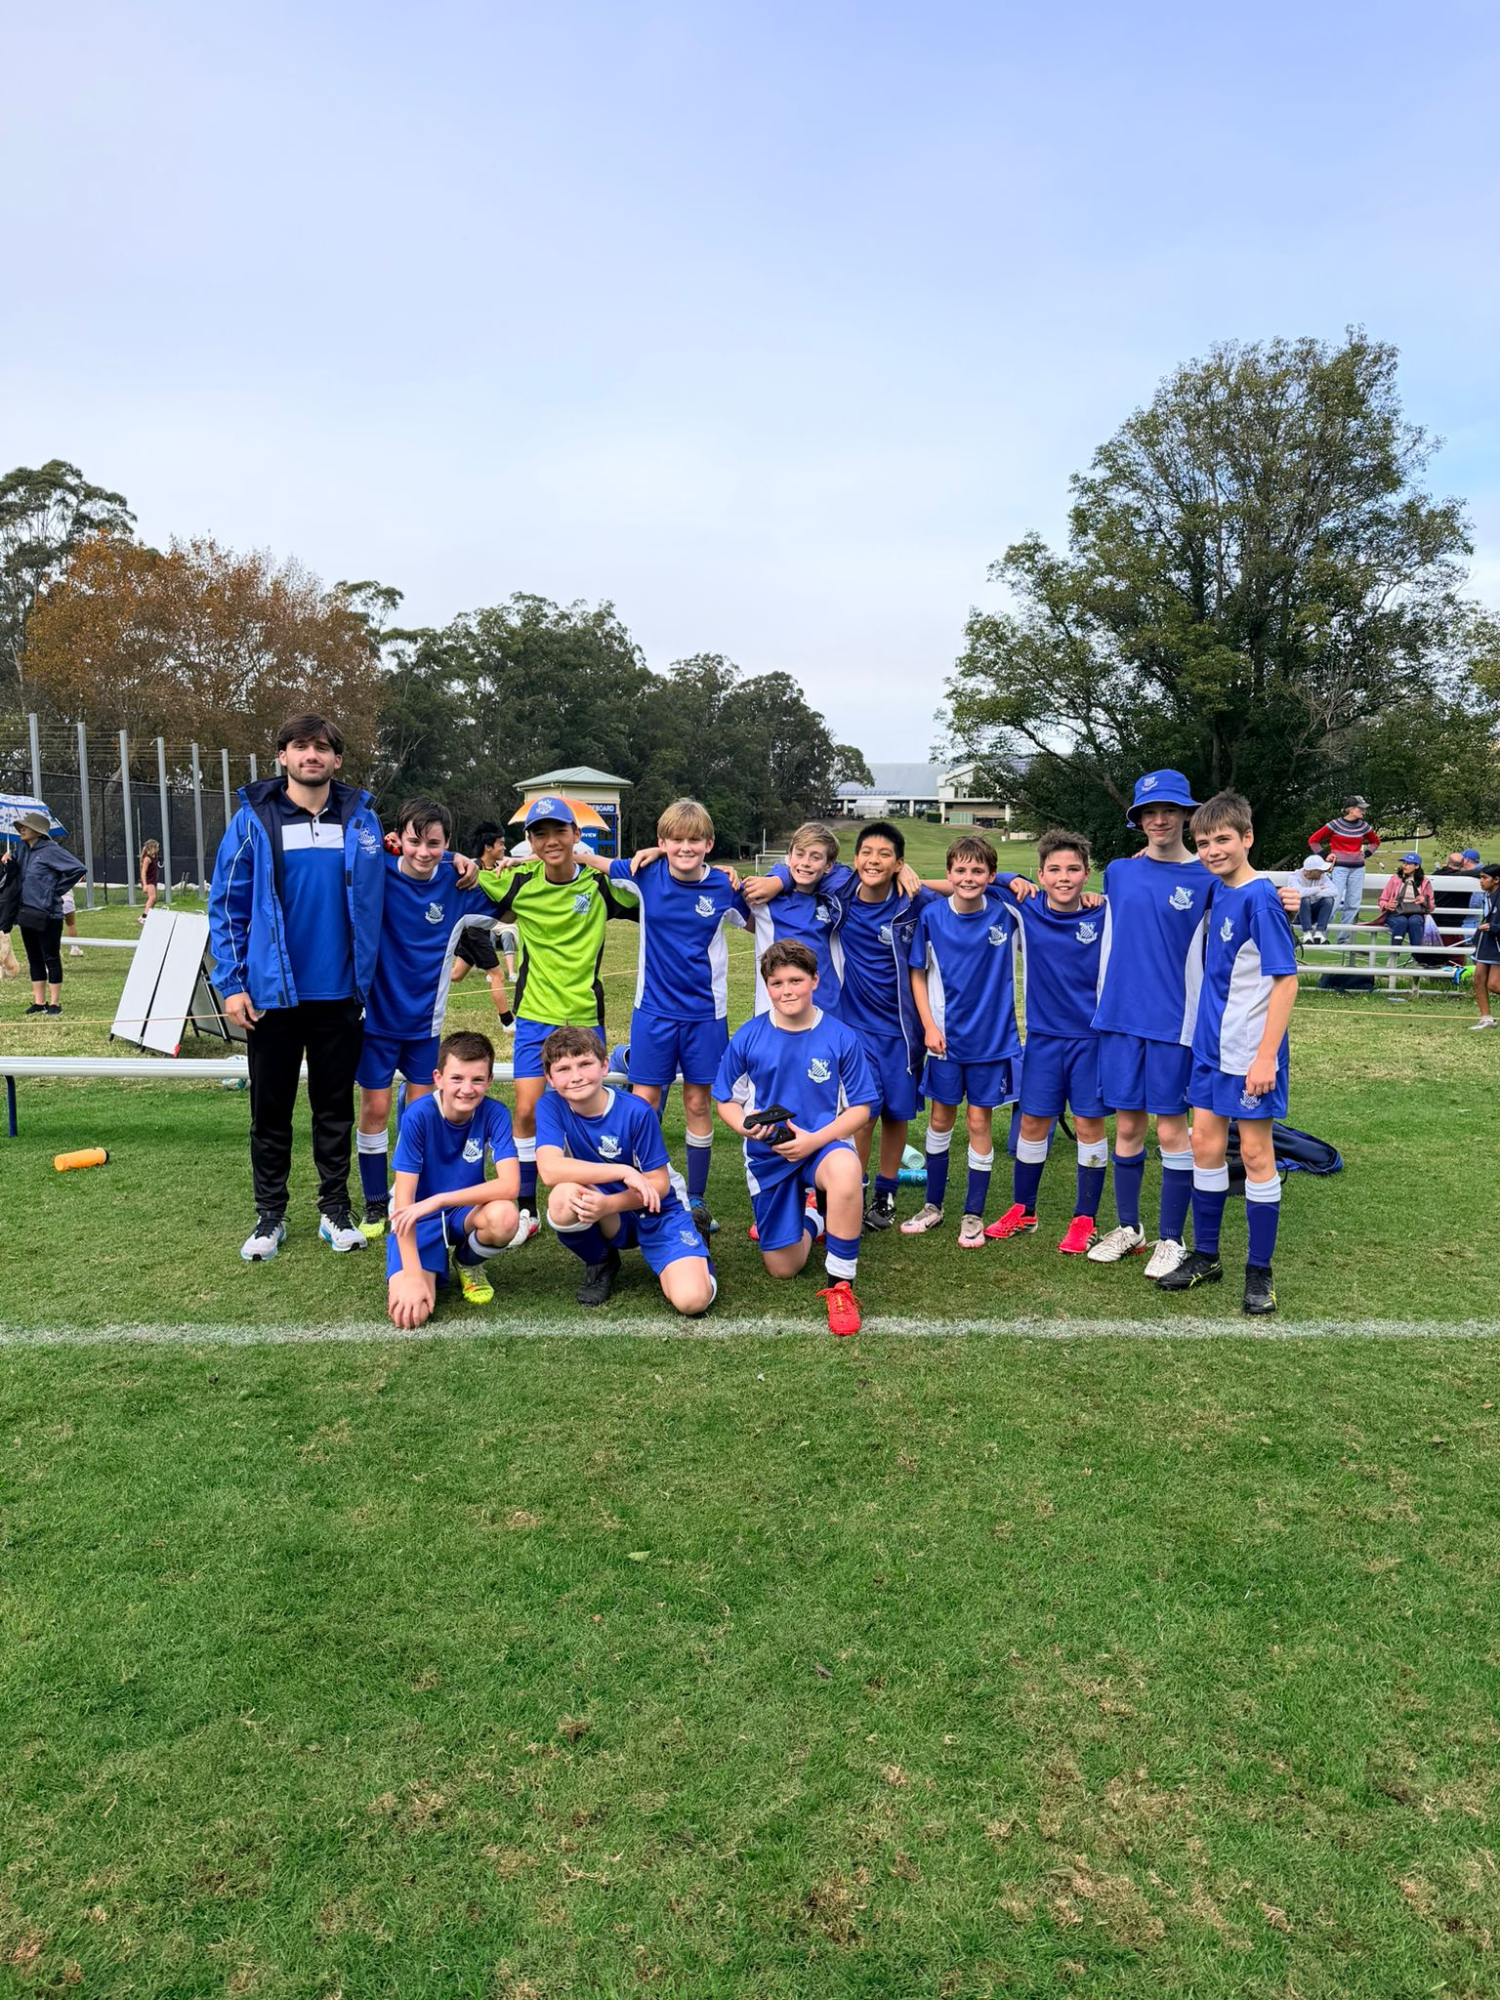

13D Match Report: Coach Michael Portale
The 13Ds boys produced an outstanding performance this weekend, securing a dominant 7–0 victory. The team displayed excellent teamwork, intensity, and composure throughout the match, controlling possession and creating opportunities consistently. Their communication and positioning across the field showed significant improvement and contributed to a well-deserved clean sheet. It was especially pleasing to see new players on the scoresheet and every player working hard for one another, maintaining focus from start to finish. A fantastic team effort and a great reward for the hard work being shown at training each week.
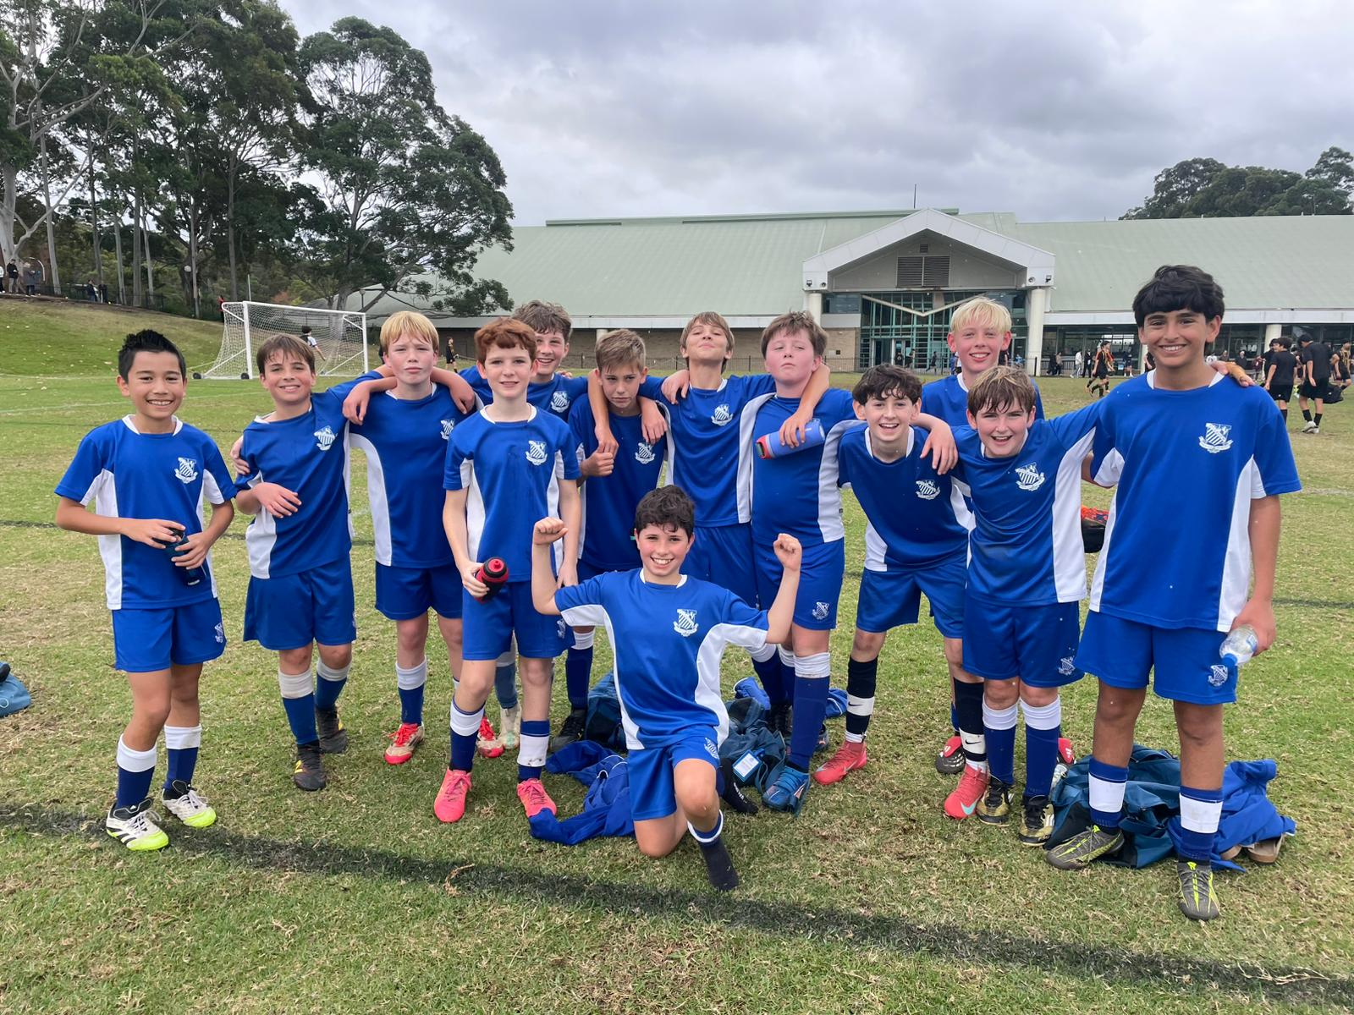

13C Match Report: Coach Nelson Meehan
A great win for the Cs, who continued their unbeaten streak with an impressive 3–0 victory. It was a dominant first half from the Riverview side, who took control of the game early through some excellent passages of play and strong teamwork across the field. The second half began with a solid defensive effort, as the boys worked hard to keep Sydney Grammar at bay while continuing to look dangerous going forward. Another well-taken goal helped secure the 3–0 result and cap off an excellent team performance. Overall, it was a great Saturday for the Riverview boys, with plenty of positives to take into next week’s match.

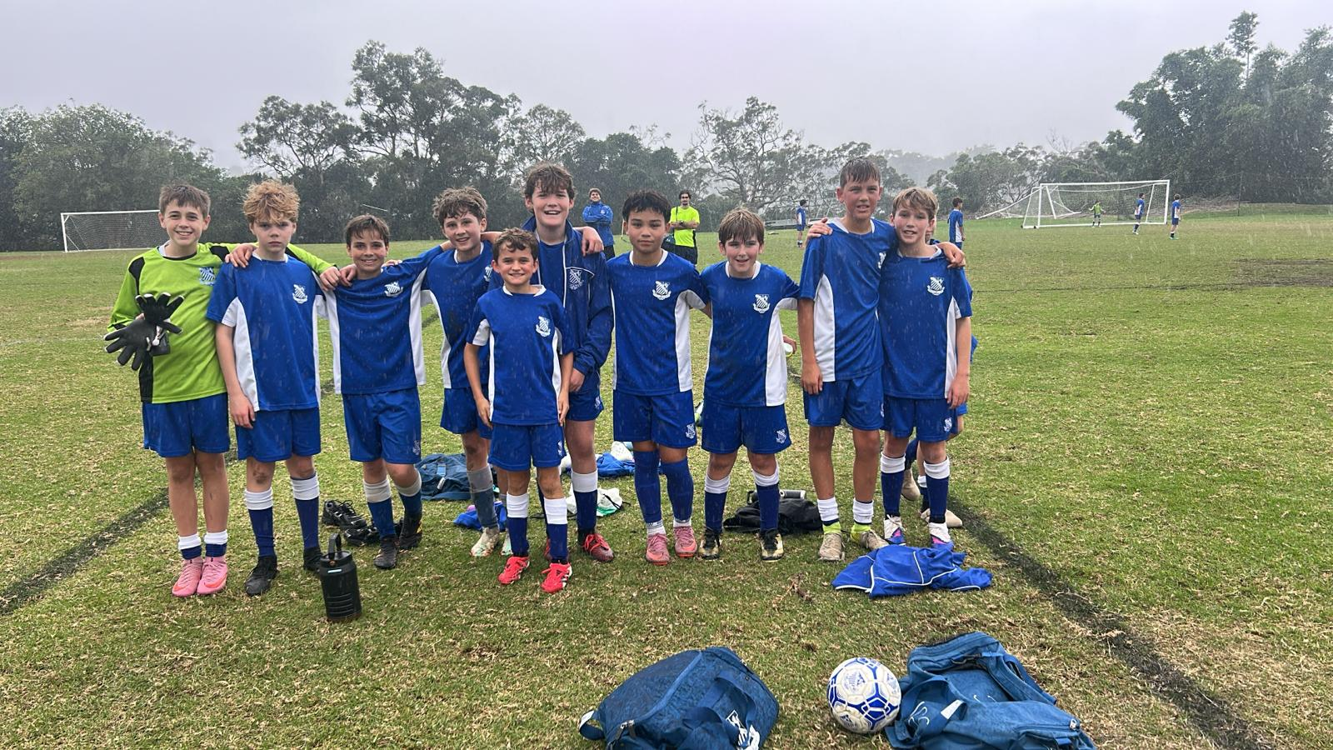

13B Match Report: Coach Josh Engelmann
The 13Bs faced a strong Sydney Grammar side and went down 4–0 in a challenging match. Despite the result, the boys continued to work hard throughout the game and showed good effort against quality opposition. There are plenty of positives to build on as the team continues to develop and improve each week.

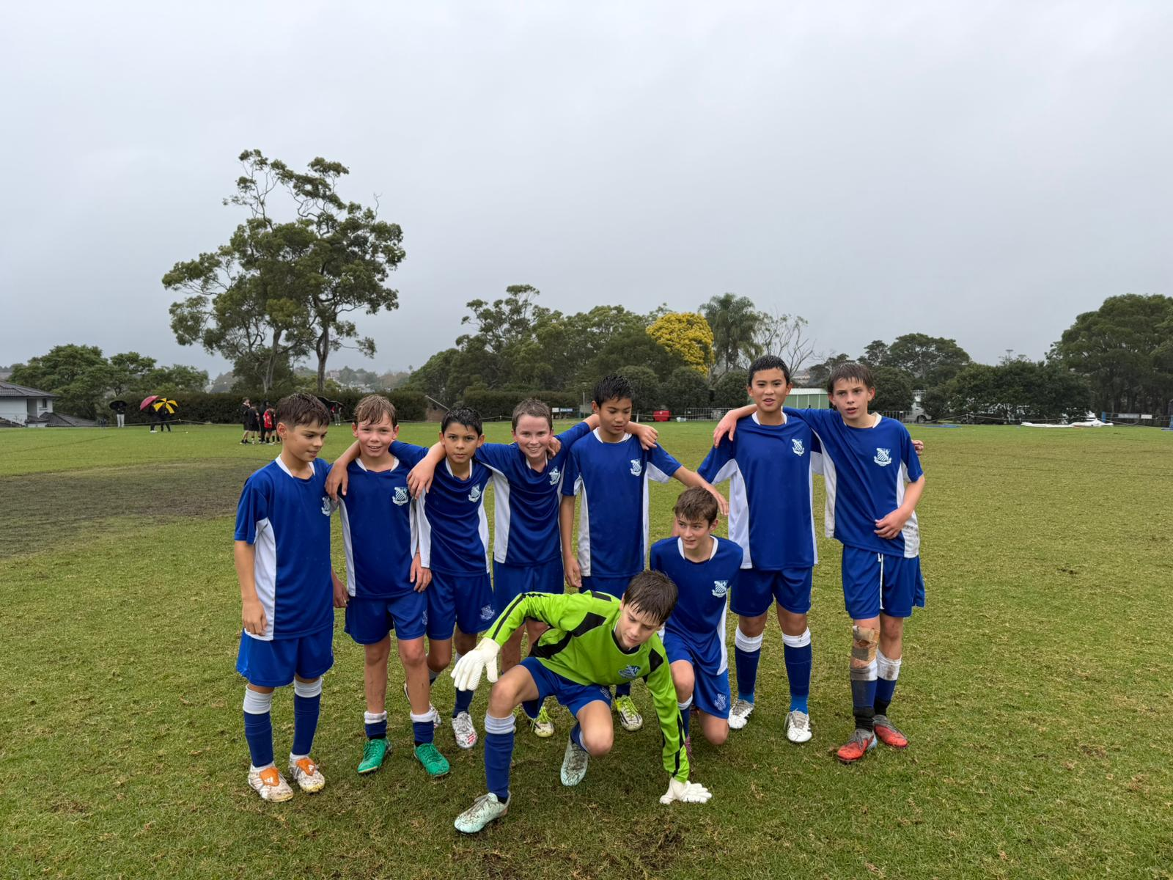
13A Match Report (no photo available): Coach Lewis Morsella
The team played exceptionally well today, with everything finally coming together on the field. In the first half, the boys were relentless in their approach and looked very dangerous with their direct attacking play, consistently putting pressure on the opposition defence. The reaction in the second half was particularly impressive. After focusing on it throughout the week in training, the boys did an excellent job of winning the ball back within three seconds of losing possession, which allowed us to maintain pressure and control the tempo of the game. Player of the Match goes to Dre, who produced an outstanding performance by scoring a brace and creating several excellent goal-scoring opportunities for his teammates. Overall, it was a very strong team display and a great reward for the hard work put in at training.

YEAR 8

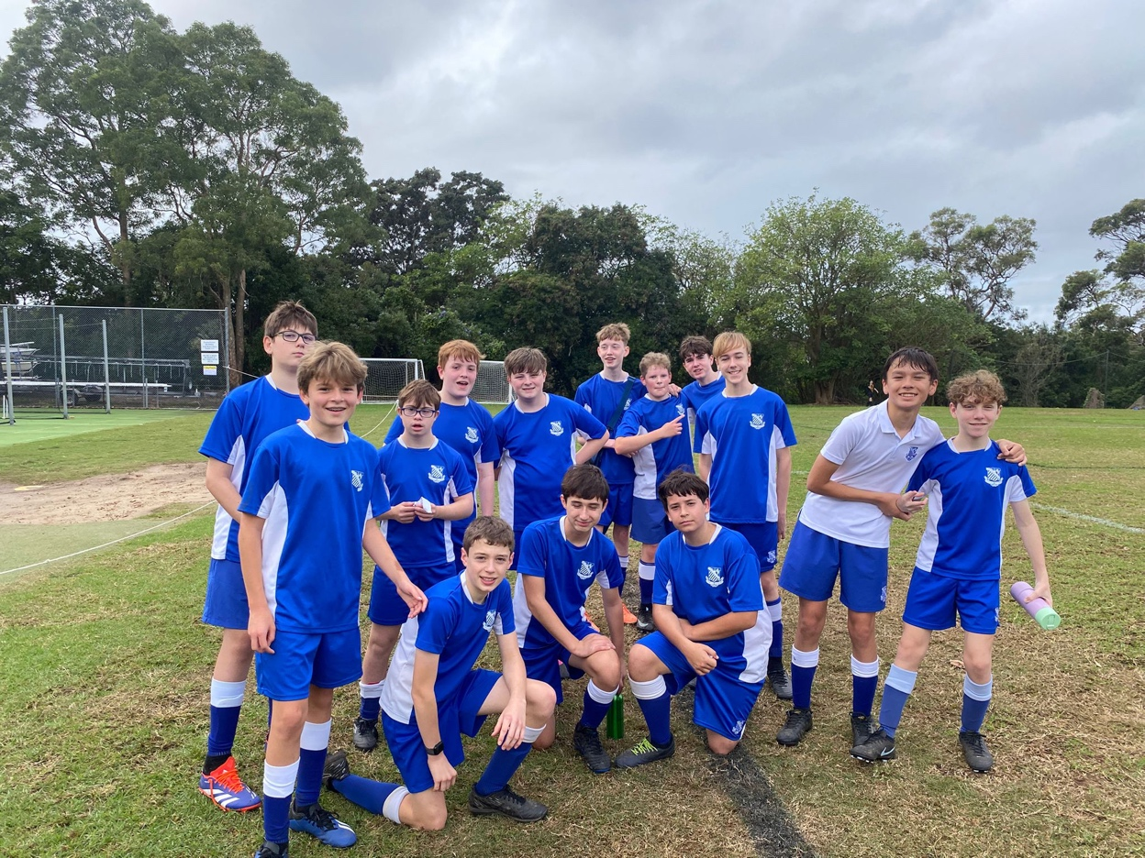
14D Match Report: Coach Matthew Chung
This Saturday, the 14 Ds took on Sydney Grammar School and went down 8-0, although the boys showed great effort and defensive improvement throughout the game. The back line of Byron, James, Felix and Noah Ang once again put up a strong fight to contain a constant wave of attacks. Alex Marren and George made up our centre midfielders, with Angus, Scott and Hamish playing as wide midfielders. Fergus spent more time up top and showed flashes of quality, at times managing to create chances on his own, while Julian also featured in the forward line and worked hard to stay involved in play and support the attack when possible. Sam put in a very determined performance, constantly pressing and showing effort both on and off the ball, while Flynn also contributed strongly with his defensive work rate and willingness to step into different positions when needed. Overall, despite the result, the team showed improvement once again in both organisation and resilience.
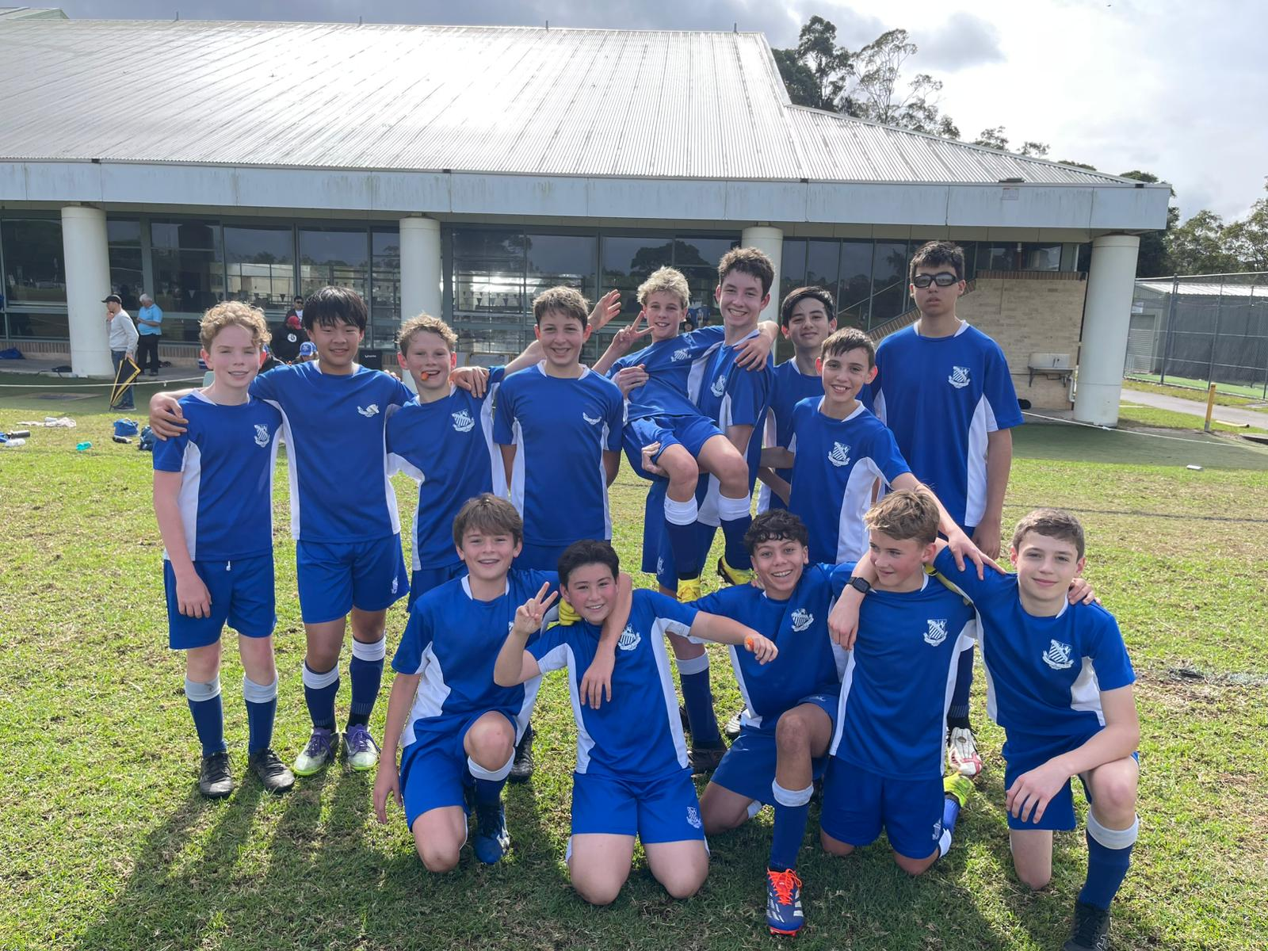
14C Match Report: Coach Tom Kalogerou
Riverview U14Cs faced another tough 7-1 result, this time against a strong Grammar SGC side. The game started evenly, with both teams fighting hard for possession and control. The View boys battled well, but Grammar took their chances through moments of individual quality and sharp passing sequences. Despite the scoreline, Riverview still produced some promising football. Cooper Stewart looked composed playing progressive passes out from the back, while Seb Richards showed strong defensive control throughout. At half-time, the boys stayed positive and came out determined to create chances. Their reward came through a well-worked team goal, starting from a midfield win before Charlie McDonald combined neatly to play in Jack Malouf, who finished calmly into the bottom corner. It was a difficult result, but the performance had promising signs. Better days are ahead.

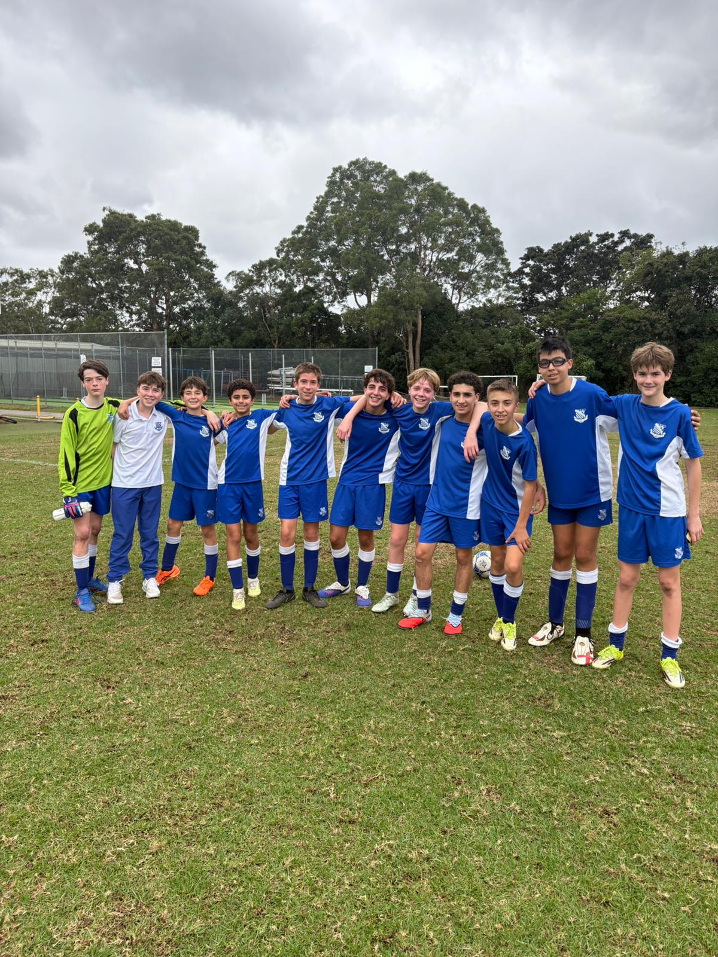
14B Match Report: Coach Lachlan Iacono
The 14B's played against Sydney Grammar this weekend. The game began in the worst way possible, conceding within the first and then the second minutes. The boys had little to no spirit after this, with Grammar racking up the goals in the first half. At half time, we discussed the issues that we though cause the events of the first half and how we could use this, not even to win, but just to make an improvement in the second half. This showed through a first half score of 8-0, which was held that way until the very end of the game, where effort and intensity dropped once again, letting in one more goal. Not a day to remember for the team, we move onto next week.

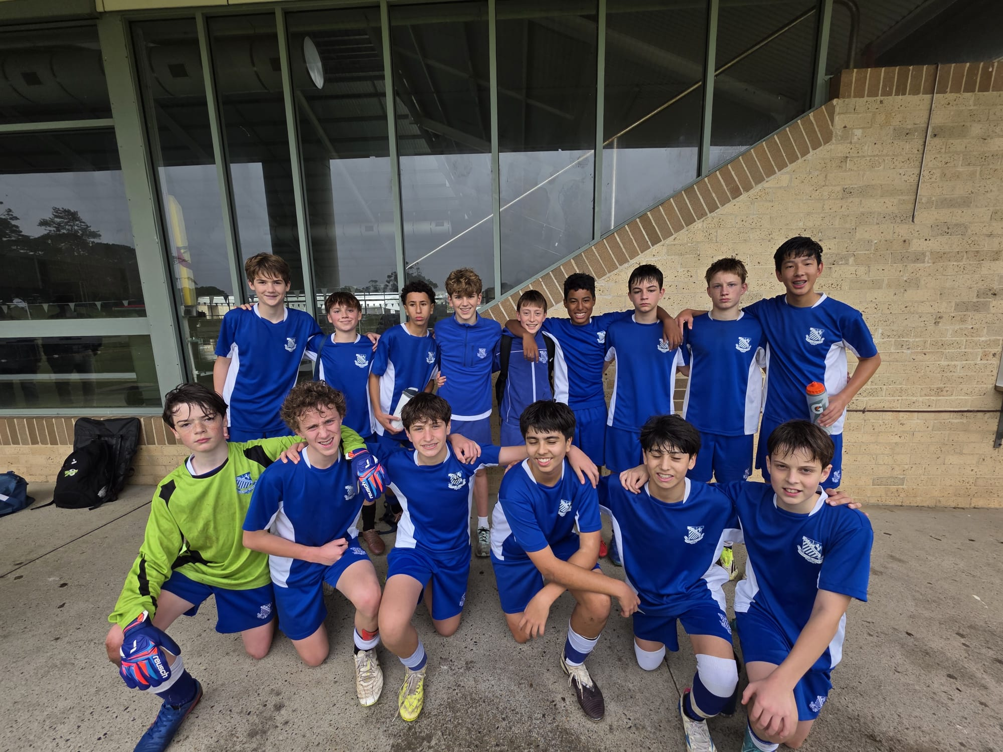
14A Match Report: Coach Domenico Garreffa
Riverview 14A’s were defeated 4-2 by Sydney Grammar School in a tough contest that did not fully reflect the balance of play. Despite the result, Riverview controlled large periods of the game and consistently looked the more composed side in possession. Unfortunately, several costly mistakes at key moments allowed the opposition to capitalise and ultimately take the points. The side showed strong attacking intent throughout the match. Emmanuel opened the scoring in impressive fashion, striking powerfully from outside the box to give the team momentum early on. Leo then finished off an excellent full-field team buildup, calmly converting after a quality pass from Jack to highlight the side’s ability to play connected and attacking football. While the scoreboard was disappointing, there were many positives to take from the performance. The group competed strongly, controlled the tempo for much of the game, and continued to fight until the final whistle against quality opposition.
YEAR 9
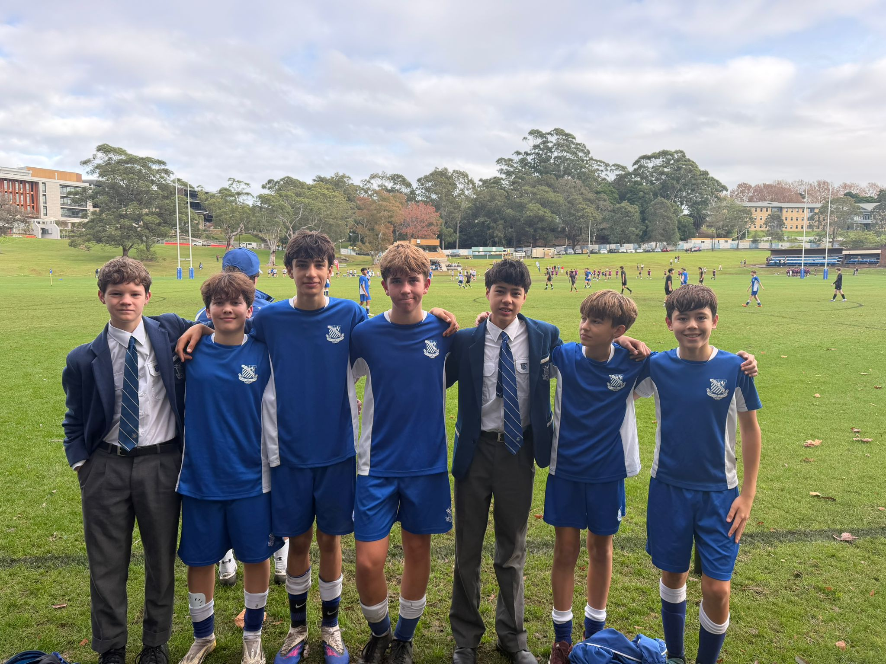
15A Match Report: Coach Travis Cooper
We suffered a 4–1 defeat against Sydney Grammar School at Riverview after a difficult afternoon against a clinical opposition. We found ourselves 2–0 down early in the contest, but a goal before halftime gave us some belief and momentum heading into the break trailing 2–1. That goal lifted the energy around the group and gave us hope that we could work our way back into the match. In the second half, we committed more numbers forward in search of an equaliser and looked dangerous in patches. Unfortunately, that opened up more space for Sydney Grammar, who were able to capitalise and extend their lead. The visitors added another late goal to put the result beyond doubt. While the scoreline was disappointing, there were still moments where we played some good football and showed glimpses of what this group is capable of. There is still a long way to go with this squad, but the focus remains on continuing to improve week by week.
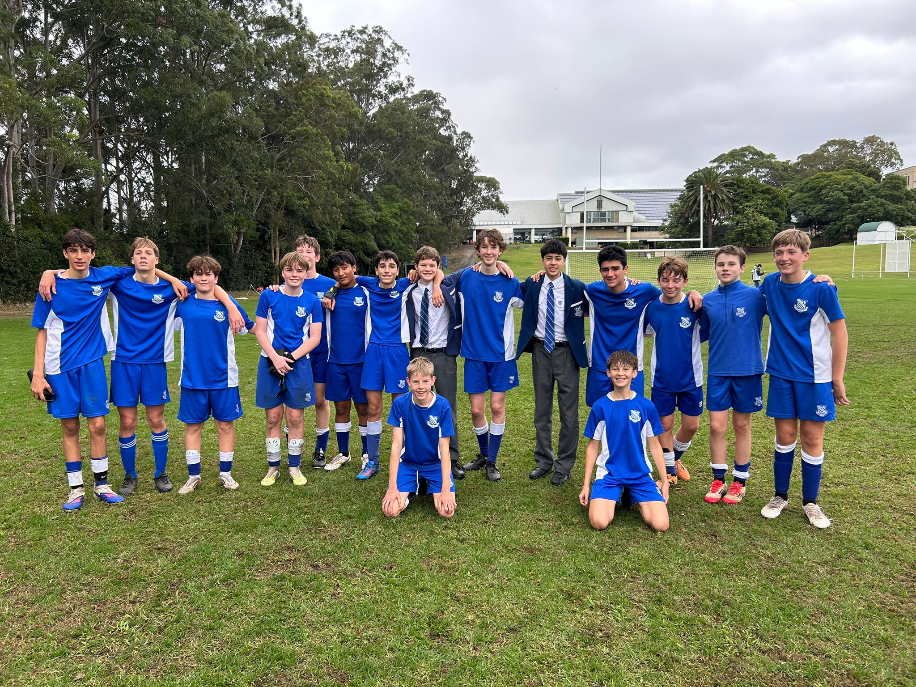
15B Match report: Coach Jonathan Codemo
The 15Bs produced a spirited and determined performance against Grammar 15Bs in a match full of resilience and fight. From the opening whistle, the boys were defensively outstanding, with Lachlan G, Will C, Luke D, and Alonzo forming a rock-solid back line that frustrated Grammar’s attack and refused to give them easy opportunities. Despite the strong defensive effort, Grammar managed to break through late in the first half to take a narrow lead. Rather than dropping their heads, the boys responded brilliantly after halftime. The second half saw the team come out firing with renewed energy and attacking intent. Two outstanding goals from Flynn and Nic H sparked belief across the field and shifted the momentum firmly in our favour. The boys pushed relentlessly, creating pressure and coming agonisingly close to completing the comeback. Although the result did not fall our way, the performance showcased the team’s resilience, hunger, and determination to fight until the very final minute.
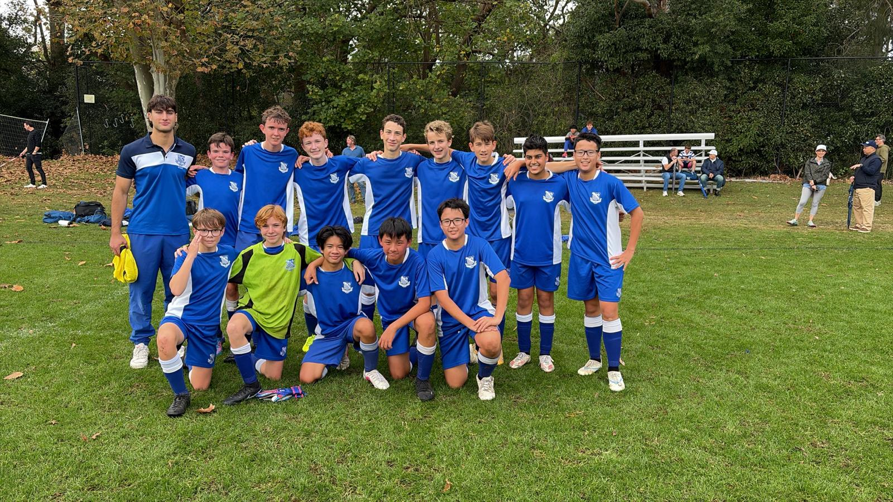

15C Match Report: Coach Cooper Sintras
The 15Cs battled hard in a competitive match against Grammar, showing great determination and resilience throughout the game. Patty Mills and Charlie Chow both found the back of the net with well-taken goals, helping the boys secure a valuable point against a strong opposition. The team worked hard for one another across the entire match and showed great character to remain composed under pressure. The result means the 15Cs continue their undefeated run so far this season, which is a credit to the effort and consistency the group has shown each week.

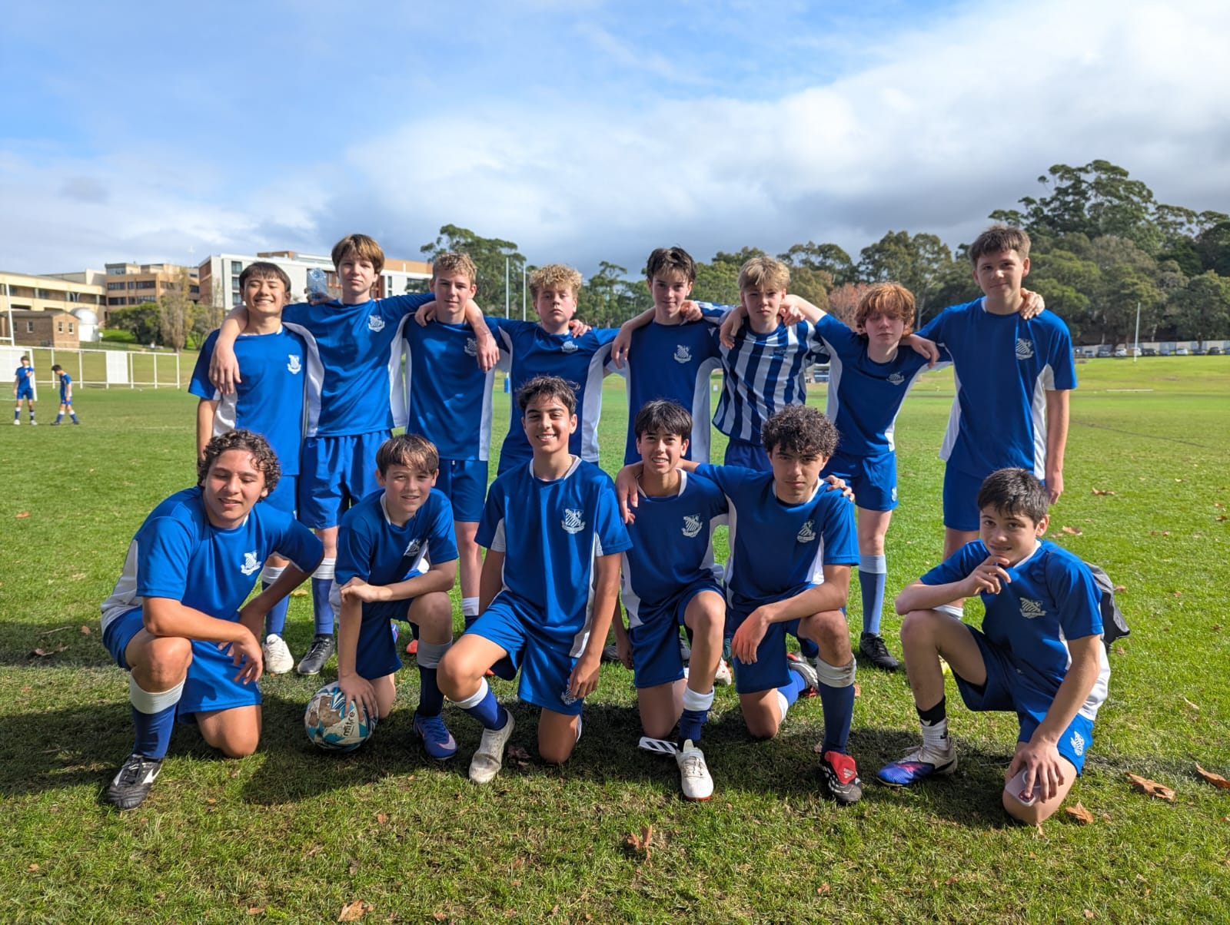
15D Match Report: Coach Alexander Mansfield
A tough result again for the 15Ds, who produced a very strong defensive performance throughout the match. The only goal conceded came after a misjudged bounce in the first half, which unfortunately also resulted in an injury to the goalkeeper. Despite the setback, the boys continued to work hard and created several good chances of their own but were unable to make an impact on the scoreline. The team also suffered another injury in the second half, making the effort and resilience shown by the group even more commendable. While the result did not go their way, the defensive commitment and determination displayed by the boys were positives to take from the match.

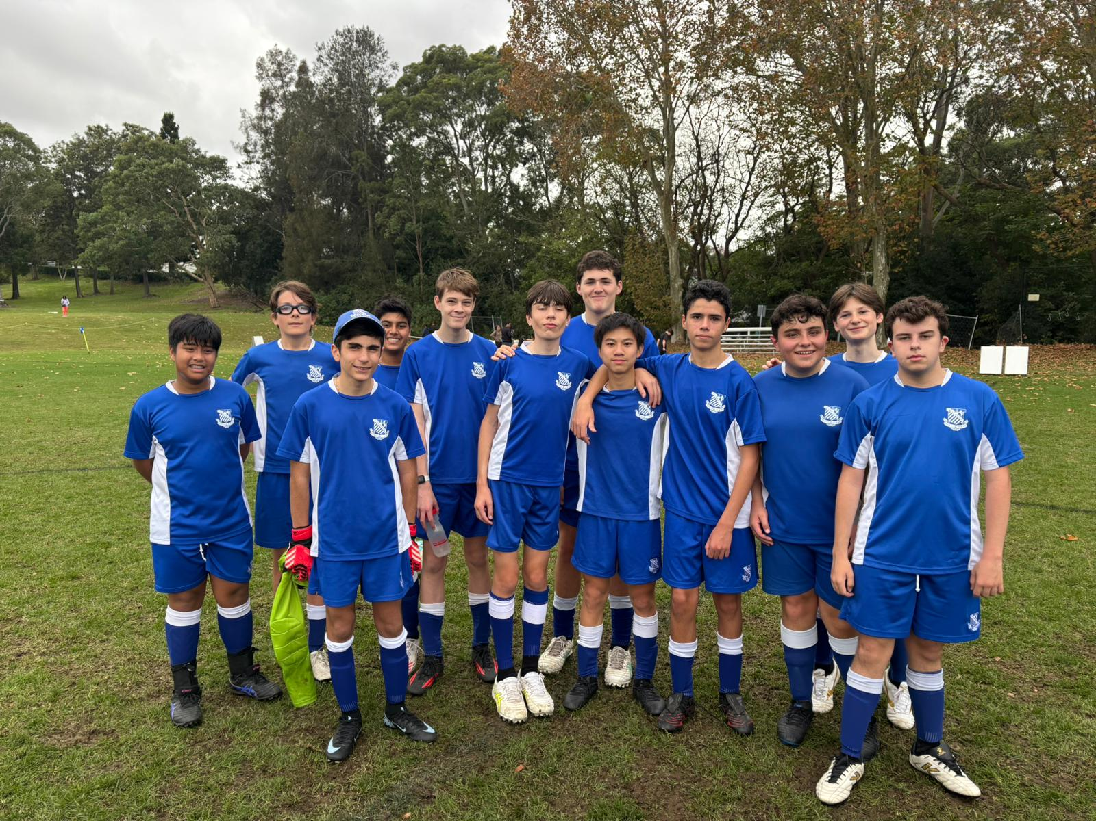
15E Match report: Coach Atticus Ireland
Great effort from the team. After starting off strong with a goal from Tom we fell behind quickly just before half time. After strong introspection at half time, the team came out energised and scored through two brilliant goals from Nick. Unfortunately, due to miscommunication, Grammar managed to snatch one back, and little time remained for us to respond. Full time: 3-3.

YEAR 10
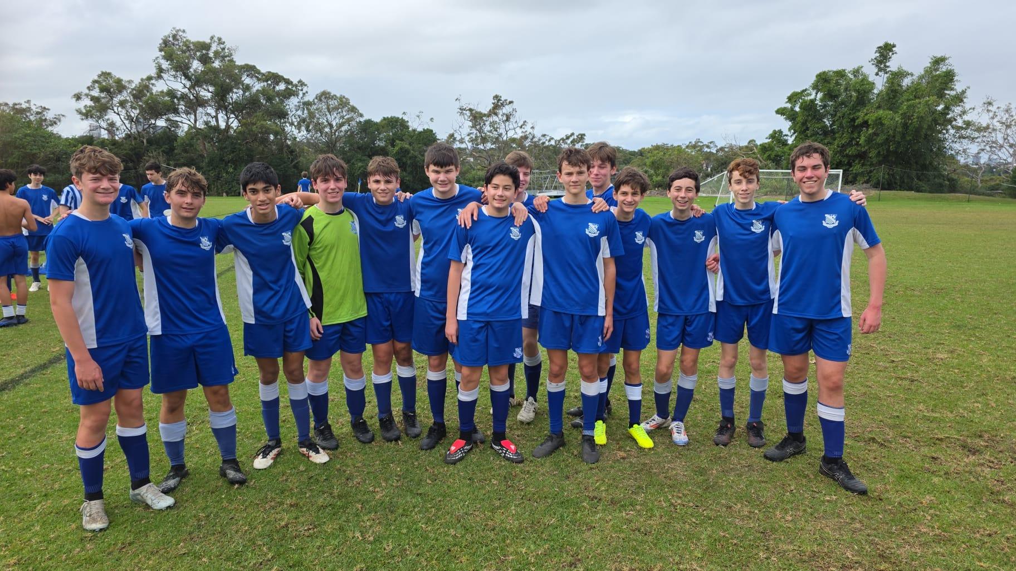
16D Match Report: Coach Jacob Stevens
We delivered an encouraging performance against Sydney Grammar, with the final score not reflecting how closely contested the match was. The team showed clear improvement and matched their opponents for much of the game. A major highlight was scoring our first two goals of the season. Defensively, we remained resilient and committed throughout. While the result did not go our way, the performance offers plenty of positives. The team will continue to work hard as we push toward securing our first win of the season.

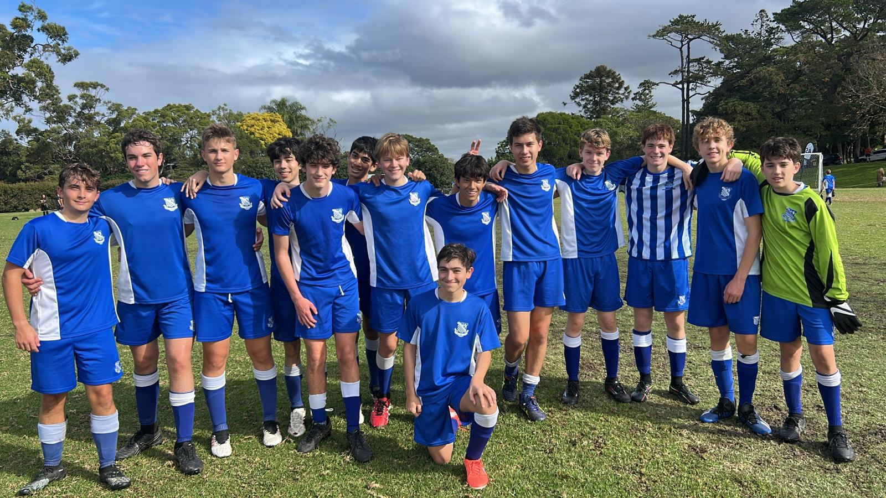

16C Match Report (no photo available): Coach Marcus Kulukovski
The 16C played Sydney Grammar school on the weekend in what was a fantastic match. The boys started on top with goals landing to Xavier O'Beid and Oscar Willis to put us up 2-0. The dominant display continued when Benny (D's Player) slotted one into the bottom corner to put us up 3-0. Sydney Grammar were able to get one late to make it 3-1. However, the boys would hit back quickly off the back of some lovely distribution from Bede Egerton-Warburton, with the goal scored by Nicholas Castagna. Sydney grammar scored one late to make it 4-2. Overall, another great win for the boys.
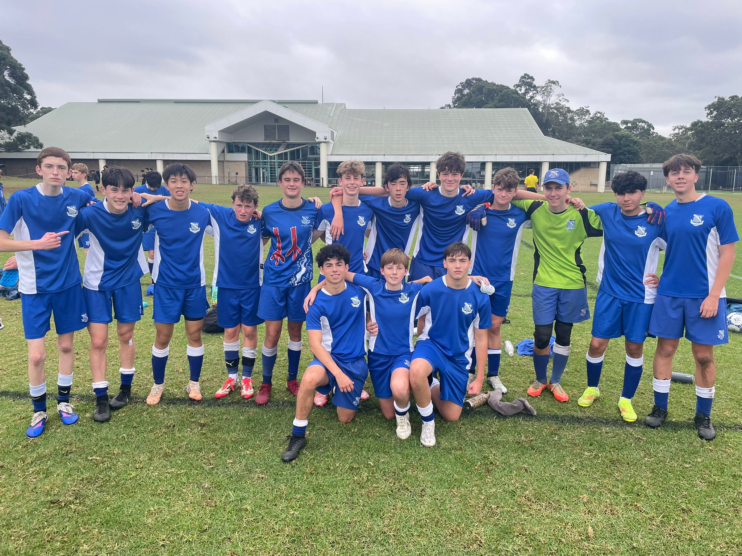
16B Match Report: Coach Stefan Visscher
The team suffered a heartbreaking 4–3 loss to Sydney Grammar School in an entertaining and hard-fought contest. Harvey gave the side the perfect start, scoring in just the 3rd minute, before SGS responded five minutes later to level the match. A soft penalty decision then allowed Grammar to take a 2–1 lead. The boys showed great resilience to fight back, with Bosco pressuring and tackling the goalkeeper to score an important equaliser. Abu later found the back of the net to make it 3–3 as the team continued to battle strongly throughout the game. Unfortunately, SGS scored in the final minute to steal the result. Despite the disappointment, there was plenty to like about the effort, intensity, and character shown by the team. The focus now turns to improving a few tactical areas at training ahead of next week.
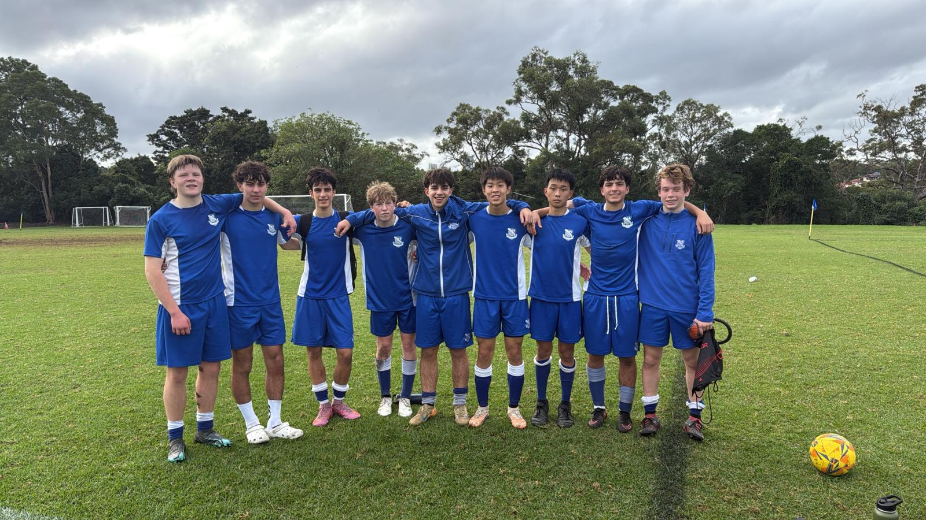

16A Match Report: Coach Stefano Rossello
The 16As recorded a strong 4–2 win against a solid Kings side. The match started sharply for the boys, who took an early lead through James Dart after some brilliant work allowed him to finish nicely. Once again, however, we allowed Kings back into the game through a set piece — an area that also hurt us the previous week. Some poor defending and a lack of bravery allowed Kings to equalise, and the teams went into half time locked at 1–1. The message at the break was clear: work harder and play more directly. The boys responded excellently at the start of the second half, with James Dart grabbing his second of the match after a beautiful through ball from Patrick Clugston. Shortly after, Luc Beasley got the goal he deserved, before an own goal forced by Bosco extended the lead to 4–1. Kings managed to score a consolation goal late on, but the game was largely controlled by the Riverview boys from that point onwards. Overall, there is still plenty to work on, but it was an excellent way to finish the trial period and a very positive performance from the team.

OPENS SQUADS
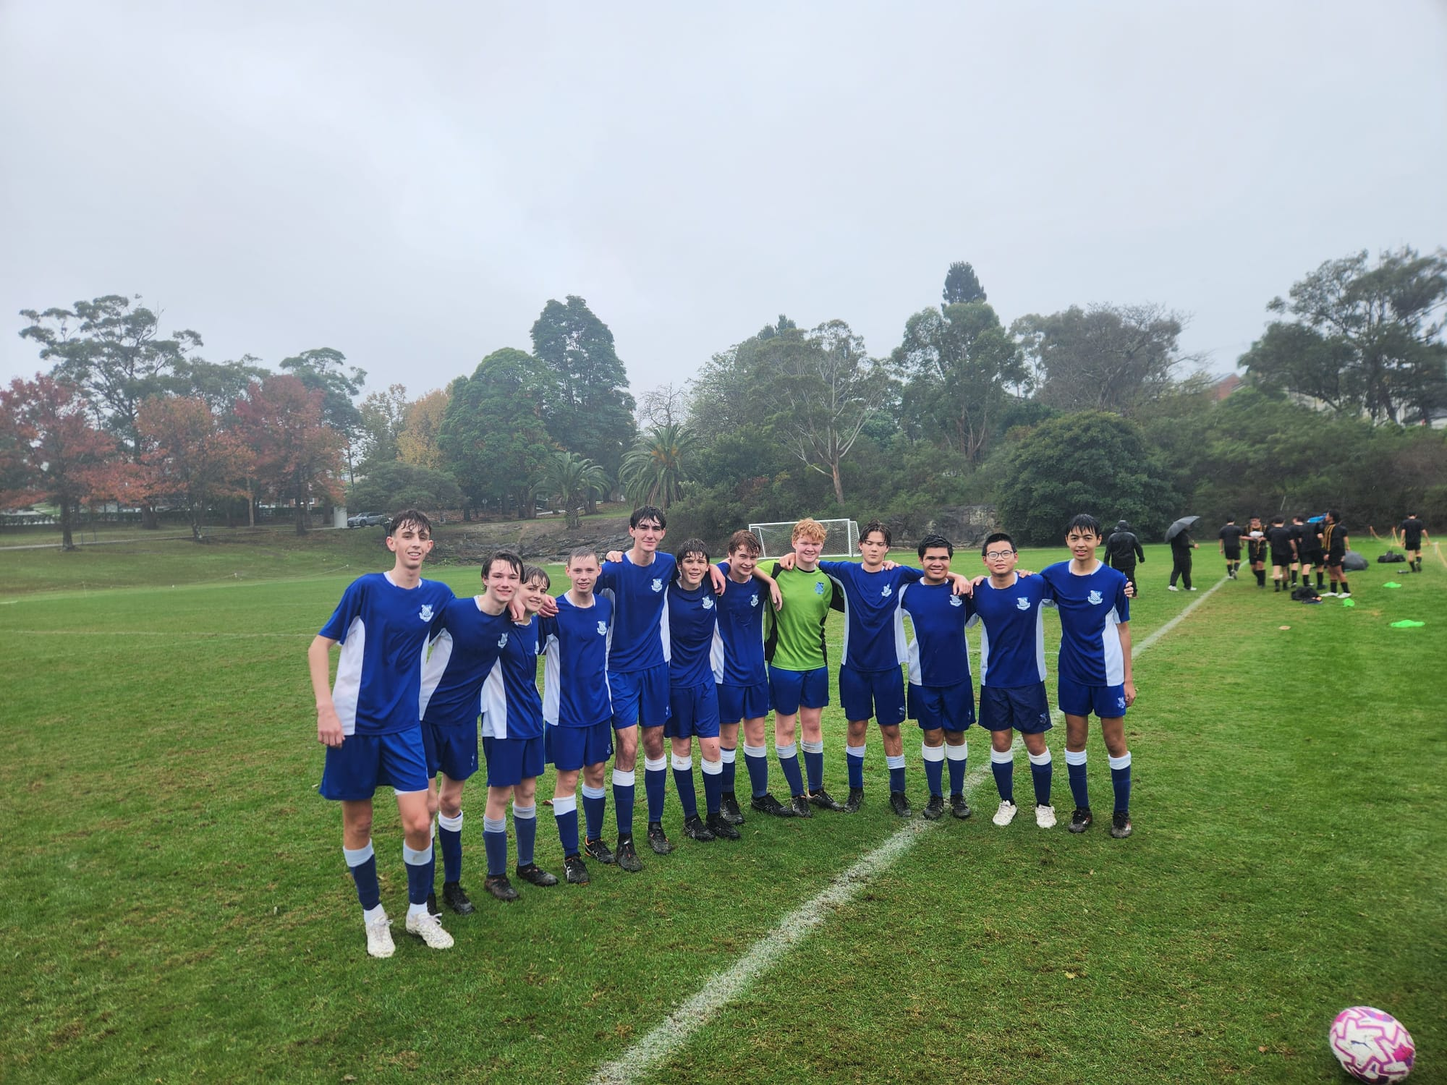
6th Match Report (no photo available): Coach Maximus Joosse
The 6ths took on Sydney Grammar School at home in tough conditions and produced a determined performance despite the final result. The first half was one of the boys’ strongest starts of the season, managing to withstand Grammar’s relentless attacking pressure while staying disciplined in defence. The team worked hard to capitalise on opposition mistakes and were rewarded with two well-earned goals, heading into halftime with momentum and confidence. The second half brought heavy rain and challenging conditions, with morale beginning to drop as fatigue set in due to minimal substitutions available on the bench. Unfortunately, a few moments of miscommunication allowed Grammar back into the game, eventually leading to four second-half goals. Despite going two goals down, the boys never stopped fighting and continued to put in effort right until the final whistle. The result did not reflect the determination and resilience shown throughout the match, and there were plenty of positives.
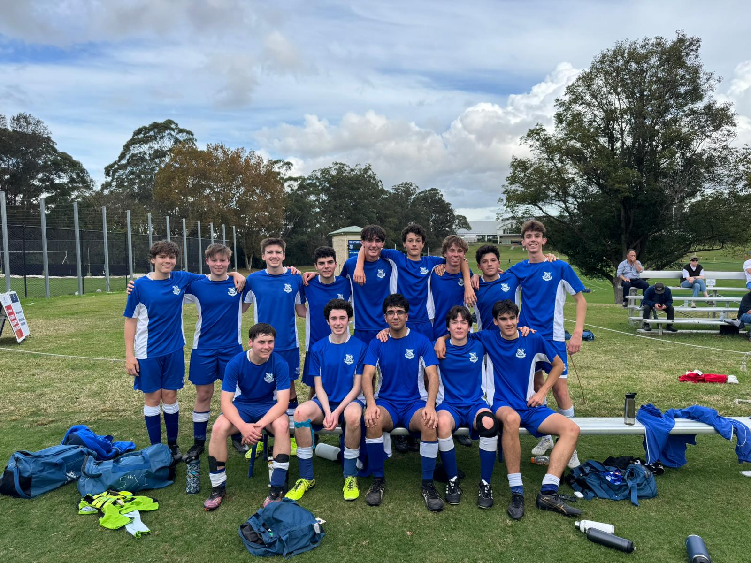
5th Match Report: Coach Jack Aman
A solid performance today from the 5ths. I felt we created the better chances throughout the game but unfortunately could not convert when it mattered most. Overall, we need to improve our ability to clear the ball from the box more effectively, but it was still a strong team performance and a great effort from all involved.

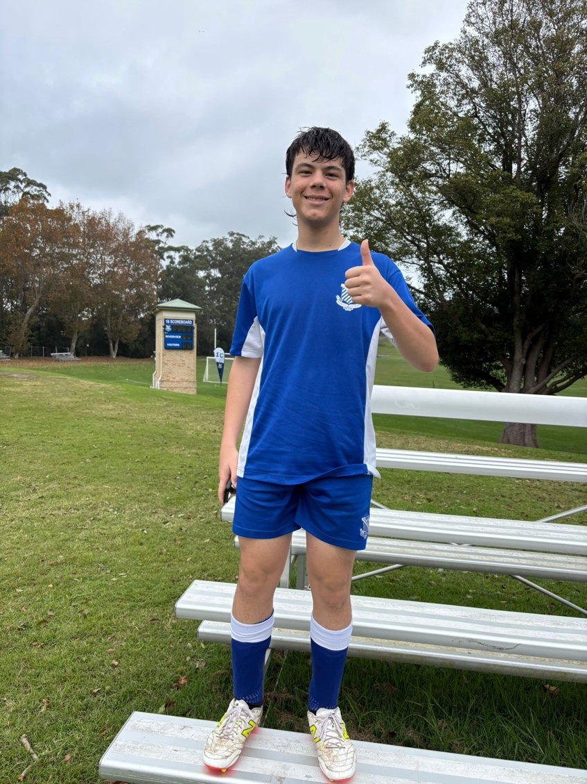

4th Match Report: Coach Gabriel De Haast
Grammar opened the scoring early on, and the boys did well to head into half time without conceding another thanks to some excellent saves from borrowed goalkeeper Oli Jones. At the break, the plan was simple: break down their defence by using the wide areas more effectively. The lads started the second half strongly, and captain Jack Stanic managed to place a composed finish past the goalkeeper to make it 1–1. With all the momentum seemingly in our favour, the boys were rolling until the Grammar winger won a penalty after going down theatrically in the box, which he converted to make it 2–1. The boys never gave up and created several close opportunities late in the game but unfortunately could not find the equaliser before the final whistle. A 2–1 loss with plenty to improve on, but overall, a strong effort from the team.

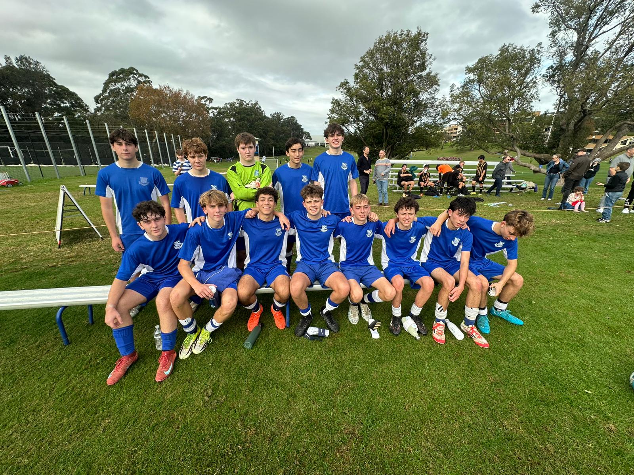
3rd Match Report: Coach Andrew Ferrara
The Thirds drew 1–1 with Sydney Grammar in a disappointing result. In the first half, we fell into their style of play and were far too direct, which led to constant transitions. Whilst we created a few half chances, we were unable to convert them. In the second half, we looked to improve this and had periods where we kept the ball much better. We eventually went 1–0 up through a fantastic solo dribble and finish from Brendan. However, with three minutes remaining, we conceded after failing to clear the ball. A few key areas for improvement for the team are our physicality and positional play, as we were too often drawn towards the ball instead of maintaining our structure.

