
Riverview Football Program - Match reports Saturday 10th, May 2026
YEAR 7

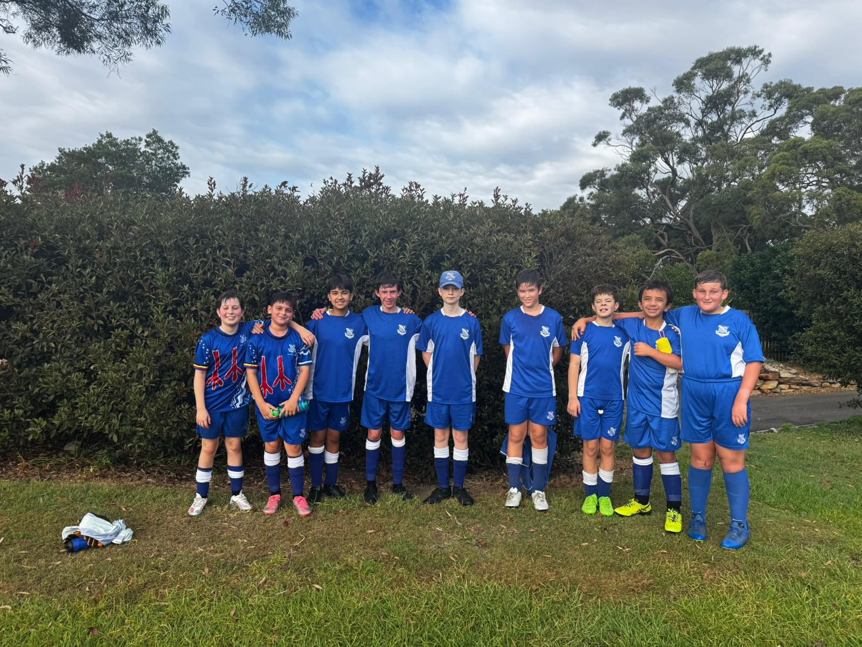
13F Match Report: Coach Sam Burkitt
The boys made an excellent start to the season, showing great character in challenging circumstances. With only 10 players available against a well-resourced Shore side of 14, the team demonstrated resilience, determination, and a strong collective spirit throughout the match. Despite conceding early, the players maintained a positive attitude and continued to work tirelessly for one another. Their effort and willingness to compete never dropped, and the team’s morale remained high from start to finish — a strong reflection of their commitment and mindset. Several players delivered standout performances, with Toby Thistlewood and Evan O’Neil particularly influential. Both contributed significantly with their work rate and impact on the game. Toby’s commitment was further highlighted as he stayed on after the match to support the E’s team, demonstrating excellent team-first values. Overall, it was a very encouraging first performance of the season, built on effort, resilience, and a positive team culture.
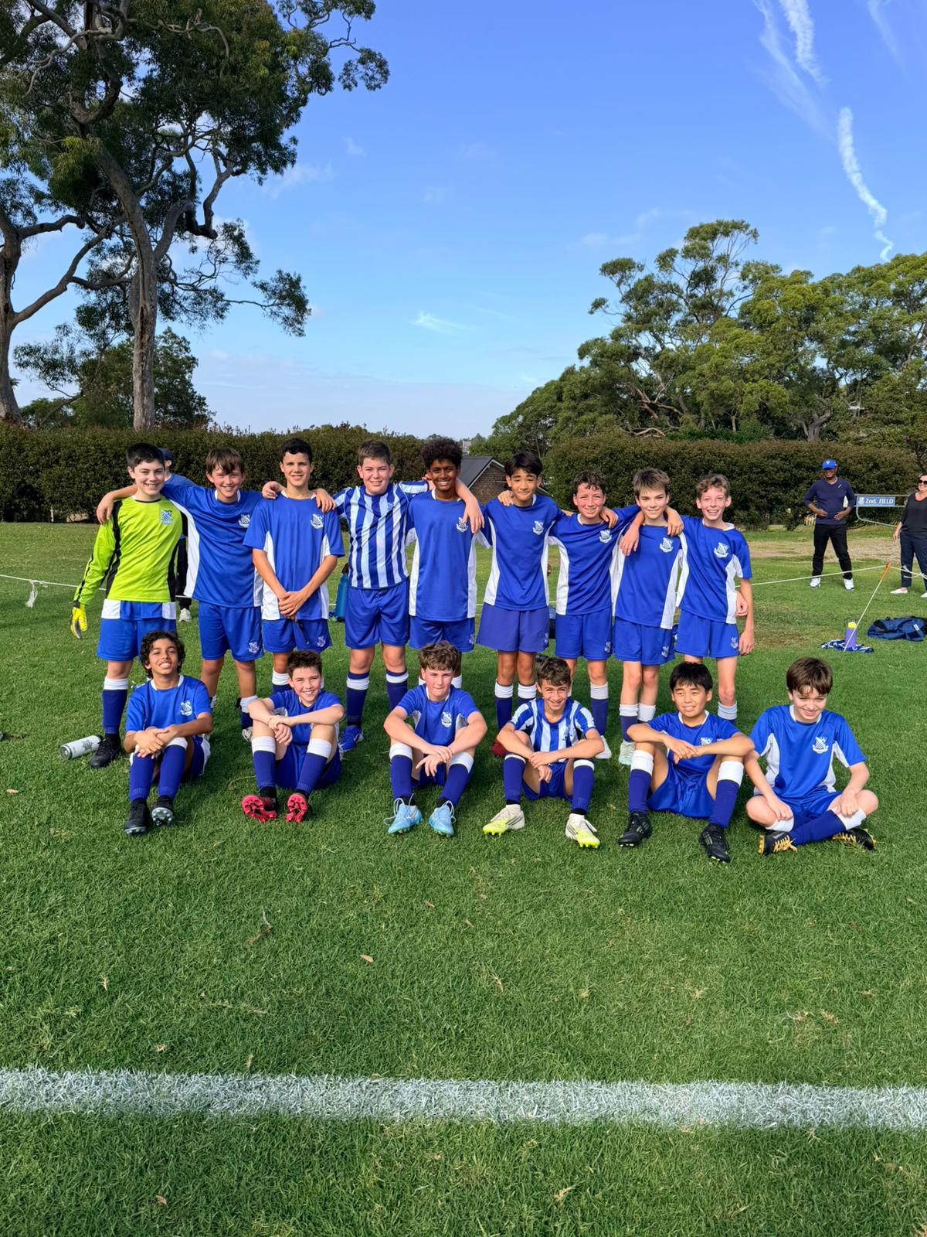
13E Match Report: Coach Michael Portale
The boys delivered a very strong performance, and it was great to see the reward with a 3–0 victory. The result reflected the team’s growing cohesion, with clear signs of strong teamwork and organisation throughout the game. Defensively, the group was disciplined and well-structured, maintaining their shape and limiting opposition opportunities. Going forward, they showed good composure and efficiency, taking their chances well when they arose. There is still room for improvement, particularly in making quicker decisions on the ball and maintaining concentration consistently across the full duration of the match. These are important next steps as the team continues to develop. Overall, this was a very solid and encouraging performance, highlighting both the team’s progress and potential.

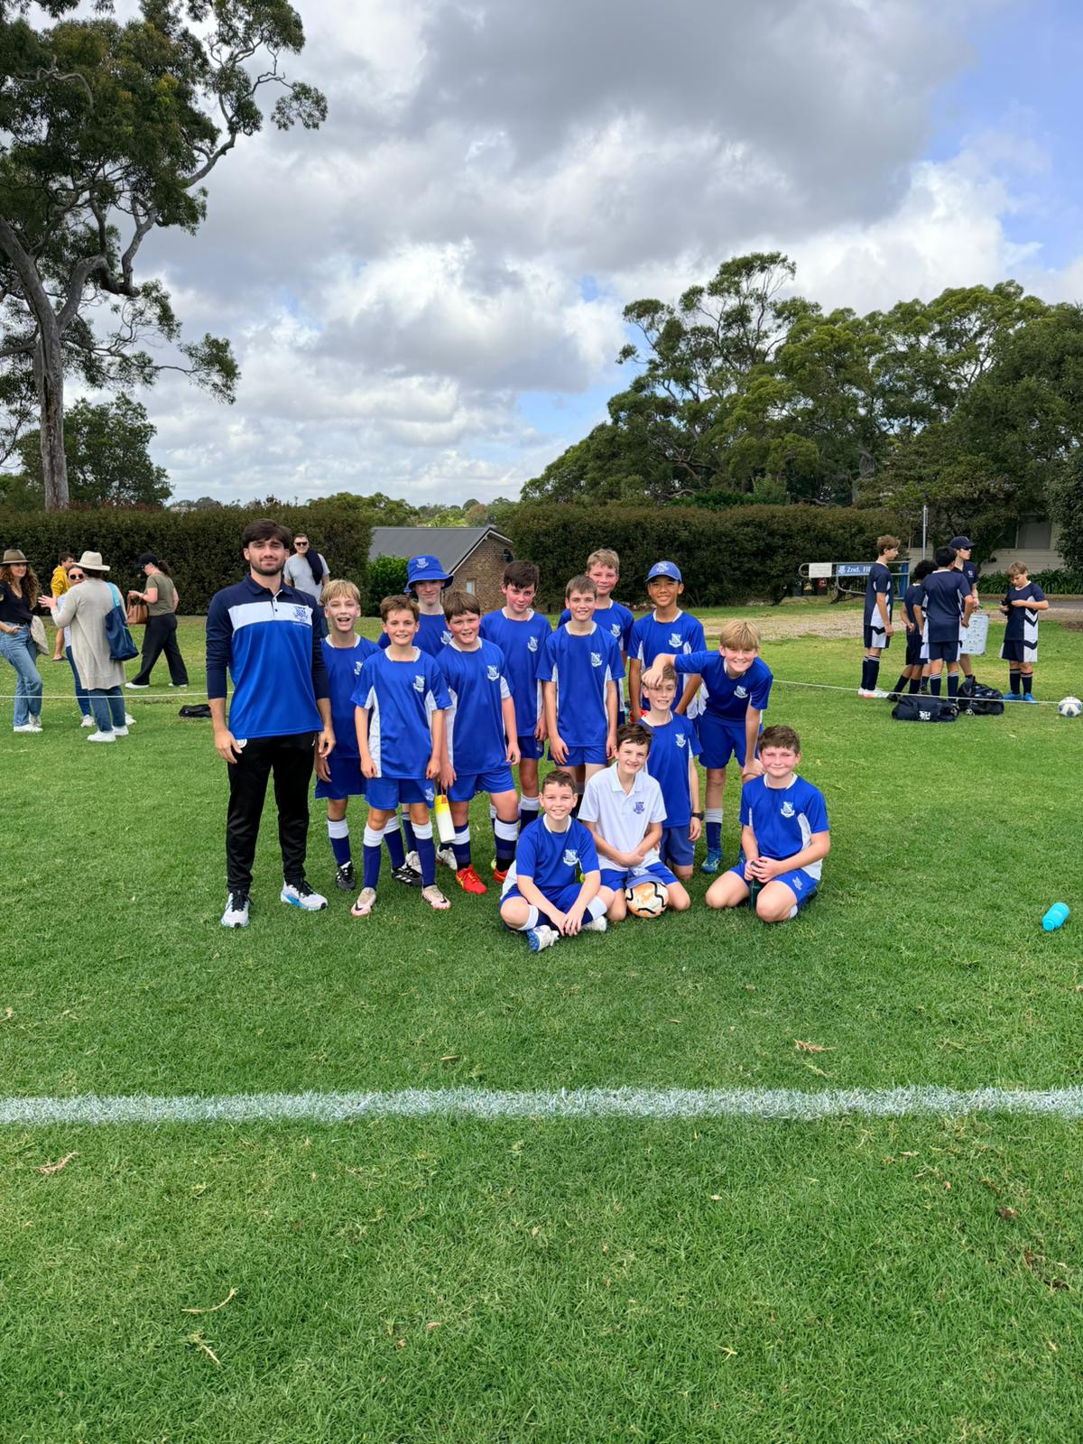
13D Match Report: Coach Michael Portale
It was a tough result Saturday, but there were still several positives to take from the performance. The boys showed good effort and commitment, working hard for one another throughout the match. At times, the team demonstrated their ability to play well, moving the ball effectively and creating some promising chances. These moments highlighted the potential within the group when they are composed and connected. Moving forward, there are clear areas for development. Communication on the field needs to improve, along with maintaining better defensive organisation. In addition, sustaining focus for the full duration of the match will be key to turning performances into positive results. These are aspects we will continue to work on during training. Despite the result, this was a valuable learning opportunity for the team.

13C Match Report (no photo available): Coach Nelson Meehan
The 13C’s had a great win over shore for their first game of the season. Riverview conceded a very early goal but were able to get their heads back into the game and make it level soon after. The rest of the half saw a number of incredible saves from the man of the match James Finch to keep Riverview in the game. The second half saw Riverview working hard defensively to keep shore away from the goal as well as a number of good scoring opportunities from the likes of Ethan Bennet. The Home side scored another great goal from a fantastic run and ball through to make it 2-1 however soon after conceded one back to take it level again. A great run and shot on goal from Ethan Bennet left the ball dribbling towards the goal where Toby Danzinger finished the play off to secure the third goal. From there the Riverview team held on defensively with more great efforts from everyone. A great start to the season.
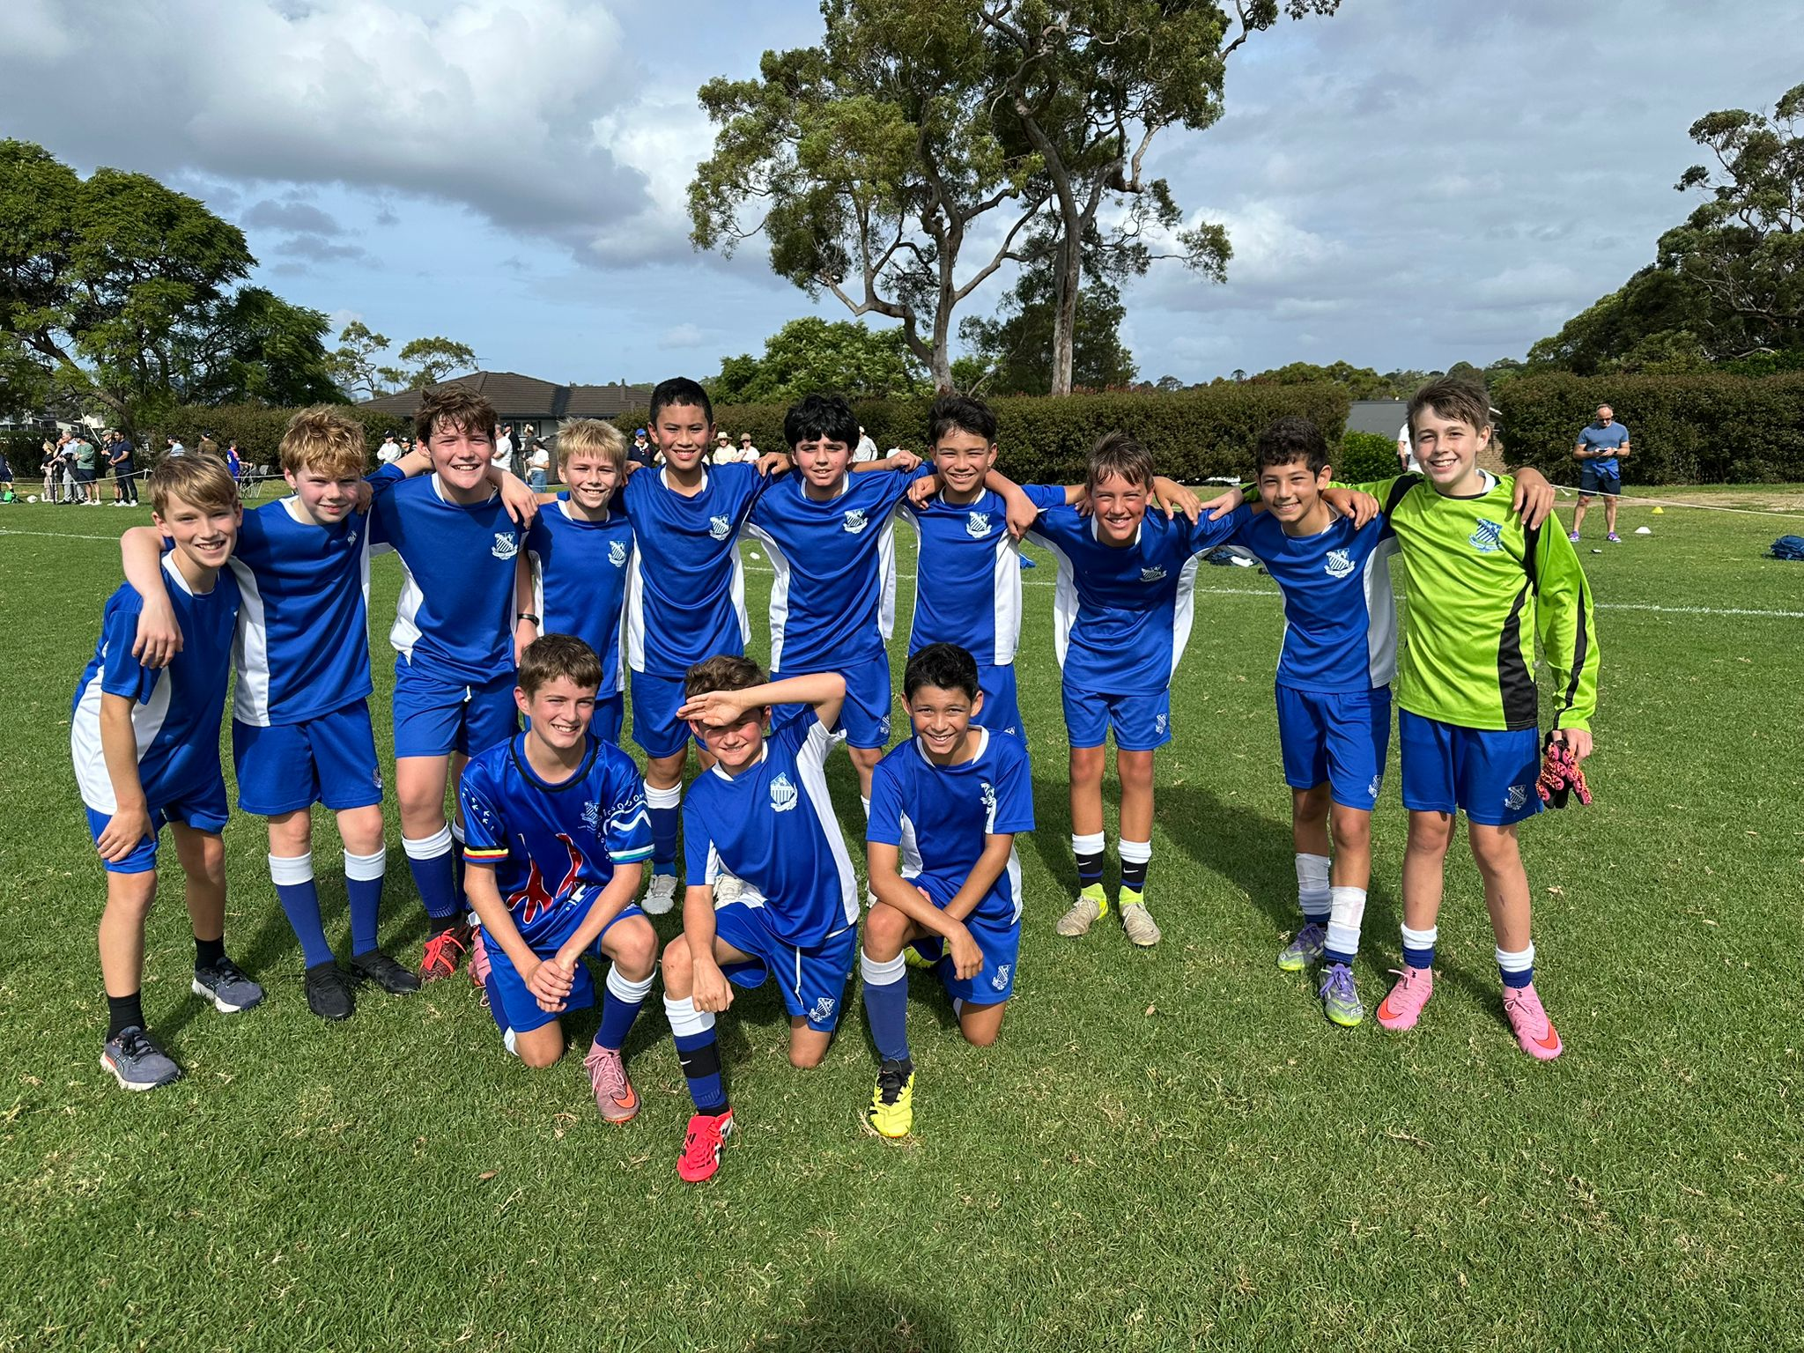
13B Match Report: Coach Josh Engelmann
The 13B's were excited to play their first trial match of the season and it showed. With St Ignatius producing a dominate 7-0 win over Shore. St Ignatius would start off quick winning a penalty. It narrowly missed off the post, but Alastair was quick with the follow up and making 1-0. However, the 13B's weren't done. shortly after Darcy would make it 2-0 with a brilliant strike into the bottom corner. Quickly after Charlie then make it 3-0 with some brilliant dribbling in the box. Half time came around and the boys were still hungry for more goals. Darcy would open the scoring with two in quick succession giving himself hat-trick. Riverview continued with Xavier getting on the scoresheet with a long-driven shot outside the box and Charlie would grab the last one goal of the day before the final whistle. Riverview put on a strong performance with plenty of positives.

13A Match Report (no photo available): Coach Lewis Morsella
It was a challenging game for the boys over the weekend, and the result did not go our way. At times, the team found it difficult to build strong cohesion, which impacted our overall performance. There were, however, some positives to take from the match. The boys worked to create a number of good scoring opportunities, showing what they are capable of when they play with confidence and composure. As we move forward, there are a few areas we will continue to develop in training. These include strengthening our defensive organisation, building clearer communication across the team, and maintaining a positive and resilient mindset throughout the game — particularly when facing difficult moments. This match provides a valuable learning opportunity, and the focus now is on continuing to grow as a team. With a strong week of training, we are confident the boys will respond well in the next fixture.
YEAR 8
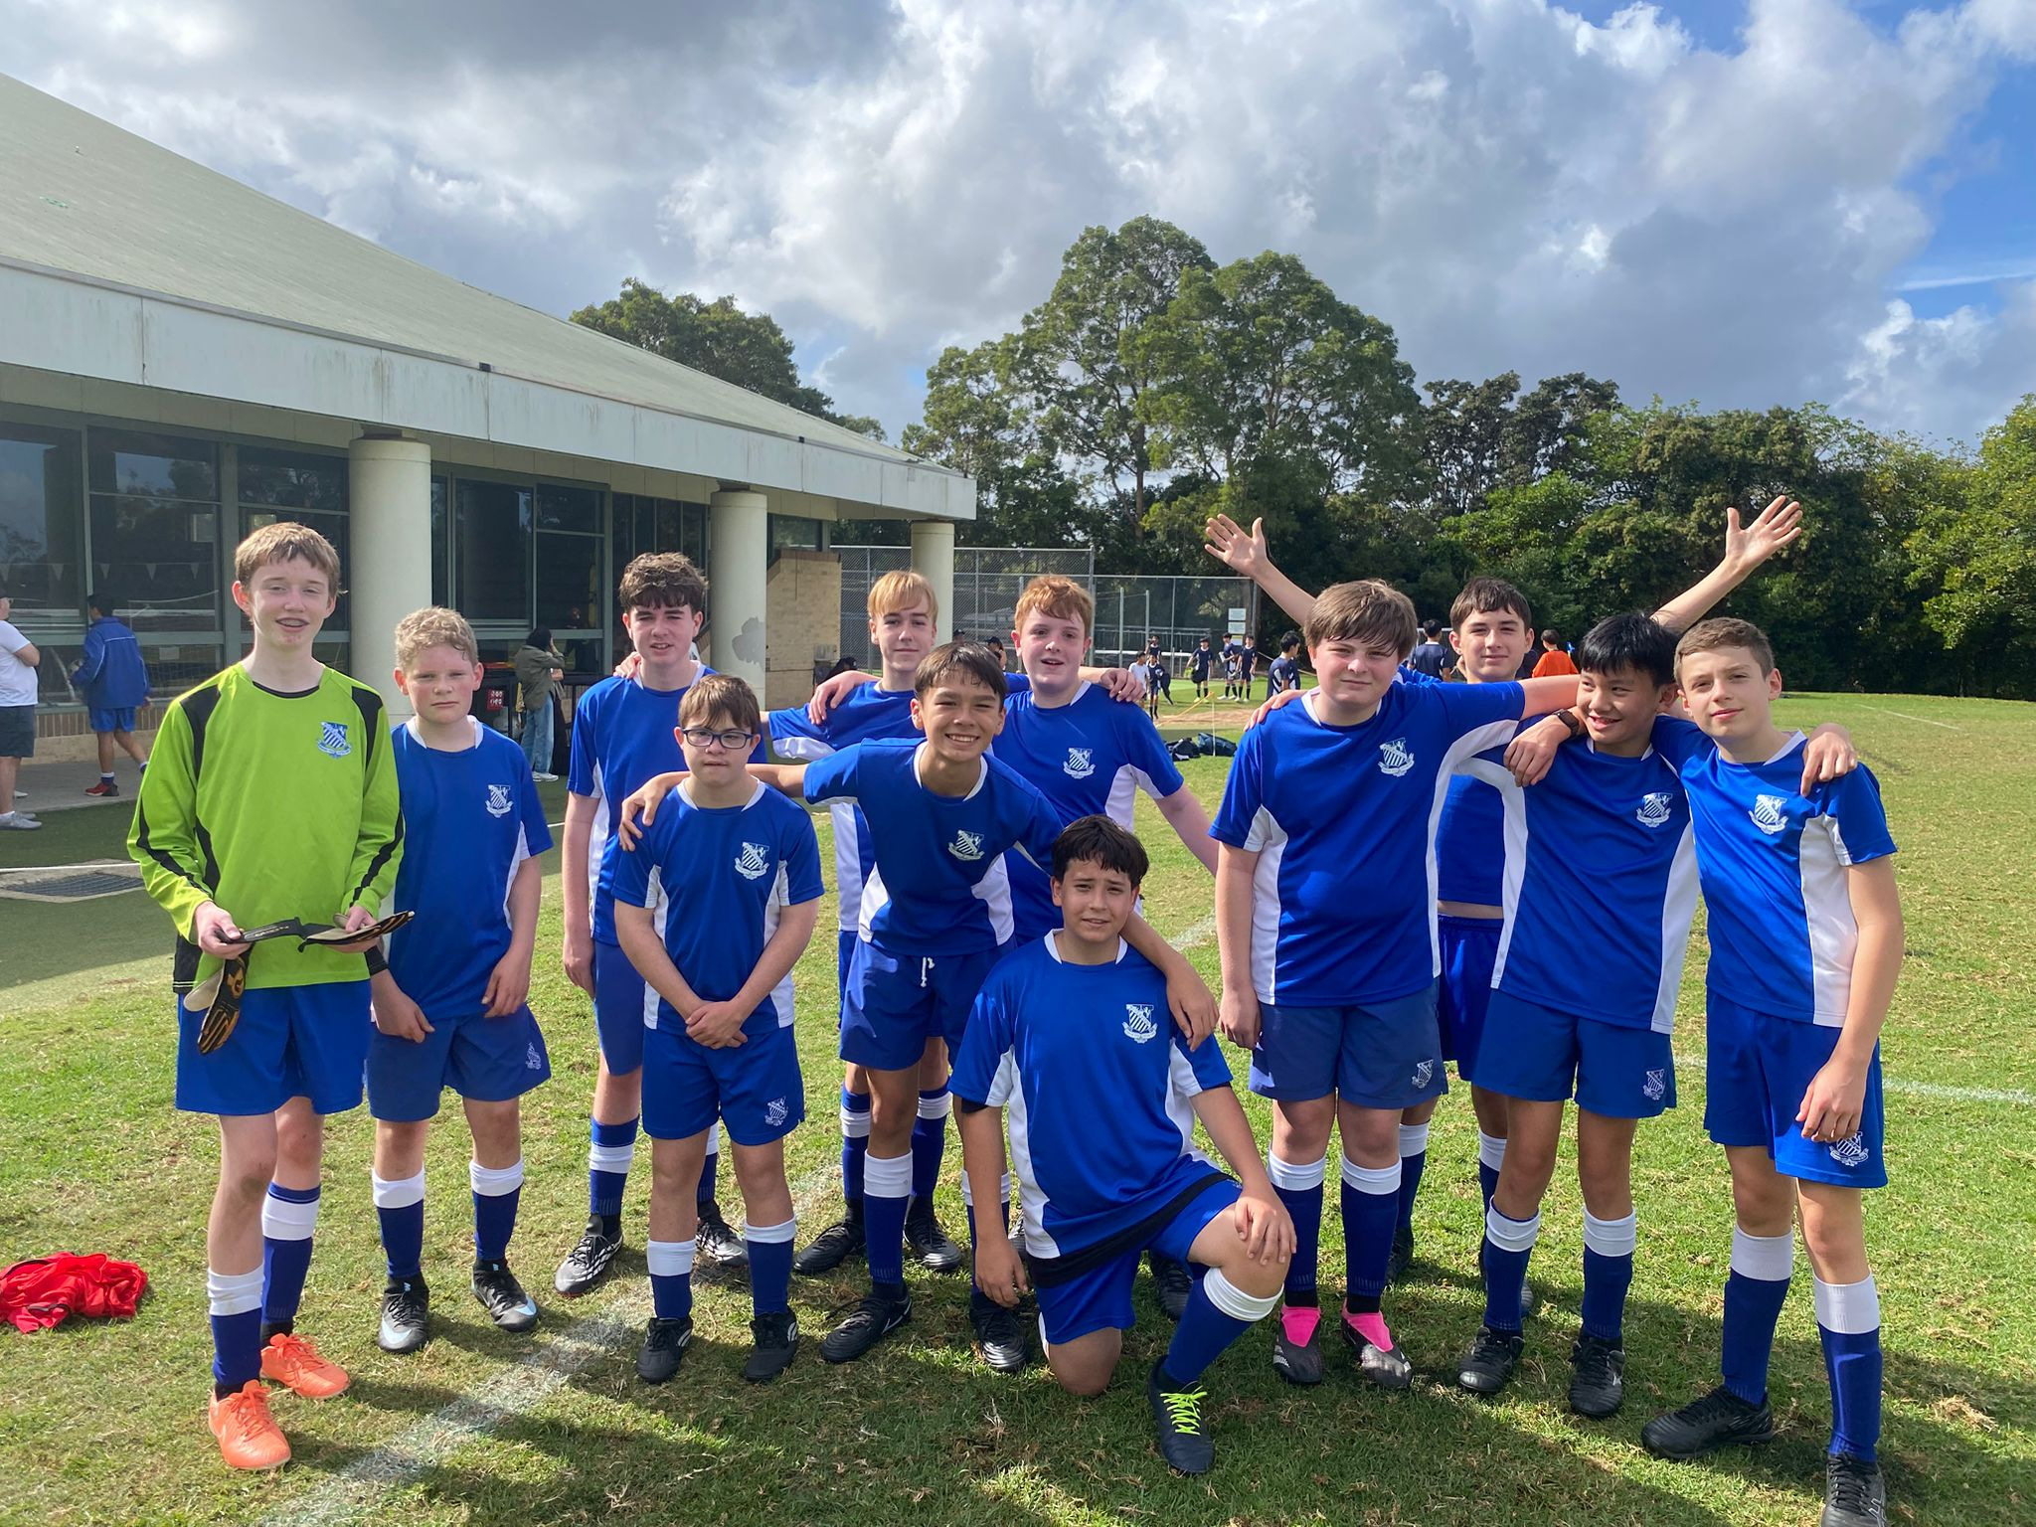
14D Match Report: Coach Matthew Chung
St Ignatius’ U14 Ds faced a strong Shore side this weekend, with the match ending in an 18–0 result. Shore displayed a high level of organisation, skill, and composure throughout, which tested our team both defensively and when in possession. To the boys’ credit, they continued to show effort and resilience across the full match. The back line of Scott King, George Palmer, Hamish Munnelly, and Angus Healy worked hard under sustained pressure, doing their best to contain Shore’s attacking play. In midfield, Sam Cleary, Byron Hunt, and Flynn Nolan covered significant ground and remained committed in supporting both defence and transition. In goals, Fergus faced a constant challenge but showed determination and courage, continuing to compete and make important saves right through to the final whistle. While the result was a difficult one, there are clear positives in the team’s attitude and effort. It’s still early in the season, and this experience provides a valuable opportunity for learning and growth as we continue to develop as a group.

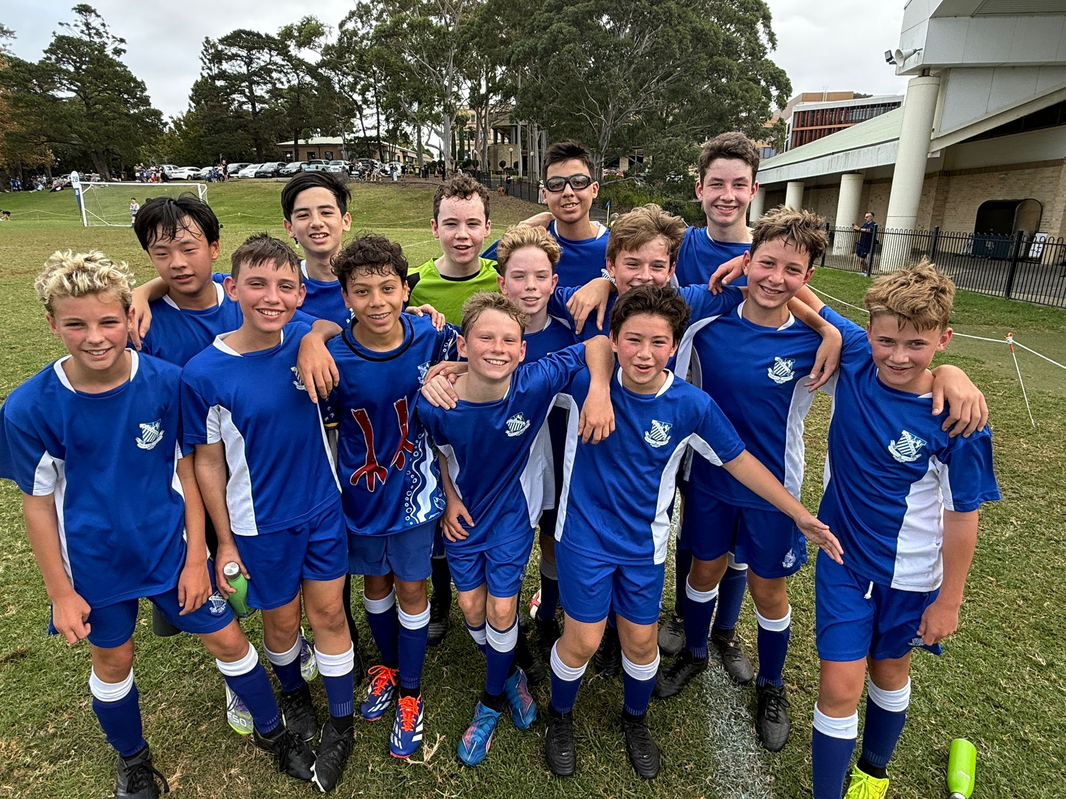
14C Match Report: Coach Domenico Garreffa
St Ignatius secured a hard-fought 2–1 victory over Shore in their U14C clash, delivering a disciplined and well-rounded performance across the pitch. The difference came through Charles McDonald, who scored both goals with composure and attacking quality, finishing his chances with confidence at key moments in the game. Ignatius looked composed throughout, building play effectively from the back and maintaining a strong defensive structure. Central defenders Michael Coorey and Alex Gontarczyk were outstanding, forming a reliable partnership that dealt well with Shore’s attacking threats through their positioning, communication, and composure. In goal, Archer Branson provided a calm and dependable presence, making important interventions when required and helping to limit Shore’s opportunities. It was a strong team performance, combining attacking efficiency with defensive resilience to secure a well-deserved win.
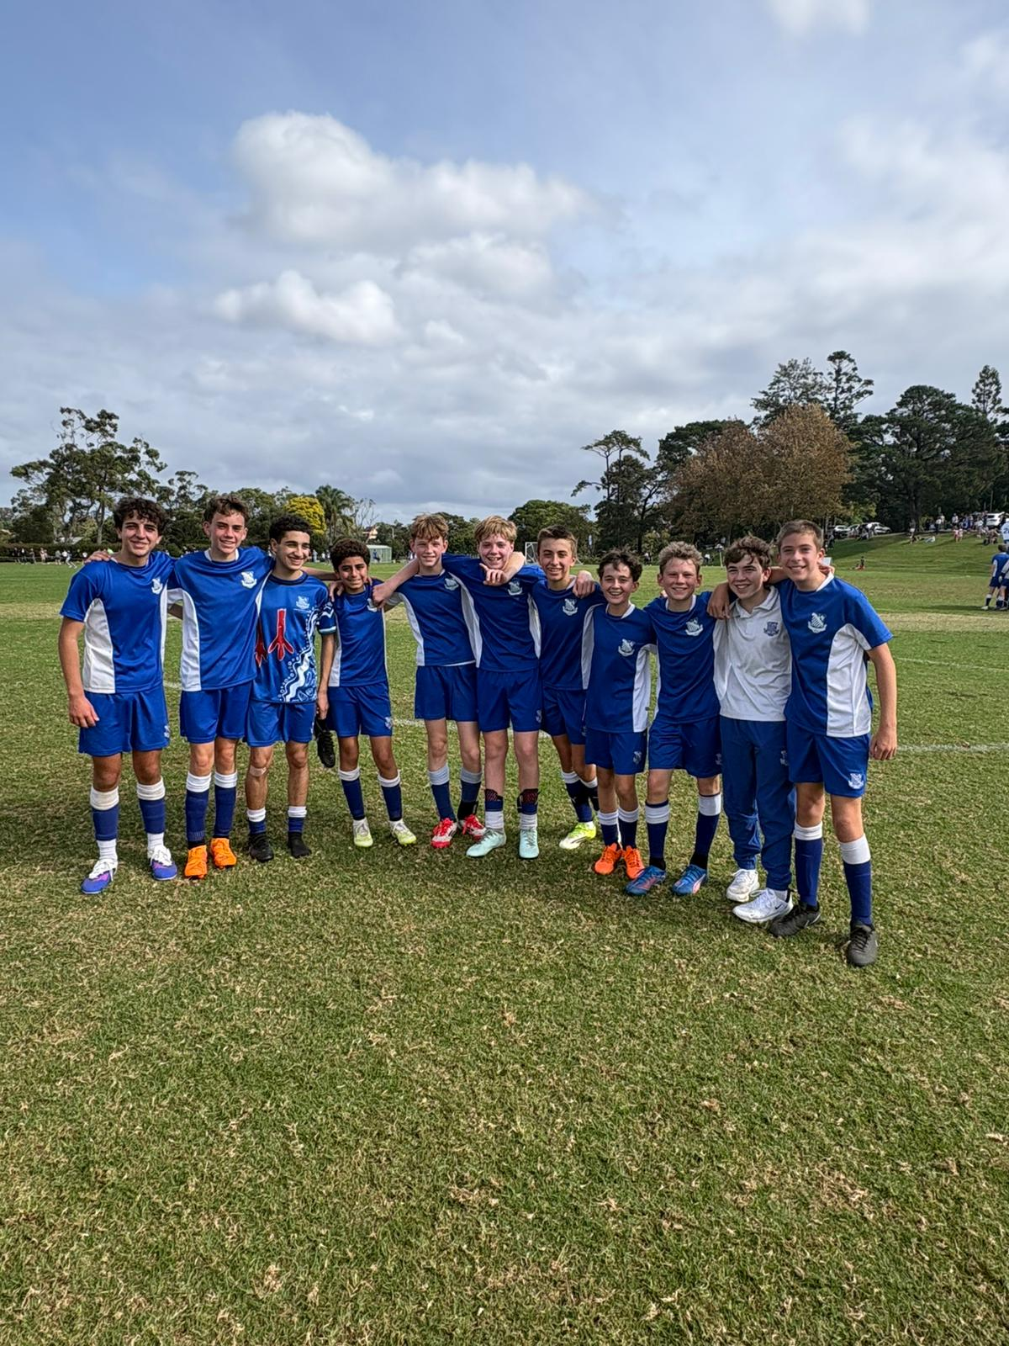
14B Match Report: Coach Lachlan Iacono
The 14B’s started with a few injuries including Xavier Salameh and Ollie Thistlewood. We began the game in high spirits, quickly crushed by Shore scoring within the opening minutes of the game. We had multiple chances going forward from the likes of Noah Gatt and Girgis, as well as a few promising opportunities from Nick Triggs. Besides the first slip up, our defence in the likes of Dan Musso, Will Moult, Matteo Scardilli and Hugo Brabant. We went into the half 1-0 down with hopes for a more energetic second half. We came out firing with a few close chances created by Javier and Elliot in the middle. Nearing the end of the game we had a corner perfectly executed by Javier, with Will Moult getting on the end of it to make it 1-1. A few more chances within the last minute and a close call by Nick Triggs, but we were fine to walk away with a 1-1 draw.
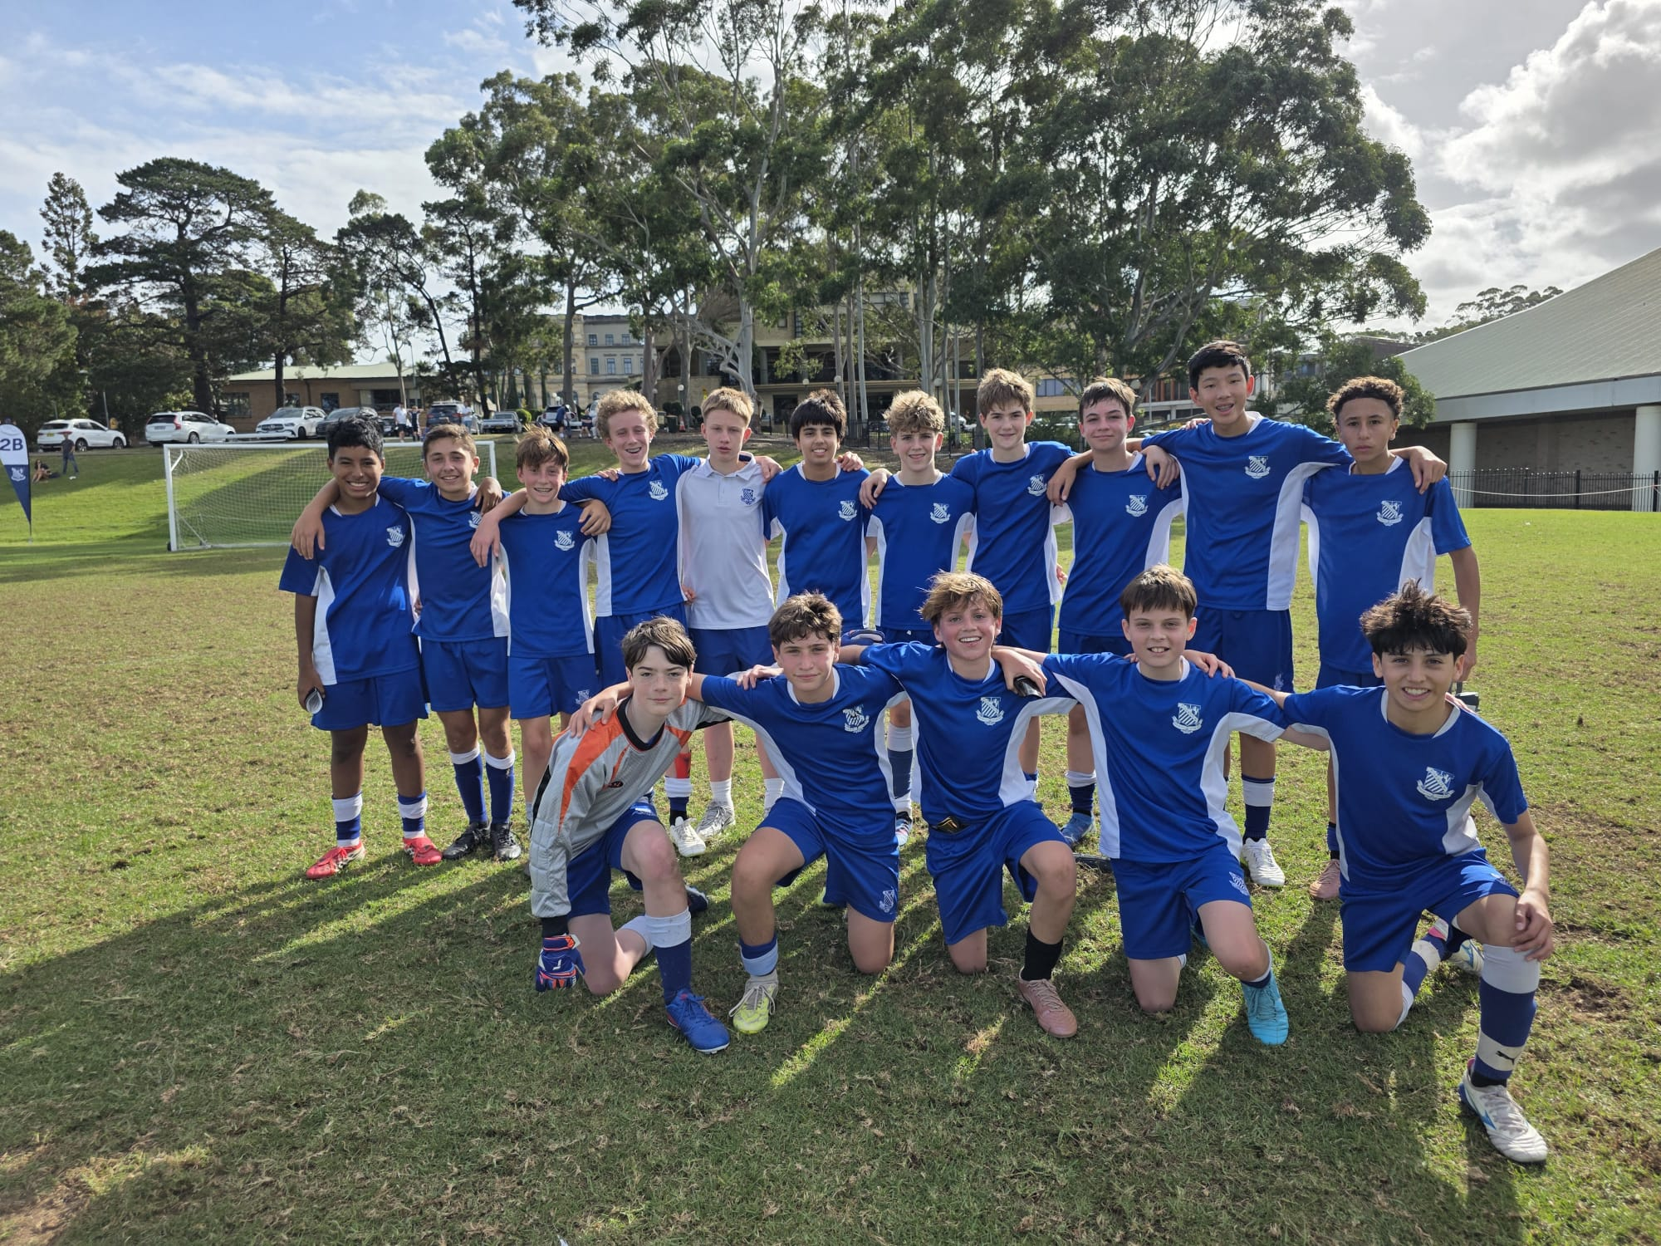

14A Match Report: Coach Domenico Garreffa
St Ignatius edged out Shore 4–3 in a thrilling 14 A’s clash, with the contest evenly poised from start to finish. It was a fast, end-to-end game, with both sides trading goals in a match that could have gone either way. Leo Stevens was outstanding and deservedly named Man of the Match, leading the attack with energy and composure. Jack Watson scored twice, including a well-taken penalty after David Raphael won the foul. Raphael also delivered the decisive moment, netting the match-winning goal to seal it. Special mentions go to Archie Crothers and Algernon Marchant for their strong contributions, helping maintain intensity throughout. St Ignatius looked sharp going forward, creating plenty of chances, while still building defensive cohesion. It was a hard-fought and exciting win, showcasing both attacking quality and resilience.
YEAR 9
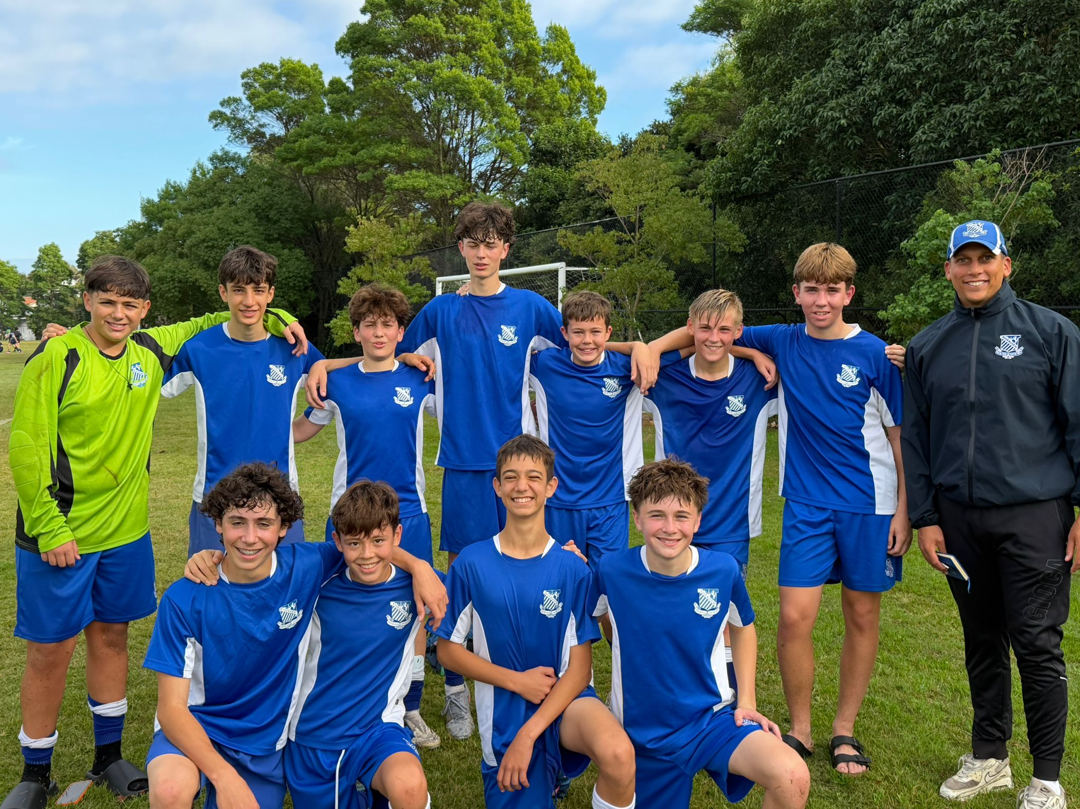
15A Match Report: Coach Travis Cooper
We endured a very difficult start away at Shore, conceding within the opening 10 seconds and quickly finding ourselves 2–0 down. Despite this early setback, the boys showed excellent character to respond, gradually working their way back into the contest and taking a 3–2 lead. The first half remained open and end-to-end, eventually finishing 3–3. At halftime, we reinforced our key messages around structure, composure, and how we wanted to approach the second half. The response after the break was outstanding. Defensively, we were far more organised and disciplined, keeping Shore scoreless in the second half. In possession, the team played with greater clarity and intent, taking control of the game and capitalising on our opportunities. Our attacking play was clinical, with five additional goals sealing an impressive 8–3 victory. Noah led the line superbly, finishing with a well-earned hat-trick and providing a strong focal point in attack. The second-half performance in particular reflected the quality, resilience, and mindset we are looking to build within this group.
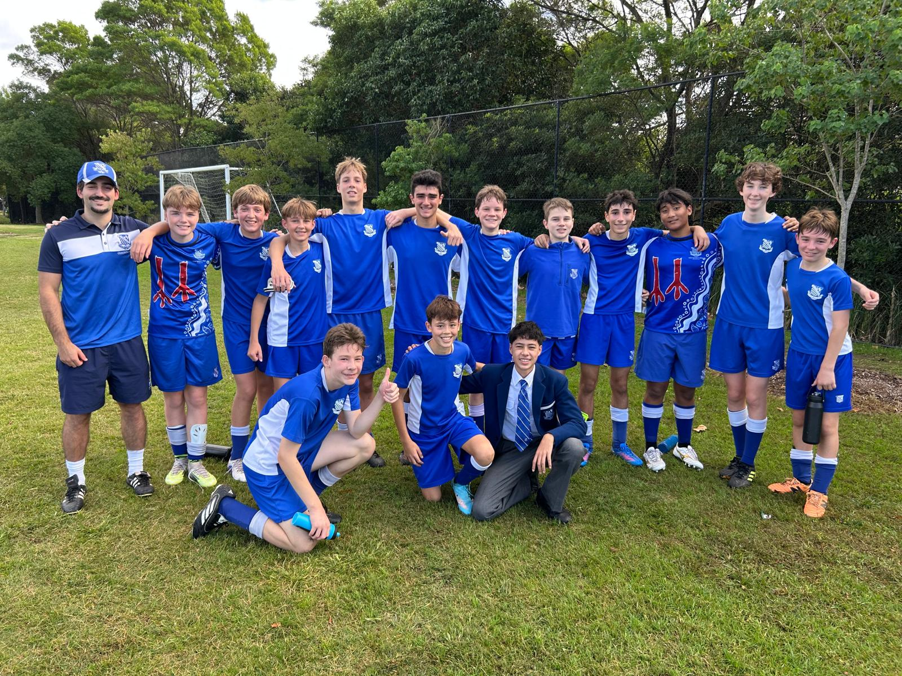
15B Match report: Coach Jonathan Codemo
The 15B’s delivered an excellent performance against Shore, showcasing a strong understanding and execution of key tactical principles throughout the match. Their structure and discipline allowed them to control the tempo effectively, applying consistent pressure while maintaining possession in important areas of the pitch. The team’s attacking play was highlighted by three well-taken goals, each reflecting both individual quality and collective teamwork. Lachlan N produced an outstanding long-range strike, while Ben T showed great composure to finish confidently across goal. These moments underlined the attacking intent and confidence the group brought into the game. Defensively, the team was equally impressive. Finn, Lachlan G, Will C, and Luke D led a committed and organised backline, working cohesively to limit the opposition’s opportunities. Their positioning, communication, and determination were key factors in maintaining control of the match. Overall, it was a dominant and well-rounded performance, demonstrating both strong tactical awareness and a positive team mentality.
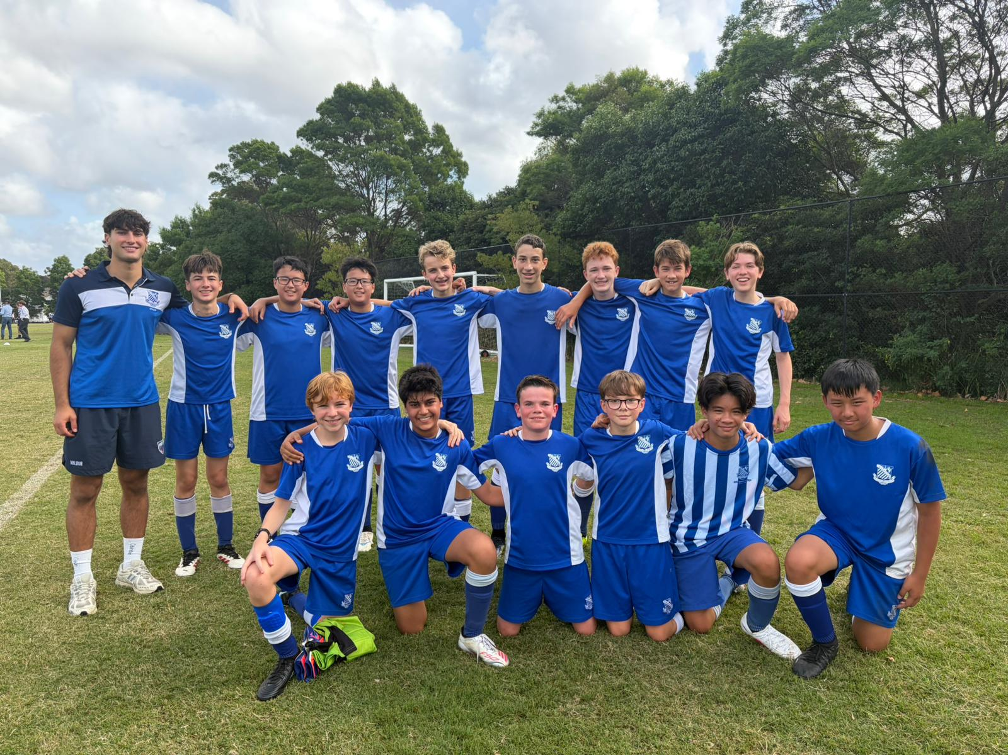
15C Match Report: Coach Cooper Sintras
The boys were very sharp from the opening whistle, starting the game with strong intensity and intent. Their early pressure set the tone for a dominant performance throughout the match. A hat-trick from Man of the Match Finn Hutchins, along with a well-taken brace from Patrick Mills, secured a comfortable 5–0 victory for the 15C’s. Both players showed excellent composure in front of goal and were clinical when chances presented themselves. Overall, it was a strong team performance built on energy, focus, and attacking efficiency, with the group maintaining control of the game from start to finish.
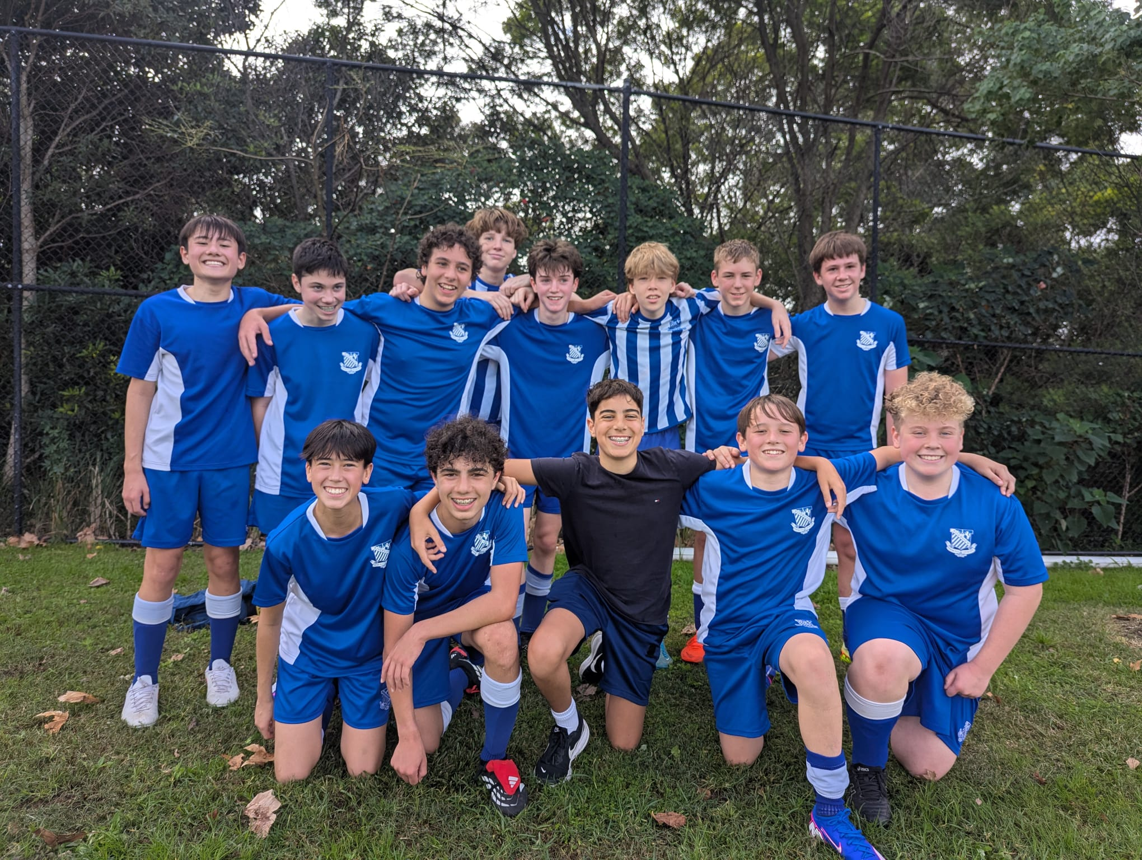
15D Match Report: Coach Alexander Mansfield
A very positive start to the season saw the 15D’s deliver a commanding 8–0 victory away from home. The team-controlled possession throughout and set the tempo of the match with confident, forward-thinking play. Their unity on the pitch was evident, with players linking well in attack and consistently supporting one another across all areas of the field. Alfie Mannassen was the standout performer, scoring an excellent hat-trick from his central attacking midfield role and influencing the game with his creativity and movement. Additional goals came from the wide areas through Max Molesworth and Sam Abouchrouche, as well as striker Ben Allan, highlighting the team’s attacking spread and versatility. Defensively, Shore were limited in their opportunities, with Nick Mian and Oliver Lee forming a composed and reliable centre-back partnership that ensured a comfortable afternoon at the back. It was an impressive team performance that showcased structure, cohesion, and attacking quality to begin the season strongly.

15E had a BYE
YEAR 10
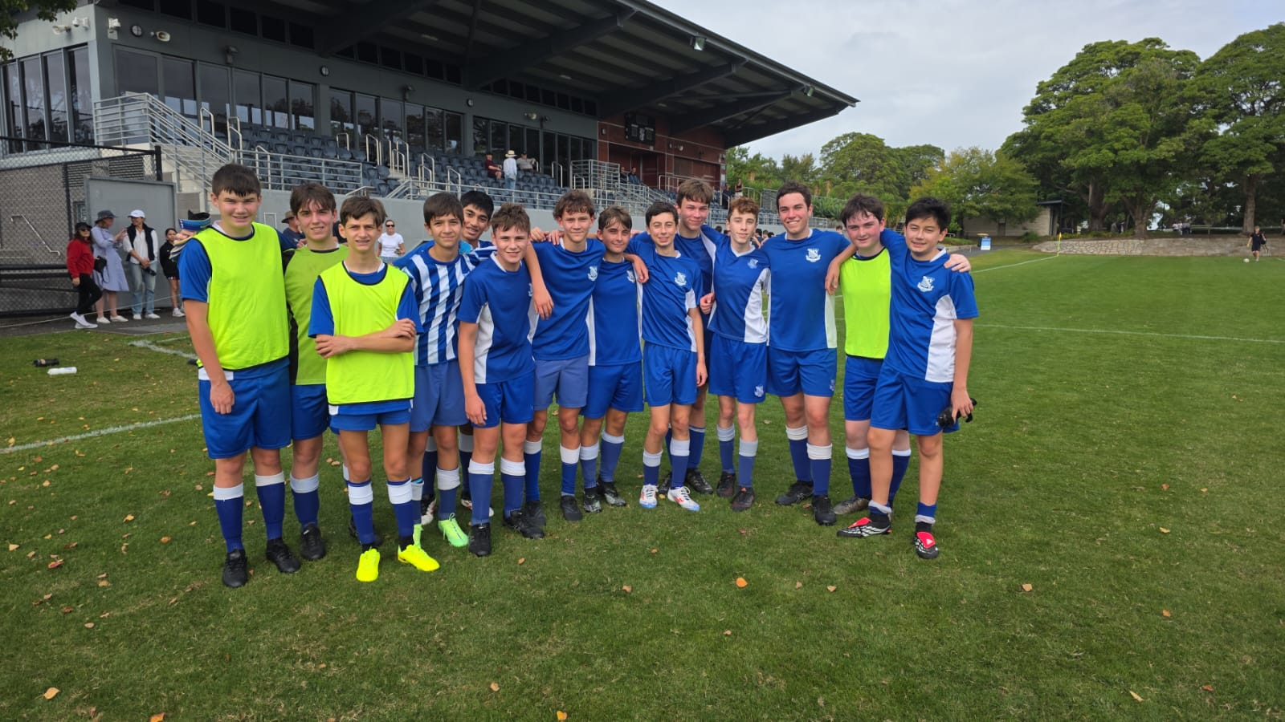
16D Match Report: Coach Jacob Stevens
St Ignatius’ College battled hard but fell 0–4 to SHORE in their Under 16D clash. We showed encouraging passages of play, moving the ball with intent and creating a few promising chances, particularly through midfield. Despite these bright moments, SHORE proved more clinical and controlled the tempo for long periods, capitalising on defensive lapses to build a comfortable lead. Our effort never dropped, with strong defensive work, in particular through Joshua Tamana, and determined runs forward, but they struggled to convert opportunities. In the end, SHORE’s organisation and finishing separated the sides, leaving us with lessons to learn going forward.
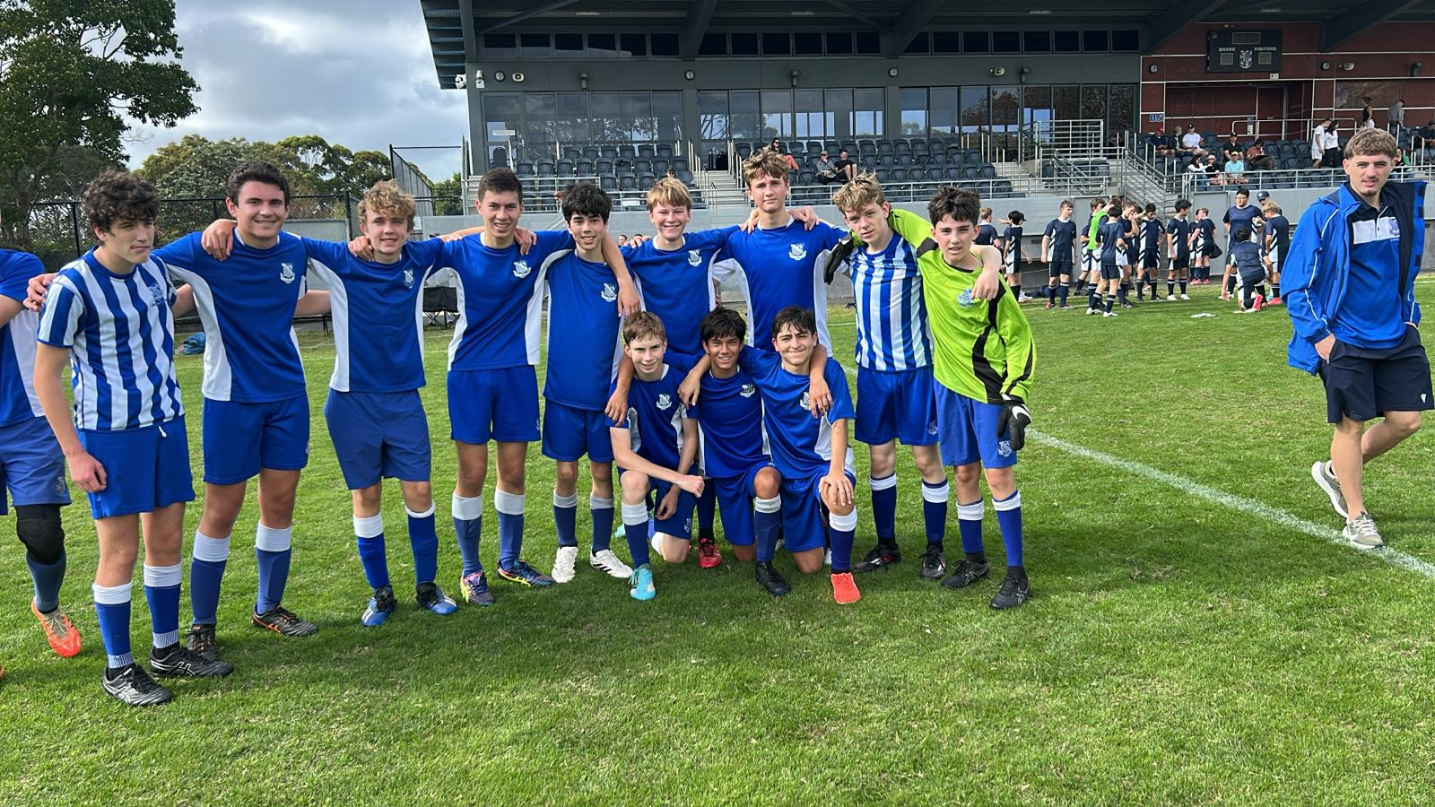

16C Match Report: Coach Marcus Kulukovski
The 16C’s faced Shore in their opening game of the season, with the match starting as a tight and competitive contest. The defensive pairing of Jack Costa and Kerr Chidgey were strong early, showing excellent organisation and making important interventions to deny the Shore attack. As the first half progressed, Shore managed to gain momentum and scored a couple of goals late in the half to take control of the game. Despite this setback, the boys continued to work hard and showed determination to respond. Their efforts were rewarded with a well-taken goal from Xavier O’Beid, who finished confidently to get the team back into the match. The game ultimately finished in a 4–1 defeat. While the result was disappointing, there were clear positives in defensive structure and effort levels. The group will be focused on building on these aspects and aiming to bounce back strongly next week.

16B Match Report (no photo available): Coach Stefan Visscher
Shore proved too strong in a 6–1 result, capitalising on periods where our intensity and work rate dropped below the required level. While the scoreline was disappointing, there were still positive moments to take from the match. Xavier Chien scored a superb individual goal, showing excellent composure and quality to finish confidently. Defensively, Freddie O’Halloran was a standout performer, producing several strong and well-timed tackles to disrupt Shore’s attacking momentum. Overall, the match highlighted a number of key areas for improvement, particularly around consistency in effort, defensive organisation, and maintaining intensity throughout the game. The focus moving forward will be on addressing these aspects in training and responding strongly next week.
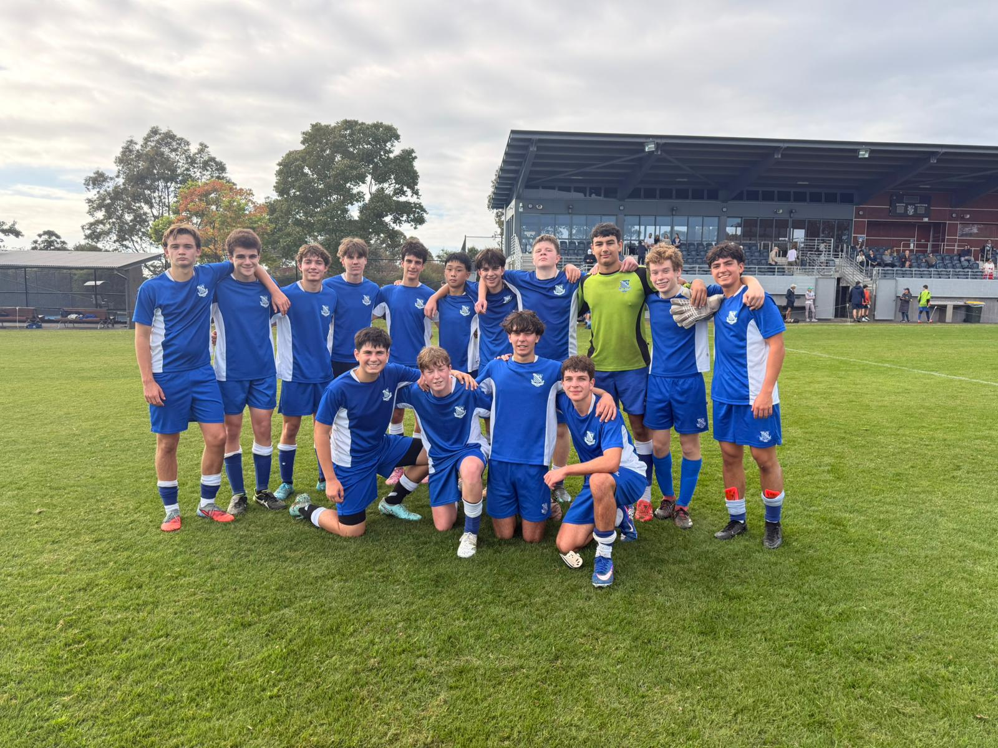
16A Match Report: Coach Stefano Rossello
It was a proud performance from the 16A’s against a strong Shore side on Saturday morning, with the boys coming away deserved 2–1 winners in a fast-paced and competitive match. After a strong week of training and preparation, the team arrived ready for the challenge. Riverview started brightly, bringing excellent energy from the first whistle and setting the tone early. The opening 15 minutes were dominated by Riverview, and the pressure was rewarded when Xavier Scadelli scored a brilliant volley to give the boys a 1–0 lead. Despite Riverview’s control of the first half, Shore managed to find an equaliser just before half-time, taking the score to 1–1 at the break. The message at half-time was positive, with an emphasis on continuing to press aggressively and maintain strong work rate off the ball. That approach paid off almost immediately in the second half. Tom Gibson’s high press forced an error from the Shore centre-back inside the box, resulting in a foul and a penalty for Riverview. Tom stepped up and calmly converted from the spot to restore the lead at 2–1. From there, the boys showed maturity and discipline to manage the game effectively, defending strongly and working together to see out a well-earned victory. It was an excellent team performance built on energy, organisation, and commitment, with the group executing the game plan very well against strong opposition.
OPENS SQUADS

6th Match Report (no photo available): Coach Maximus Joosse
The 6th’s kicked off their season with a competitive fixture against Shore, ultimately going down 2–0 in a hard-fought contest. The first half was a strong showing from the boys, with both teams evenly matched and competing well across the pitch. Riverview were able to build several promising attacking phases through good movement and link-up play, though they were unable to convert their chances. Defensively, the team was well organised and worked effectively to keep Shore at bay, heading into half-time at 0–0. In the second half, Shore began to gain more control and made the most of their opportunities, scoring twice to take the lead. Despite this, the effort and commitment from the boys remained consistent throughout, with the team continuing to press, compete, and support one another until the final whistle. Overall, it was a solid first performance of the season with plenty of encouraging signs to build on moving forward. The group will take confidence from large parts of their play as they look ahead to next week.

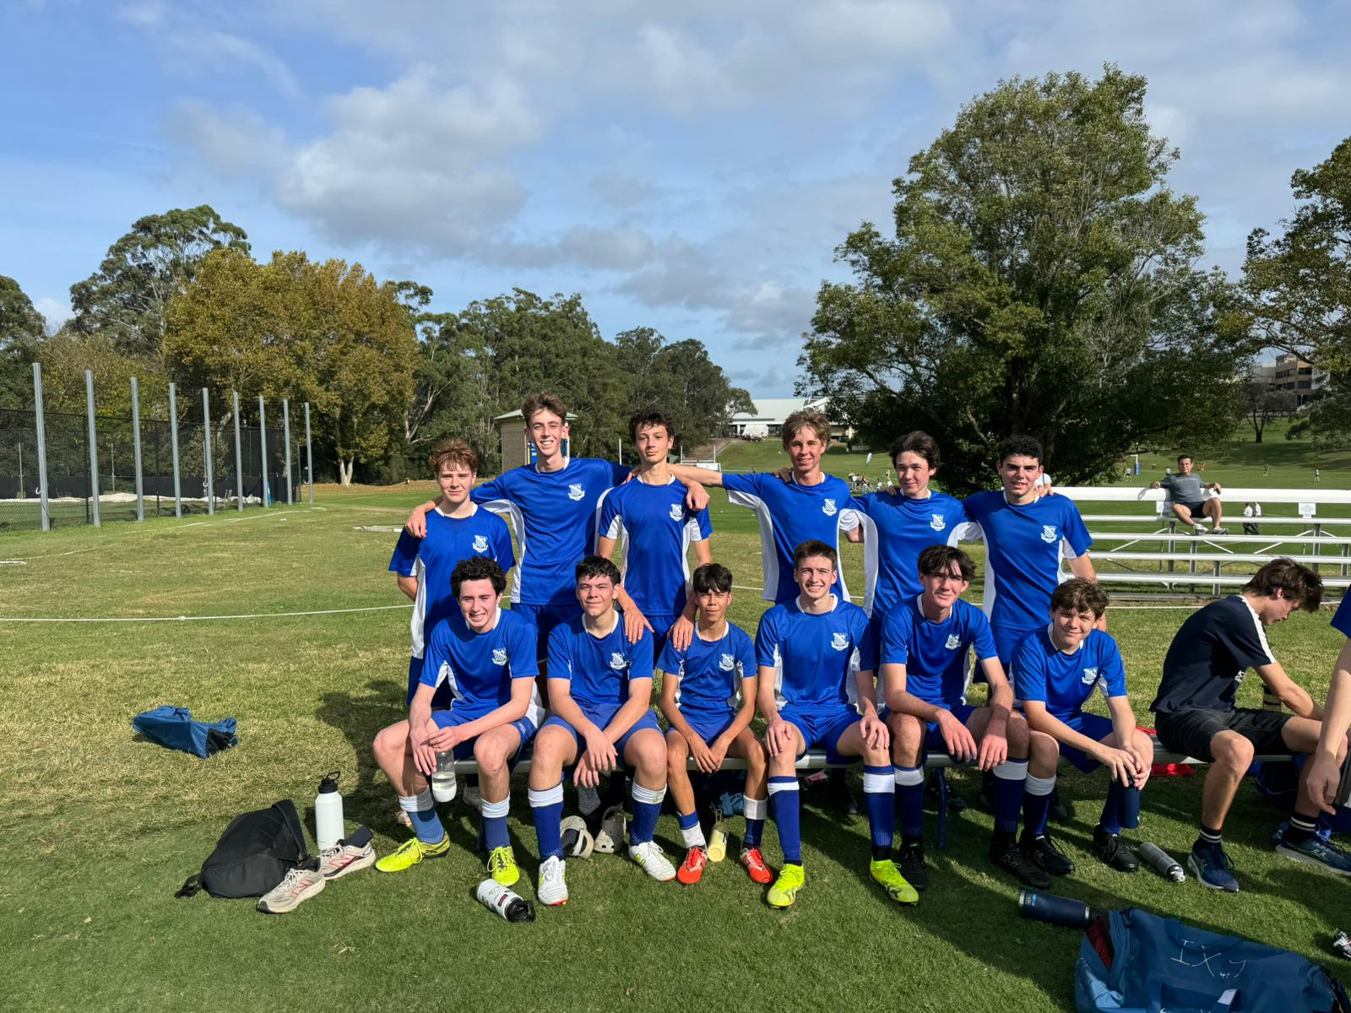

5th Match Report: Coach Jack Aman
A great way to start the season for the 5th’s, with a dominant 4–0 victory over a strong Shore side. The boys began the match in excellent fashion, scoring an early goal to set the tone and establish control. From there, they maintained their momentum, playing with confidence and intensity across the pitch. The team continued to create chances and were rewarded with a further three goals to extend their lead and secure a comprehensive win. Defensively, the group remained organised and disciplined, ensuring a clean sheet and limiting Shore’s opportunities throughout the match. It was a fantastic team performance built on energy, structure, and attacking quality. A strong start to the season, and the group will be looking to carry this momentum into next week.
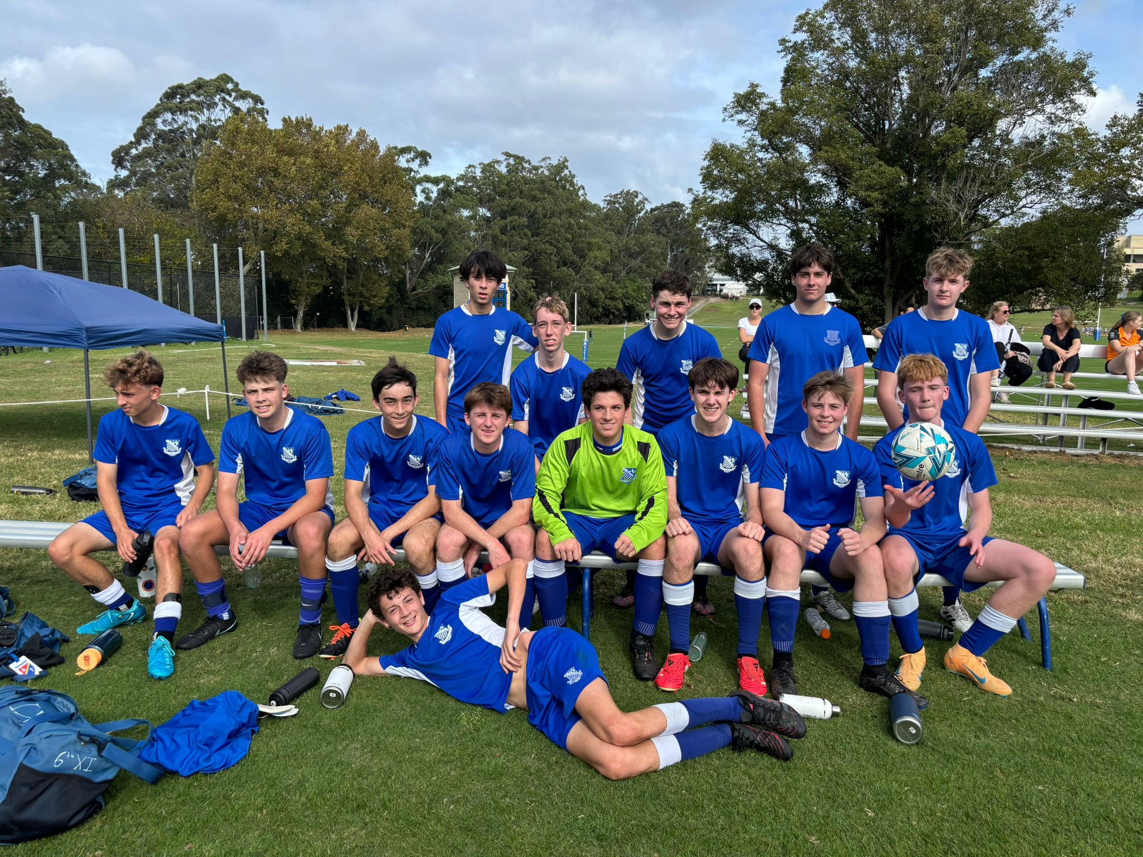
4th Match Report (no photo available): Coach Gabriel De Haast
The 4th’s got off to a positive start to the season with a hard-fought 1–0 win over Shore. The team began in a 4–3–3 formation, but after finding it difficult to gain control in midfield, adjustments were made at half-time which led to immediate improvements. In the second half, the boys showed greater intensity, improved organisation, and closed down space much more effectively, which helped swing momentum in our favour. Lewis Mills scored the decisive goal with a composed finish into the bottom corner, rewarding the team’s improved second-half performance. A special mention goes to Julian Polido, who stepped in as goalkeeper and made several important saves to secure a clean sheet and help the team see out the result. While there is still plenty to work on moving forward, the boys can be proud of their resilience, adaptability, and effort to turn the game around. A strong way to start the season — well done lads.
3rd Match Report (no photo available): Coach Andrew Ferrara
Riverview secured a gritty win against Shore, starting strongly before holding off a second-half fightback to take the result. The first half belonged to Riverview, with two goals in the opening ten minutes setting the tone. The breakthrough came when Harry played a defence-splitting through ball into Marcus, who showed great composure to chip the keeper and make it 1–0. The pressure continued, and Riverview soon doubled their lead when Lucas reacted quickest in the box to bundle the ball home following a corner. However, the momentum shifted after the break. Riverview’s intensity dropped, allowing Shore to grow into the game and pull one back with a near-post finish, bringing the score to 2–1 and setting up a tense final phase. With the match finely balanced, Riverview found the decisive moment. Finn Richards provided a well-weighted assist for Reuben, who produced a superb strike from outside the box to restore the two-goal cushion. Despite a few defensive scares in the second half, Riverview showed enough quality and composure in key moments to secure a deserved win.

