
Riverview Football Program - Match reports Saturday 30th, May 2026
YEAR 7
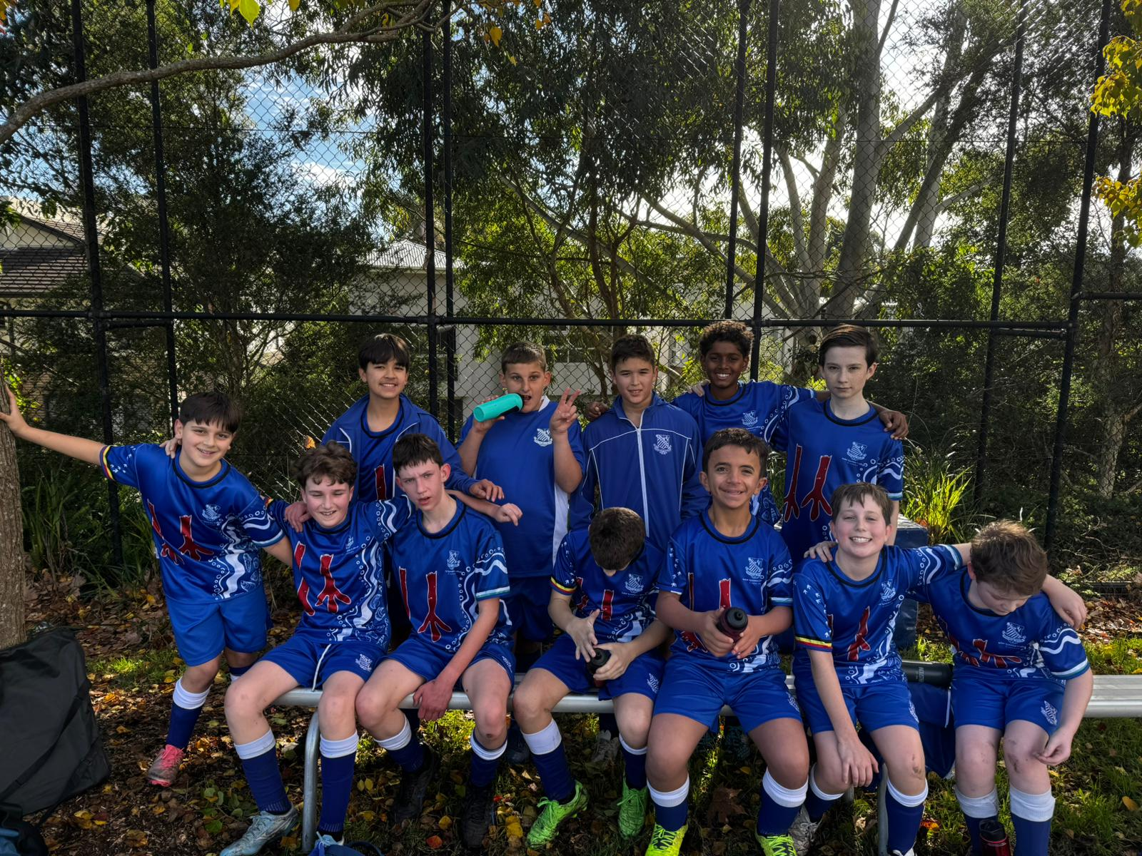
13F Match Report: Coach Sam Burkitt
The 13F’s went down 5–2 away to Shore on a cold morning but showed great character throughout the match. Despite the result, the boys remained positive, supported one another and continued to compete hard until the very end of the game. Their resilience and attitude were a credit to the team, and they should be proud of the way they represented the College.
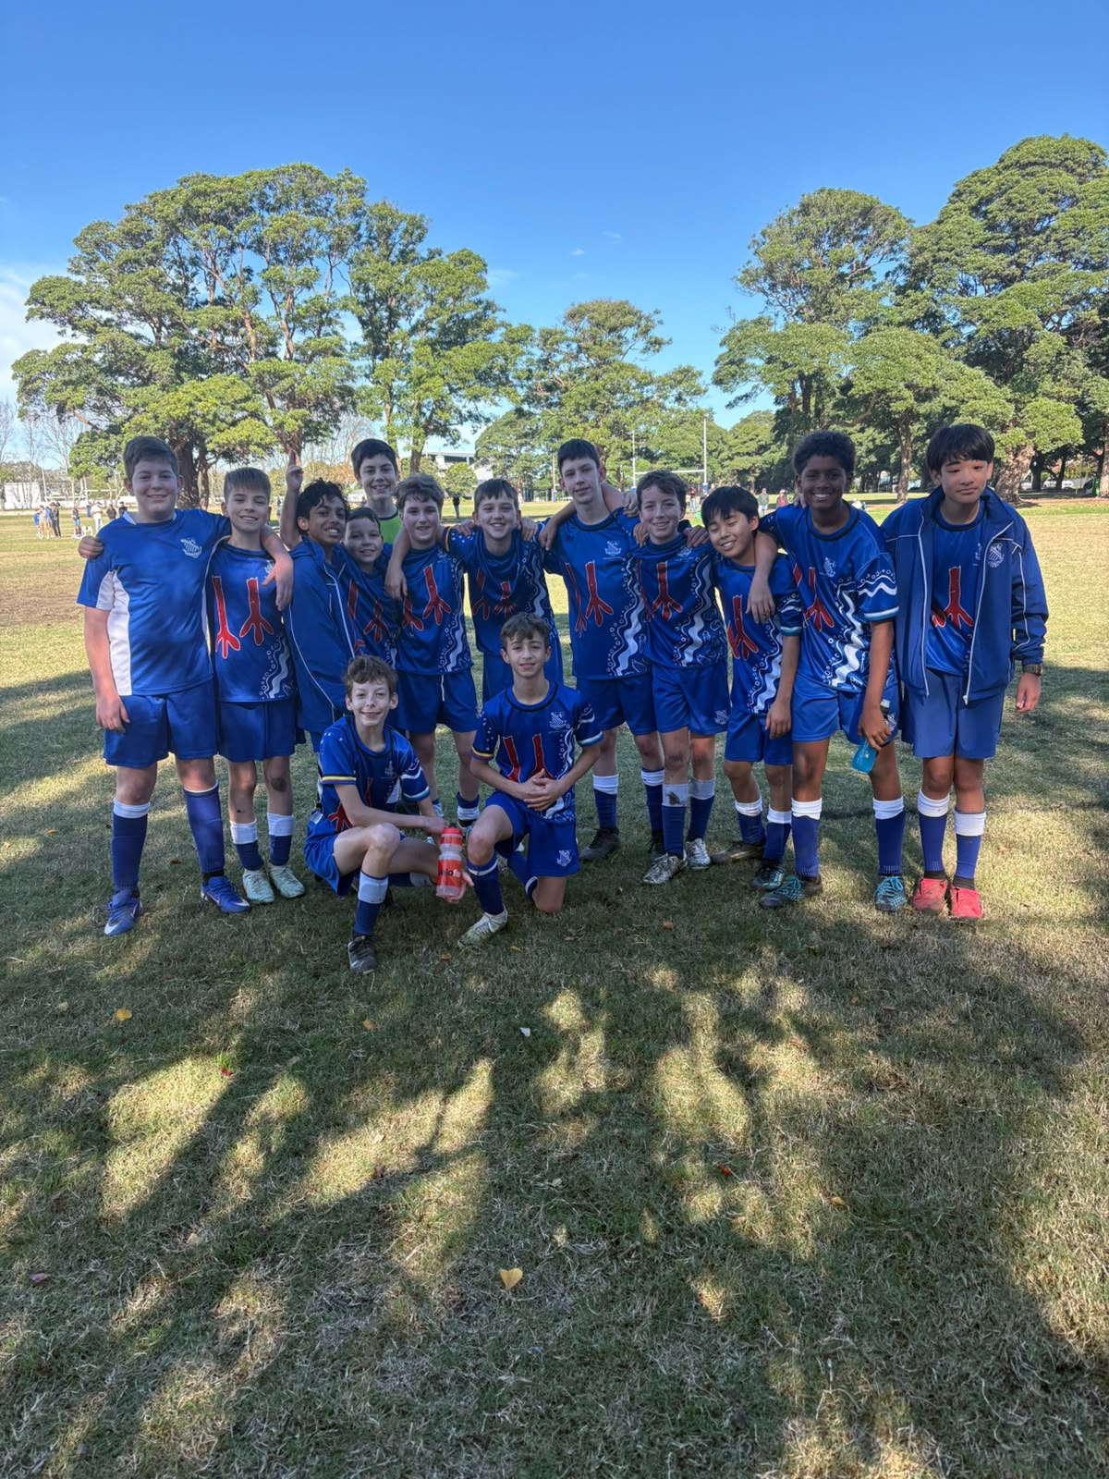

13E Match Report: Coach Joseph Salameh
What a morning from the boys. A clean 5–1 win over Shore and another performance that made us really proud of what this group is building together. Ezekiel was at it again with 2 goals, he just finds a way to get goals. James and Isaac both got on the scoresheet too, and it was great to see their hard work paying off in the right moments. Seb was all around solid, scoring and his physicality and offensive contribution were something else, and he really led the way for the group. Ollie was brilliant. He played with real intensity and passion that lifted the whole team, controlling the game and setting the standard for everyone around him. Callum ran his heart out as always, and George was rock solid at the back. Liam in goals was excellent — handled himself really well despite Shore grabbing a consolation. Henry, Sam, Oliver, and Isaac all put incredible effort I was very happy with.
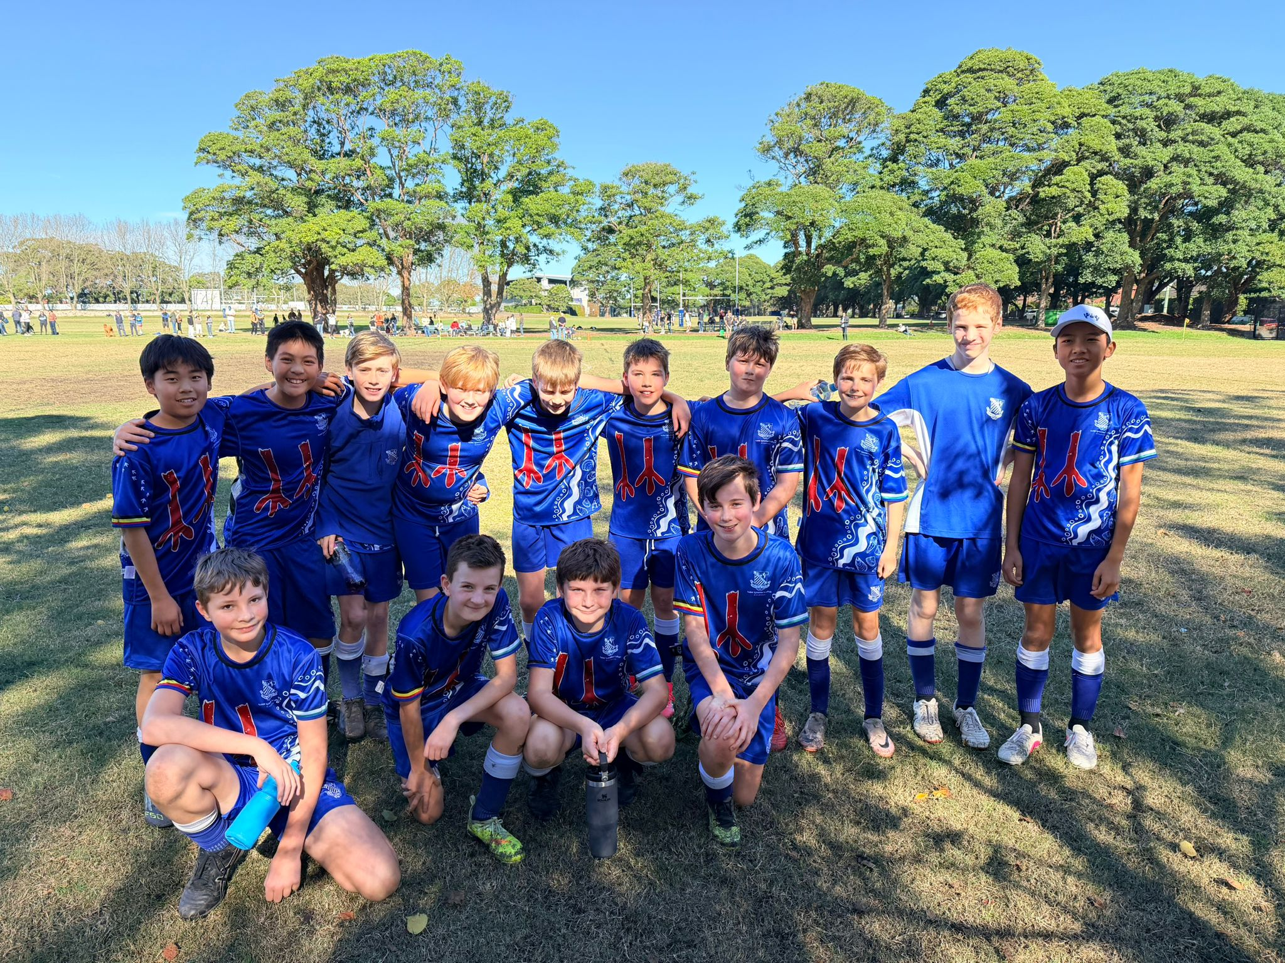
13D Match Report: Coach Michael Portale
It was a mixed afternoon for Riverview 13D, who came away from a tough trip to Shore School on the wrong end of a 4–2 scoreline. There were genuine moments of quality throughout the game, and the team deserves credit for never giving up despite the scoreline. The star of the show was Isaac, who was a constant threat going forward and grabbed both goals for the visitors. His finishing was sharp and his energy infectious — exactly the kind of performance to build on. Defensively, however, it was a difficult day against a strong Shore School side. Conceding four goals away from home is something the squad will want to address, and organisation at the back will be a key focus in the coming training sessions. Overall, there is plenty of talent in this Riverview side. With more consistency and defensive discipline, better results are well within reach.
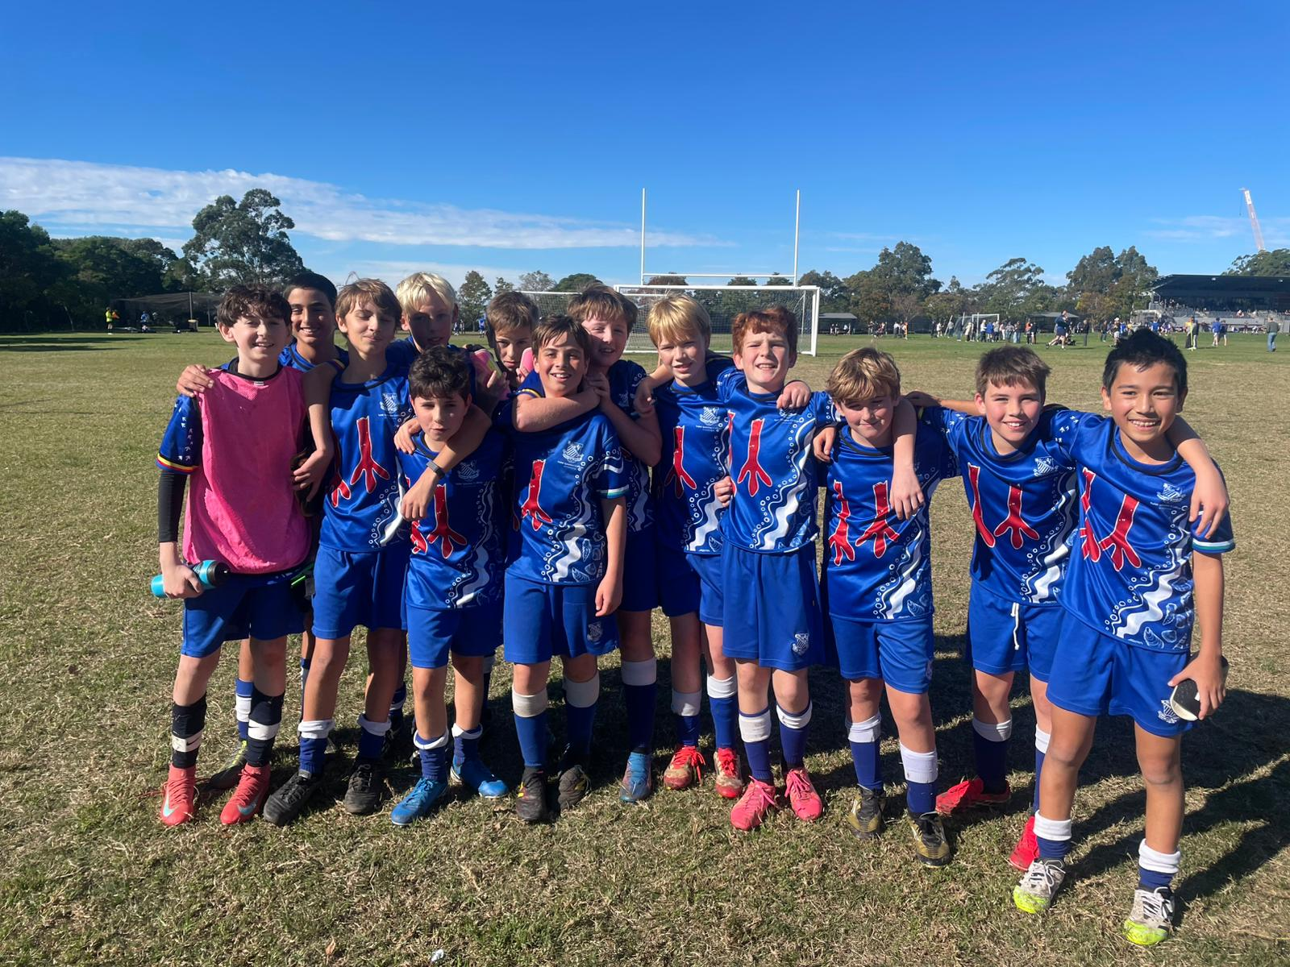
13C Match Report: Coach Nelson Meehan
It was a tough game for the Riverview 13C’S with their first loss of the season. Shore had a strong performance with some very good finishes to get past Riverview’s defence. There was positive play from both teams with the View team playing some good through balls and making some good forward runs however it was the shore side that dominated the game proving there is lots to work on in the coming weeks. Riverview now need to leave it behind them and look to next week to keep improving on what has been a solid start to the season.
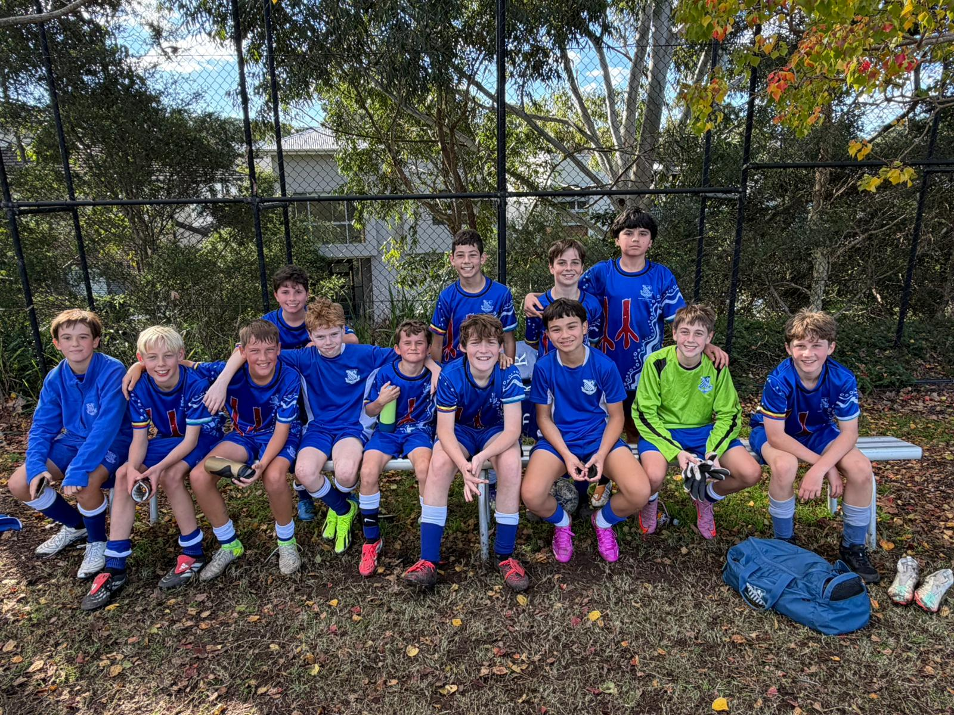
13B Match Report: Coach Josh Engelmann
Riverview’s 13B side delivered a strong 4-1 win over Shore in a confident team performance. The boys started well, with Xavi opening the scoring after finishing neatly from a dangerous cross. Charlie then produced a brilliant long-range effort from the edge of the 18-yard box, finding the top of the net to double the lead. Darcy added another highlight with a superb volley from outside the box, before Ethan finished from close range after Eddy’s cross caused problems in the Shore defence. Shore had a chance to get back into the match from the penalty spot, but the effort flew over the bar. From there, Riverview controlled the game well. Defensively, Abdul, Henry and Xavier were excellent, making strong tackles, covering spaces and stopping Shore from building momentum. It was a complete performance from Riverview, with quality goals, hard work and discipline across the pitch. Final score: Riverview 4, Shore 1.
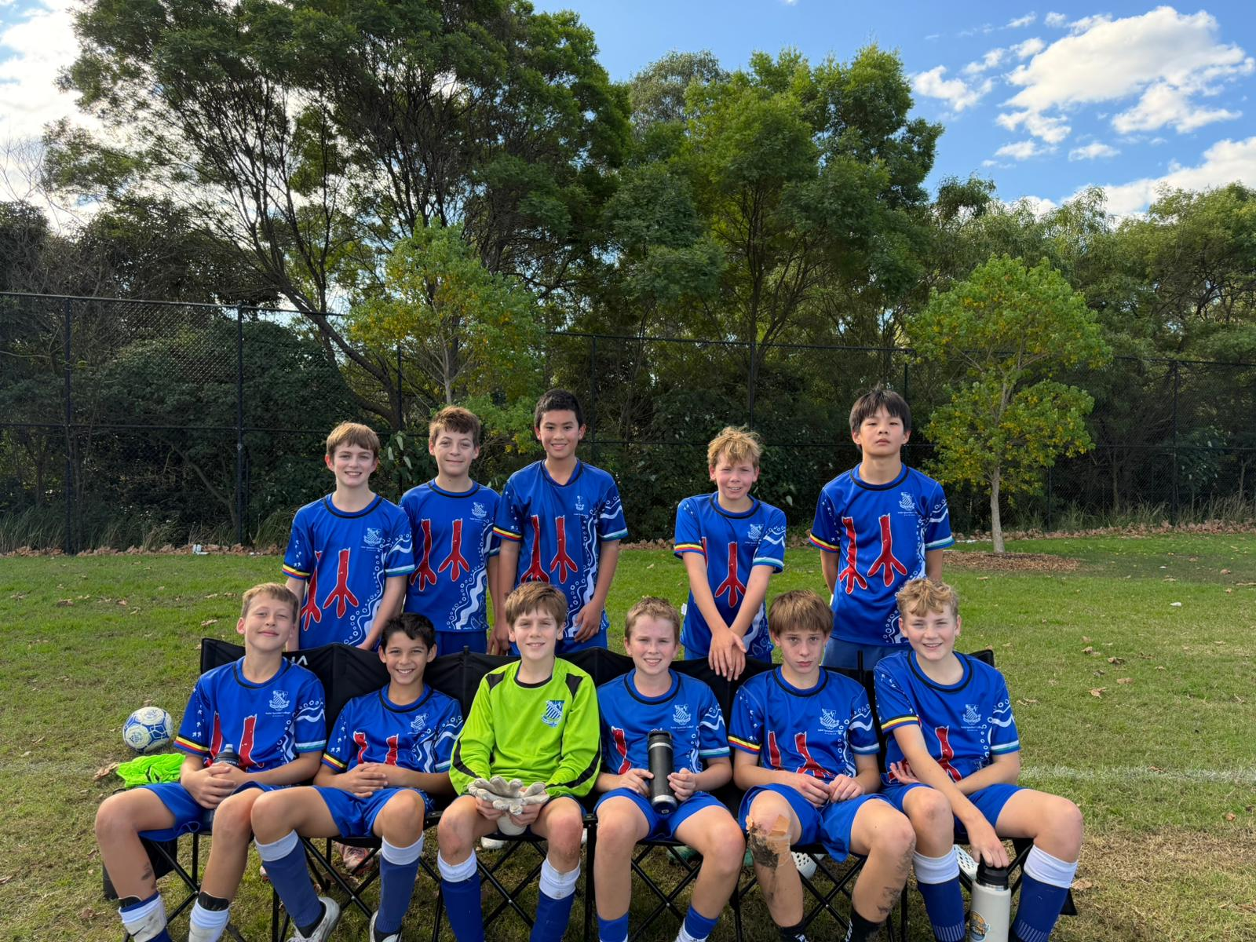
13A Match Report: Coach Lewis Morsella
Great game on the weekend followed with a great result. The boys really taking the things we work on during the week at training into the weekend showing through two of the goals coming out of our press which we worked on Monday afternoon. My man of the match would definitely have to be Clark as he scored all 5 goals on the day with a very directional focus I which I told him at the start of the game which was when you get the ball take your first touch forward and drive at the defenders and use your strengths which is one on one attacking and his speed to beat players which he did. Overall, very pleased with how the boys went on the weekend had a great game with a well-deserved result.

YEAR 8
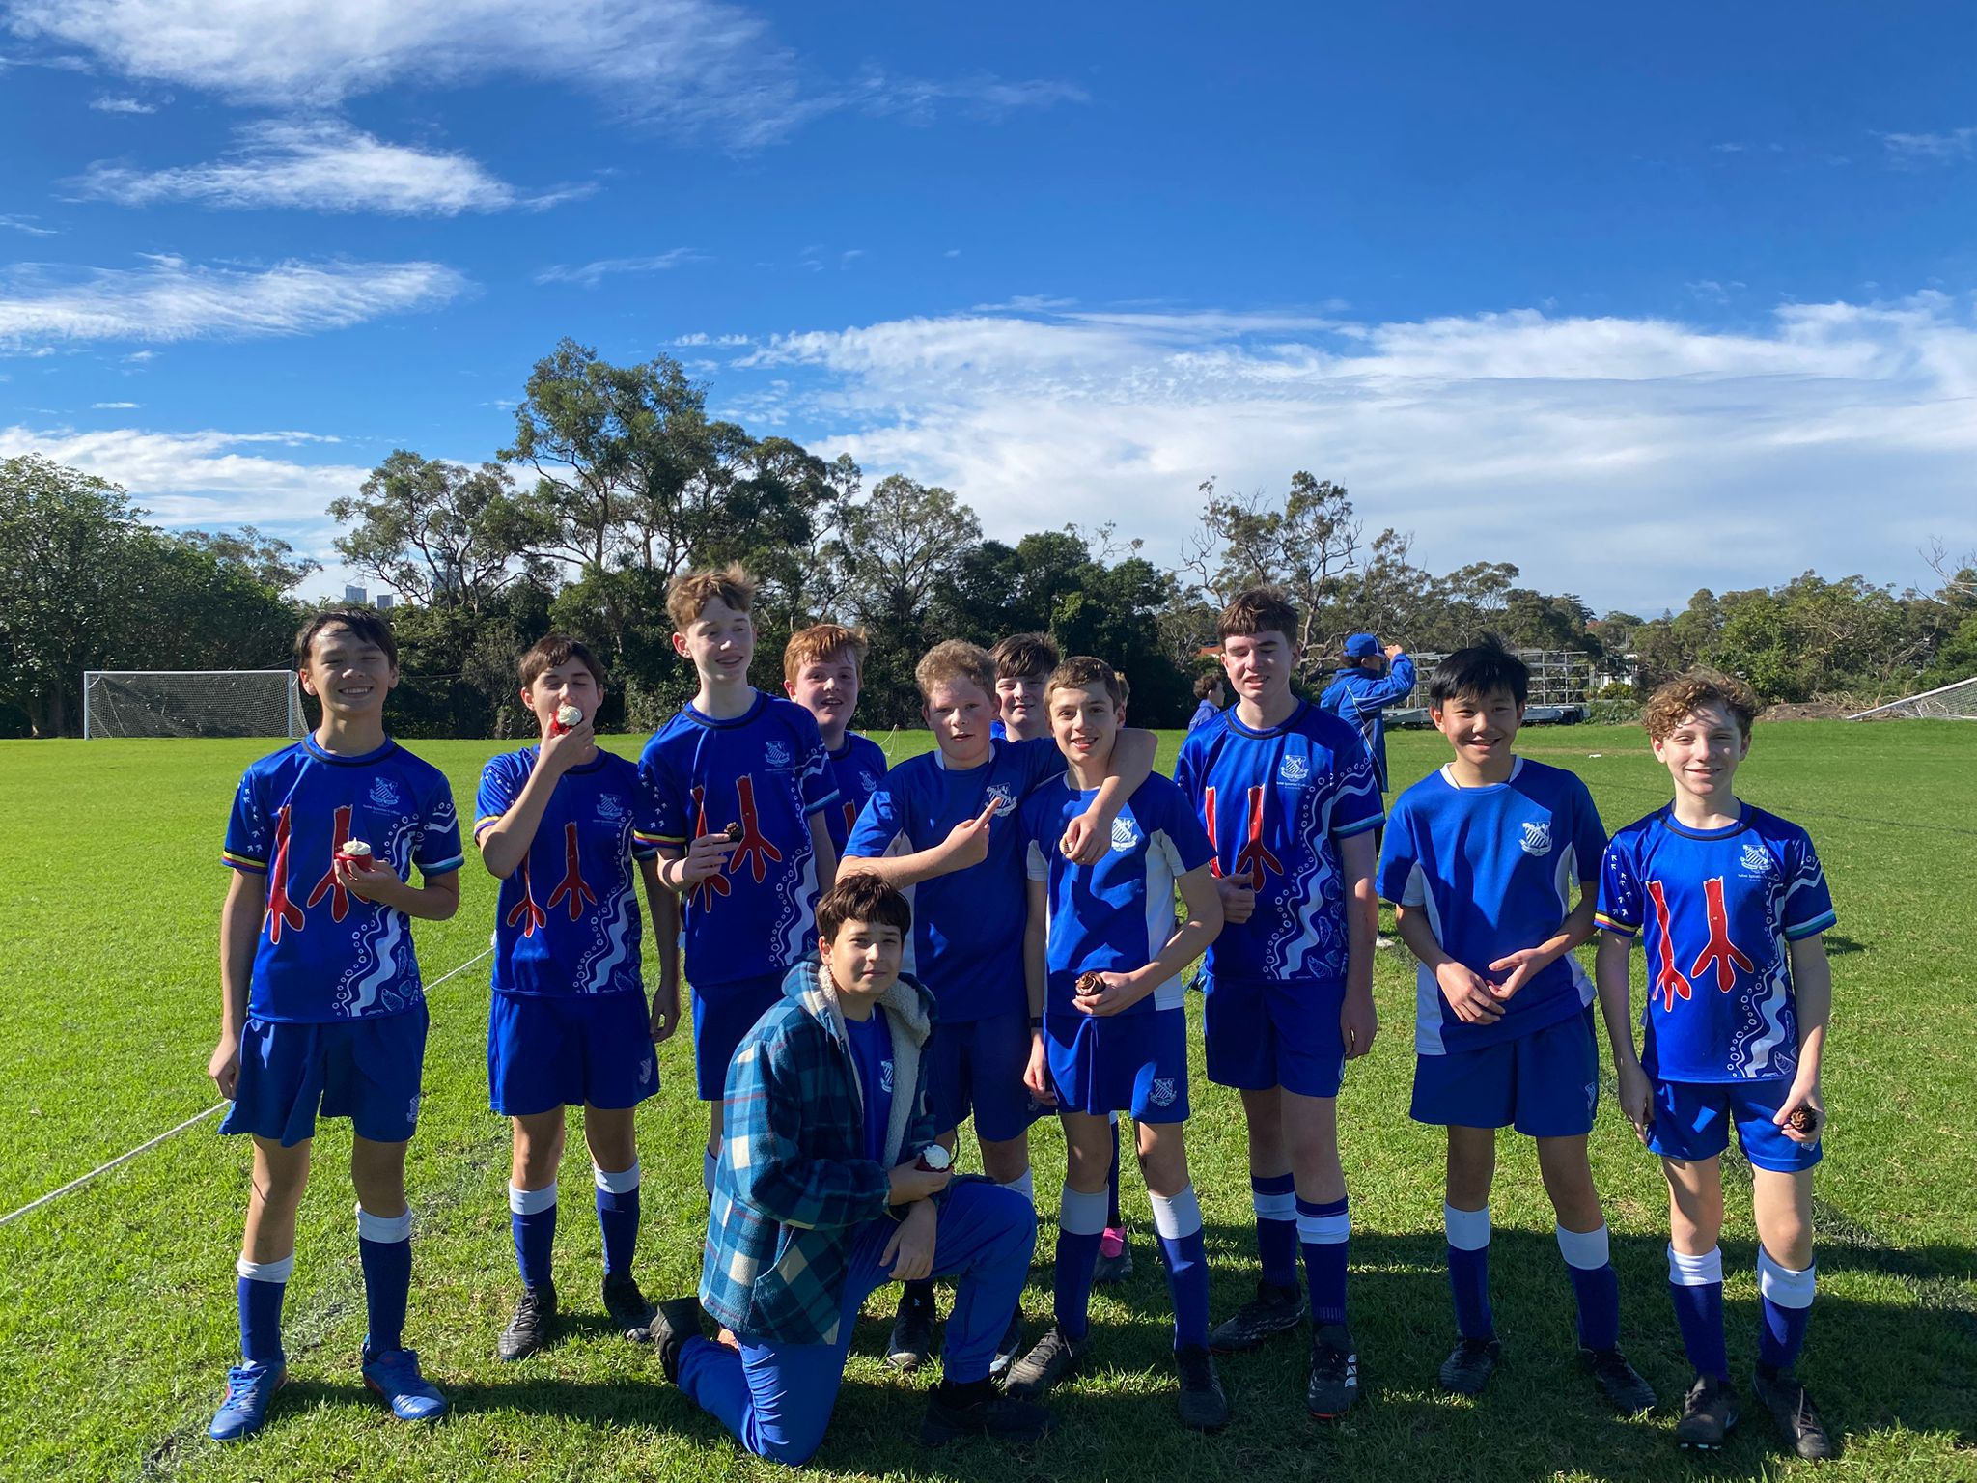
14D Match Report: Coach Matthew Chung
The U14 Ds faced Shore for the second time this season in what proved to be another challenging fixture against a strong and well-organised opponent. Shore controlled much of the game from the outset, applying consistent pressure and making it difficult for us to establish possession and build attacks. Despite facing a strong attack, the defensive unit of Noah, Byron, Alex Marren, and James maintained a high level of effort throughout the entire game. In midfield, Alex Alam and Sam Cleary battled hard in the centre, while Angus Healy and Lachlan Lay played a big role out wide, often dropping back to support the back line when needed. Up front, Fergus and Hamish continued to press and look for opportunities whenever they arose. Despite the difficult circumstances, the boys maintained a positive attitude and continued to support one another until the final whistle.
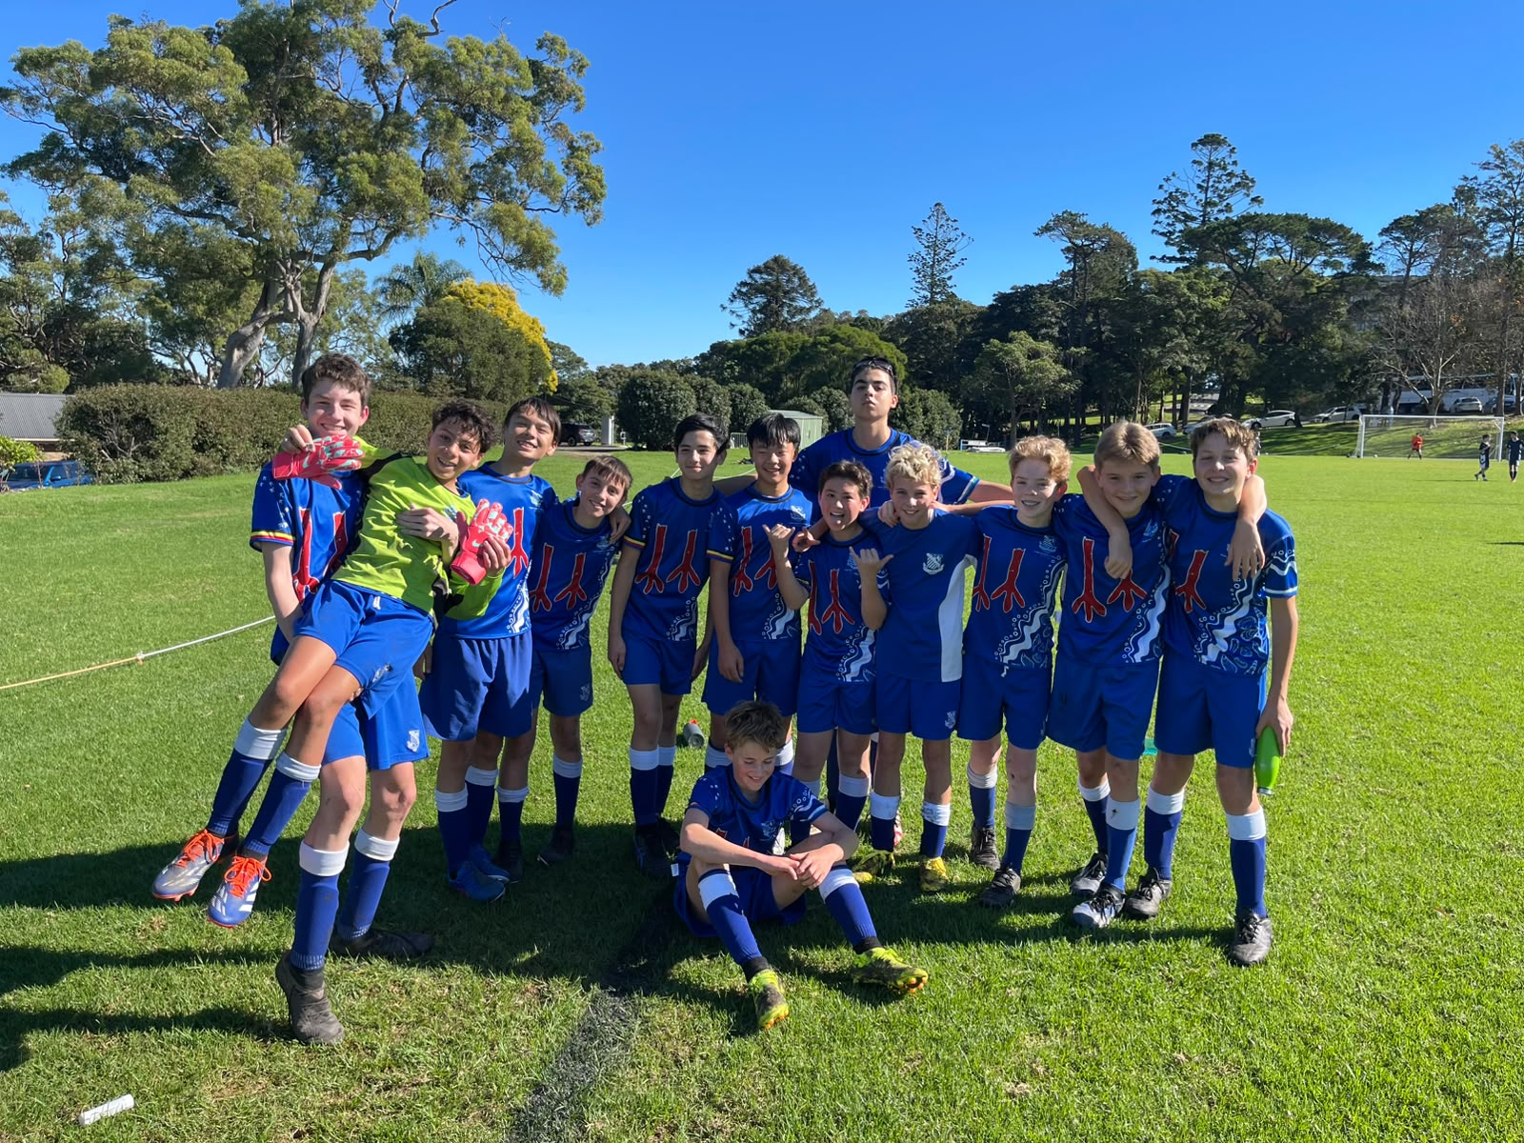
14C Match Report: Coach Tom Kalogerou
Riverview U14Cs faced a tough 7-0 loss against a quality Shore side, who were sharper, hungrier and more determined across the park. Shore started quickly, scoring two early goals that made it difficult for Riverview to build any real attacking rhythm. The second half showed a much better response from the View boys, with a stronger focus on winning individual battles, progressing the ball forward and creating chances. Some promising combination play between Jack Malouf and Toby Pool helped Riverview get into dangerous areas, but Shore responded with clinical finishing of their own. Despite the scoreline, Jacob Mikhael produced a heroic performance, making several important saves and keeping the result from becoming far worse. It was a humbling day, but one the boys can learn from as they look ahead to the coming rounds.

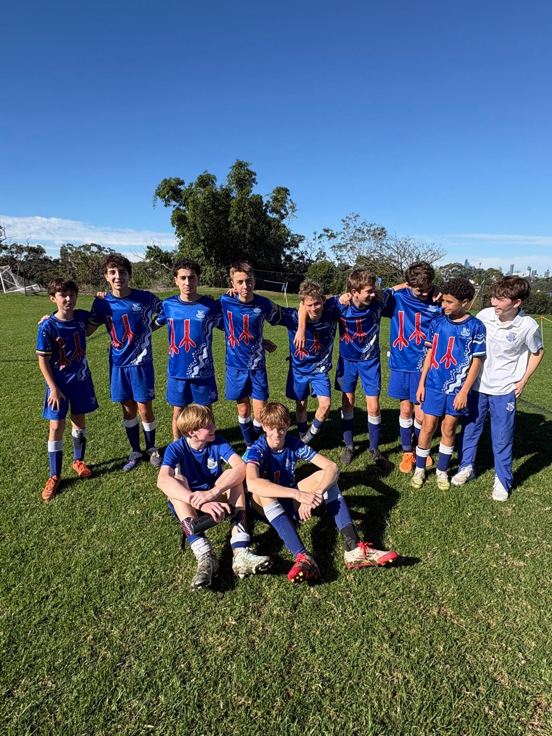
14B Match Report: Coach Lachlan Iacono
This weekend the 14B's played against Shore. Today we were missing Hugo Brabant due to sickness and Ollie Thistlewood still recovering from his broken wrist. Luckily, we regained Elliott Johnston and Charlie Macdonald for this week. The game began quite evenly, with both sides having equal opportunity. Shore broke through our lines several times, nearing a goal, until a cross came in that was not dealt with - leaving a Shore attacker with a shot on goal. I believe after the first goal, like against Grammar, the boys had their heads held quite low, conceding another 2 before half time, one being an accidental own goal by our Nick Triggs. Going into the second half we looked to improve on our structure and formation with/ without the ball. We played more compact in defence, with more players in the middle of the park. This change worked well for the first 15 minutes of the second, but again similarly to the Grammar game, the boys dropped, conceding a few more before full time.

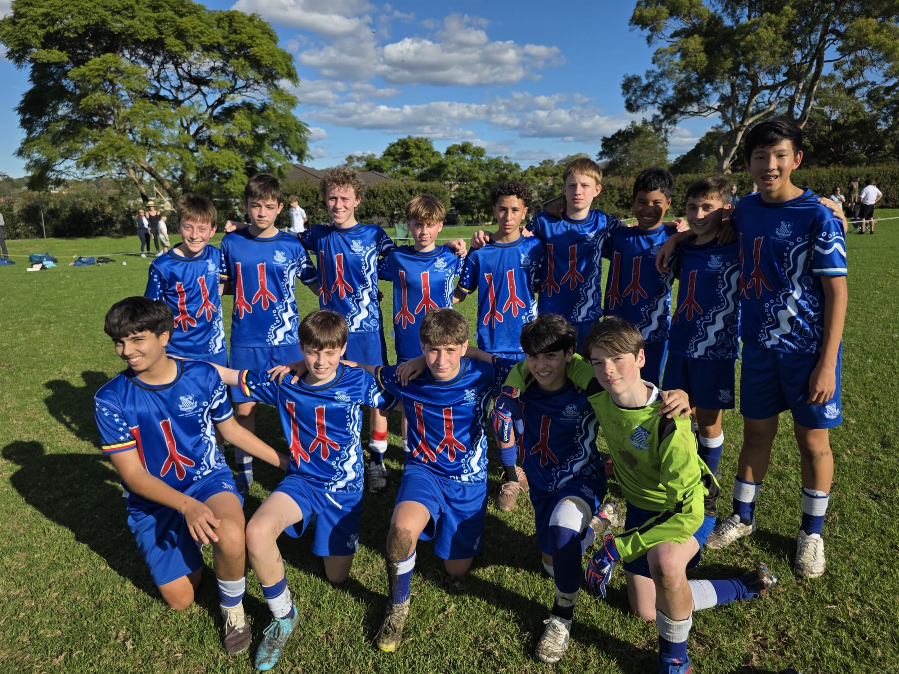
14A Match Report: Coach Domenico Garreffa
Riverview 14A’s secured a hard-fought 3-2 victory over Shore in a match that was far closer than it should have been. From the opening whistle, Riverview controlled large periods of the game, creating numerous chances and looking dangerous every time they went forward. Jack Watson continued his excellent form in front of goal, scoring twice to give Riverview a deserved advantage. However, despite their dominance, several missed opportunities allowed Shore to remain in the contest and eventually fight their way back into the match. Riverview’s inability to convert chances kept the game on a knife edge and gave the opposition belief. With the scores level late in the game, Riverview continued to push for a winner and were rewarded in dramatic fashion. David Raphael stepped up in the dying moments, finding the back of the net with a last-minute strike to secure the win and cap off an entertaining contest.
YEAR 9
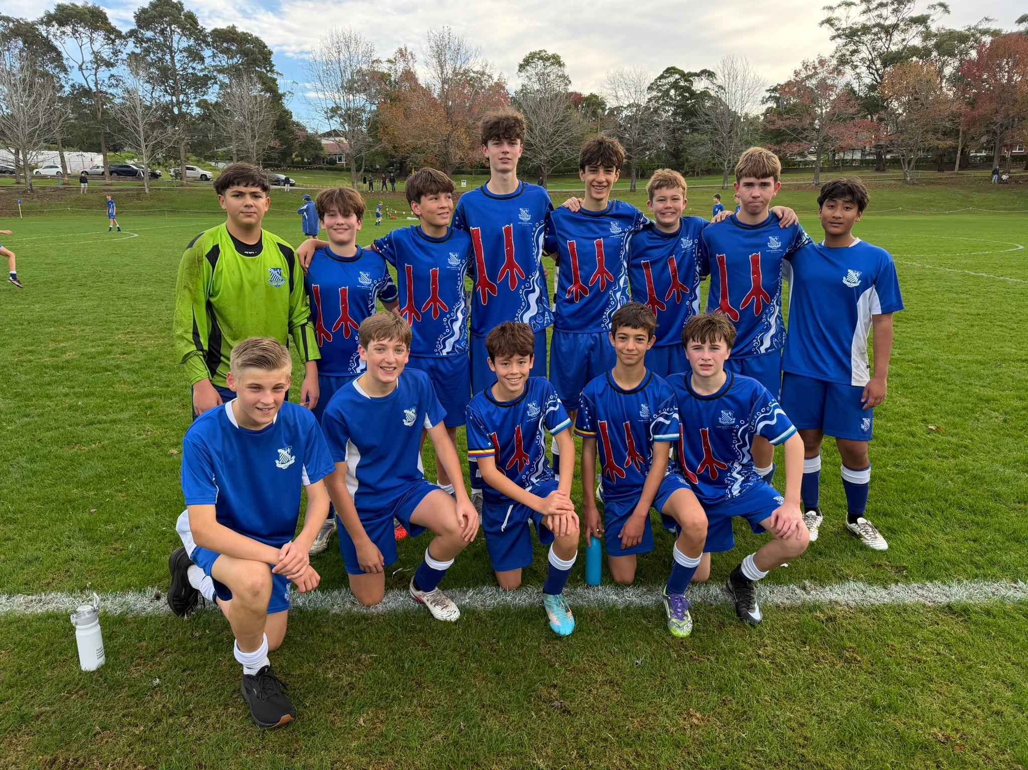
15A Match Report: Coach Travis Cooper
The 15A’s faced a strong Shore side at home on the weekend, going down 5–0 in a challenging match. Despite the result, the boys showed resilience and continued to work hard throughout the game against quality opposition. Shore started brightly and were able to capitalise on their early chances, taking control of the match and putting pressure on our defensive structure. While Riverview had periods where they looked to build possession and play through the lines, Shore’s intensity and organisation made it difficult to create clear scoring opportunities. To the team’s credit, the effort and commitment never dropped. The boys continued to compete for every ball and supported one another until the final whistle, showing positive character in a difficult contest. While the result was disappointing, there are valuable lessons to take from the match as the squad continues to develop and improve throughout the season. The focus now shifts to the next fixture, with the group determined to respond positively and build on the areas identified from this performance.
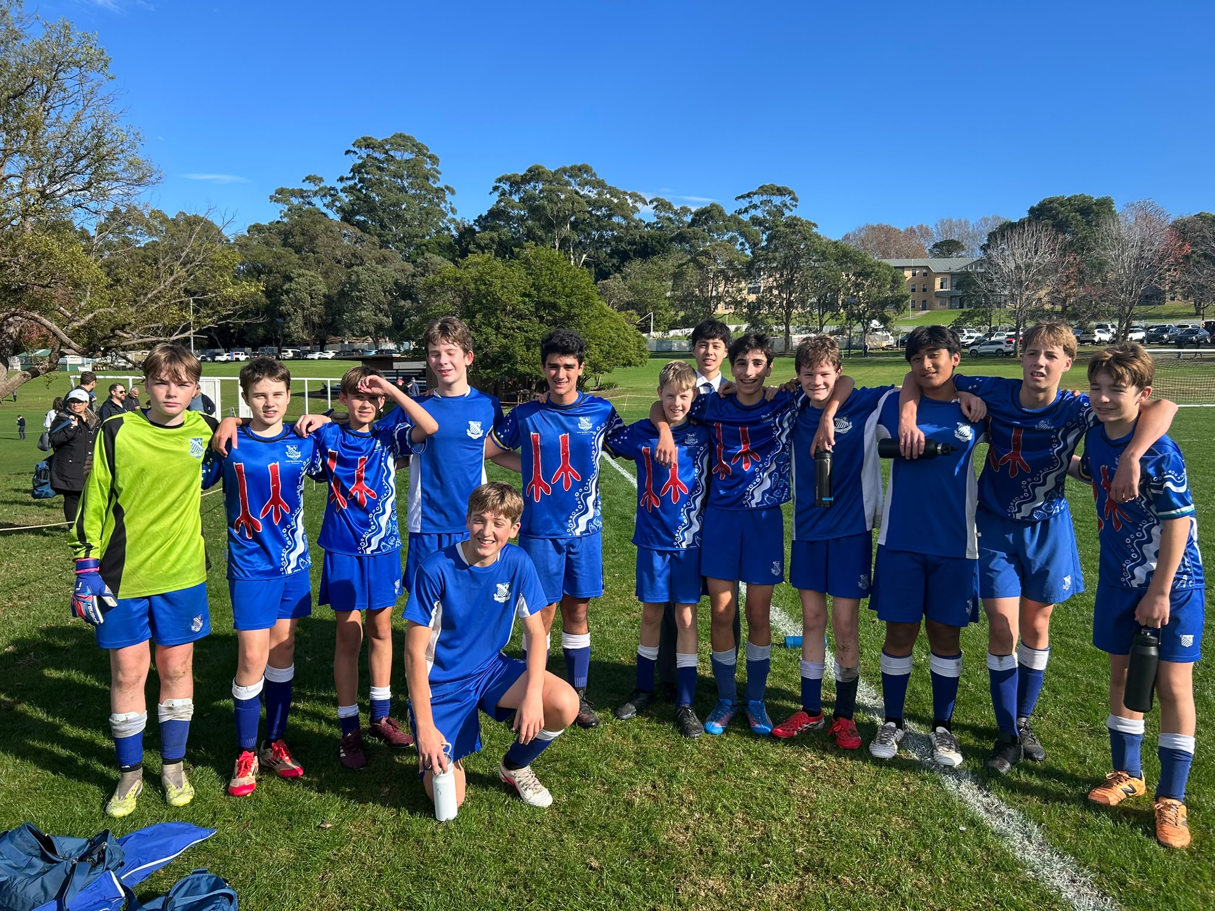
15B Match report: Coach Jonathan Codemo
The 15Bs produced a spirited performance against Shore 15Bs, despite eventually going down 3–1 in a hard-fought contest. The boys started the match superbly, dominating much of the first half with confident possession, strong attacking play, and a solid defensive structure. Numerous chances were created going forward, while the backline remained organised and difficult to break down. Shore struck early in the second half to take the lead, but the boys responded positively and refused to let their heads drop. Their determination and work ethic remained evident as they continued to press and look for opportunities. Although Shore managed to add a second goal, the boys showed great character and resilience. Their efforts were rewarded when Enzo produced a moment of brilliance, curling a fantastic strike from outside the box into the top corner to reduce the deficit. Overall, the boys played well, competed strongly throughout, and can be proud of their performance.
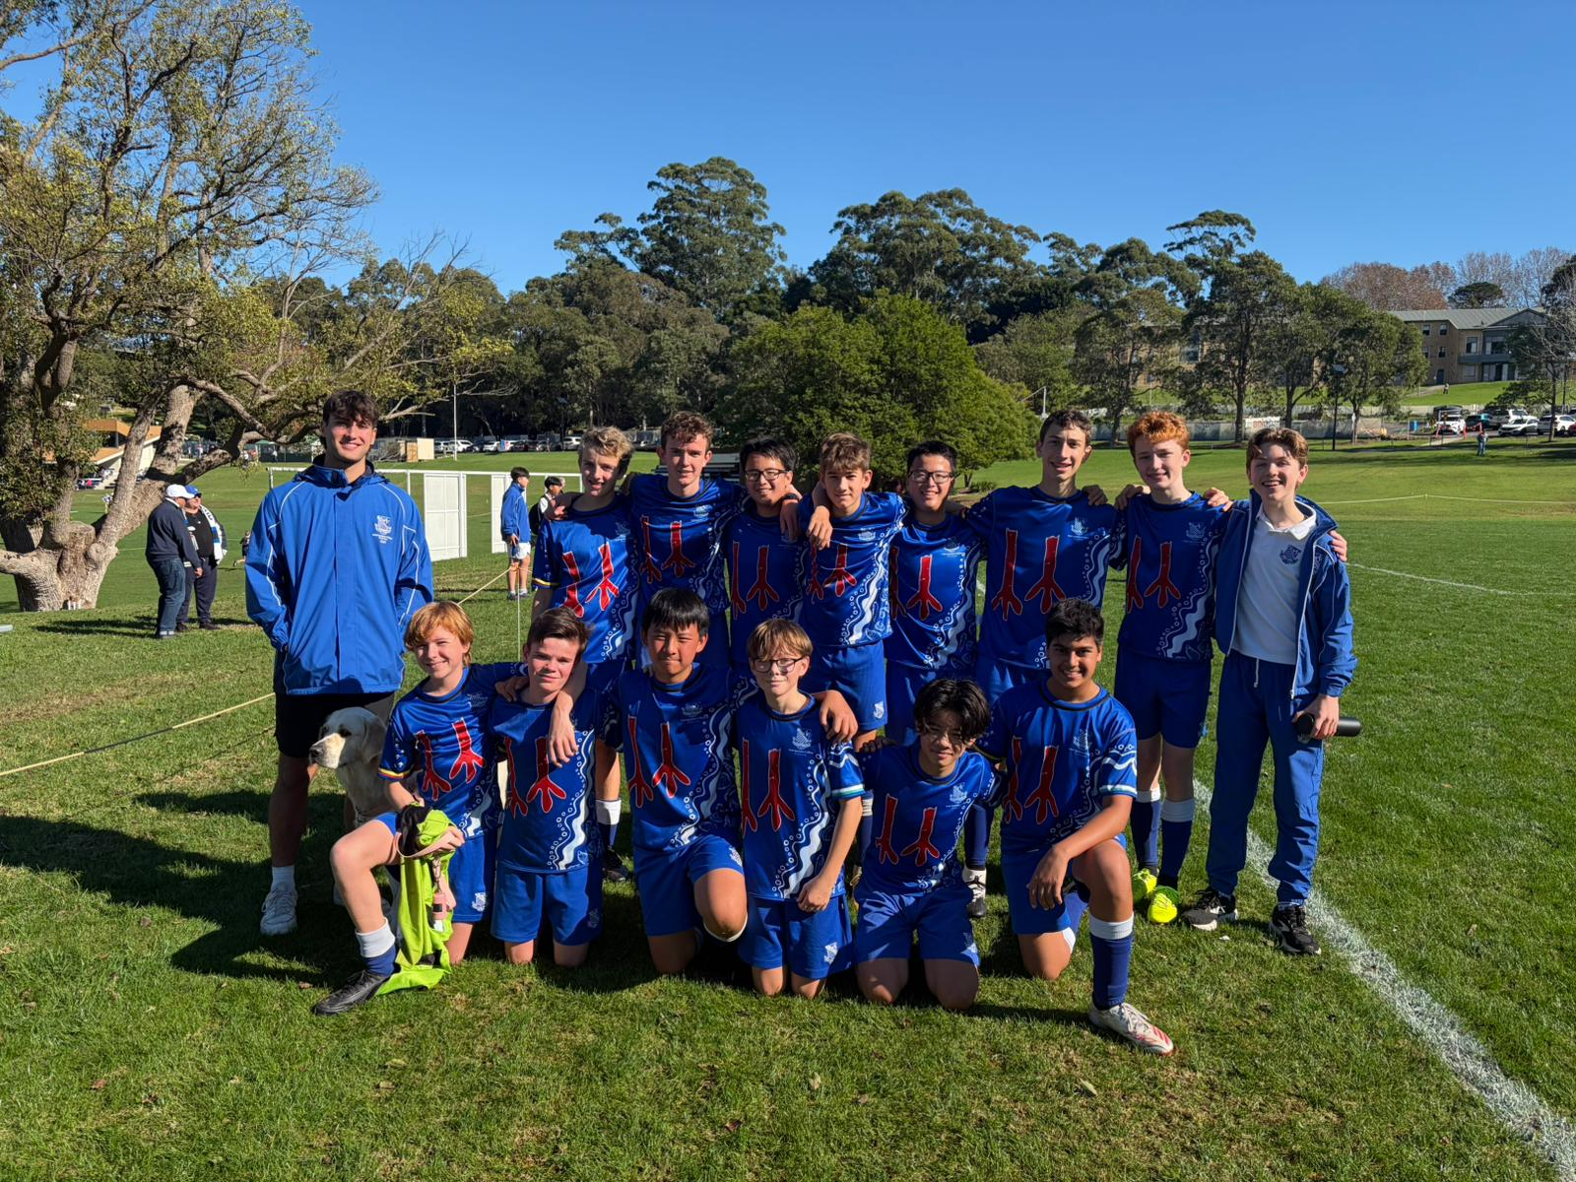
15C Match Report: Coach Cooper Sintras
After a convincing 5–0 win in the previous meeting, many expected another comfortable afternoon for Riverview’s 15Cs. While Riverview dominated possession and created numerous chances, they were unable to convert enough of them and had to settle for a hard-fought 2–1 victory over Shore. Patty Mills scored both goals and earned Man of the Match, helping Riverview edge a determined Shore side in a much tighter contest than many had anticipated.
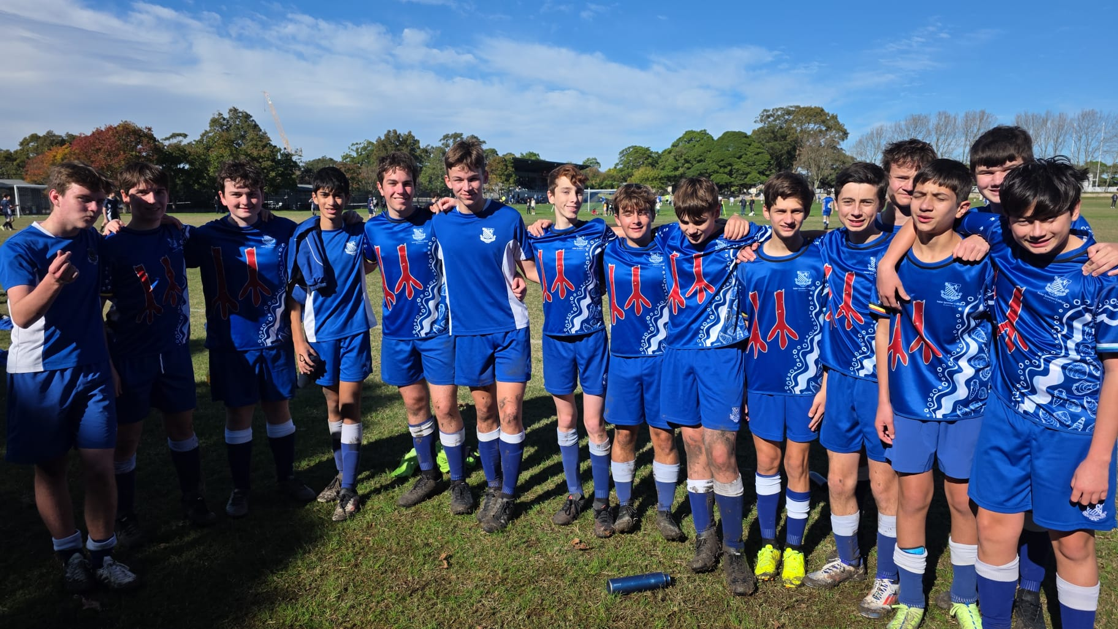
15D Match Report: Coach Alexander Mansfield
15Ds started the game off with a lot of energy, scoring three goals in quick succession straight after kicking off against a defensively weak Shore side. Further goals came in the second half with some excellent finishes from striker Ben Allan and winger Max Molesworth. With the final touch of the game, Harry Scharenguival scored his debut goal with a header to make it nine.
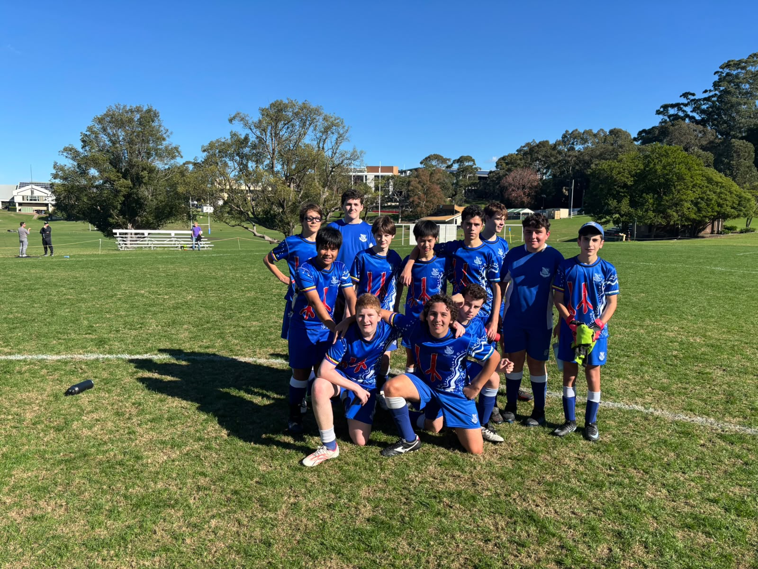
15E Match report: Coach Atticus Ireland
It was an unfortunate result for the team this weekend. A difficult first half saw us fall 4–0 behind, with the opposition capitalising on their chances and putting us under pressure. To the boys' credit, they responded much better after the break, showing greater determination, intensity, and willingness to compete. While we were unable to claw our way back into the contest, the second-half performance was a positive sign and demonstrated the character within the group. There are plenty of lessons to take from this match, and we will continue to work hard on the training ground this week as we look to improve and push for a much better result next weekend.

YEAR 10
16D Match Report (no photo available): Coach Jacob Stevens
Riverview and Shore battled through a tightly contested first half, with both sides struggling to gain a clear advantage. Defensive pressure dominated early, as Riverview in particular showcased some tough tackling that disrupted Shore’s attacking rhythm and kept the contest evenly poised. We scored a solid, well-constructed goal, rewarding their persistence and physical intensity around the contest. However, Shore gradually asserted control in the second half, lifting their tempo and execution. Despite Riverview’s resilience, Shore proved a bit too strong overall, capitalising on their opportunities and maintaining composure under pressure. In the end, Shore’s class and consistency saw them edge ahead and secure the win in a hard-fought encounter.
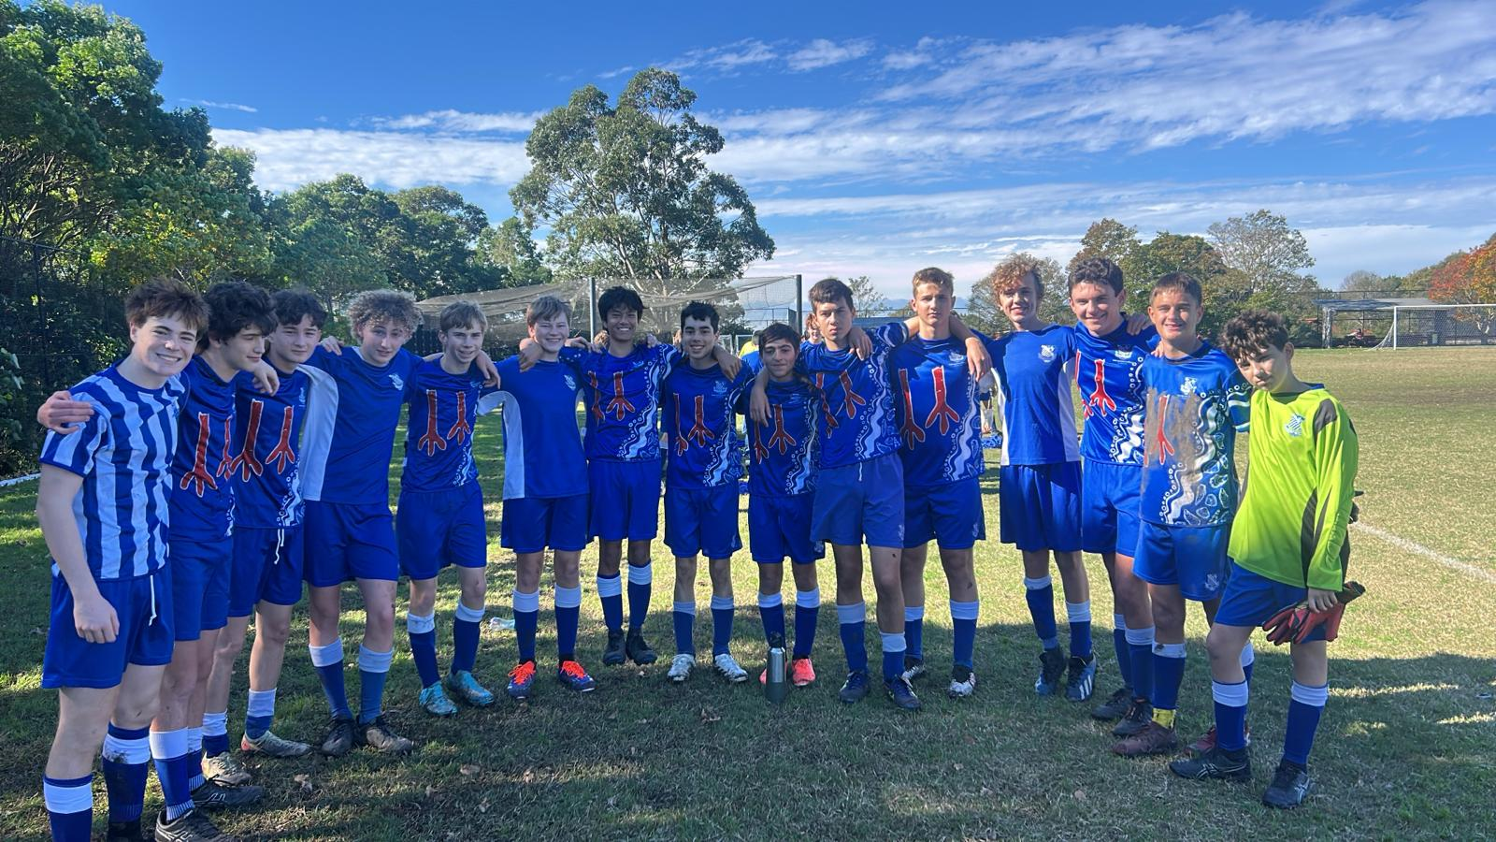
16C Match Report: Coach Marcus Kulukovski
The Riverview 16C's played Shore for the second time looking to try and get revenge after a loss in their first match. The boys dominated the game in the first half with Hugo Lennon scoring a double. The second half saw goals fall early to Xavier O'Beid and Oscar Willis to put the boys up 4-0. Shore were able to make a late rally to bring the game back to 4-2. However, Hugo Lennon was able to seal the win, securing his hattrick with the game ending in 5-2 for the Riverview 16C's. Another great performance by the team who will look to continue their hot streak of form next week.
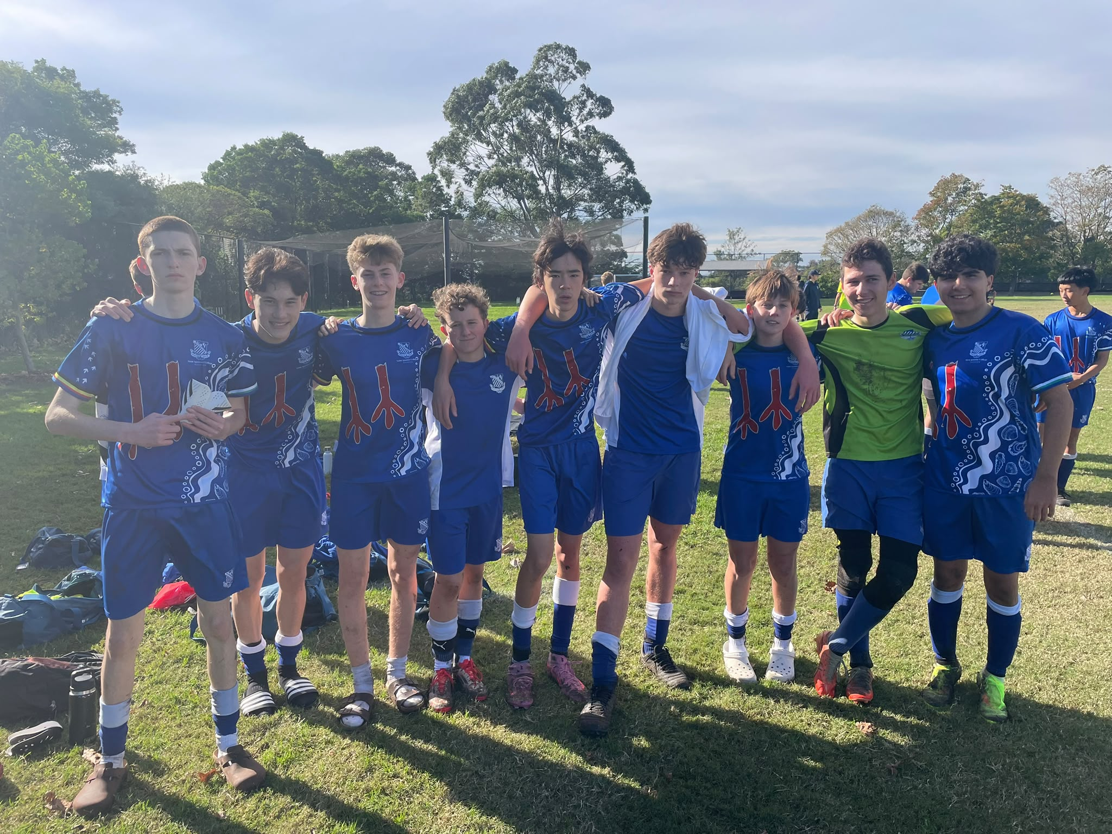
16B Match Report: Coach Stefan Visscher
A tough 2-1 defeat to Shore School, with the result decided in the final minute of the match. The team started brightly and took the lead through Hugo, who finished well after a fantastic assist from Angus. Defensively, we showed resilience for long periods and remained competitive against a strong opponent. Unfortunately, conceding late highlighted some areas that need improvement. Tactically, we must be better at managing key moments of the game, particularly when protecting a result. Our positioning, communication, and decision-making under pressure all need further work on the training ground. Equally, our effort levels were not where they need to be. Too many players were second to lose balls and lacked the intensity required to compete for the full 60 minutes. Football rewards hard work, and we must bring greater determination, urgency, and commitment moving forward. We will learn from this performance and come back stronger next week.
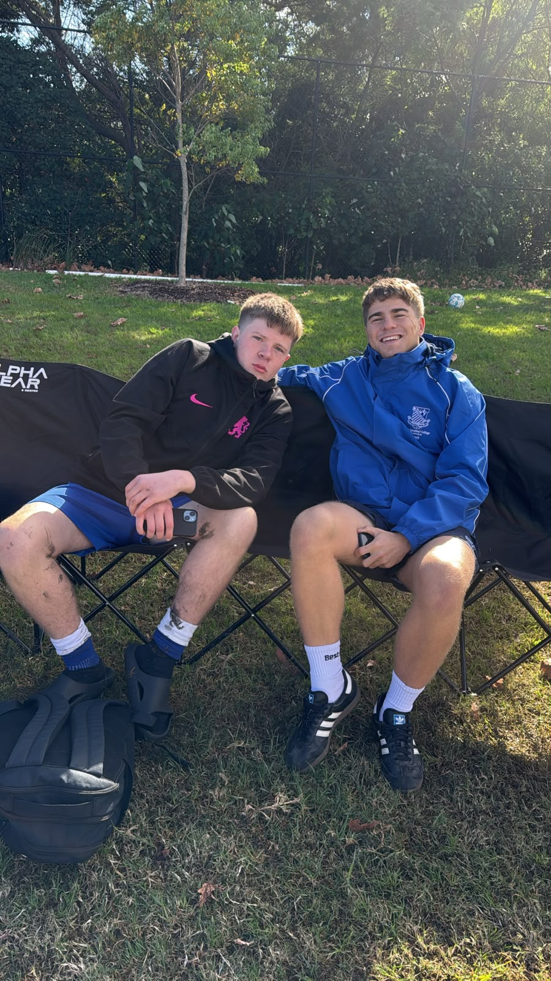
16A Match Report: Coach Stefano Rossello
The 16A's were forced to settle for a hard-fought 1–1 draw against Shore on the weekend. Having defeated Shore 2–1 earlier in the season, Riverview entered the match confident, but difficult conditions played a significant role and prevented the boys from playing their usual brand of football. The game started slowly for both sides, with the pitch heavily affected by the rain throughout the week. The poor surface made it extremely difficult to play through the middle of the field and disrupted the team's rhythm in possession. Despite the challenging conditions, Riverview lacked some of their usual energy and intensity, losing too many individual duels and not working hard enough off the ball. This allowed Shore to grow into the contest and create several promising opportunities, although some desperate and committed defending kept the scores level. The breakthrough eventually came from a Shore corner. After struggling to deal with set pieces throughout the afternoon, Riverview were punished when a free header found the back of the net, giving Shore a 1–0 lead. With just five minutes remaining and trailing by a goal, Riverview threw everything forward in search of an equaliser. Their persistence was rewarded when the ever-reliable James Dart stepped up once again, finding the back of the net with a late goal to rescue a point for the visitors. While the result was disappointing given the team's ambitions and previous performance against Shore, the boys showed great character to fight until the final whistle. There will be plenty to work on at training this week, particularly around intensity, winning individual battles, and defending set pieces, as the team looks to return to winning ways next weekend.
OPENS SQUADS
6th Match Report (no photo available): Coach Maximus Joosse
The game against Shore was a really tough day for the boys against Shore, with only nine players available for the match. Despite being two players short for the entire game, the effort, determination, and attitude shown by every player was inspiring. From the first whistle to the last, the boys never stopped competing. They worked tirelessly for each other, supported one another through difficult periods of the game, and continued to fight for every ball. Even when fatigue started to set in, the team showed great resilience and refused to give up. What stood out most was the character of this group. Every player stepped up, encouraged their teammates, and put the team before themselves. While the result may not have gone our way, the commitment and sportsmanship displayed throughout the match is something everyone should be proud of. Well done to all the boys for showing what it means to play for each other and never stop trying, regardless of the circumstances.

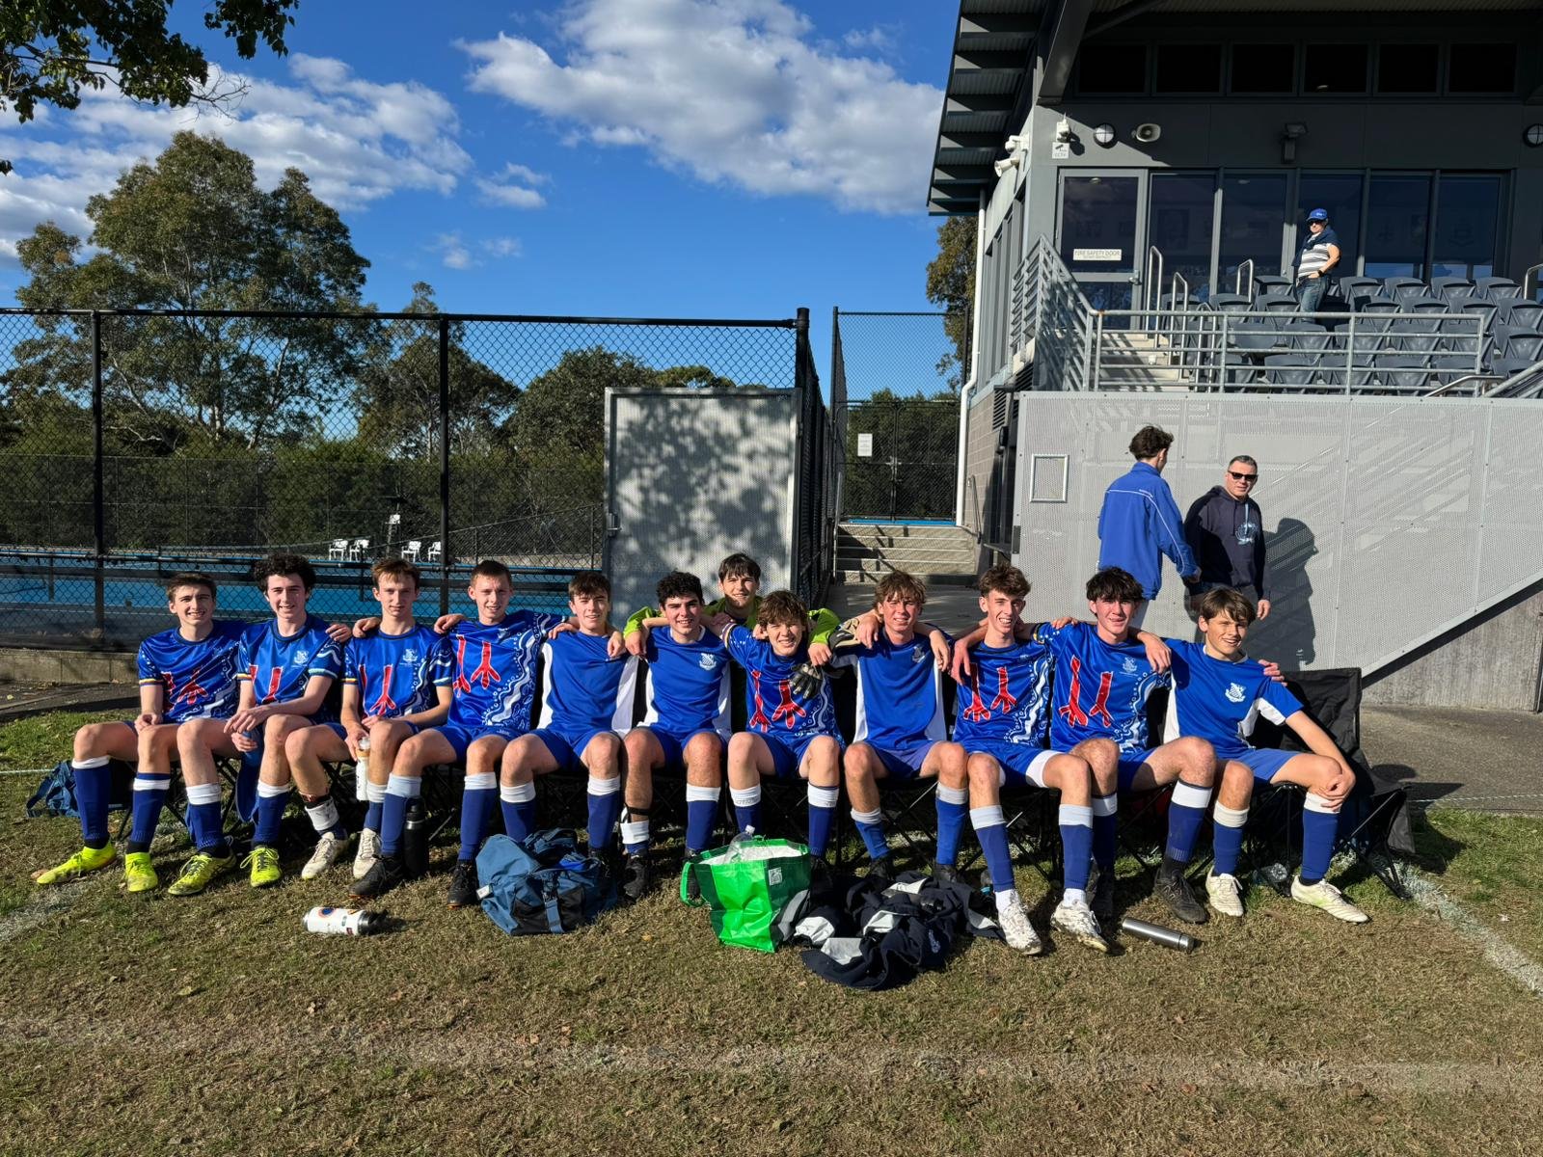
5th Match Report: Coach Jack Aman
A solid effort today from the 4ths, unfortunately losing 3-1 to a much-improved Shore side. They were the better team in the first half, leading 1-0 at halftime after we conceded two penalties, one which was fantastically saved by Oli. We started the second half a lot better, equalising but unfortunately conceding two further goals. We controlled the game more in the second half and that is a positive to take, however communication is a weakness across the team at the moment and that will be our main focus for this week.
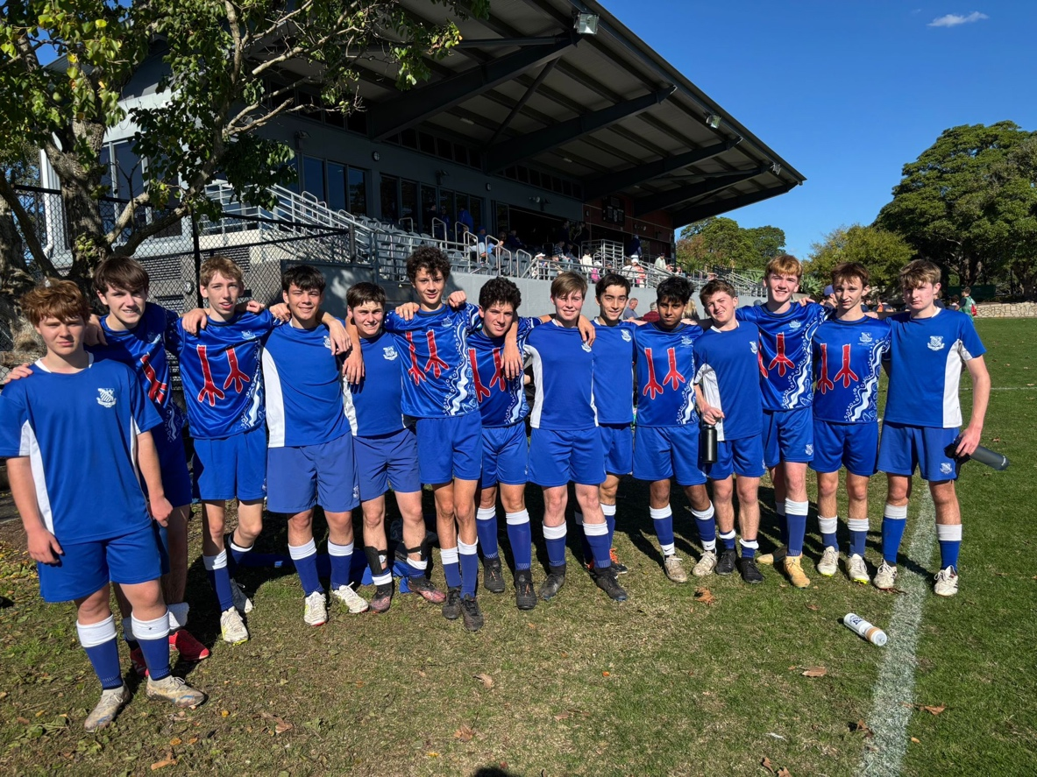
4th Match Report: Coach Gabriel De Haast
The 4th XI travelled to Shore on the weekend and were unfortunate to come away with a narrow 1–0 defeat in a closely contested match. The game was evenly balanced throughout, with both sides creating opportunities and competing strongly in all areas of the field. Riverview showed great organisation defensively and worked hard to limit Shore’s chances, while also looking dangerous on the counterattack and in possession. Despite going behind, the boys responded positively and pushed hard for an equaliser, creating several promising attacks and maintaining pressure until the final whistle. While the result did not reflect the effort and commitment shown by the team, there were many positives to take from the performance. The players demonstrated resilience, discipline, and teamwork throughout the match and can be proud of the way they competed against a strong opposition away from home. The focus now turns to the next fixture as the squad looks to build on this encouraging performance and return to winning ways.
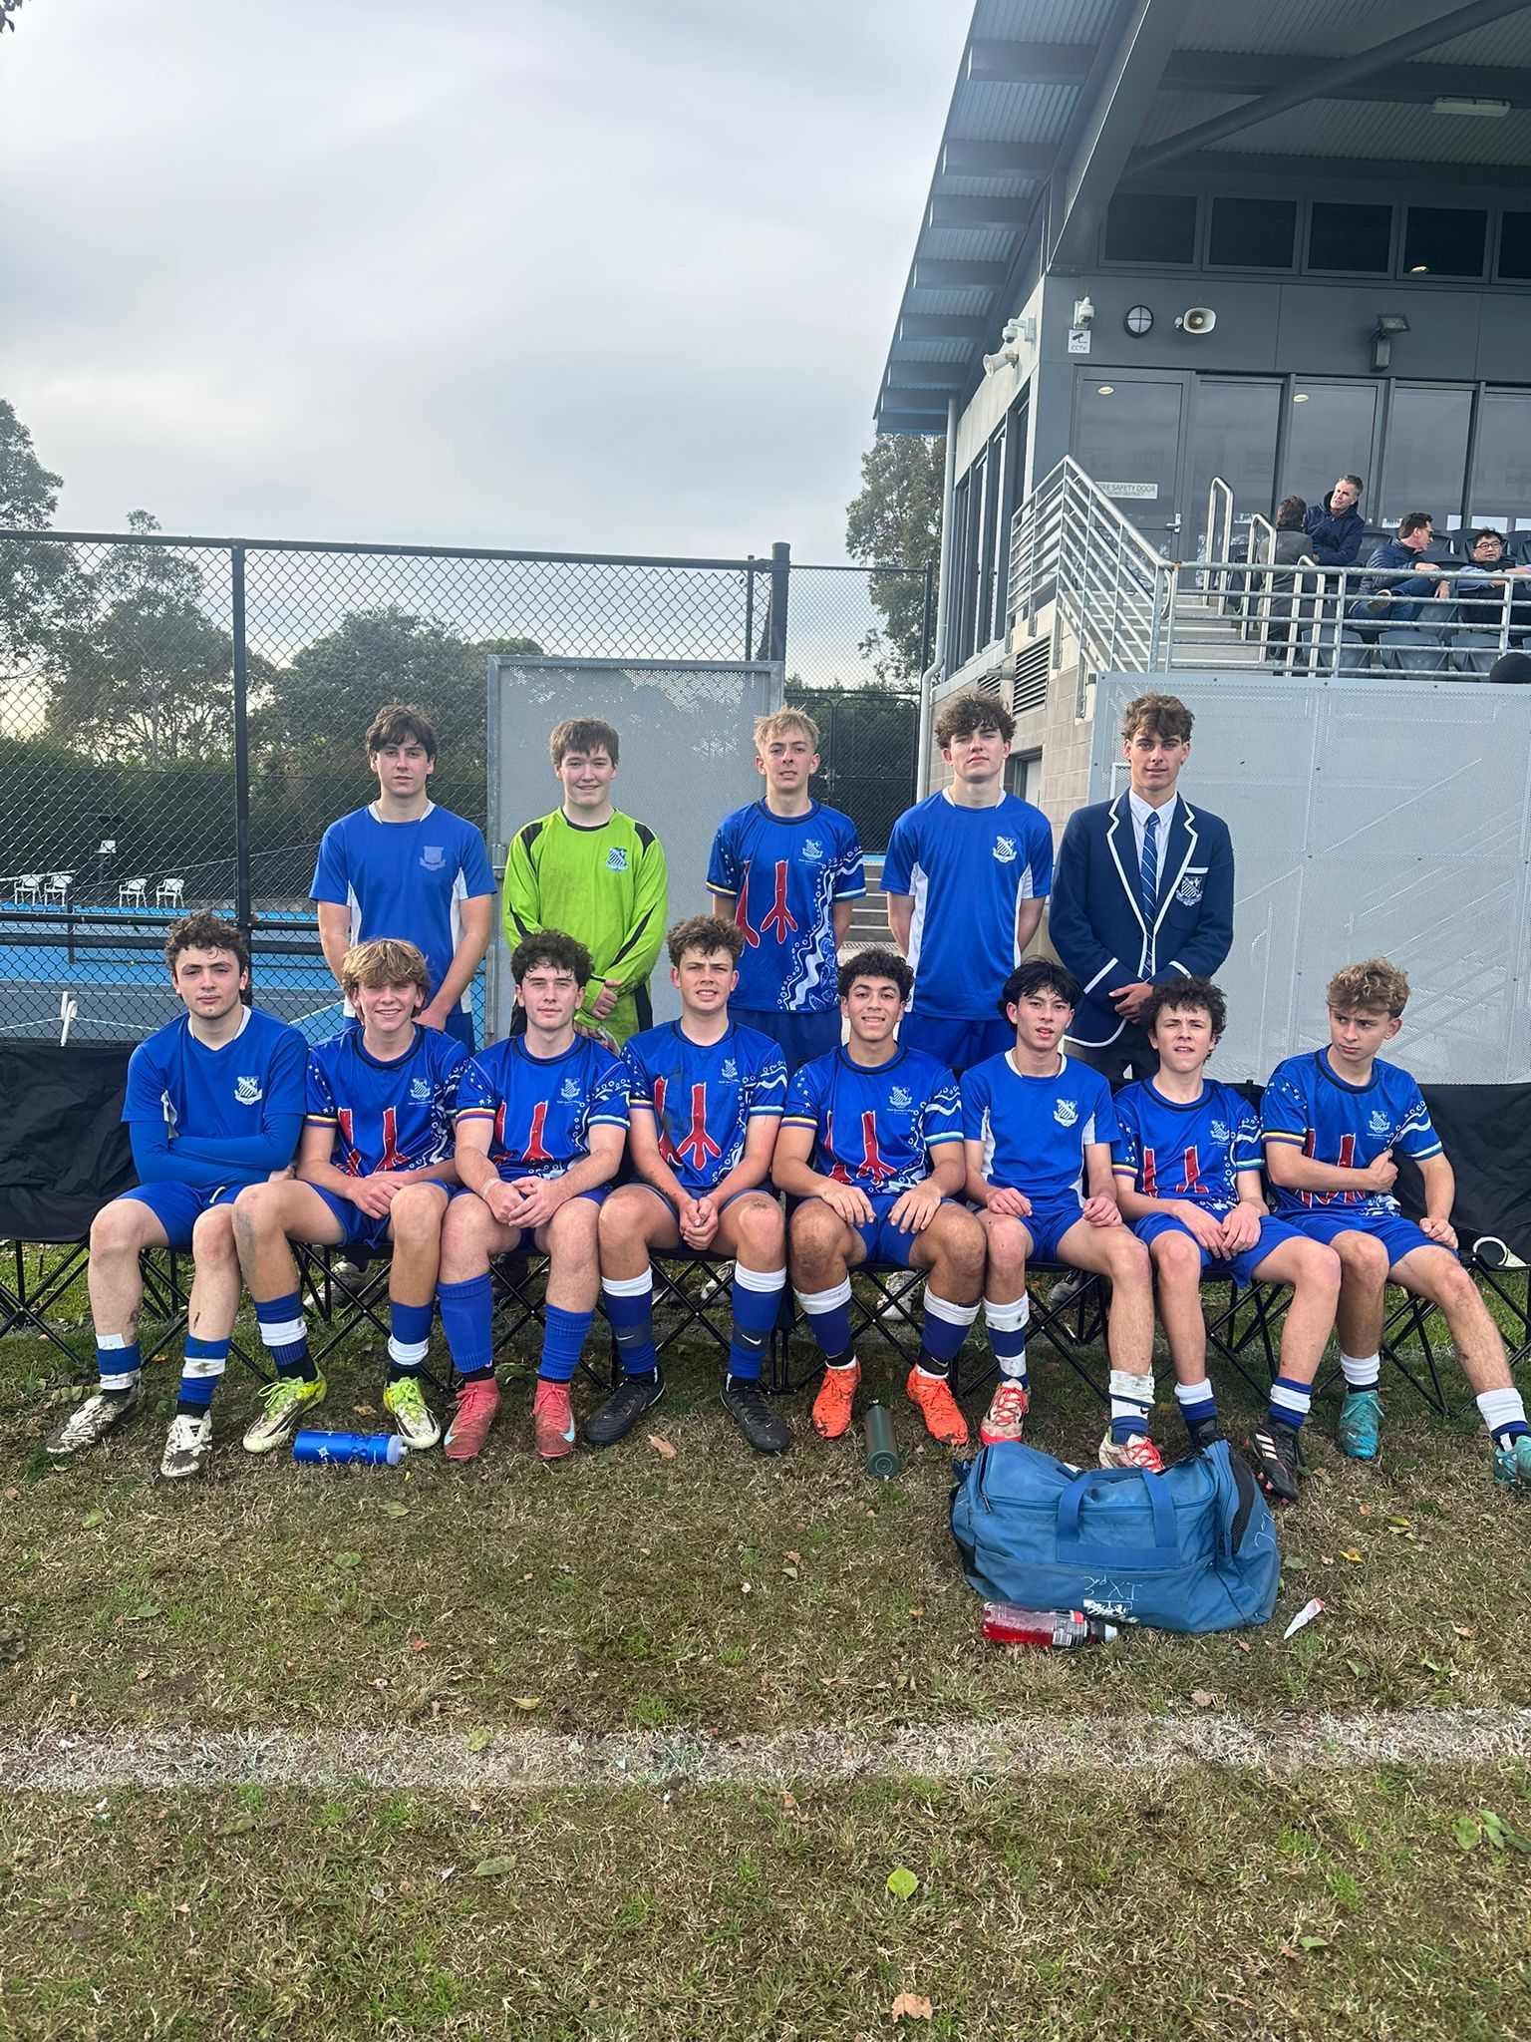
3rd Match Report: Coach Andrew Ferrara
The Thirds had a strong display and were unlucky to not be victors on Saturday morning. Despite missing training due to the wet the team aimed to play more as a team, be more aggressive and look to take our chances and despite missing a few chances I think the team did well. In the first half we played quite well but we were a little disjointed and there was a lot of transition. We conceded a soft goal in the first half of their only attack. Later Brendan pounced on an error from their keeper to make it 1-1. In the second half we drastically improved as we created more chances and had a stronger control of the game. In the end we were unlucky to not win.

