
Riverview Football Program - Match reports Saturday 9th, May 2026
YEAR 7
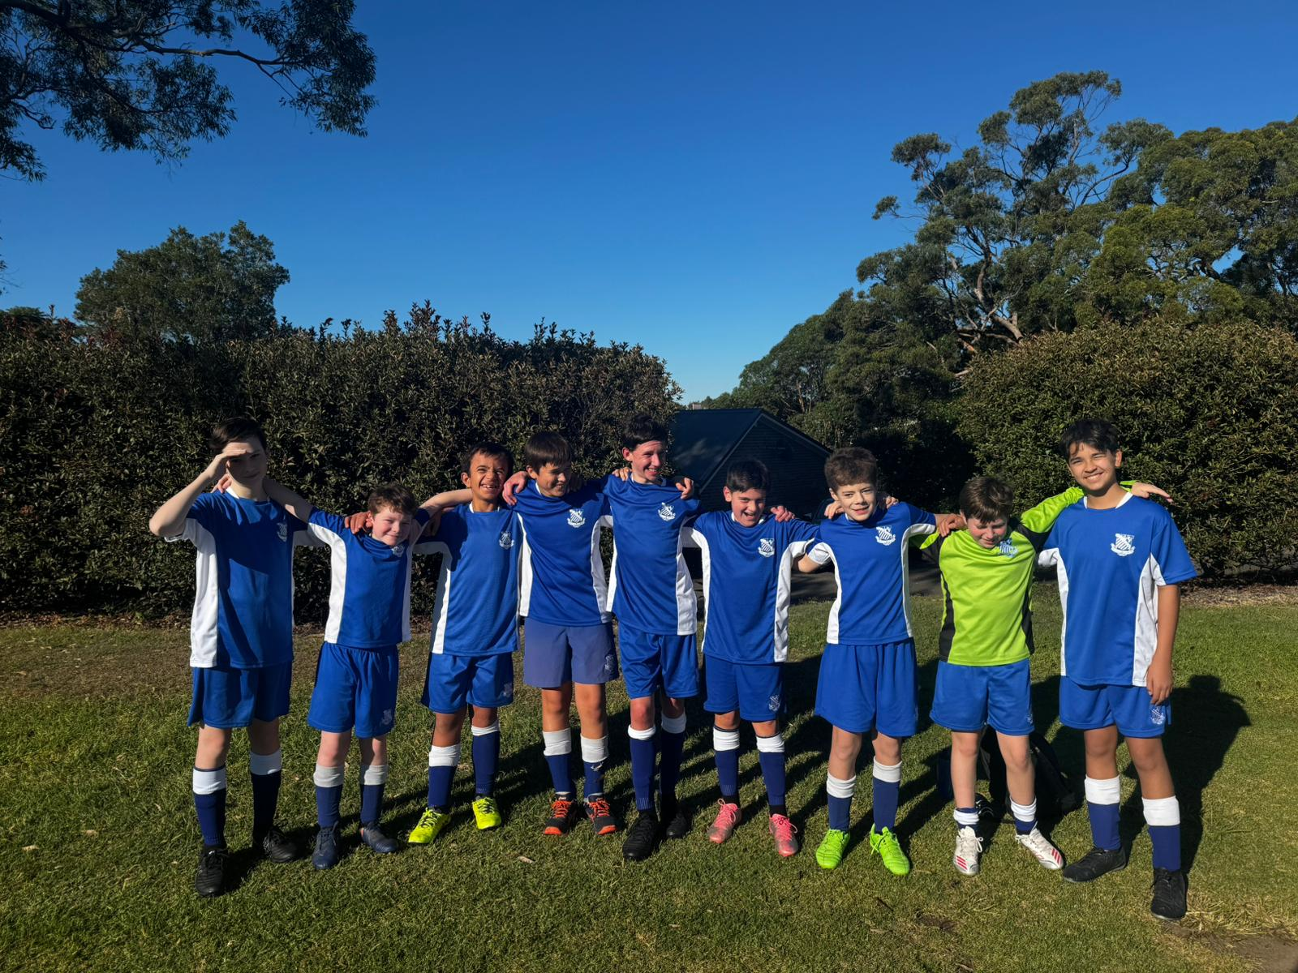
13F Match Report: Coach Sam Burkitt
Despite the 9–2 scoreline, the 13 Fs should be extremely proud of the effort and attitude they displayed against a strong Reddam House side. The boys tried their best the whole game, never dropping their intensity no matter the score line. The team continued to encourage each other and play with determination the entire game. The group’s attitude and commitment were outstanding and provide a strong foundation moving forward.
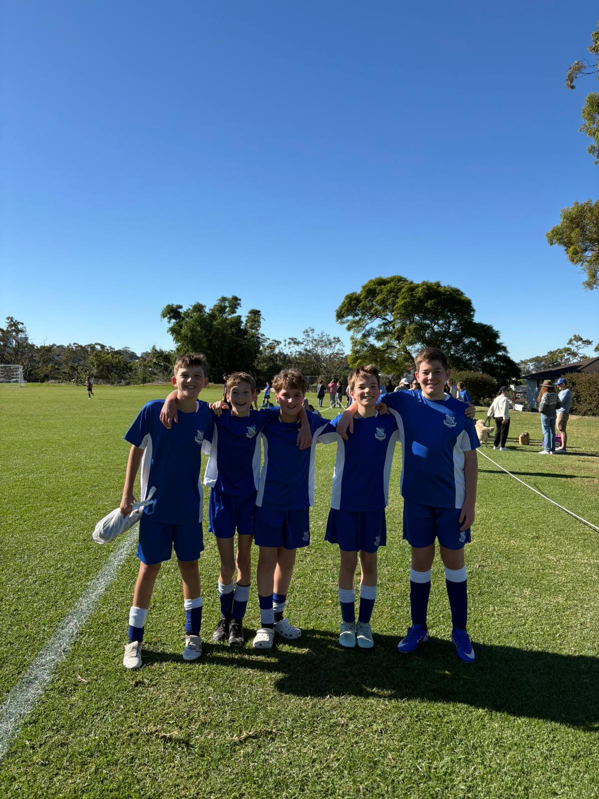
13E Match Report: Coach Joseph Salameh
Today’s game against Reddam was a hard-fought loss. From the beginning, Reddam set the tone, dominating the first half completely. While things were looking gloomy initially, the boys kept a positive attitude and kept smiling through it all. Eventually, Ezekiel was able to score an amazing goal while their keeper was pushing out too far! This brought the mood up quite a lot and the boys brought the energy in the second half, dominating for most of it. While the first half was a rough 7-1 to Reddam, Riverview was able to put up a tightly contested 3-3 second half thanks to an all-round effort. Starting with Liam in goals, Will working hard on defence, all the mids running hard, Callum dominating the wing, we had a very strong performance. James had a very good goal deflecting the goal keepers kick and it rebounded right into goal! We have lots to work on at training this week to put us right back in the win column.
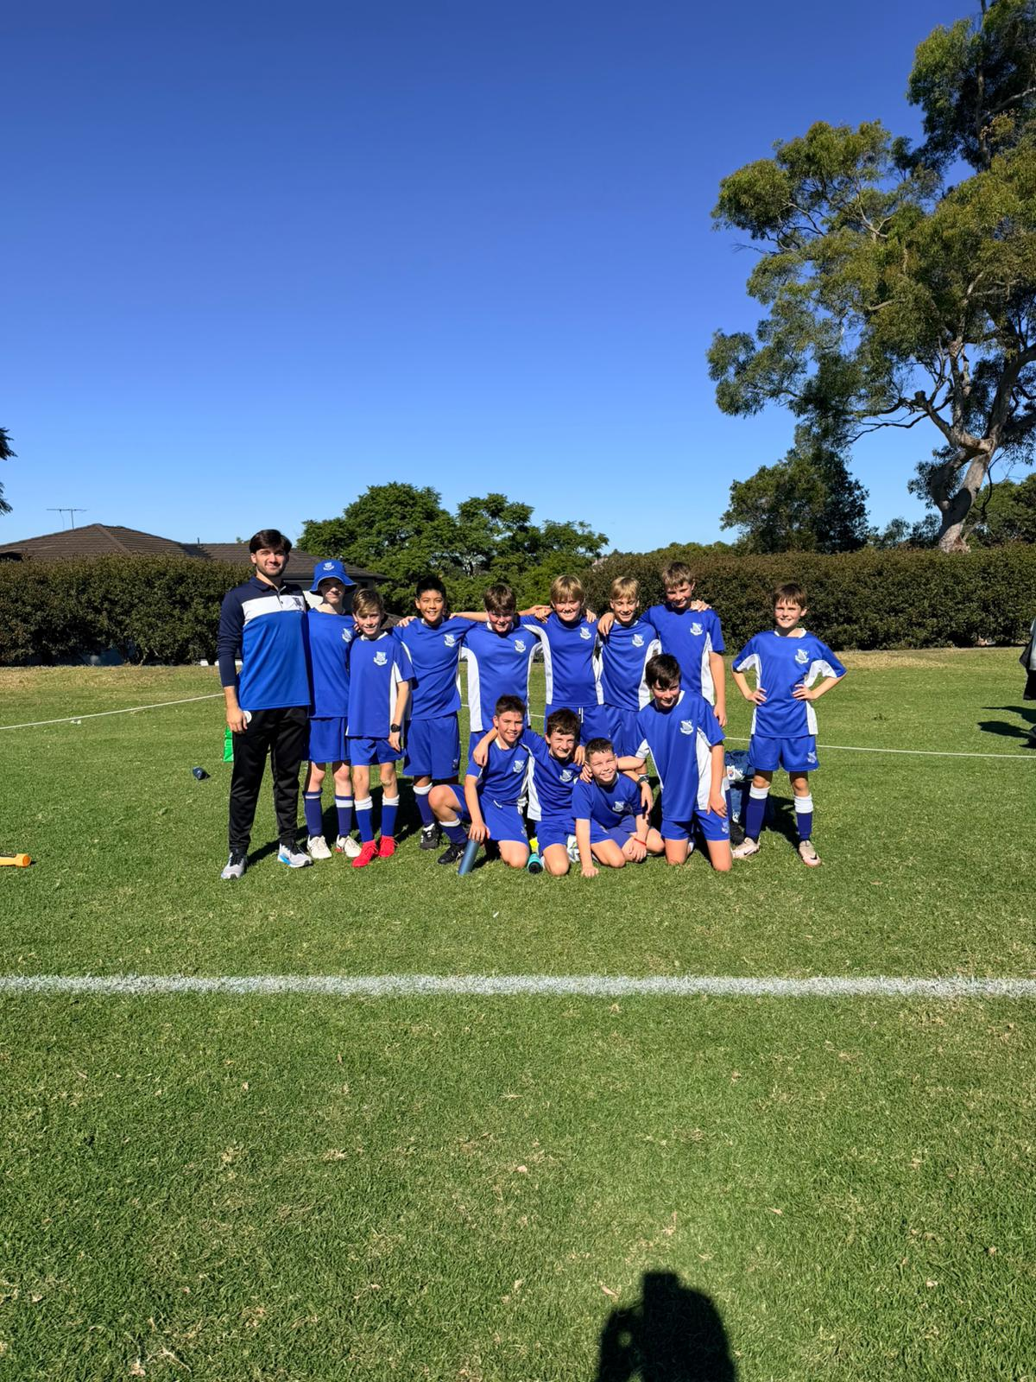
13D Match Report: Coach Michael Portale
Despite the 8–2 result against Reddam, the 13Ds displayed resilience, determination, and a positive attitude throughout the match. The boys continued to compete strongly until the final whistle and created several encouraging attacking moments, scoring two well-worked goals through committed play and persistence. While the result highlighted areas for improvement, particularly in defensive organisation, communication, and maintaining possession under pressure, the team remained united and continued to work hard for one another. The group will take valuable lessons from this performance, remain positive, and continue focusing on development at training and in future fixtures.
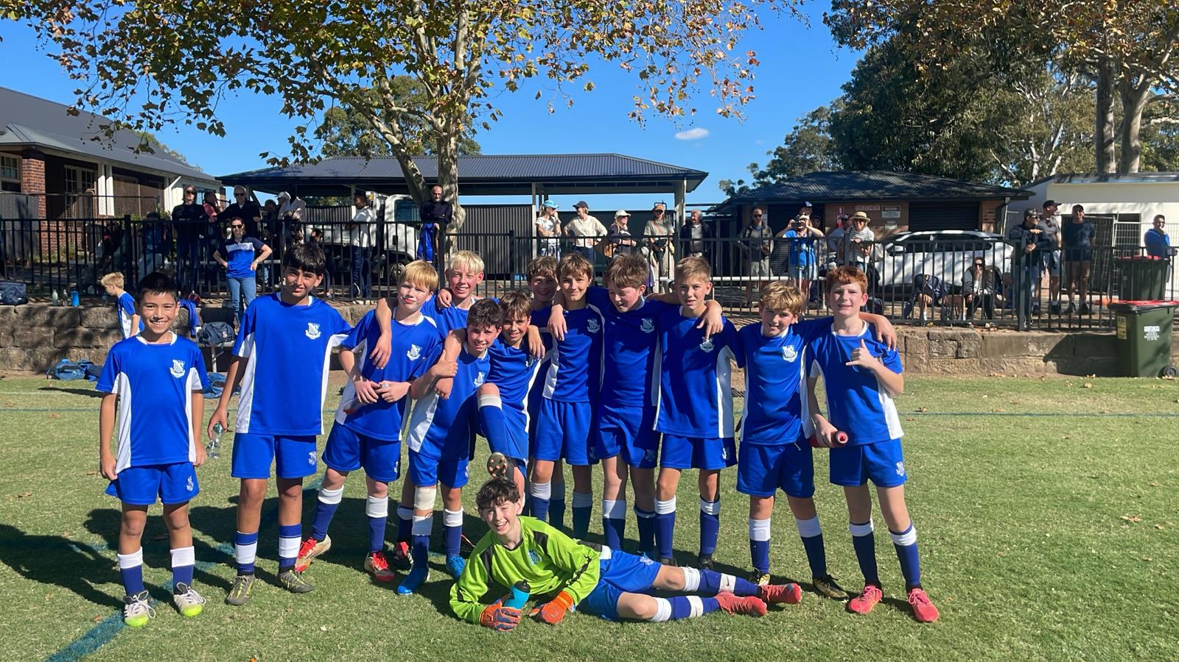
13C Match Report: Coach Nelson Meehan
Another excellent performance from the U13Cs as they took on Joeys. Riverview made a strong start, racing to a 4–0 lead within the opening 20 minutes and maintaining that advantage heading into half time. The second half began more evenly, with both teams starting slowly as Riverview defended strongly to deny several Joeys opportunities and preserve the four-goal lead. As the game progressed and spaces began to open up, Riverview capitalised with some well-taken chances, adding a further five goals to their tally. Although the team conceded once in the second half, the final 9–1 result reflected a highly impressive all-round performance. The boys should be commended for their attacking intent, defensive effort, and teamwork as they remain undefeated heading into Round 3.
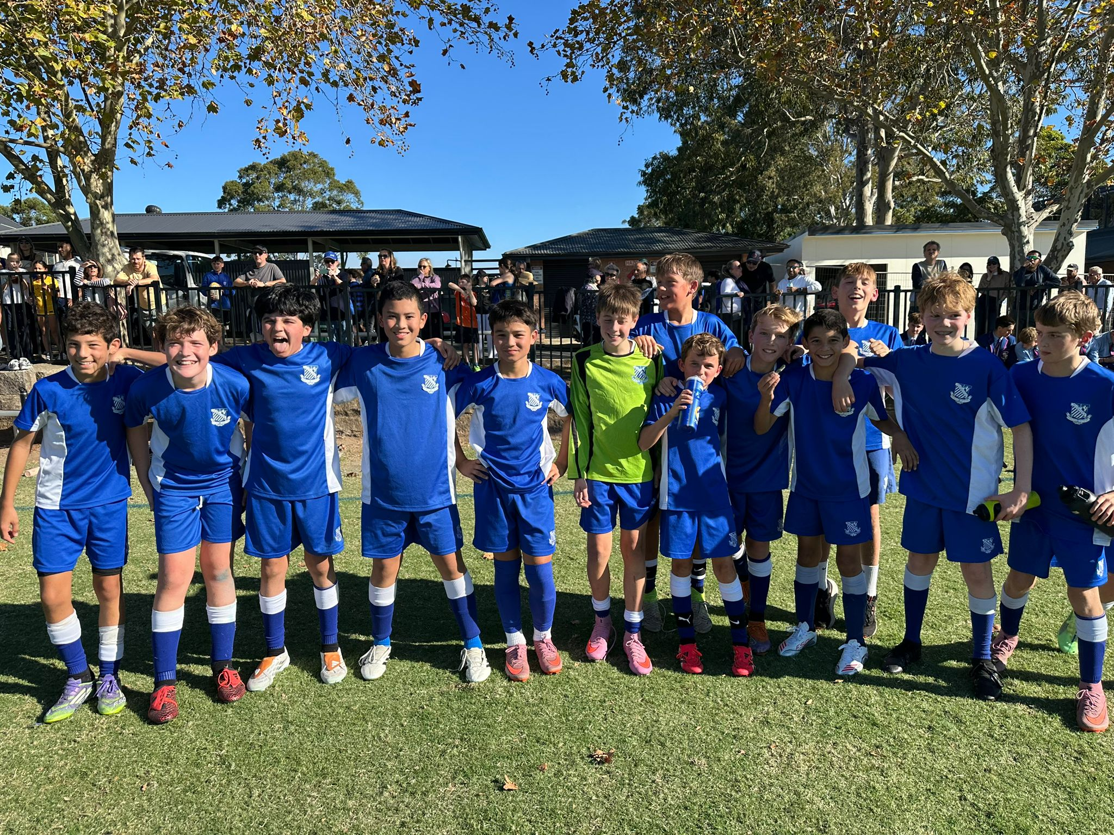

13B Match Report: Coach Josh Engelmann
The 13B’s produced a dominant team performance in a strong win over St Joseph’s College. From the opening whistle, Riverview played with energy, confidence and control, creating chances through quick movement and sharp attacking play. Sweets opened the scoring from outside the box before Darcy added another from a corner, setting the tone for the match. Josh was clinical in front of goal, including a brilliant slide tackle finish and a composed bottom-corner strike, while Edward impressed with a goal of his own, a clever floating shot and some excellent skill in the box to create another. Declan and Alistair also got on the scoresheet to complete a convincing attacking display. Defensively, Francesc and Paul were outstanding, staying switched on and shutting down Joseph’s chances before they became dangerous. Harry and Xavier were also excellent on the wings, giving Riverview width, pace and constant attacking threat. A brilliant all-round performance finishing in a 9-1 victory.
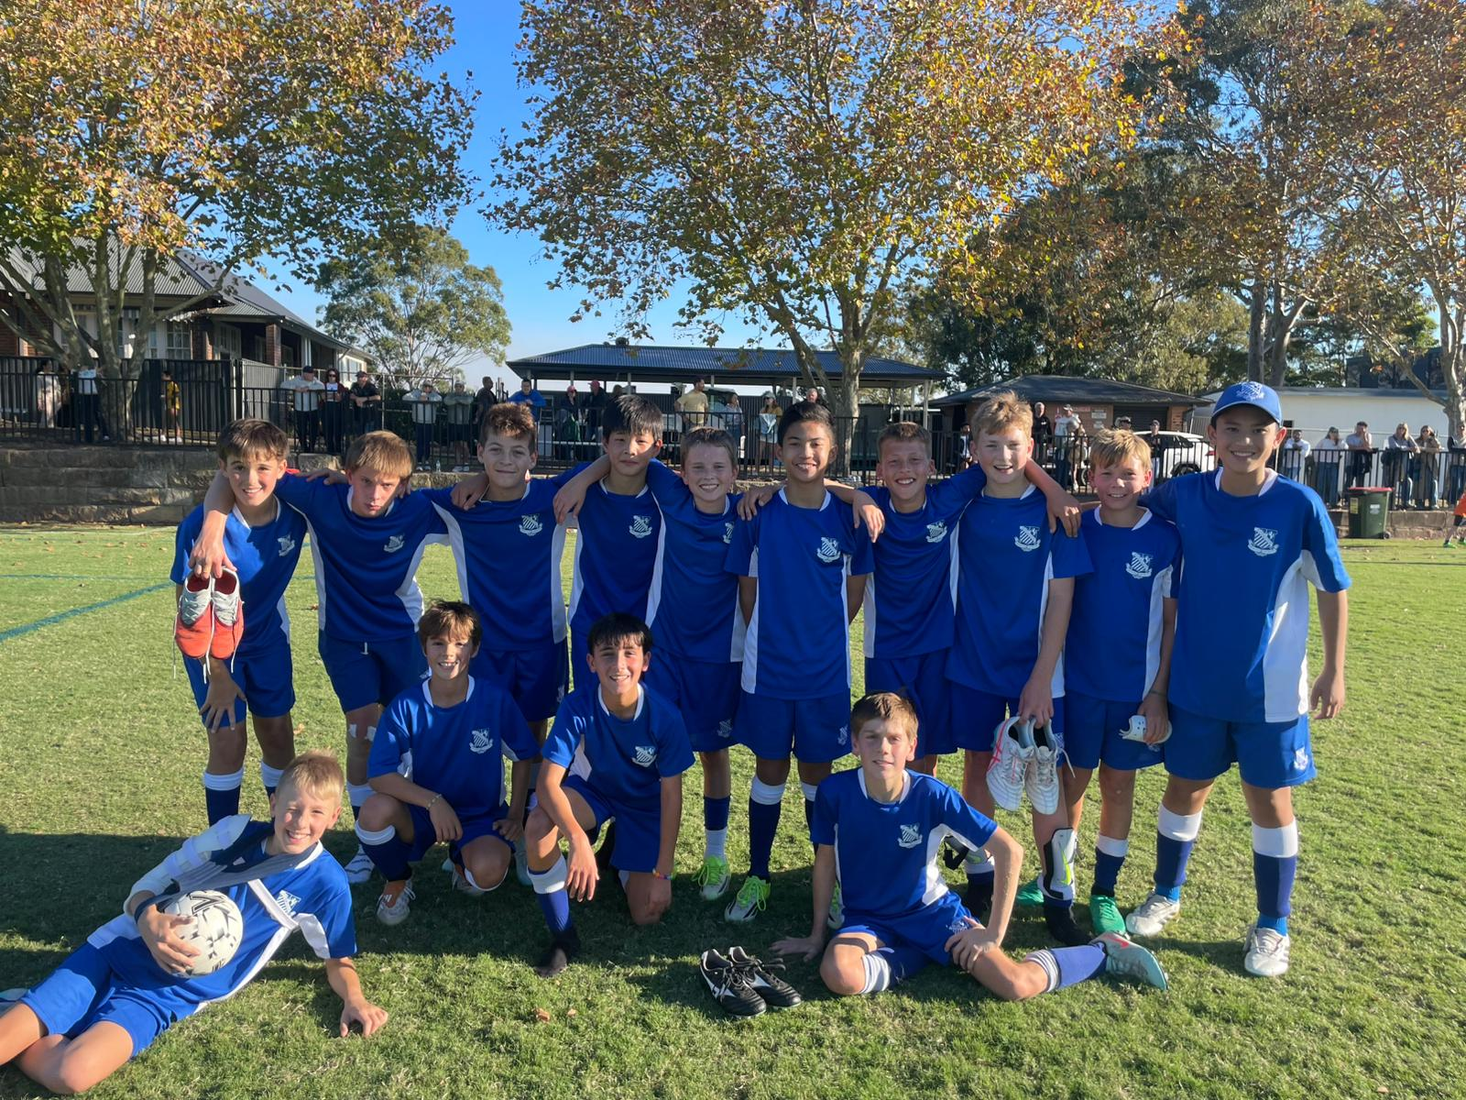

13A Match Report: Coach Lewis Morsella
The game on the weekend was a very close and exciting contest, a real thrill for everyone involved. The match started with Joeys scoring first, a well-taken goal that would have been difficult for any goalkeeper to stop. Riverview responded immediately, showing great character to bring the score back to 1–1, which is how it remained until half time. The second half saw Riverview start strongly, scoring early and building real momentum. From there, the boys played some excellent football, showing confidence in possession, strong teamwork, and attacking intent to control the game and secure the win. Neal was named Man of the Match after a standout performance, consistently contributing across the pitch and influencing the game in key moments. Overall, the players responded well to the feedback from the week, applying it effectively in their performance. It was a strong team effort, and the group will look to carry this momentum into the coming week.
YEAR 8
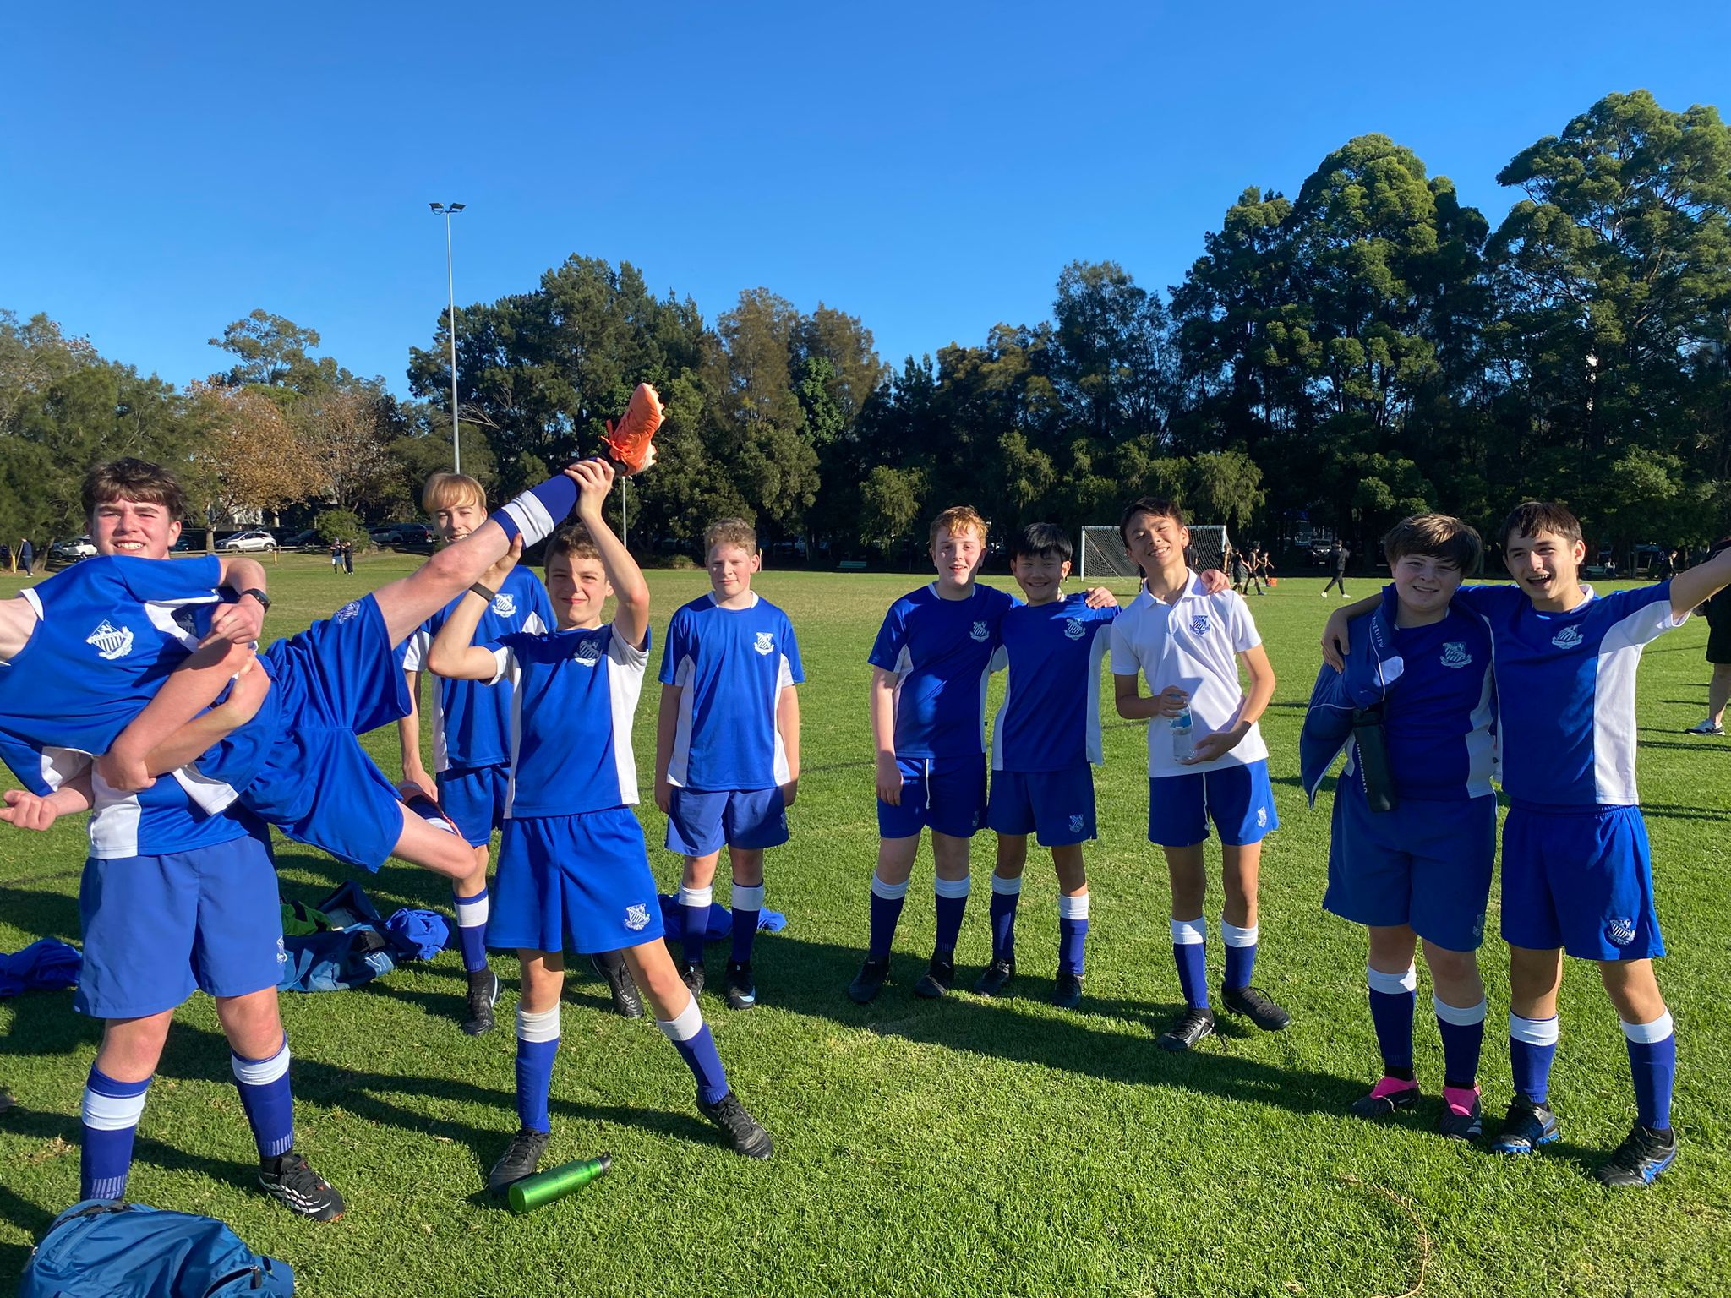

14D Match Report: Coach Matthew Chung
The St Ignatius’ 14Ds took on St Patrick’s in what proved to be an action-packed match filled with intense moments and individual brilliance. Our forwards, Noah and Fergus, were standout performers throughout the game, both showing excellent pace and composure in driving the ball into the final third. Fergus, in particular, played a key role in both goals. The opening goal saw him dribble past the opposition backline, using his speed to create a one-on-one opportunity with the goalkeeper, which he calmly converted. The second goal followed a similar pattern, with Fergus again using his pace and skill to set up another confident finish. In midfield, Sam, Flynn, and Byron worked tirelessly, contributing strongly in both attack and defence. Their work rate and pressure on the opposition helped the team transition effectively from defence into attack and maintain competitiveness throughout the match. The backline of Angus, George, Hamish, Marren, and Julian also put in a determined performance, working hard to limit the opposition’s opportunities against a strong St Patrick’s side. Overall, it was a spirited team effort with many positive passages of play and encouraging individual performances across the park.
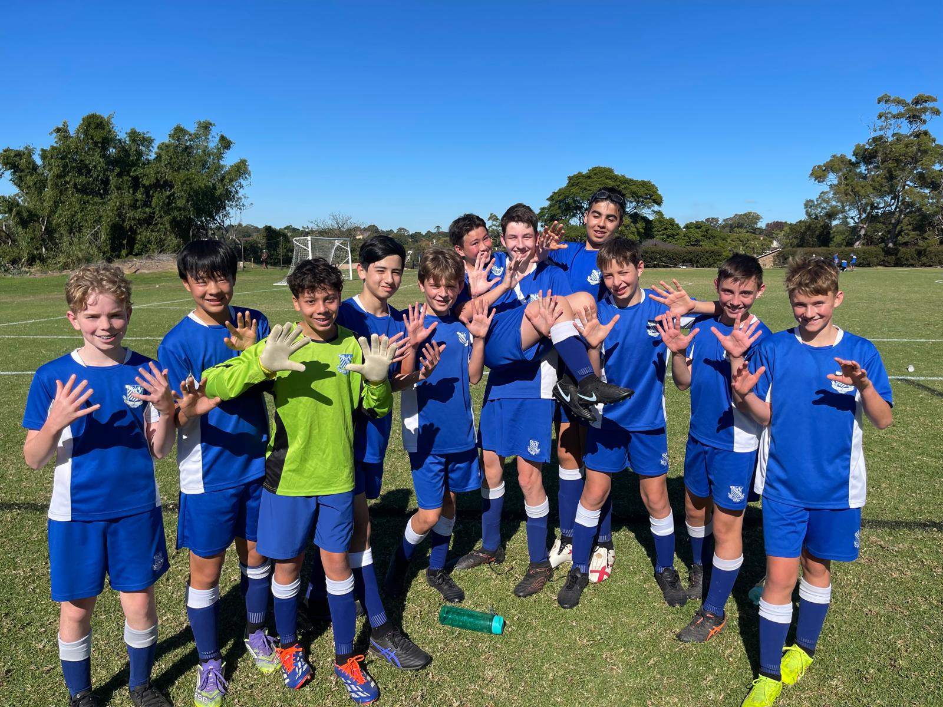
14C Match Report: Coach Tom Kalogerou
Riverview U14Cs produced an outstanding performance against Joeys, running out convincing 10–1 winners. From the opening whistle, Riverview played on the front foot, applying constant pressure and creating numerous scoring opportunities. Early on, a few players seemed more focused on hitting the crossbar than finding the net, but once Charlie McDonald opened the scoring, the floodgates well and truly opened. Goals followed through Henry Hayduk, Curtis Liu with an excellent hat-trick, Jack Malouf, Toby Pool with two goals, Seb Richards, and Marcus Strano. Riverview’s passing and movement throughout the match were exceptional, with the team switching play effectively and breaking down the opposition through sharp combinations and intelligent runs into the final third. The second-half two-touch football was particularly impressive, creating fast, fluent passages of play that were a pleasure to watch. It was a brilliant all-round team performance and an excellent platform to continue building from in the weeks ahead.
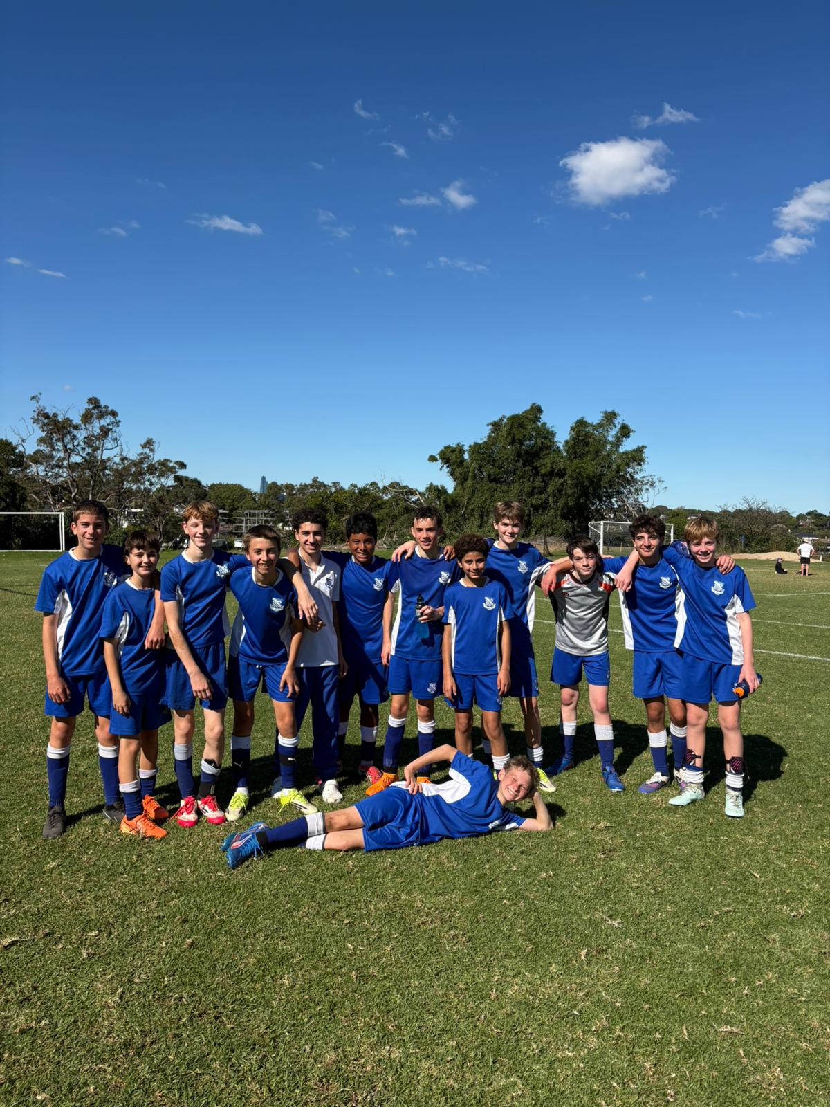
14B Match Report: Coach Lachlan Iacono
Joeys were applying early pressure that kept the ball in our half for most of the first 10 minutes of the game. This was followed by a well deserved goal from Joeys from a clearance that caught our defence off guard, leaving the Joeys forwards 1v1 with Callum in goals - opening the scoring at 1-0. Just before the half, Riverview strung a few passes together and over the top to Noah Gatt, which Joeys deflected out for a corner. Javier played a world class cross finding Daniel Musso at the back post, drawing the game at 1-1 for the half. The second half saw a number of opportunities for both sides, few a lot of transitional moments. Callum narrowly kept us in the game with a few amazing saves and one particularly notable sweep in which he left his box to collect. Within the last 5 minutes, a ball played over the top went too far, which the Joeys goalkeeper attempted to claim. With a stroke of luck, the goalkeeper missed the ball, leaving Charlie to finish it and end the game 2-1.
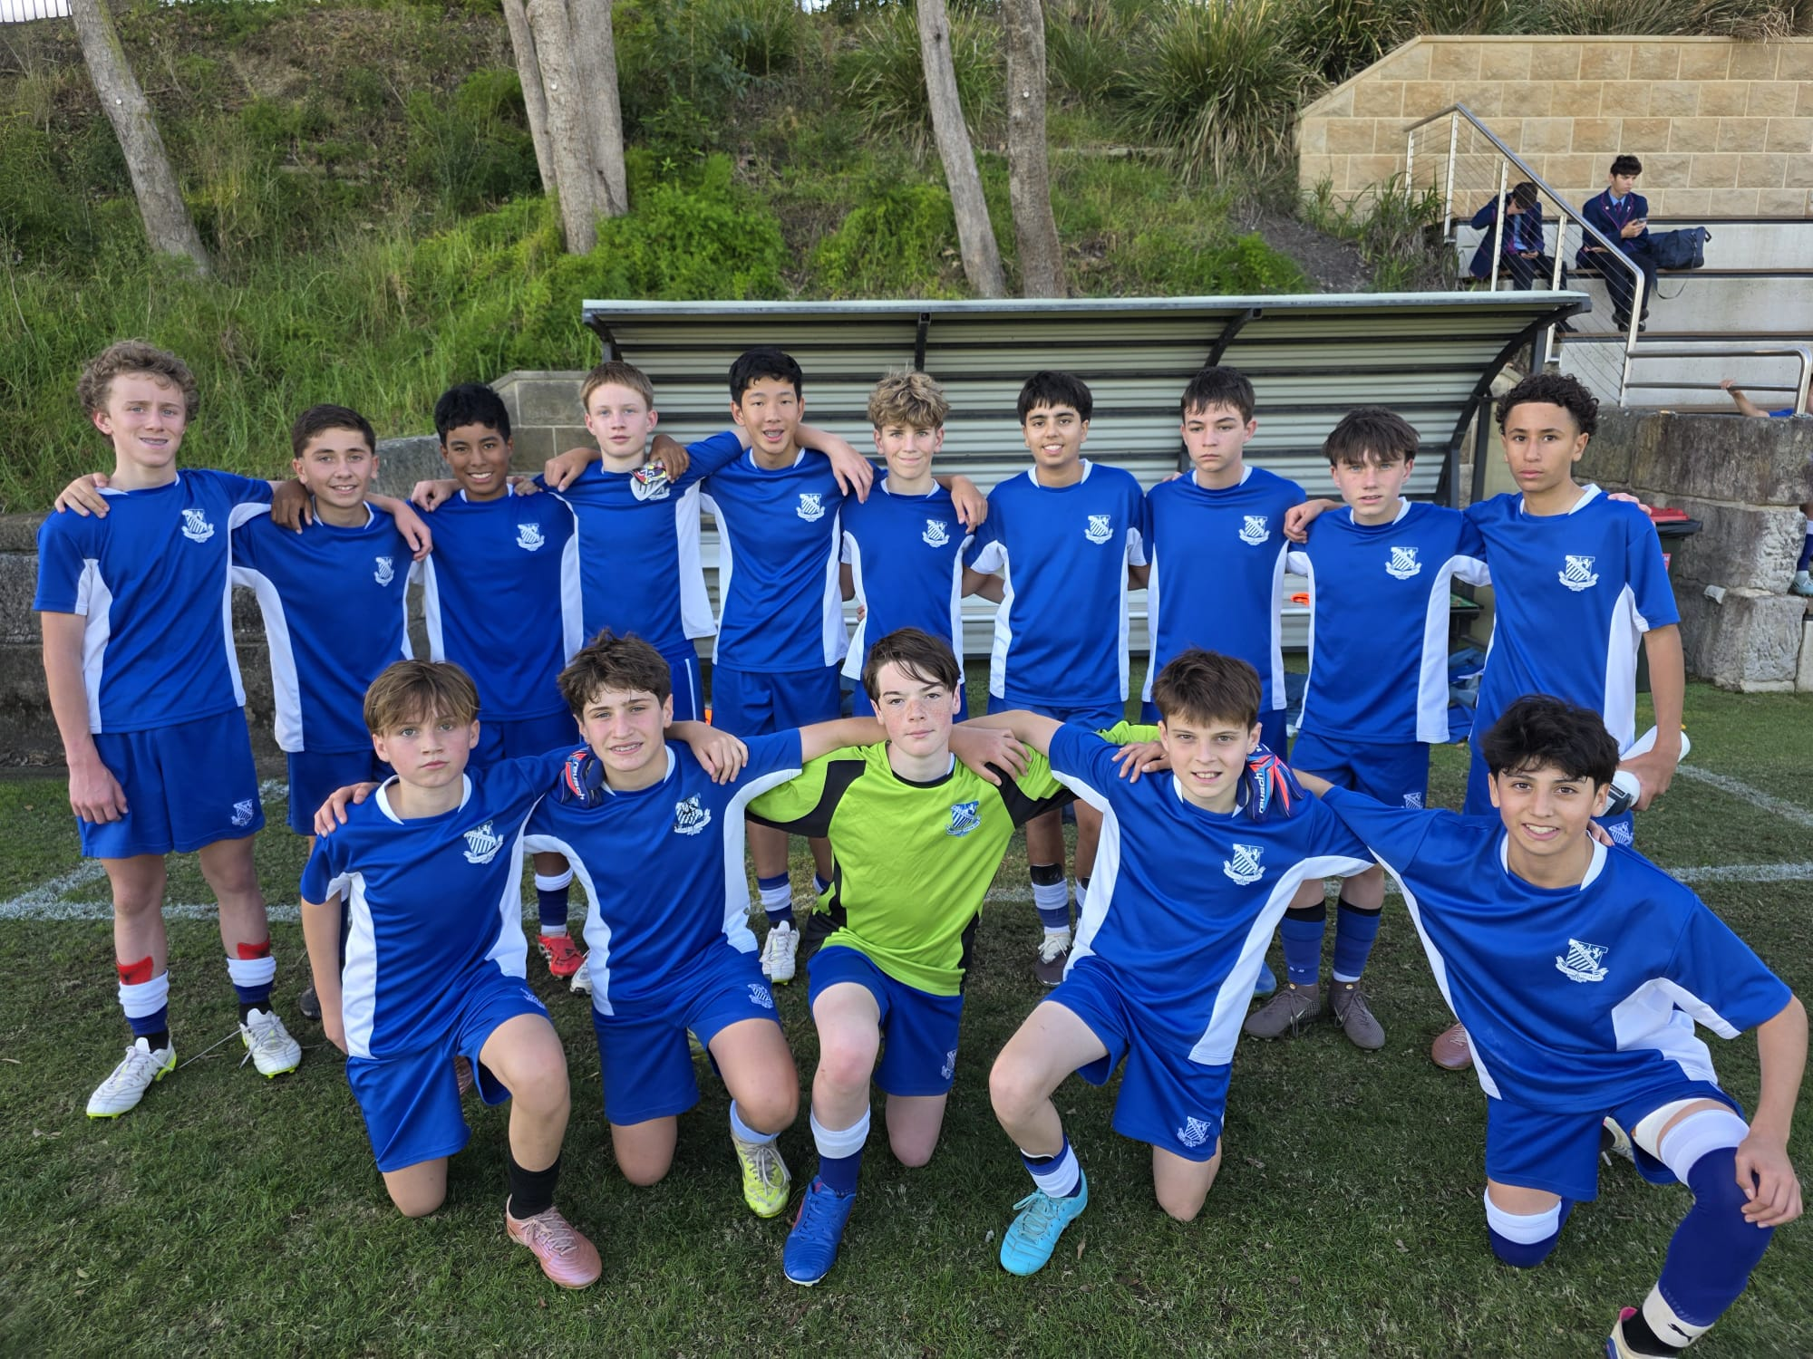
14A Match Report: Coach Domenico Garreffa
St Ignatius’ 14A XI suffered a frustrating 1–0 defeat against Joeys despite producing a dominant display for large periods of the match. From the opening whistle, Ignatius controlled possession and consistently found dangerous spaces in and around the attacking third, creating numerous opportunities inside the penalty area. However, despite the team’s attacking pressure and quality build-up play, they were unable to find the finishing touch needed to reward their performance. The decisive moment came from a brief lapse in concentration, allowing Joeys to capitalise and score what proved to be the winning goal. While the result did not reflect the overall balance of play, there were many positives to take from the performance, particularly the team’s control, intensity, and ability to consistently create chances throughout the game. It was a match that highlighted the fine margins in football, with efficiency in both penalty areas ultimately making the difference on the day.
YEAR 9
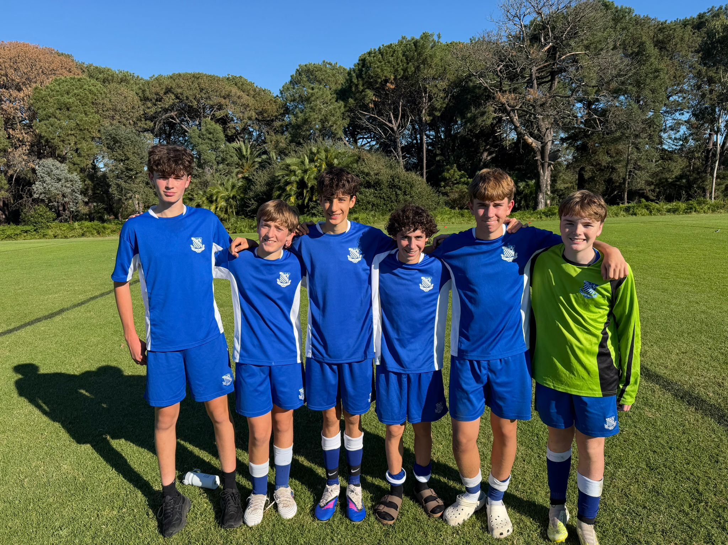
15A Match Report: Coach Travis Cooper
We were left frustrated after a narrow 1–0 defeat to Sydney Boys High School. Our opponents struck early, which meant we were chasing the game for the majority of the contest. Despite the setback, I thought we created enough chances to get ourselves back into the match. We had several promising opportunities and I felt that if we could find one goal, the momentum would swing firmly in our favour and the floodgates might open. Unfortunately, that breakthrough never came. In patches, we played some very good football and moved the ball with purpose. In the second half, we committed more numbers forward in an effort to force an equaliser and put Sydney Boys under sustained pressure. Our best chance came in the final minute when Aiden rose well to meet a header, only to see it go agonisingly close. It was a disappointing result, but there were plenty of positives to build on.
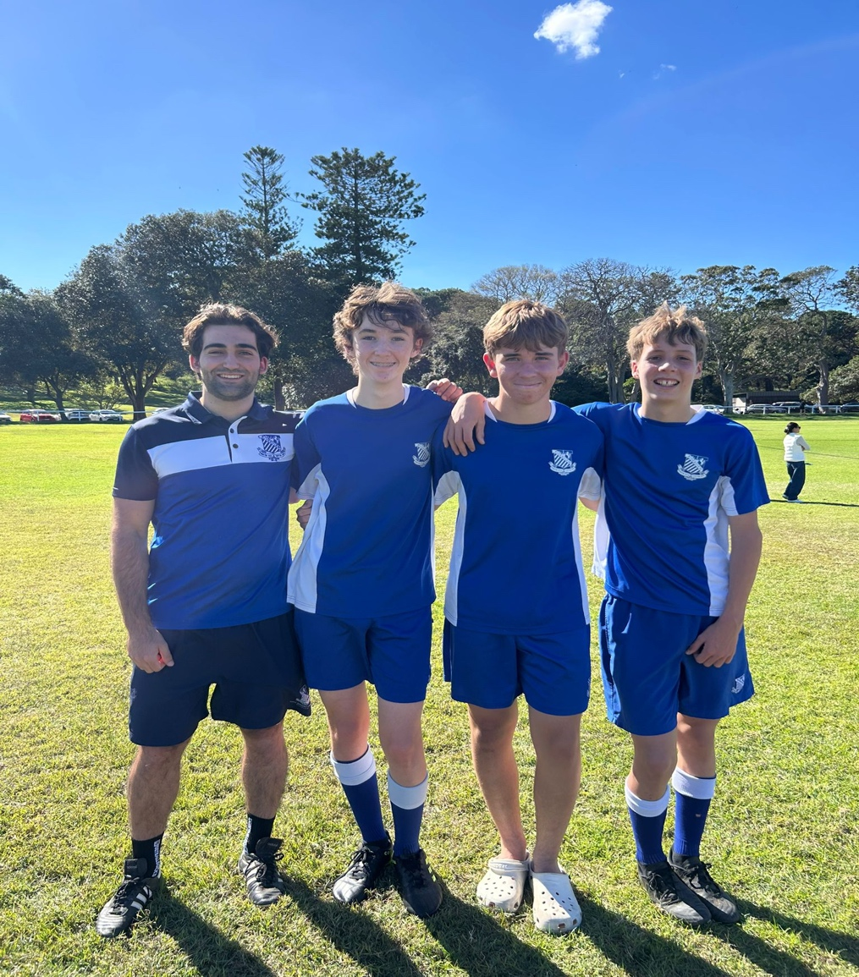
15B Match report: Coach Jonathan Codemo
After a strong first half, the boys lifted their intensity even further after the break and took full control of the tempo of the game. The second half featured sharper passing, improved composure in possession, and an even stronger defensive work rate across the pitch. All three goals were excellent examples of team football, each created through well-constructed build-up play and finished with confidence and precision. The ability to work through phases of play and execute in the final third highlighted the team’s growing cohesion and understanding. Overall, it was a highly disciplined and entertaining performance that reflected the boys’ teamwork, determination, and attacking quality, as well as their continued development as a unit.

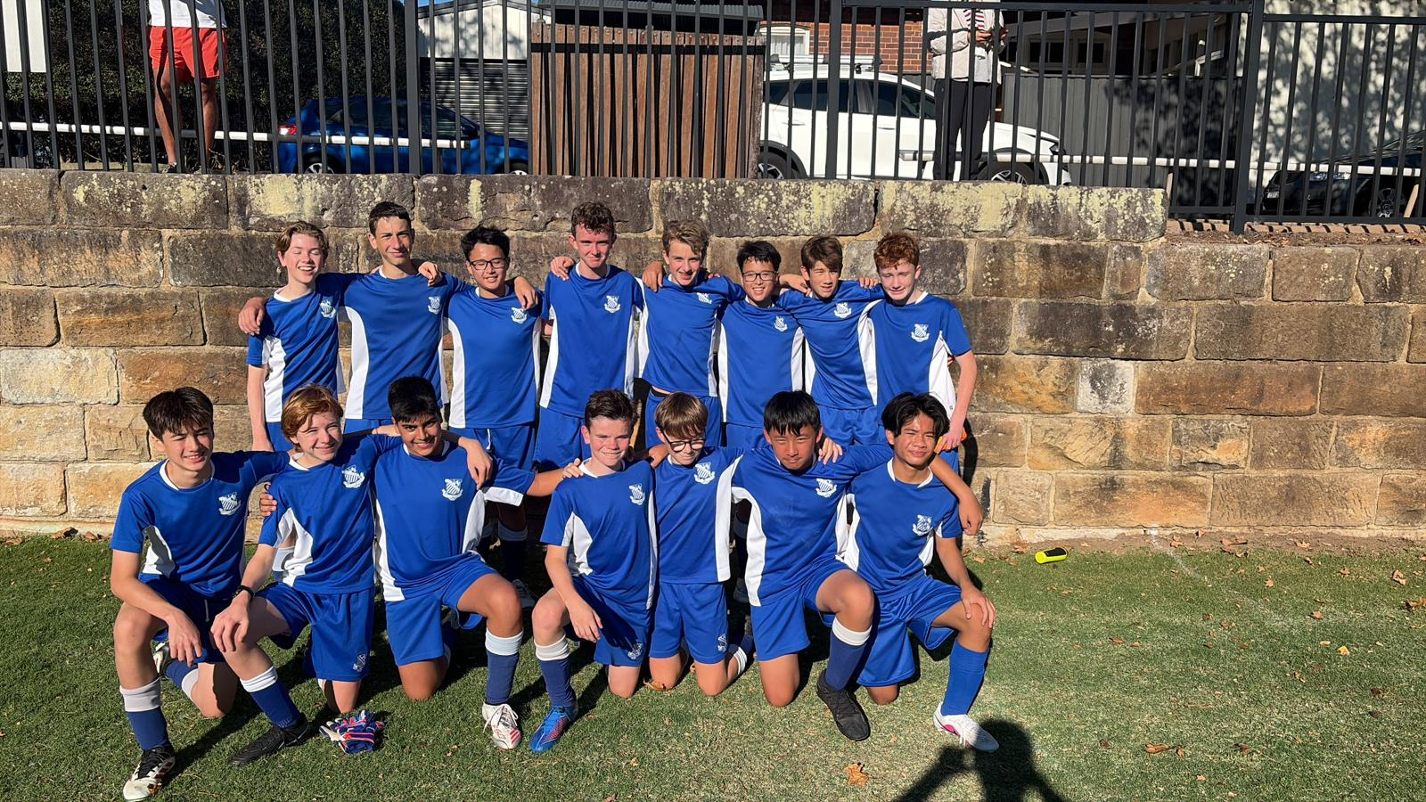
15C Match Report: Coach Cooper Sintras
After a dominant and disciplined performance against Joeys, the 15Cs were unfortunate to come away with only a single point following a 1–1 draw. Riverview controlled large periods of the match, showing composure in possession and creating numerous scoring opportunities through strong combination play and attacking movement. Despite generating several clear chances throughout the game, the boys were unable to find the finishing touch needed to turn their dominance into a winning result. Thomas Saadat scored Riverview’s only goal with a well-taken finish, rewarding the team’s sustained attacking pressure. Defensively, the side remained organised and worked hard to limit Joeys’ opportunities, while the midfield maintained strong intensity and control throughout the contest. Although the result was disappointing given the balance of play, there were many positives to take from the performance, particularly the team’s work rate, structure, and ability to consistently create chances. The group will look to build on this encouraging display heading into the coming rounds.

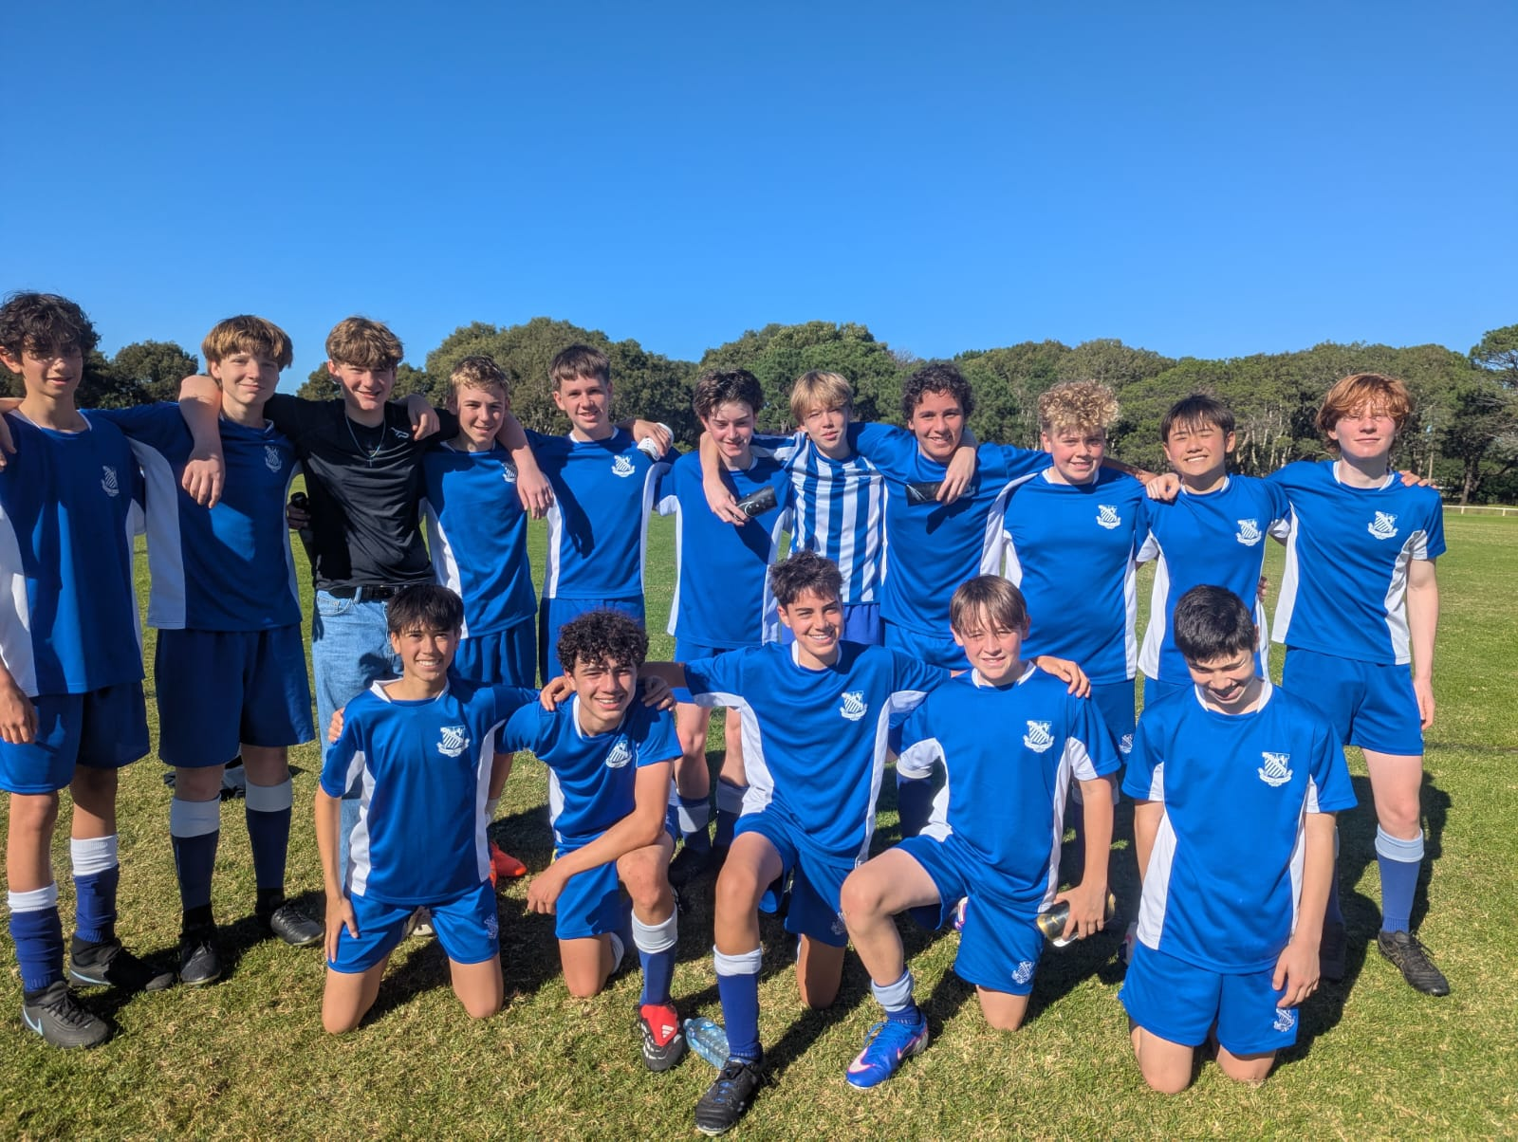

15D Match Report: Coach Alexander Mansfield
The 15Ds faced a tough challenge against a strong Sydney Boys High C team. Despite the difficult contest, the boys demonstrated resilience, perseverance, and a positive attitude, continuing to compete with determination until the final whistle. Standout performances came from Nick Mian and Oliver Lee, who both made several important tackles and worked tirelessly under sustained pressure from the opposition attack. Their defensive commitment and willingness to battle throughout the match were a credit to the team. Up front, Ben Allan played with flair and energy as striker, using his pace effectively to make several dangerous runs in behind the defensive line. While the team was ultimately unable to convert their opportunities on the scoreboard, there were still encouraging signs in their attacking intent and overall effort. The group will continue to build on this performance and look to improve further in the coming weeks.
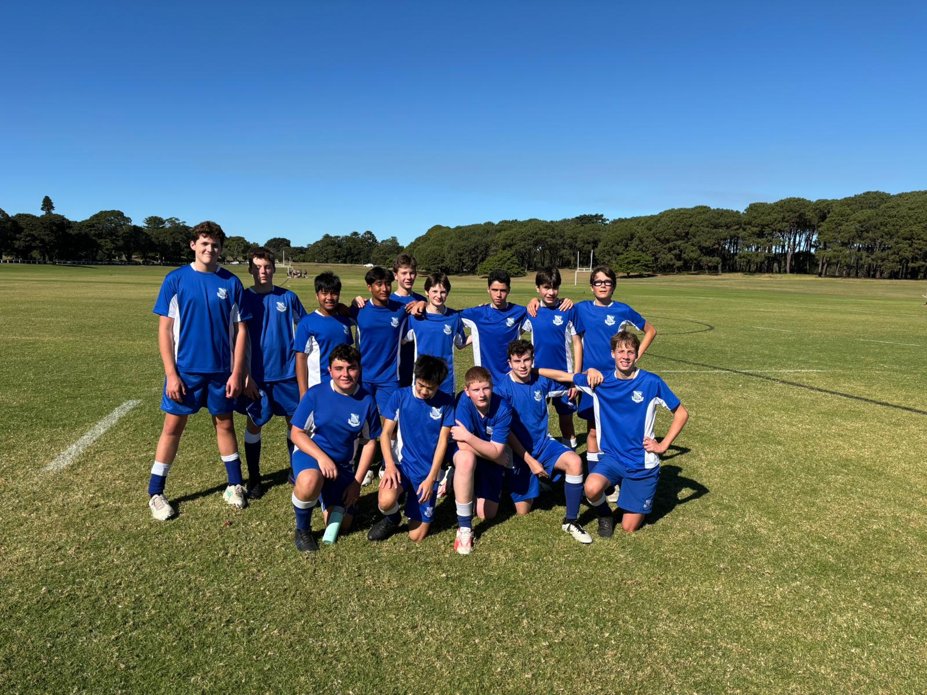

15E Match report: Coach Atticus Ireland
It was an unfortunate result in the opening game of the season, with the team falling to a narrow 2–1 defeat. Riverview conceded two goals in the first half and initially found it difficult to deal with the opposition’s pressure and intensity. However, the boys responded strongly after the break, showing great resilience, determination, and a much-improved performance in the second half. With ten minutes remaining, Riverview found a deserved goal to bring the game back within reach and continued to push forward in search of an equaliser. Despite creating several promising opportunities and striking the post on multiple occasions, the team was ultimately unable to find a second goal before full time. While the result was disappointing, there were many encouraging signs from the group’s response, attitude, and fighting spirit, providing a strong foundation to build on for the remainder of the season.
YEAR 10
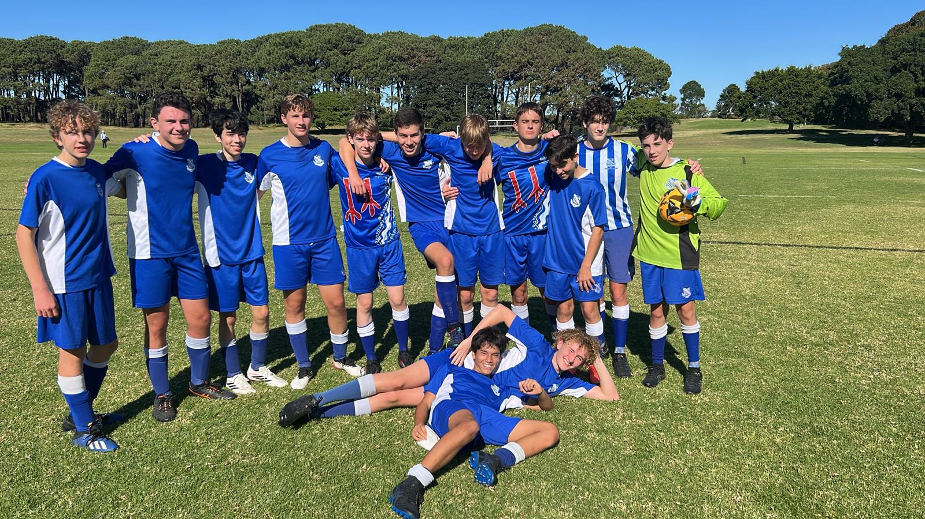
16D Match Report: Coach Jacob Stevens
The 16Ds faced a very strong opposition in a tough fixture, ultimately going down 12–0. Despite the difficult scoreline, the boys continued to show effort, determination, and a positive attitude throughout the match, never dropping their heads and working hard until the final whistle. There were still important learning moments within the game, particularly in defensive organisation, communication, and dealing with sustained pressure. The back line and goalkeeper were often under constant attack but continued to compete and try to limit further opportunities wherever possible. Most importantly, the team stayed together, supported one another, and showed resilience in a challenging situation. While the result was not what the group wanted, it provides a valuable opportunity to reflect, reset, and focus on improvement in training. With continued effort and commitment, the boys will look to build confidence and respond strongly in their next fixture.
16C Match Report (photo not available): Coach Marcus Kulukovski
The 16Cs played Reddam on Saturday, looking to secure their first win of the season. The boys started strongly, creating a number of early chances with Kyle Patterson and Nicholas Castagna both going close, narrowly missing the target. Riverview’s dominance continued throughout the first half and was rewarded with a quick Hugo Lennon double, giving the team a 2–0 lead at the break. In the second half, solid defensive work from Jack Costa and Kerr Chidgey allowed Riverview to continue building attacks with confidence and control. Hugo Lennon went on to complete his hat-trick, extending the lead to 3–0. Reddam managed to score late in the game, but Riverview responded quickly to restore control and make it 4–1. Jules Roche produced several excellent saves throughout the match to ensure Reddam were limited to just one goal. Overall, it was a strong and well-earned victory for the team, built on attacking quality, defensive organisation, and a positive team performance across the park.
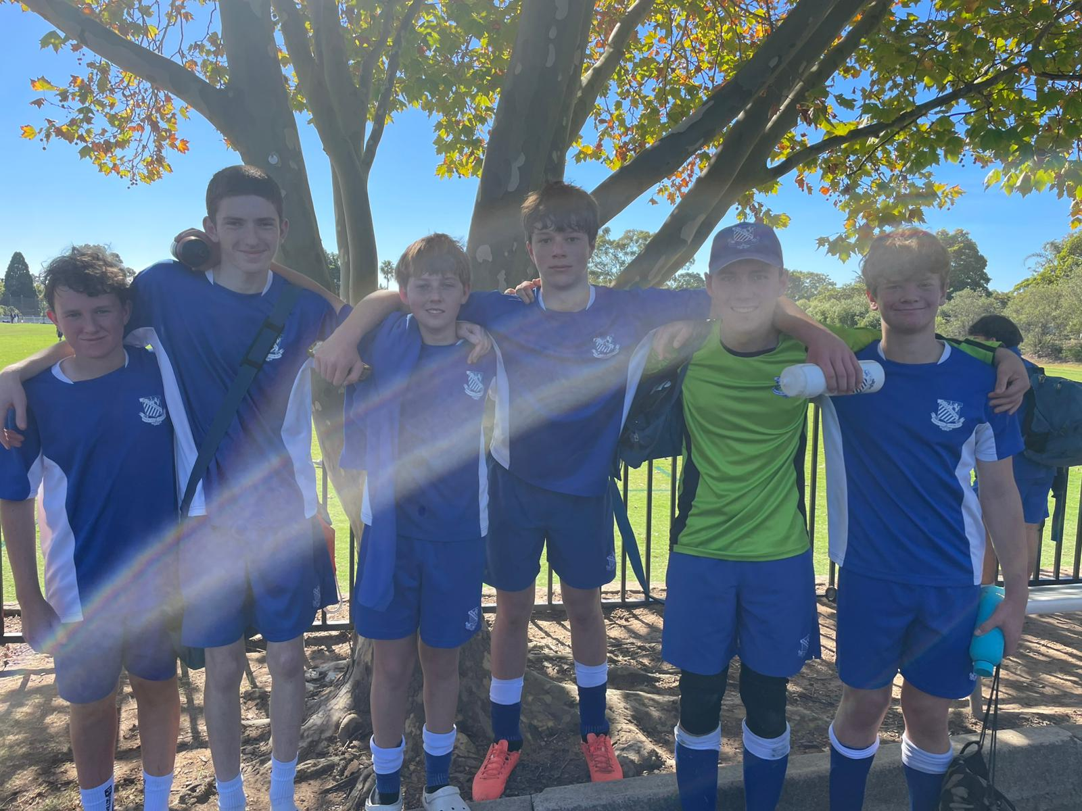
16B Match Report: Coach Stefan Visscher
A superb response to last week’s disappointment saw the side secure an impressive 2–0 victory over Joeys. The team showed far greater intensity, discipline, and determination from the opening whistle, producing a complete performance across the park. Freddie marked his debut as striker in perfect fashion, finding the back of the net to set the tone for the game. Bosco then finished the scoring with a composed finish to seal the win in the second half. Riley delivered an outstanding all-round performance and was deservedly named Man of the Match, leading by example with his work rate and composure throughout the game. The result reflected a significant turnaround in attitude and effort, with the team working far harder collectively and showing the quality they are capable of when fully committed.
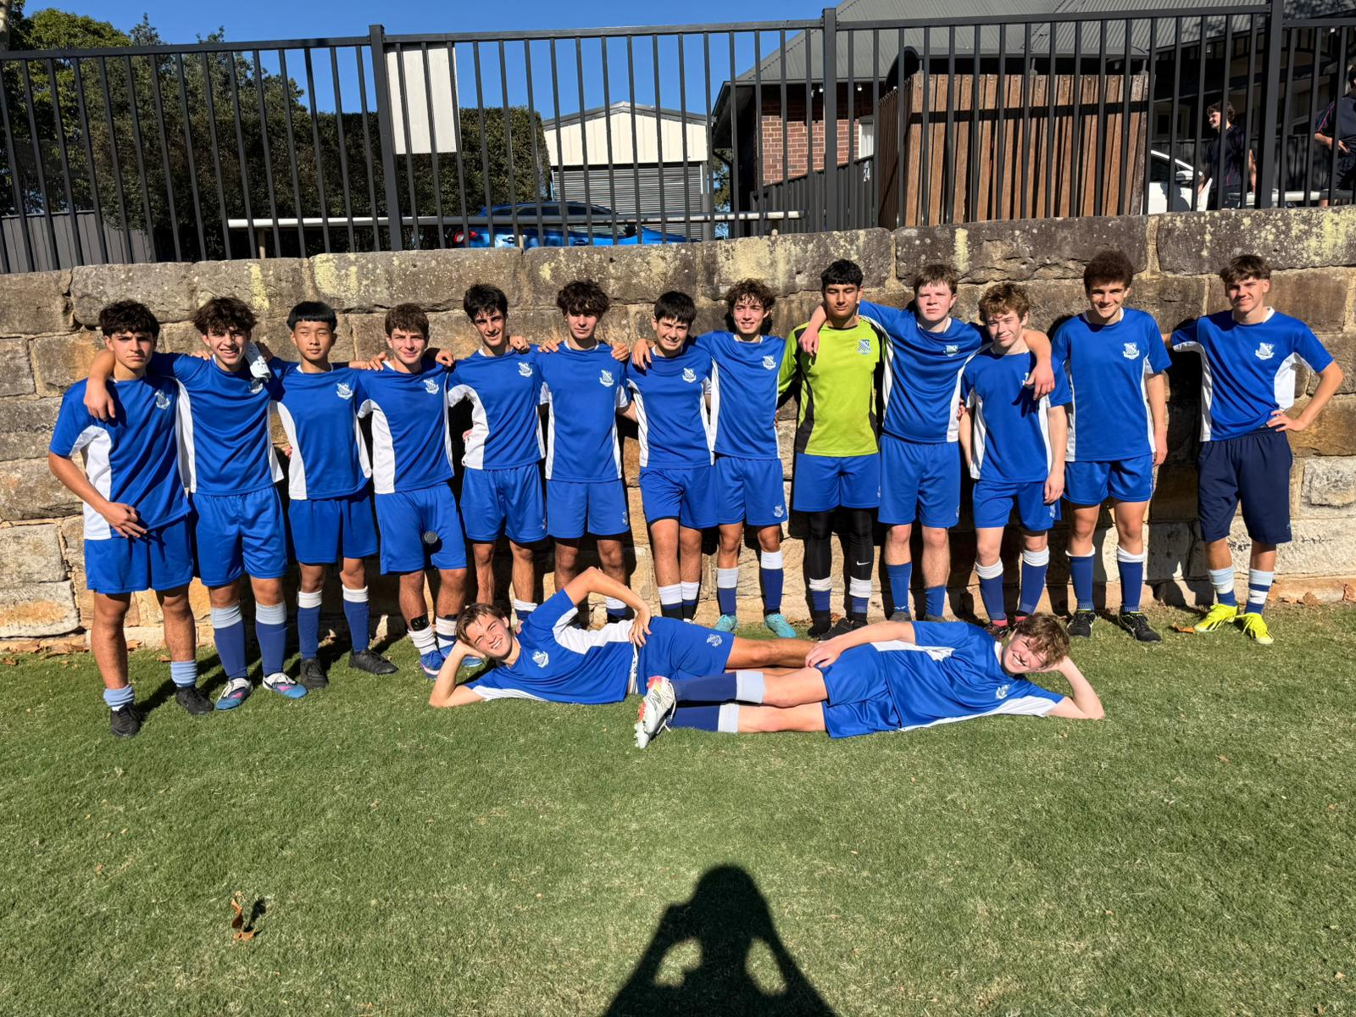
16A Match Report: Coach Stefano Rossello
Saturday morning saw an emphatic 11–0 victory for the 16As against Joeys. The match started slowly, with Riverview initially struggling in their tackling and conceding possession too easily. However, the team soon settled and broke the deadlock through some well-worked team play to make it 1–0. From that point onwards, Riverview took full control of the game. Despite not playing at their absolute best, the As were able to capitalise on Joeys’ mistakes and extended their lead to go into half-time 5–0 up. The half-time message was positive, while also reminding the boys not to drop the tempo despite the scoreline, and to aim for double digits to continue building on their goal-scoring patterns in match conditions. In the second half, Riverview maintained their dominance with greater composure and attacking intent. Both Luc Beasley and Buffet Chow were rewarded with hat-tricks for their determination, work rate, and focus, particularly after the break. Oliver Bion scored a long-range strike, James Dart added a strong solo goal, and Louis contributed with a well-taken brace. Overall, it was a very dominant performance in terms of the scoreline, particularly against rivals Joeys, with plenty of positive attacking moments and encouraging signs for continued development.
OPENS SQUADS
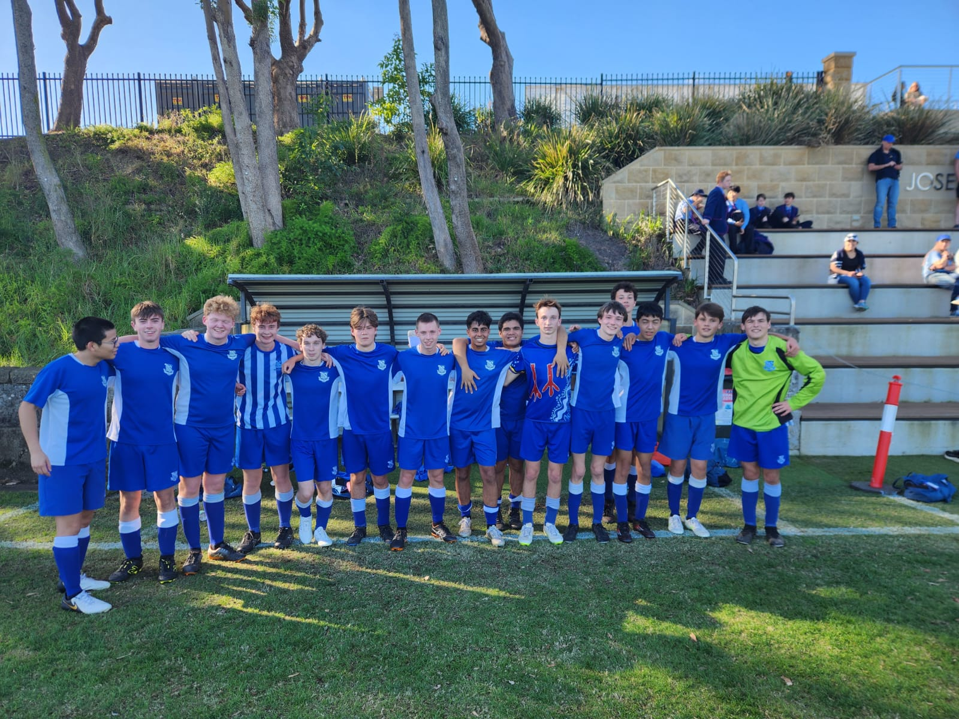
6th Match Report: Coach Maximus Joosse
The 6ths put in a massive performance against Joeys 5ths, coming away with a hard-fought 2–1 win in a match that truly tested the boys’ chemistry, resilience, and fitness. Joeys applied sustained pressure for the full 70 minutes and made it difficult for Riverview to play their usual counter-attacking style, with their sweeper system effectively limiting space in behind throughout the game. As a result, the boys were forced to adapt, working the ball up the field patiently and collectively as a unit. This showed strong teamwork, communication, and discipline across the pitch, particularly in difficult phases of play. The first half finished 0–0, with both sides competing strongly and neither team giving much away. The second half opened up slightly, with both teams eventually finding the net to make it 1–1. Despite growing fatigue and continued pressure late in the match, the boys kept pushing forward and were rewarded in dramatic fashion, scoring a late winner with just one minute remaining to seal a brilliant 2–1 victory. It was a fantastic all-round effort from everyone involved and a strong example of resilience, teamwork, and determination under pressure.
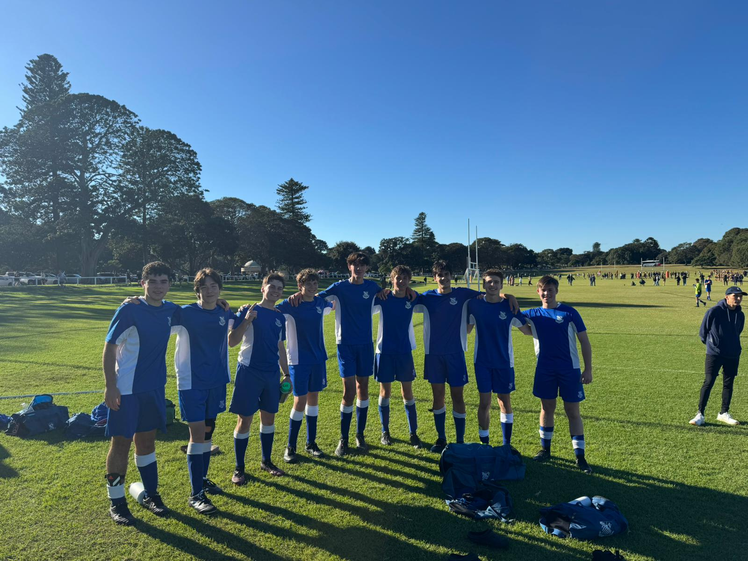
5th Match Report: Coach Jack Aman
A tough result today against a very strong Reddam side, with the boys aware from the opening minutes that they were up against a quality opponent. Reddam started sharply, scoring two early goals within the first five minutes. However, Riverview responded by settling into the game, slowing the tempo, and producing a much more competitive 20-minute spell, despite conceding further goals as the half progressed. At 5–0 down at half time, the focus was on improving the second-half performance, and the boys responded positively with greater effort, structure, and intensity across the park. The back line, in particular, produced several strong defensive efforts under sustained pressure, helping limit Reddam to just two goals in the second half. Overall, while the result was not what the team wanted, there were clear signs of resilience and improved application after the break, providing important lessons to take forward into future matches.
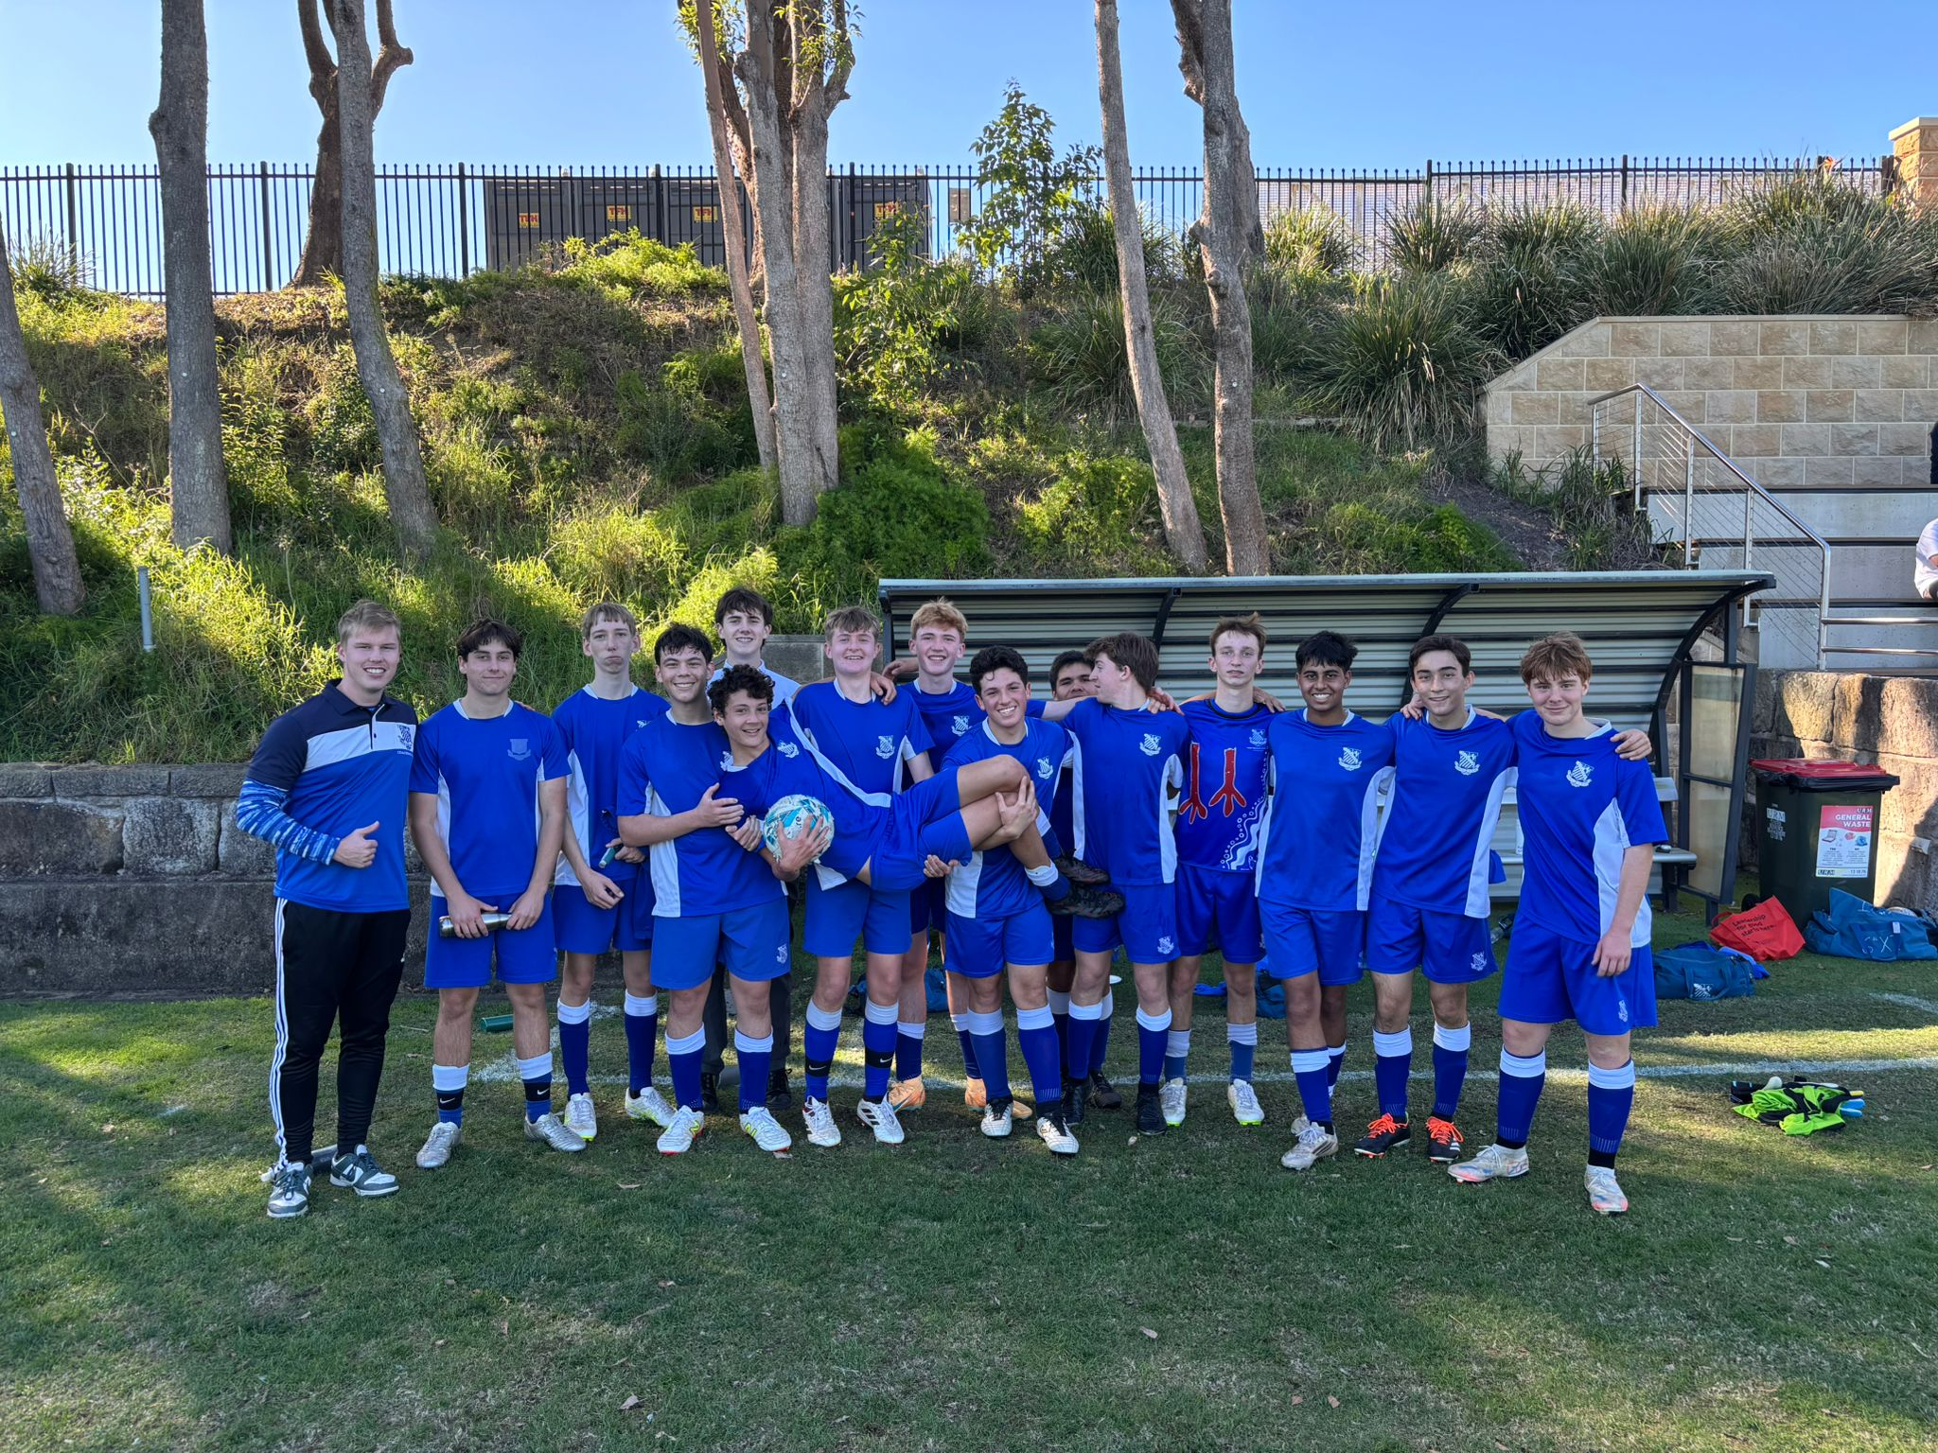4th Match Report: Coach Gabriel De Haast
The boys went into the game full of confidence, using the same setup as the previous week. Riverview started strongly, with Lewis opening the scoring early to make it 1–0 within the first 10 minutes. Julian added a second shortly after, finishing well after receiving a quick goal-kick pass from the goalkeeper. Luca then extended the lead with a superb finish into the bottom corner from outside the box after beating a couple of defenders. At half time, the message was clear and simple: don’t get complacent. The boys responded well to that instruction and maintained their intensity in the second half. Jack Stanic went on to score the team’s first hat-trick of the season, producing a standout performance that also earned him Man of the Match honours. The team continued to play with confidence and control, closing out the game strongly to secure a convincing 6–0 win. Overall, it was an excellent all-round team performance and a great effort from the lads.
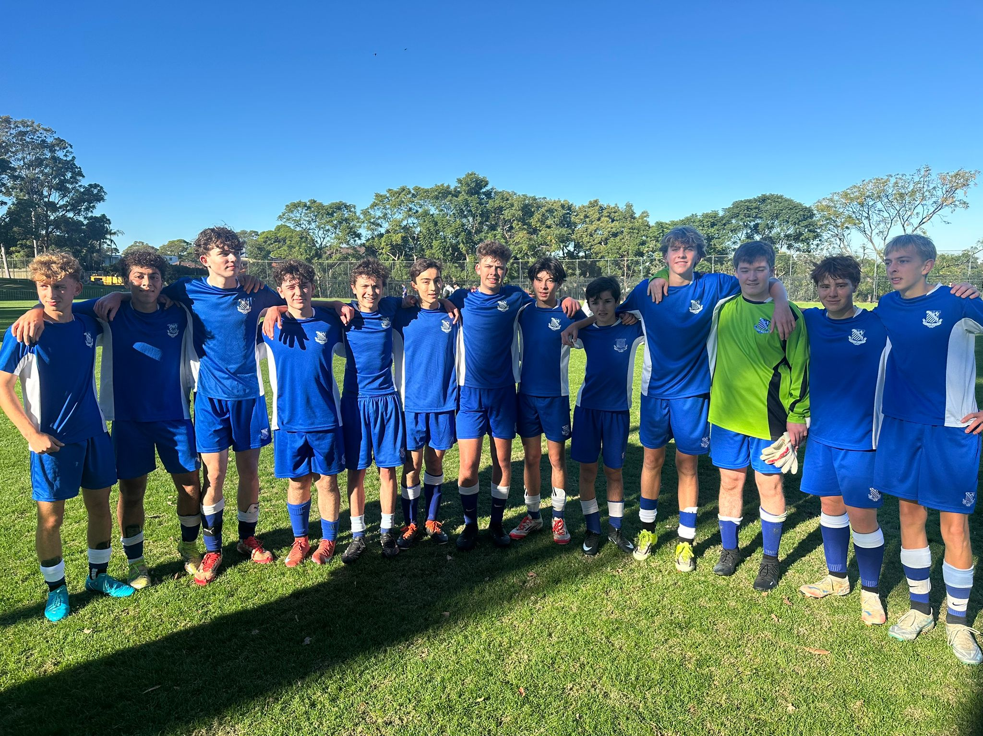
3rd Match Report: Coach Andrew Ferrara
Riverview put in a solid shift against Joeys, coming away with a 1–1 draw in a match that on reflection felt like it could have been a win. The morning started perfectly when Brendan bundled the ball over the line early on after it rebounded off the crossbar to give Riverview a deserved 1–0 lead. A brief lapse in concentration saw Joeys equalise with a soft goal, but despite this setback, Riverview still looked the stronger side for much of the opening half. The second half was where the team really asserted themselves. Riverview became more aggressive, controlled possession, and consistently pushed Joeys back into their own half, creating sustained pressure and a number of promising attacking moments. It therefore felt particularly frustrating when a late winning goal was ruled out for offside. There are still clear areas for improvement, particularly in tactical discipline. At times, the team looked to play overly ambitious forward passes rather than using shorter, simpler options to maintain rhythm and build attacks more effectively. Improving combination play, pressing in a more coordinated manner, and showing greater aggression in dealing with balls over the top will be key focus points moving forward. Despite the frustration of the draw, the performance represented a strong step in the right direction and showed clear progress in intensity, structure, and overall competitiveness.

